Ethnobotanical Diversity, Phytochemical Screening and Biological Evaluation of Selected Medicinal Mushrooms Species
CONTENTS:

Table S1. Description of mushrooms included scientific name and image.
Table S2. Informant Consensus Factor by category of different ailment within the current study of mushrooms.
Table S3. Species use value within the current study of mushrooms.
Table S4. Relative frequency of citation (RFC) within the current study of mushrooms. i.

Table S1. Description of mushrooms included scientific name and image.
S.no | Species Name | Images
1 | Agricus arvensis | 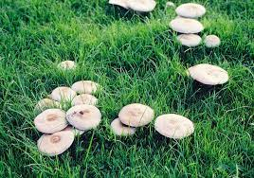
2 | Clitocybe frondasa | 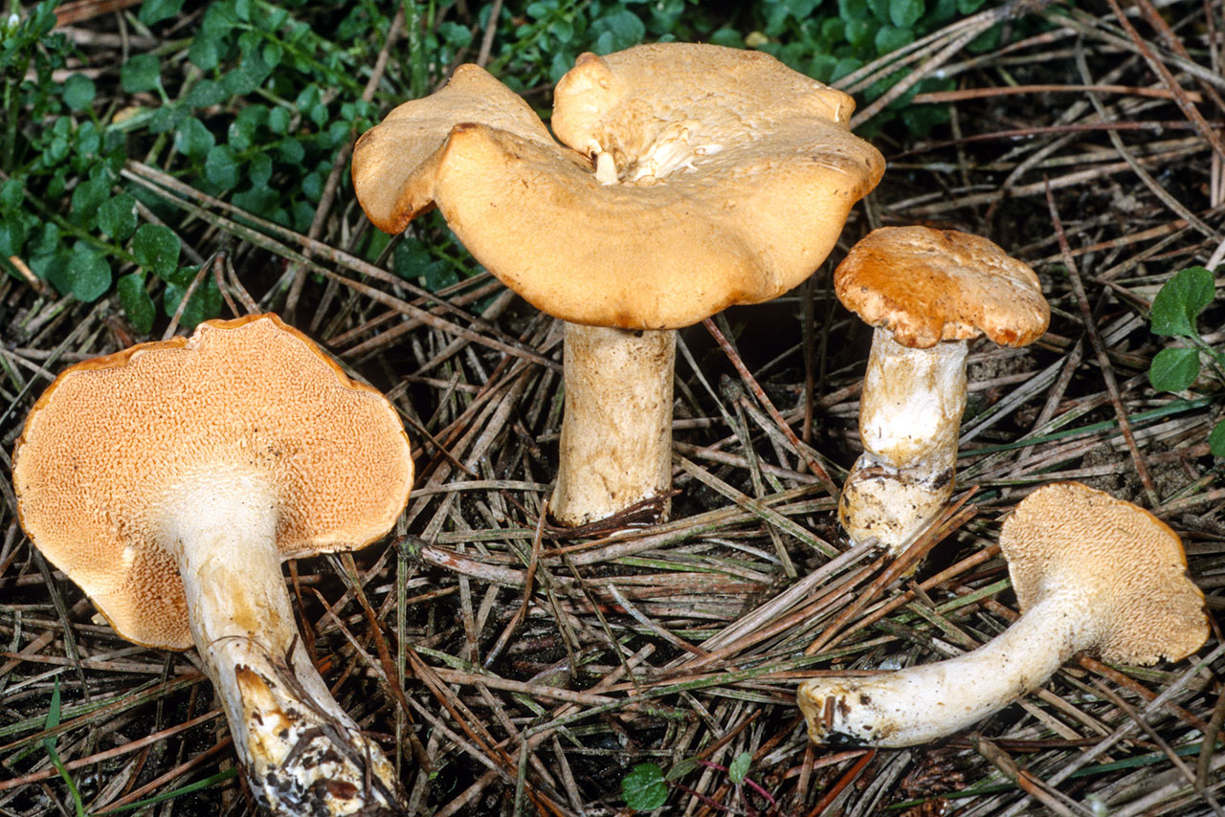
3 | Morchella conica (Fr.) | 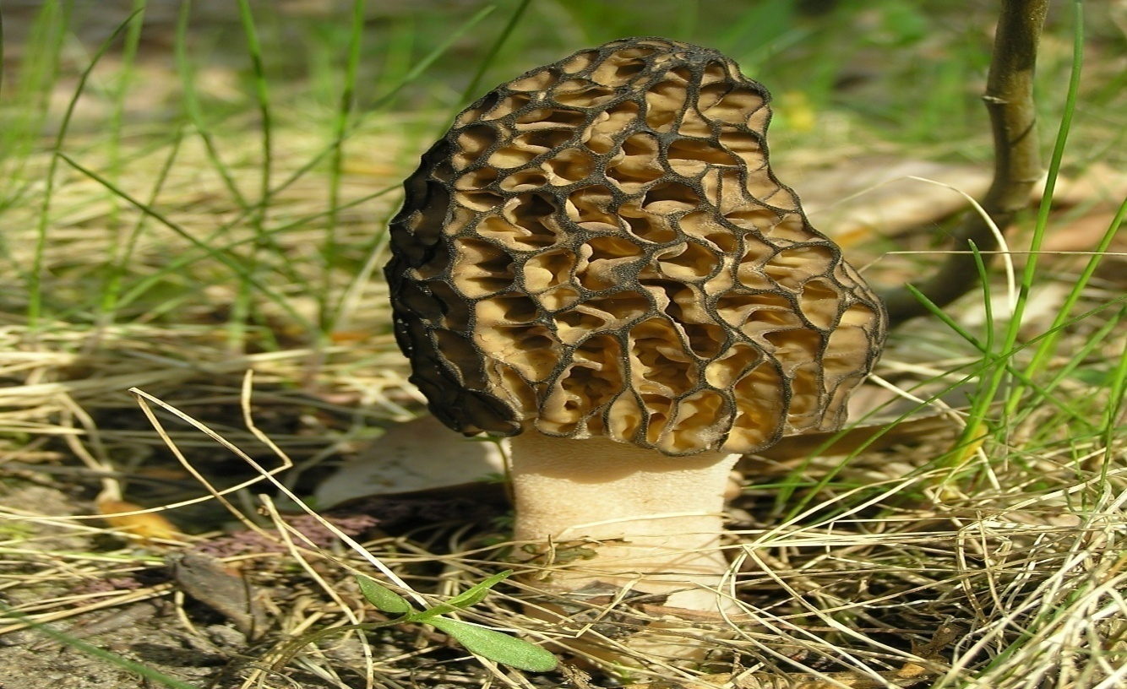
4 | Omphalotus olearius
5 | Pleurotus ostreatus | 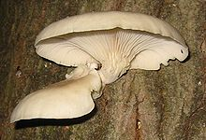
6 | Polyporus tuberaster | 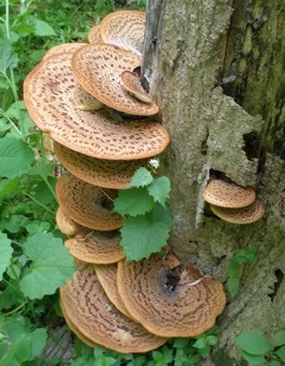

Table S2. Informant Consensus Factor by category of different ailment within the current study
of mushrooms.
S.No | Category of ailment | Number of use reports | Number of species | ICF Value
1 | Heart | 12 | 4 | 10.66
2 | Brain | 9 | 3 | 7.66
3 | Arthritis | 5 | 2 | 3.6
4 | Sex stimulant | 17 | 4 | 15.76
5 | Body tonic | 23 | 7 | 21.69
6 | promote digestion, | 31 | 7 | 29.77
7 | Immune system | 33 | 11 | 31.66
8 | Stomach problem | 17 | 5 | 15.70
9 | Chronic diarrhea | 11 | 3 | 9.72
10 | Constipation | 7 | 2 | 5.71
11 | Asthma | 8 | 3 | 6.62
12 | Allergies | 6 | 2 | 4.66
13 | microbial infection | 36 | 10 | 34.72
14 | Cytotoxicity | 32 | 3 | 30.90
15 | Antioxidant | 32 | 7 | 30.78
16 | Antihypoxic | 9 | 2 | 7.77
17 | wound healing | 8 | 2 | 6.75
18 | Inflammation | 15 | 5 | 13.66
19 | AIDS | 16 | 2 | 14.87
20 | Cancer, | 63 | 16 | 61.74
21 | Tumor | 26 | 5 | 24.80
22 | Flu | 5 | 2 | 3.6
23 | Colds | 6 | 2 | 4.66
24 | Hyperlipidemia | 28 | 7 | 26.75
25 | Hypertension | 14 | 4 | 12.71
26 | Diabetes | 27 | 8 | 25.70
27 | Vitamin D | 14 | 2 | 12.85
28 | Vitamin B1 | 9 | 2 | 7.77
29 | Blood circulation | 29 | 5 | 27.82
30 | Weight loss | 11 | 3 | 9.72
31 | Hepatitis, | 6 | 2 | 4.66
32 | Osteoporosis | 18 | 3 | 16.83
33 | Tuberculosis | 14 | 2 | 12.85
34 | Ulcer | 13 | 3 | 11.76
35 | Skin | 3 | 1 | 1.66
36 | Liver diseases | 16 | 2 | 14.87

Table S3. Species use value within the current study of mushrooms.
S.no | Species Name | UV value
1 | Agricus arvensis | 0.79
2 | Clitocybe frondasa | 0.58
3 | Morchella conica (Fr.) | 0.46
4 | Omphalotus olearius | 0.15
5 | Pleurotus ostreatus | 0.87
6 | Polyporus tuberaster | 0.49

Table S4. Relative frequency of citation (RFC) within the current study of mushrooms.
S.no | Species Name | RFC value
1 | Agricus arvensis | 0.65
2 | Clitocybe frondasa | 0.28
3 | Morchella conica (Fr.) | 0.05
4 | Omphalotus olearius | 0.64
5 | Pleurotus ostreatus | 0.46
6 | Polyporus tuberaster | 0.36

