**XRD Analysis of biosorbents**

XRD serves as a valuable technique for examining crystal properties. In this study, XRD analysis was employed to explore the phases and structural characteristics of both PDB and DPS. The XRD test results are showcased in figure S-1, covering the 2θ from 10°- 90° range. This broad range was selected to thoroughly examine and assess the complete diffraction patterns of the samples, focusing specifically on the distinctive characteristics of PDB and DPS. The XRD chart representing PDB exhibits notable broad diffraction peaks at 2θ around 11.49 and 20.54º, attributed to cellulose along with various smaller peaks across the remaining range. Conversely, the XRD chart for DPS illustrates distinct peaks at 2θ near 16.34 and 20.38º, ascribed to cellulose and several additional peaks within other ranges. These different tiny peaks in PDB and DPS curves are noticeable, and they could be related to the specimen's water content or the presence of trace pollutants. These unique peak forms and patterns in the XRD spectra provide information about the phases and structures found in the PDB and DPS samples.

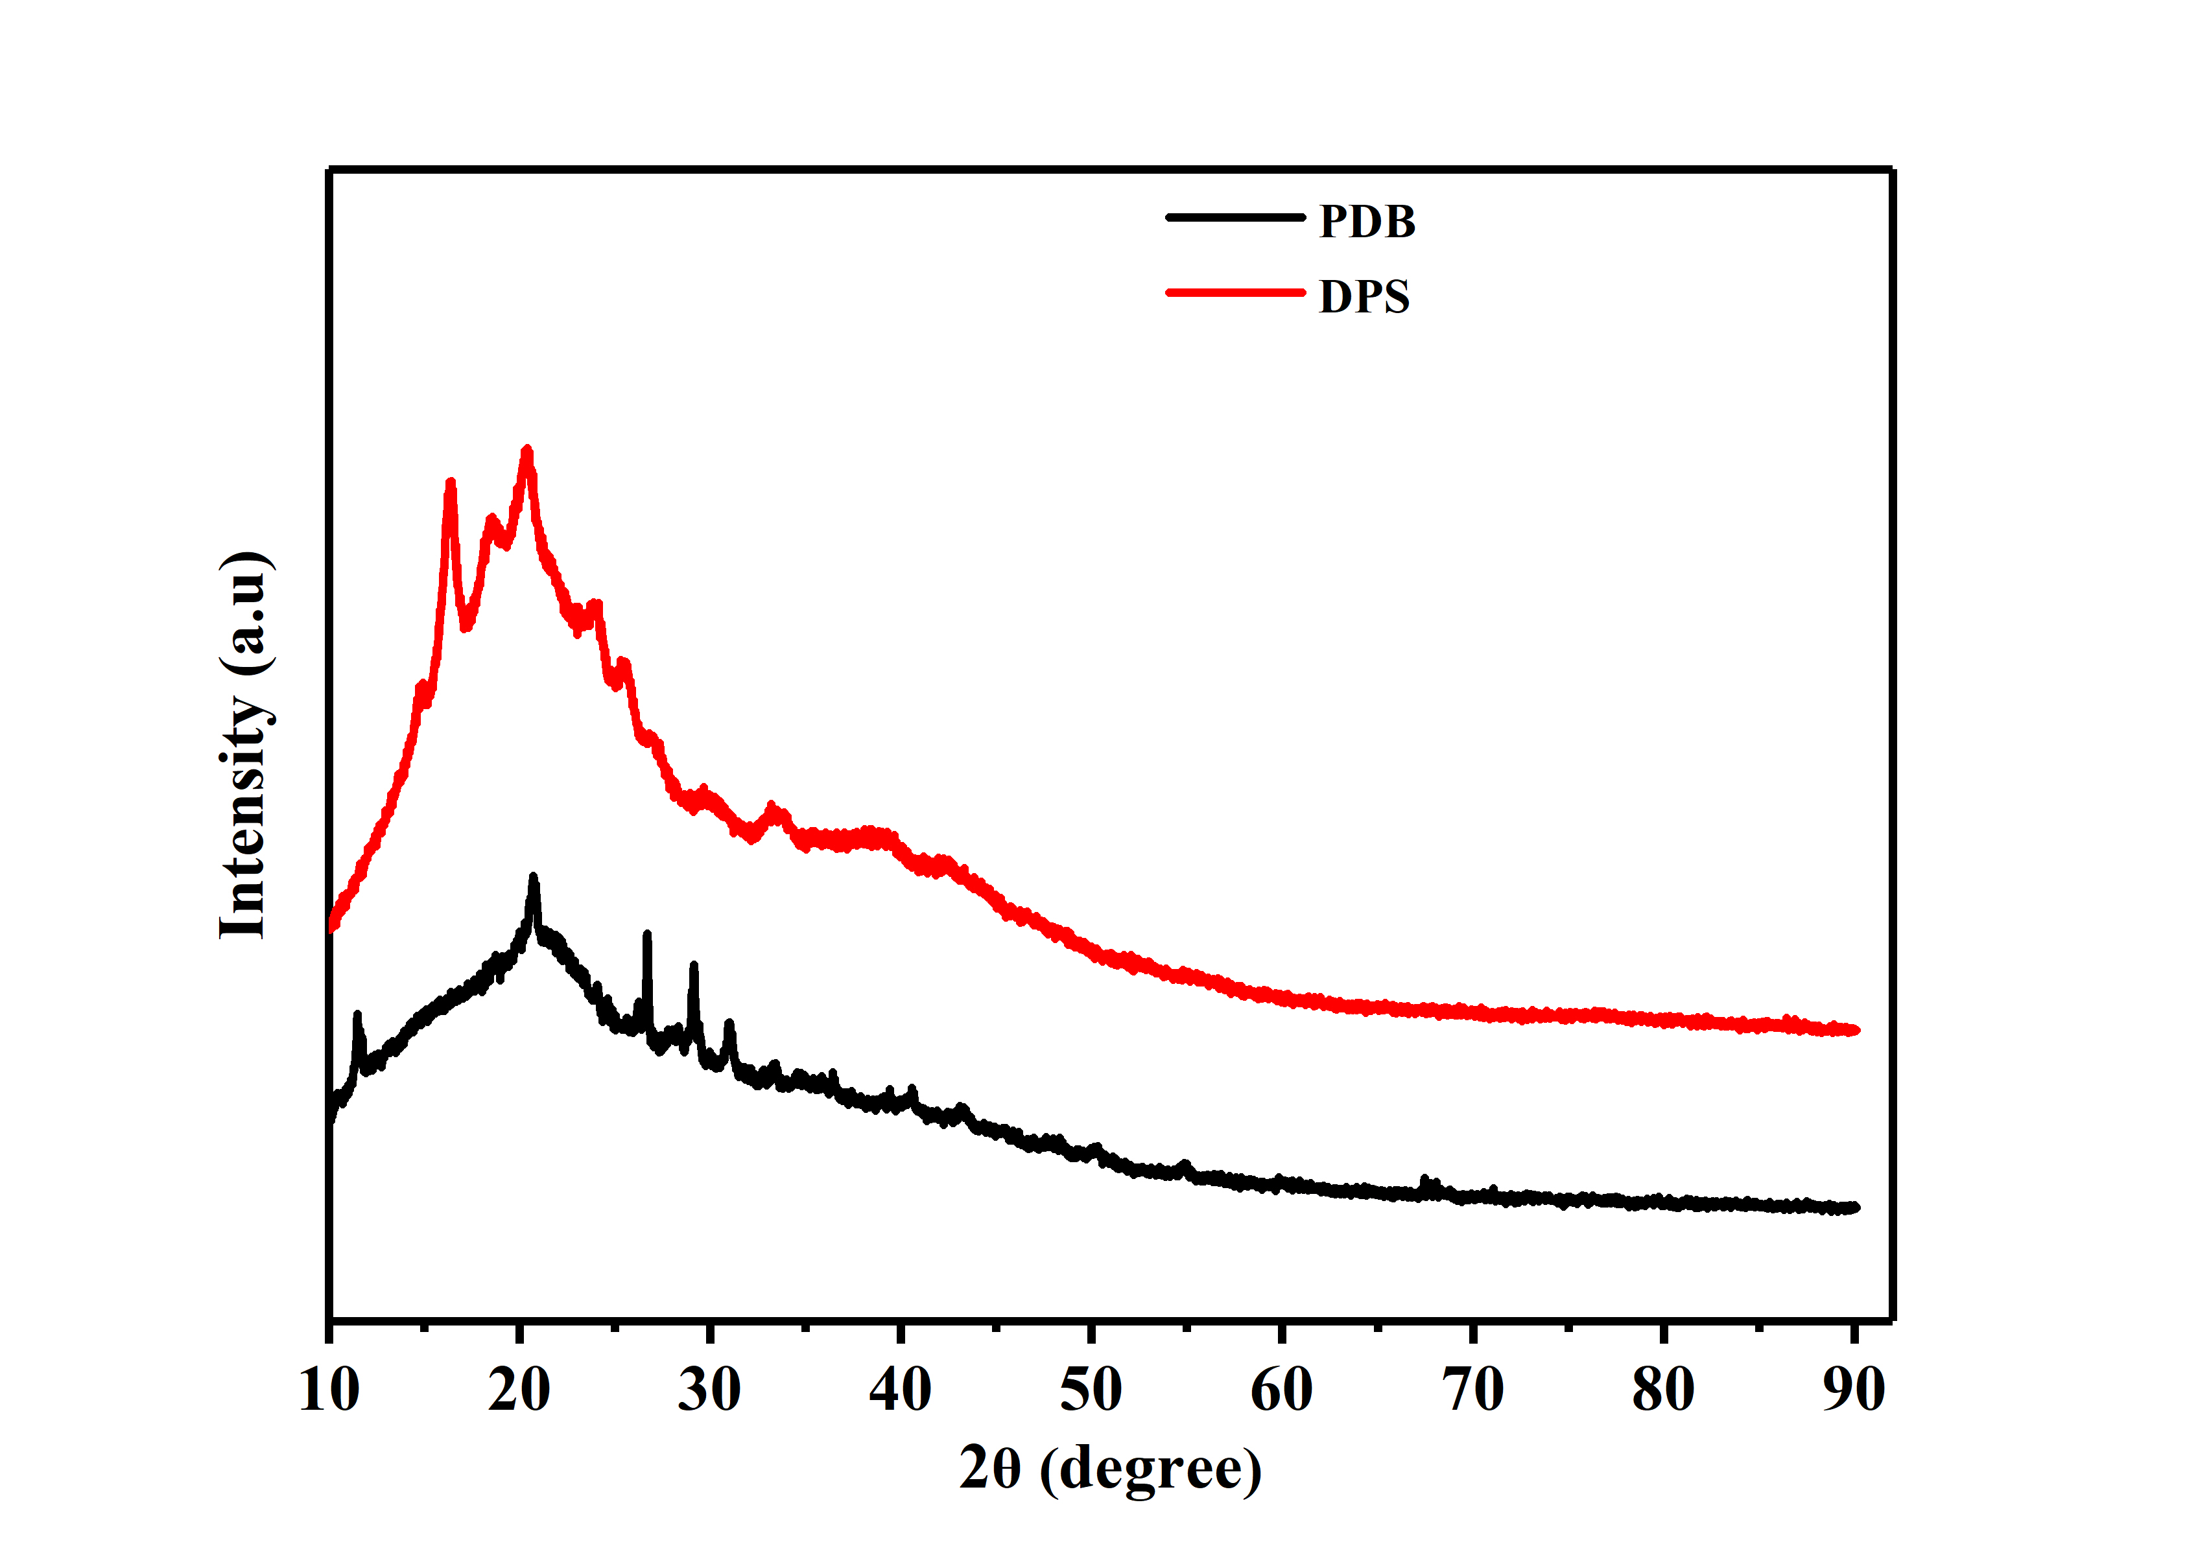

Figure S-1. XRD analysis of PDB and DPS biosorbents

**Barrett-Joyner-Halenda (BJH) pore size distribution**

Figure S-2 showcases the Barrett-Joyner-Halenda (BJH) pore size distribution (PSD) of PDB and DPS. Evidently, the PSD curve of PDB, which is based on the adsorption branches, presents a distinct peak at 2.9 nm. In the same way, the peak of DPS is centered around 2.4 nm. These outcomes affirm the homogeneous mesoporous properties of both PDB and DPS.

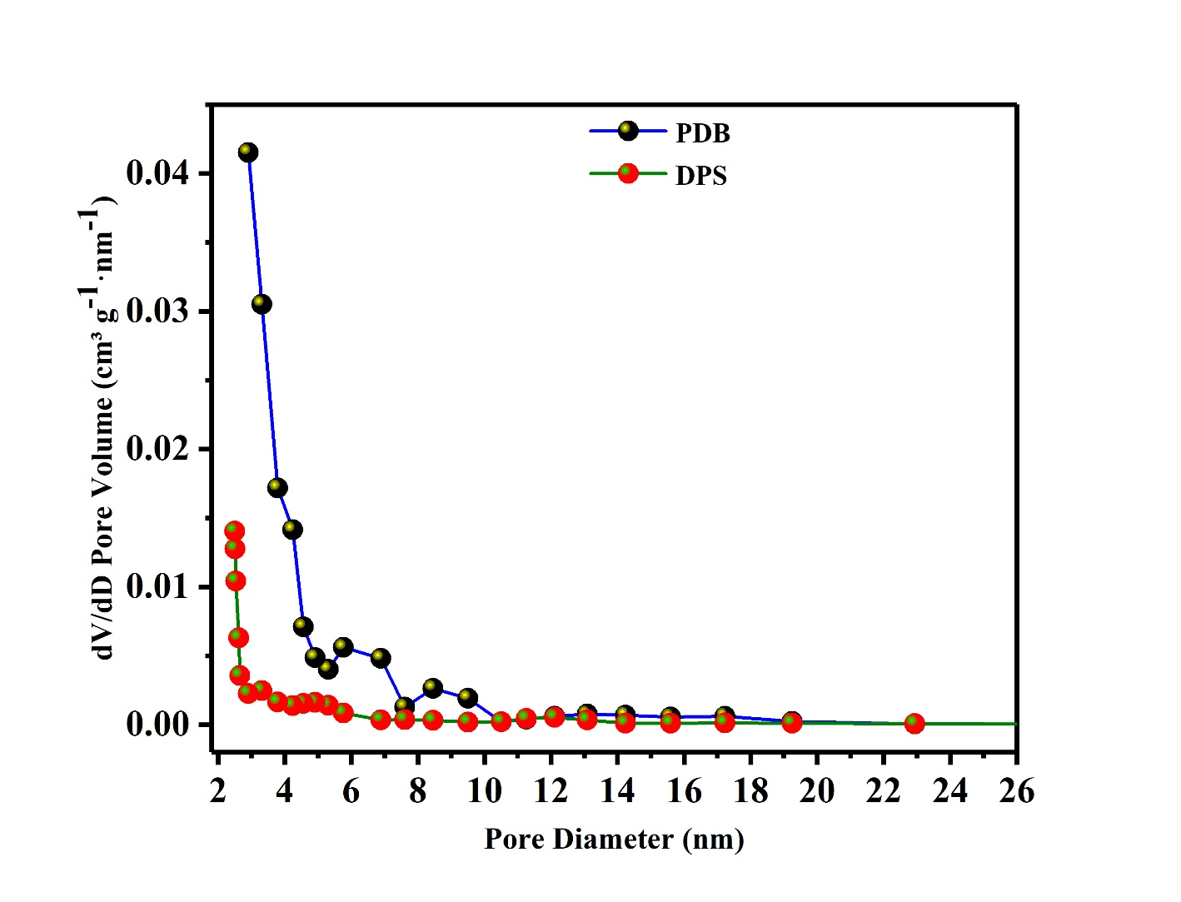

Figure S-2 BJH pore size distribution of PDB and DPS biosorbents

**Point of zero charge(pHpzc) of biosorbents**

The pHpzc refers to the pH value at which the quantity of negative charges present on the biosorbent's surface is equivalent to the number of positive charges. The pHPZC serves as a crucial parameter for determining the pH sensitivity range and facilitates the anticipation of surface activity and sorption abilities. The functional groups on the adsorbent might carry either a positive or negative charge contingent on the pH of the solution. When the pH surpasses the pHpzc, these sites predominantly exist in a dissociated state, exhibiting a negative charge. Conversely, at pH levels lower than the pHpzc of these groups, the sites tend to be associated with a proton, resulting in a positive charge. In separate flasks, 25 mL portions of KNO3 (0.01 M) solution were added. The pH range was adjusted from 2 to 12 using either HCl or NaOH (0.1 M) solutions, and then 0.1 g of PDB and DPS were added to each flask. The solutions were transferred to an oscillation chamber and kept at room temperature, shaking for 48 hours to reach equilibrium. Following filtration of the dispersions, the resulting solutions pH was determined. Figure S-3 depicts the graphical illustration of the pHpzc plot for the PDB and DPS biosorbent. The pHpzc values of PDB and DPS were determined to be 4.7 and 5.0 respectively.

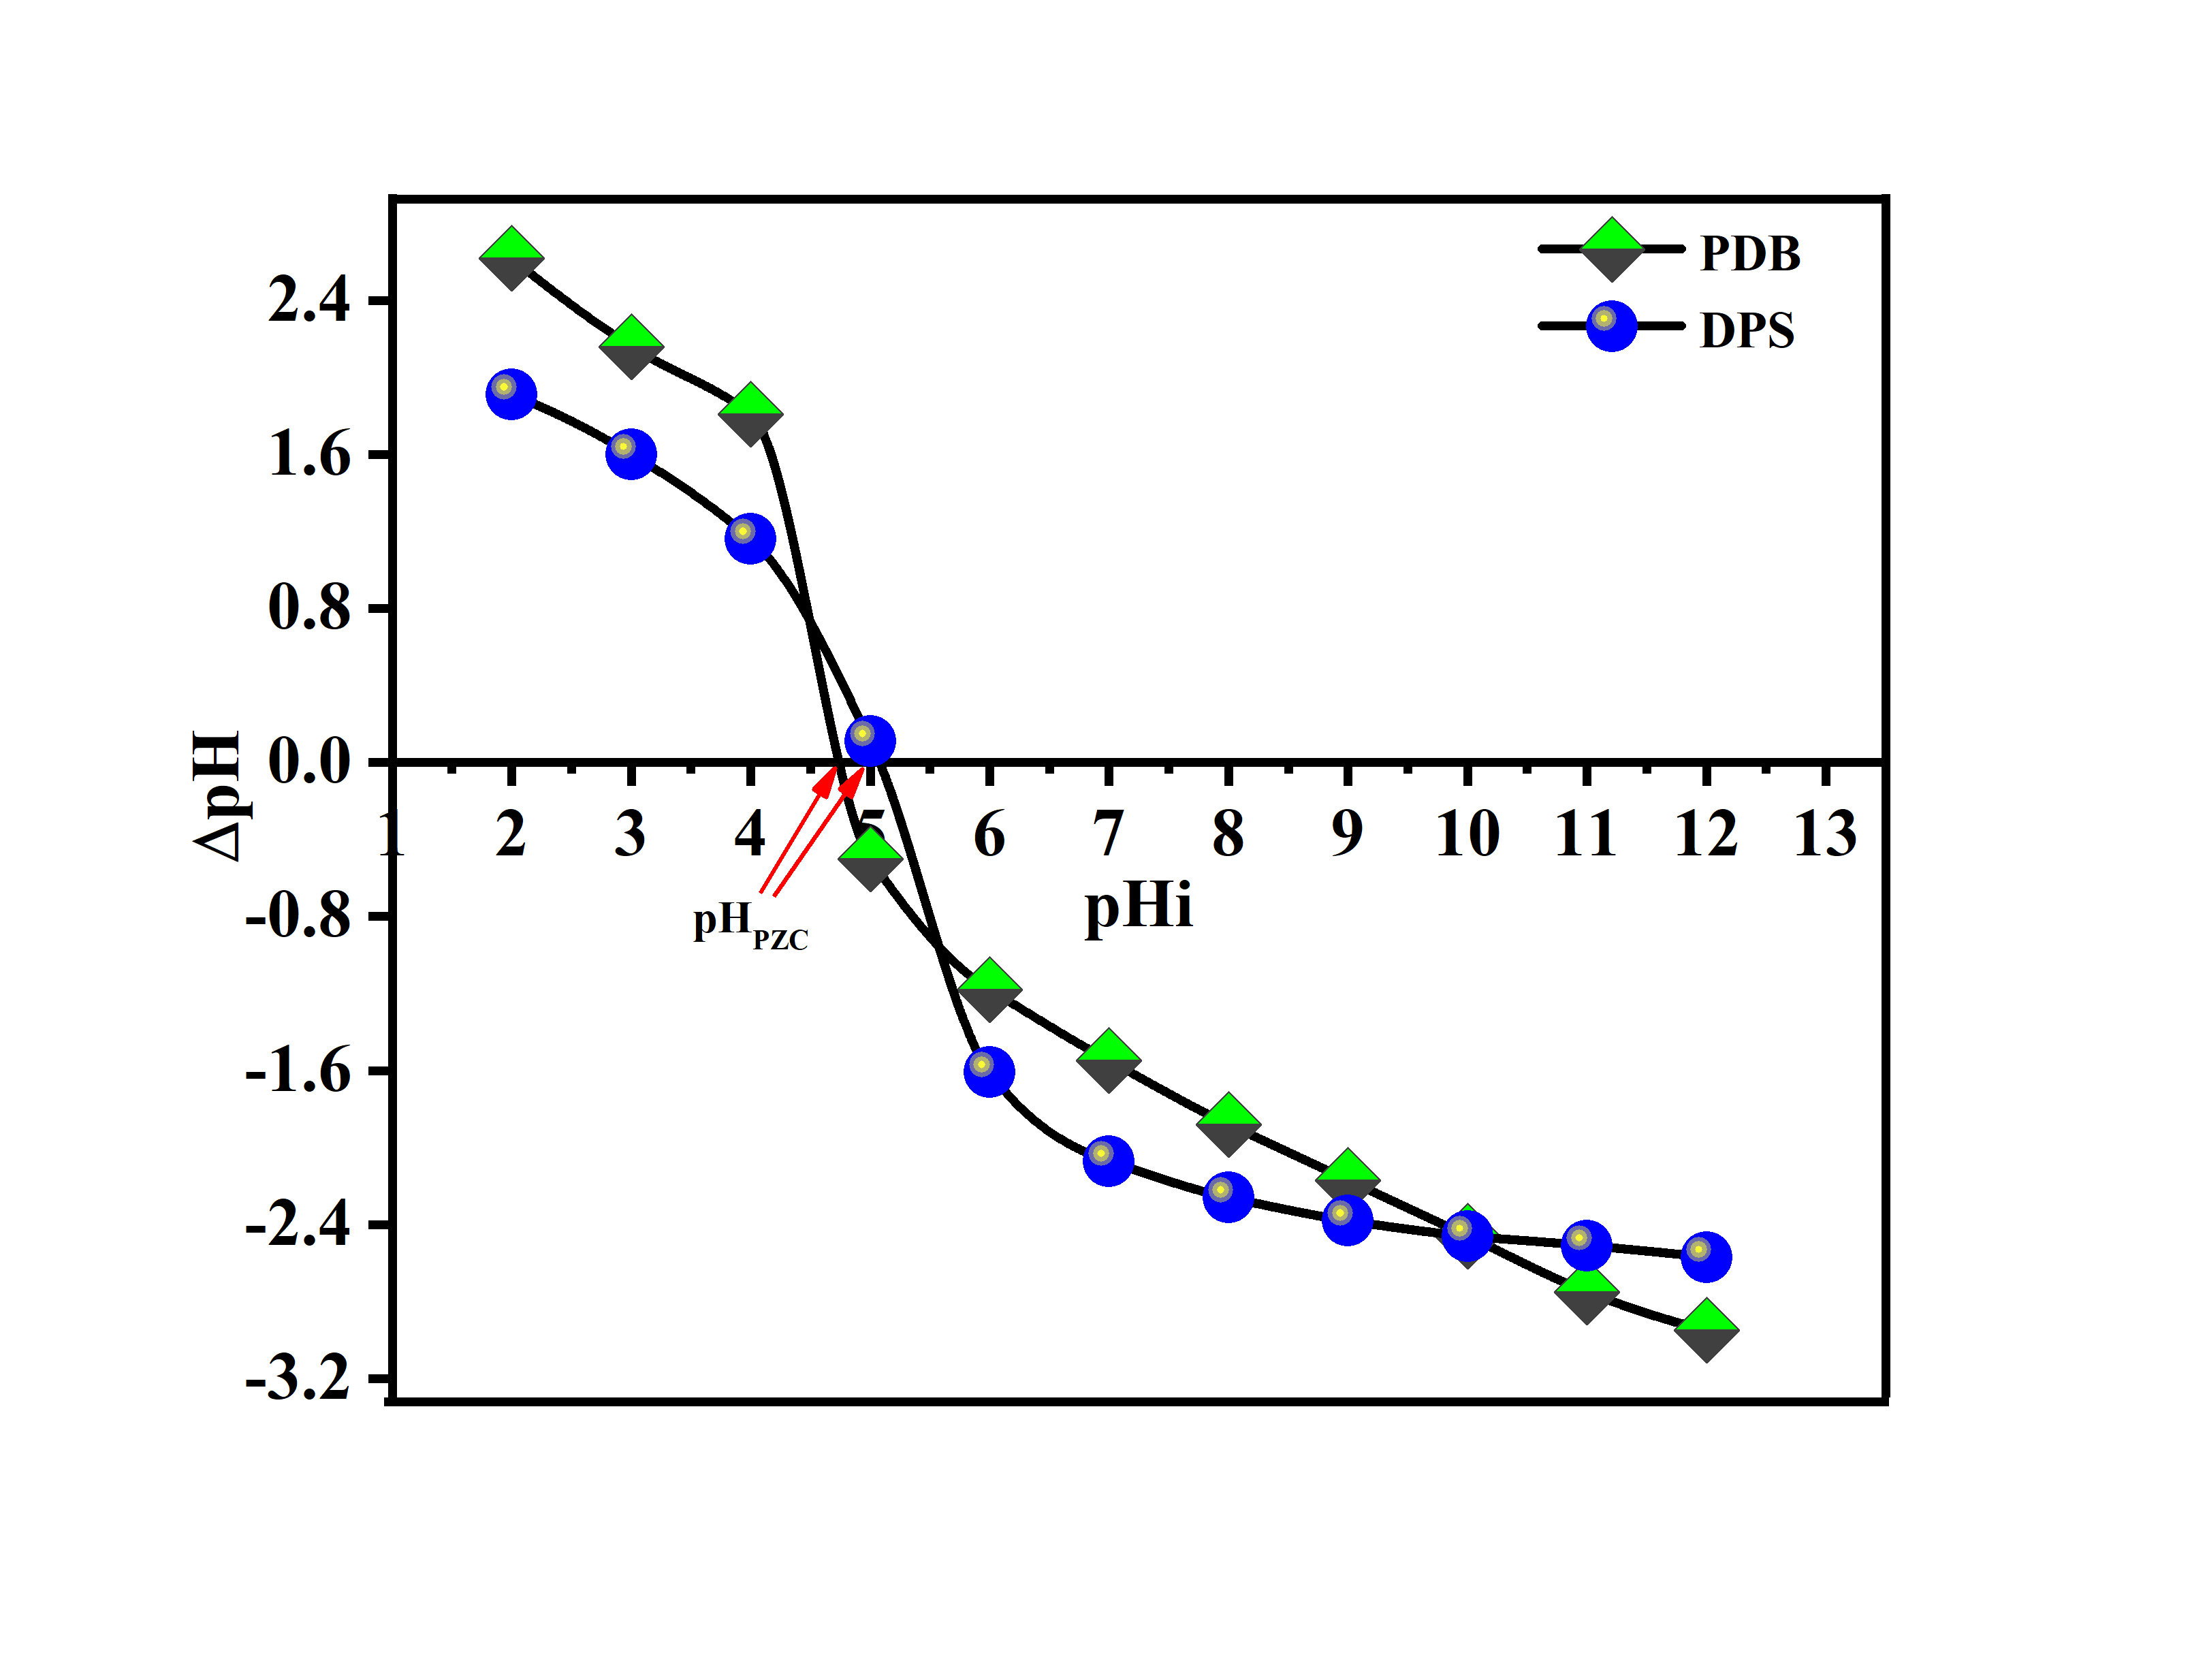

Figure S-3. The pH at the point of zero charge (pHpzc) for the PDB and DPS

##### **Uranium (VI) Concentration effectiveness**

The impact of the initial U(VI) concentration on biosorption was investigated by exposing 0.5 g of biosorbents to uranium solutions (15 ml) for 2 hours, with concentrations ranging from 5 to 120 mg/L, while maintaining a pH of 6.0. The adsorption isotherm serves to elucidate the connection between the adsorption capacity of the adsorbent and the equilibrium concentration of the adsorbate species in a solid-liquid system. As depicted in figure S-4, the percentage of U(VI) removal experiences a decrease, declining from 78.2 to 32.45 % for PDB and 70.4 to 30.62 % for DPS, as the initial uranium concentration rises from 5 mg/L to 120 mg/L. However, the adsorption capacity increases during this trend, going from 0.11 mg/g to 1.68 mg/g for PDB and 0.10 mg/g to 1.10 mg/g for DPS. This behavior can be attributed to the fact that at lower U(VI) concentrations, most U(VI) ions interact with the available active surface places of the biosorbents, leading to higher U(VI) ion extraction. However, as the U(VI) concentration increases further, an excess of U(VI) ions in the solution results in a higher adsorption amount at these higher concentrations. Conversely, higher initial U(VI) concentrations resulted in reduced U(VI) biosorption efficiency on biosorbents. The reduction in uranium biosorption capacity can be attributed to a decrease in the number of active sites available on the biosorbent. This decline occurs because U(VI) ions have a greater affinity to attach with the active locations, which is a consequence of the increased initial uranium concentration (Xiao-teng, Dong-mei et al. 2019, Haggag, Abdelsamad et al. 2020).

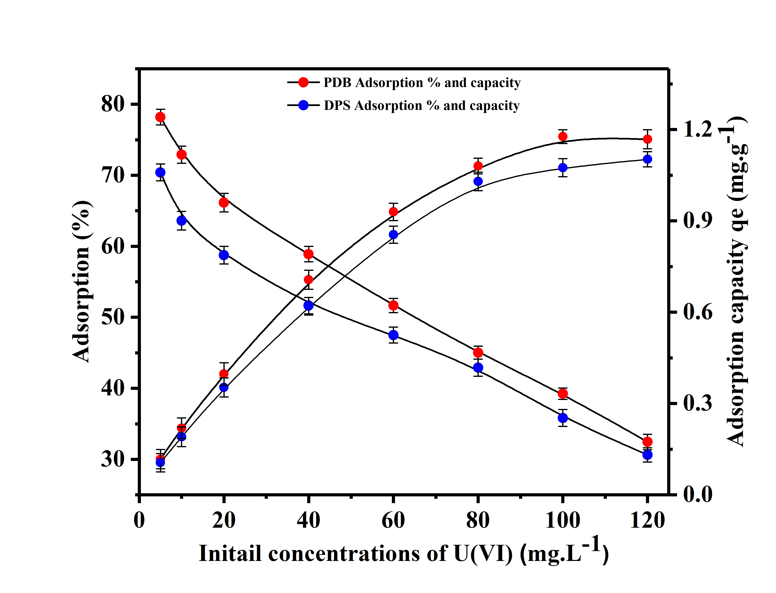

Figure S-4. Effect of different U(VI) concentrations of on the adsorption of U(VI) on biosorbents (PDB and DPS)

**References**

Haggag, E. S. A., A. A. Abdelsamad and A. M. Masoud (2020). "Potentiality of uranium extraction from acidic leach liquor by polyacrylamide-acrylic acid titanium silicate composite adsorbent." International Journal of Environmental Analytical Chemistry **100**(2): 204-224.

Xiao-teng, Z., J. Dong-mei, X. Yi-qun, C. Jun-chang, H. Shuai and X. Liang-shu (2019). "Adsorption of uranium (VI) from aqueous solution by modified rice stem." Journal of Chemistry **2019**.