Journal: **Journal of King Saud University-Science**

Title: **Effect of Probiotics on Hematology and Histopathology of Organs Associated with Immune System in Male and Female Wistar Rats**

Authors: **Zuhra Bibia, Naureen Fatimaa, Muhammad Qadeer Sarwara, Arif Ullaha, Samina Younasa, Tayyab Manzoora, Dilara Abbas Bukharia, Abdul Rehmanb\***

aDepartment ofZoology, Government College University, Lahore, Pakistan

bInstitute of Microbiology and Molecular Genetics, University of the Punjab, Quaid-e-Azam Campus 54590, Lahore, Pakistan (rehman.mmg[@pu.edu.pk](mailto:dr.dilaraabbas@gcu.edu.pk))

## *Correspondence author

(Dr. Abdul Rehman)

Professor

Institute of Microbiology and Molecular Biology,

University of the Punjab,

Lahore, Pakistan

Email: rehman.mmg@pu.edu.pk

**Supplementary data (Tables & Figures)**

**Table S1: Probiotic strains influence the mean body weight of Wistar rats.**

|  |  |  |  |  |  |  |  |
| --- | --- | --- | --- | --- | --- | --- | --- |
| **Groups** | **Gender** | **0 Day** | **NC** | **PC** | **Pro-3** | **Pro-4** | **pValue** |
| **Initial Weight (g)** | **M** | 121±0.57c | 161.6±6.0ab | 123±0.57c | 165.3±8.66a | 169.3±2.33a | 0 |
| **F** | 103.0±1.73a | 104.3±1.20a | 112.6±1.4a | 106.0±1.5a | 106±2.0a | 0.113 |
| **Final Weight (g)** | **M** | 121.0±0.57d | 192.2±18.9bc | 182.2±0.37c | 233.3±12.1a | 241.0±3.60a | 0 |
| **F** | 103.0±1.73e | 187.66±3.84bcd | 165.5±0.8cd | 180.8±9.3cd | 184.3±6.4cd | 0 |
| **Weight gain (g)** | **M** | 0.0±0.0c | 30.6±17.6bc | 59.2±0.73ab | 78±3.6a | 81.6±1.3a | 0.01 |
| **F** | 0.00±0.00e | 83.33±2.72abc | 52±0.59cd | 74.8±8.4bcd | 78.3±7.8bcd | 0 |

* The data depicted the average weight of Wistar rats (male and female) as Mean±S.E.M.

**Table S2: Influence of probiotics on the relative organ weights.**

|  |  |  |  |  |  |  |  |
| --- | --- | --- | --- | --- | --- | --- | --- |
| **Groups** | **Gender** | **0day** | **NC** | **PC** | **Pro-3** | **Pro-4** | **p Value** |
| **Liver(g)** | **M** | 3.05±0.03bc | 4.91±0.60c | 2.92±0.00bc | 4.1±0.75ab | 2.37±0.04a | 0.001 |
| **F** | 3.22±0.0a | 3.48±0.2a | 3.12±0.03a | 2.86±0.24a | 2.8±0.23a | 0.178 |
| **Thymus(g)** | **M** | 0.14±0.00a | 0.19±0.04a | 0.07±0.00a | 0.09±0.01a | 0.11±0.00a | 0.018 |
| **F** | 0.15±0.01a | 0.17±0.03a | 0.11±0.00a | 0.19±0.02a | 0.16±0.01a | 0.088 |

*Data was presented as mean±S.E.M. of organ weights in male and female Wistar rats.

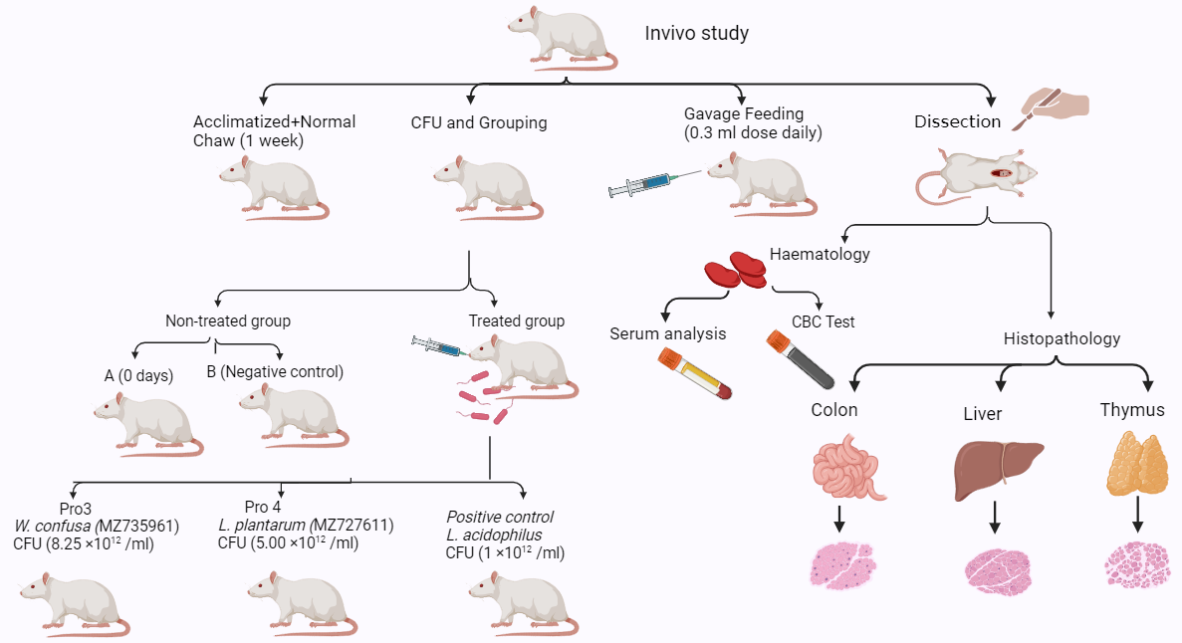

**Figure S1:** Experimental design of the research work.

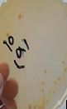 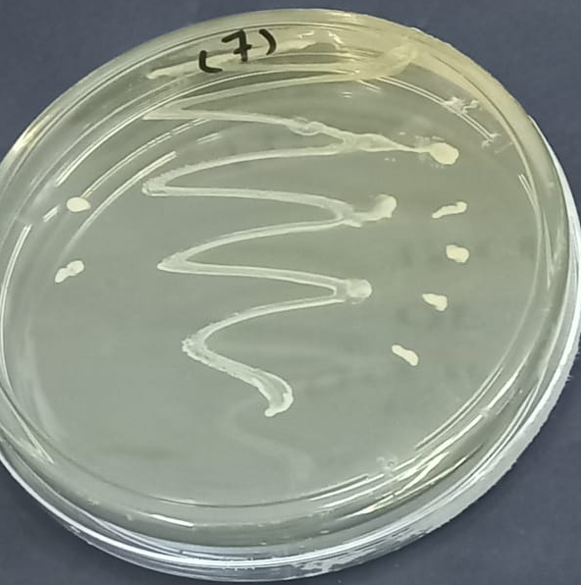 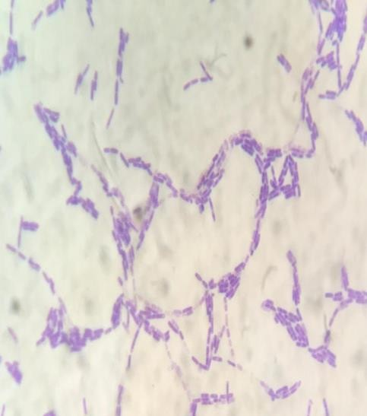 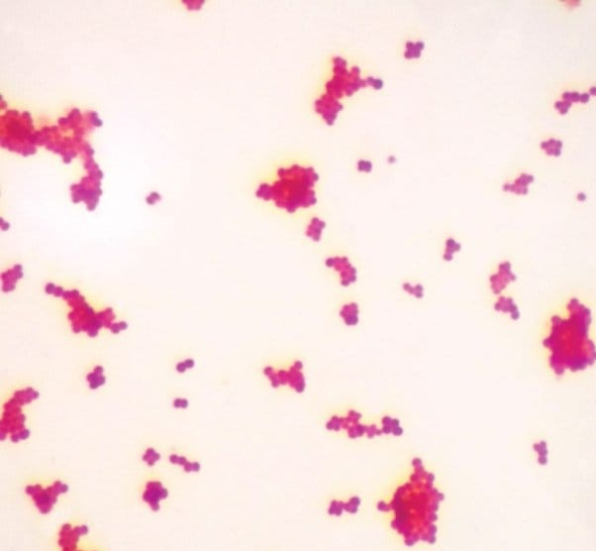

1. **Spreading b) Streaking c) Gram′s staining d) Endospore staining**

**Figure S2:** (a) Spreading, (b) streaking of isolated bacterial strains, (c) Gram staining, and (d) Endospore staining of bacterial isolate showing rod-shaped bacteria.

**a) 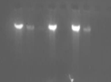 (b** 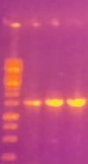

**2000**

**1500**

**1000**

**750**

**500b**

**250**

**Figure S3:** (a) Agarose gel 1 % showing the genomic DNA of bacterial isolates (b) PCR product of 16S rRNA gene of bacterial isolates.

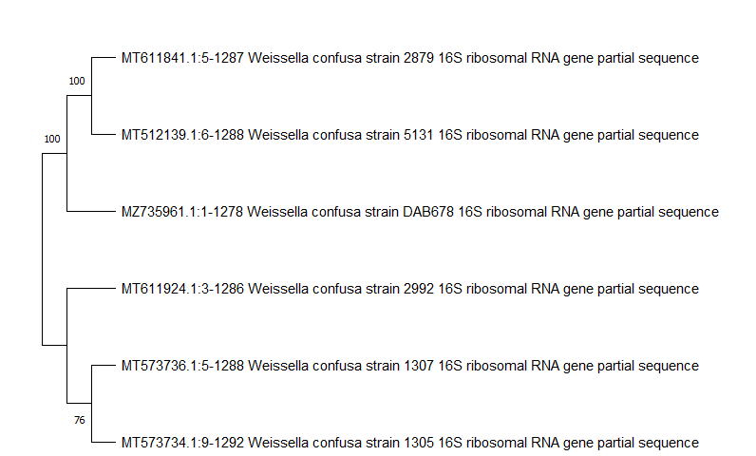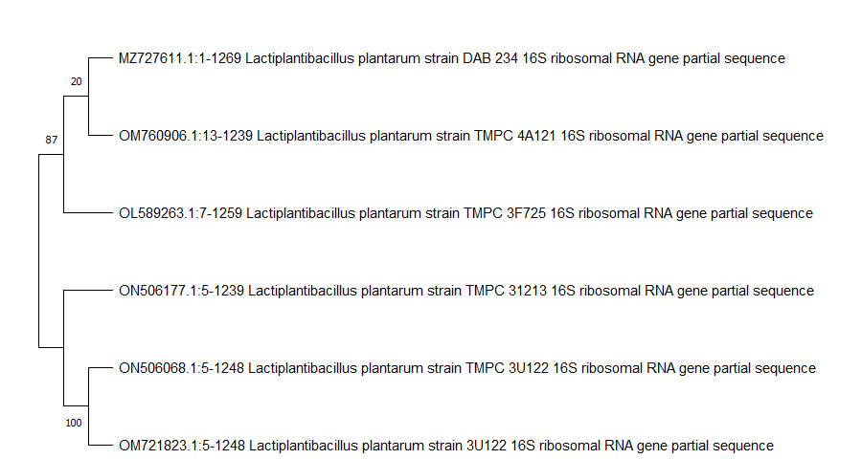

1. **(b)**

**Figure S4:** Dendrogram of **(a)** *Weissella confusa* (MZ735961) and **(b)** *Lactobacillus plantarum* (MZ727611) showing its phylogenetic relationship with reported gene.

**(a)** **(b)**

**Figure S5a, b:** Graphical representation of Wistar rat's gender fecal isolates in 0.4% phenol at 0 and 24 h with its tolerance.

