**Supplementary File**

Safety and human health: The Landscape of an effective UPLC-MS/MS method for the Identification and quantification of N-Nitroso Hydrochlorothiazide impurity in Hydrochlorothiazide

Anuradha Bhimireddya, J V Shanmukha Kumara,*, H. N. Prasada Reddy Chittireddya, Mohammed Rafi Shaikb,*, Mohamed E. Assalb, Mujeeb Khanb

aDepartment of Chemistry, Koneru Lakshmaiah Education Foundation, Green Fields, Vaddeswaram, A.P. -522302, India

bDepartment of Chemistry, College of Science, King Saud University, P.O. Box 2455, Riyadh 11451, Saudi Arabia.

*Correspondence: shanmukh_fed@kluniversity.in (J.V.S.K.); mrshaik@ksu.edu.sa (M.R.S.)

**N-Nitroso Hydrochlorothiazide (NNHCT) standard Qualification data**

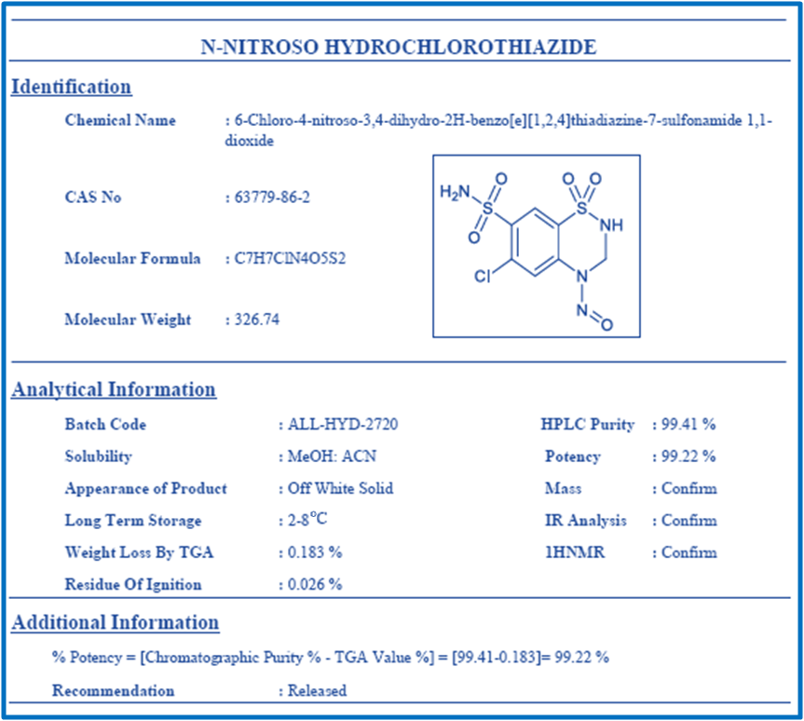

**Figure S1:** N-Nitroso Hydrochlorothiazide standard certificate of analysis

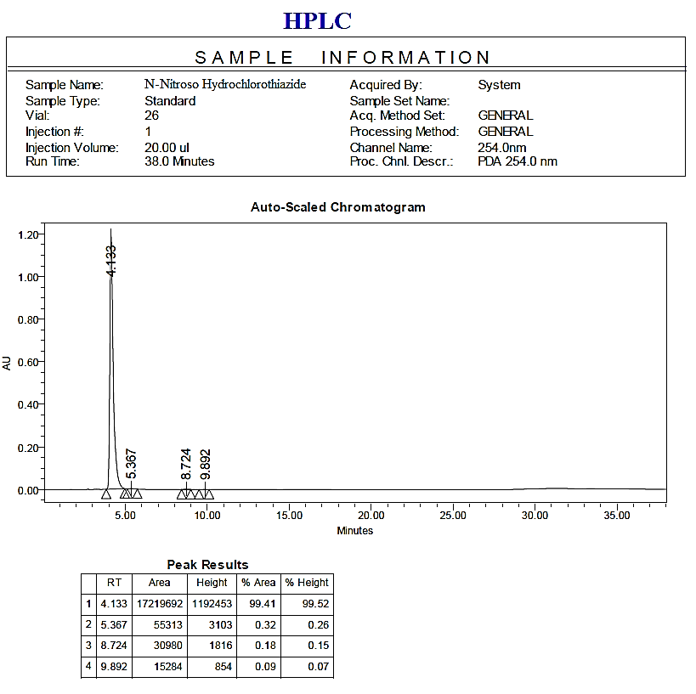

**Figure S2:**N-Nitroso Hydrochlorothiazide standard purity by HPLC analysis

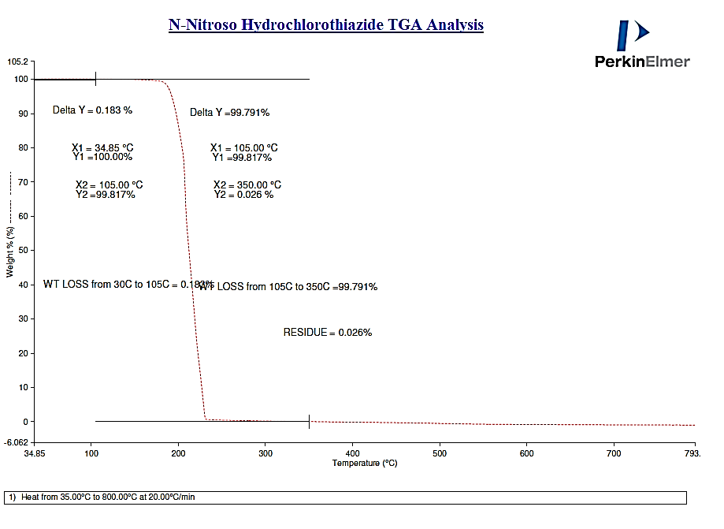

**Figure S3:** N-Nitroso Hydrochlorothiazide standard TGA analysis

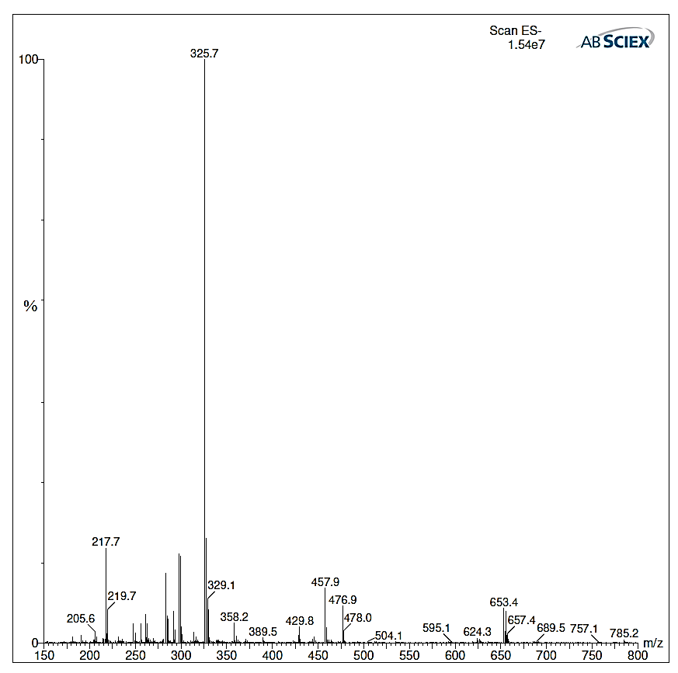

**Figure S4:**N-Nitroso Hydrochlorothiazide standard Dip mass analysis.

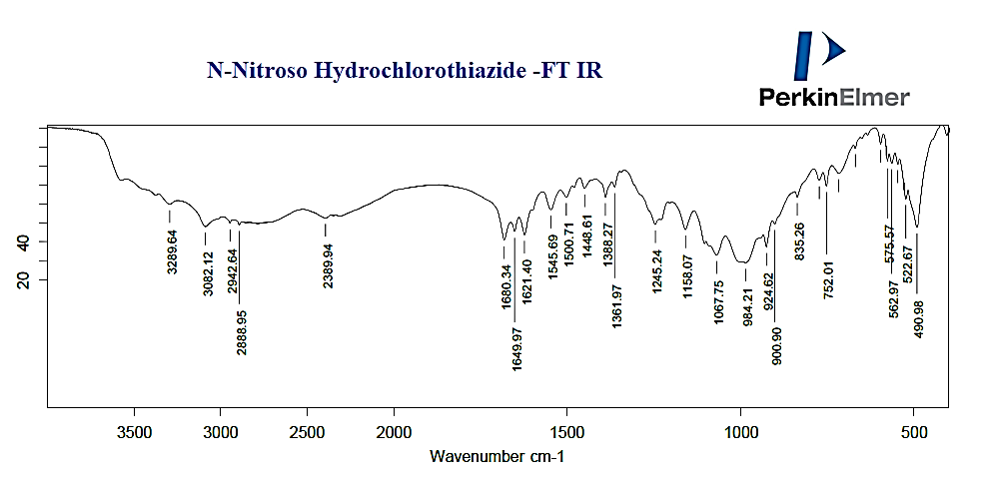

**Figure S5:**N-Nitroso Hydrochlorothiazide standard IR analysis.

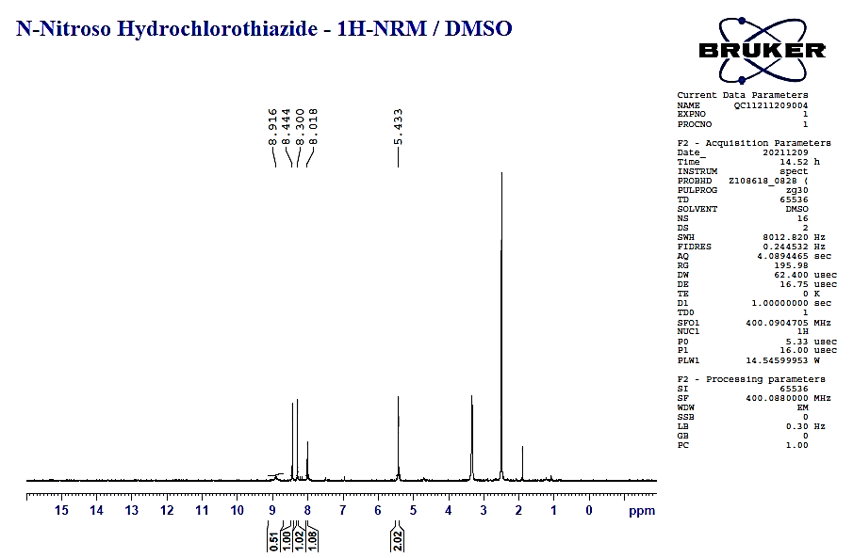

**Figure S6:**N-Nitroso Hydrochlorothiazide standard 1H-NMR/DMSO data-1.

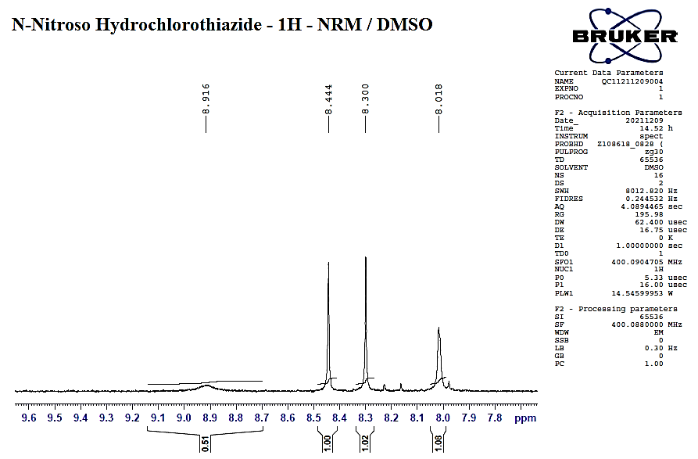

**Figure S7:**N-Nitroso Hydrochlorothiazide standard 1H-NMR/DMSO data-2

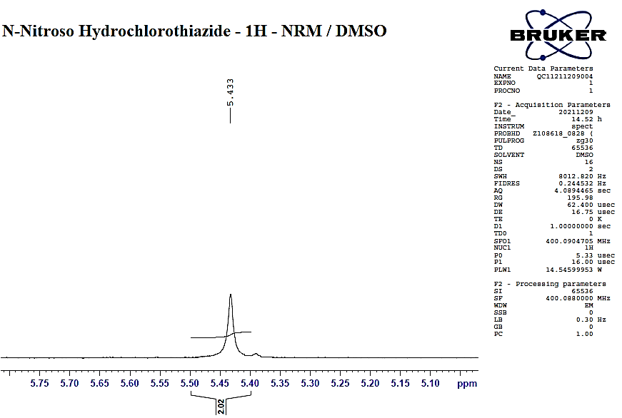

**Figure S8:**N-Nitroso Hydrochlorothiazide standard 1H-NMR/DMSO data-3.

**Figure S9**: MS/MS chromatogram of Blank solution.

**Figure S10**: MS/MS chromatogram of system suitability solution.

**Figure S11**: MS/MS chromatogram of spiked solution.

**Figure S12**: MS/MS chromatogram of LOD and LOQ solutions.

**Figure S13**: MS/MS chromatogram of LOD precision solution.

**Figure S14**: MS/MS chromatogram of LOQ precision solution.

**Figure S15**: MS/MS chromatogram of Linearity solution.

**Figure S16**: MS/MS chromatogram of Method precision sample solution.

**Figure S17**: MS/MS chromatogram of Method precision spiked solutions.

**Figure S18**: MS/MS chromatogram of Intermediate precision sample solution.

**Figure S19**: MS/MS chromatogram of Intermediate precision spiked solution.

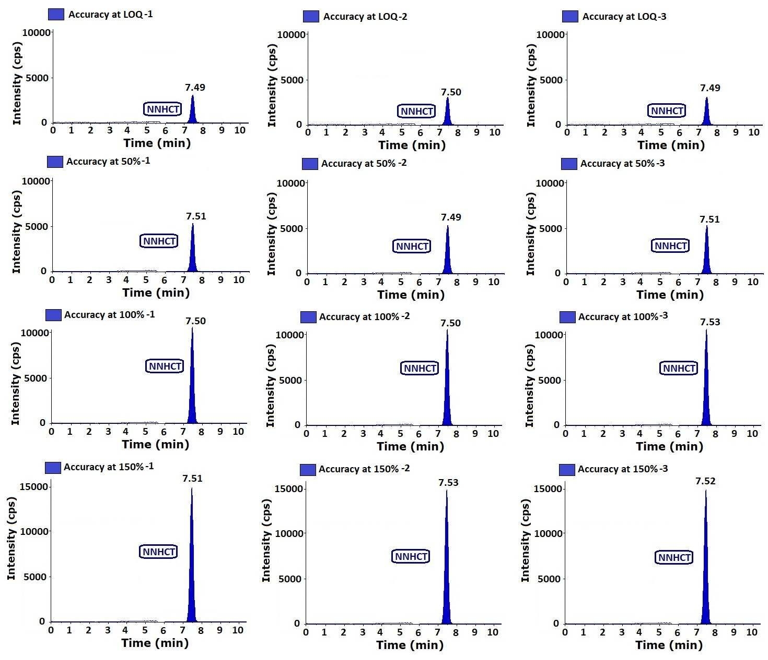

**Figure S20**: MS/MS chromatogram of accuracy solutions.