**Table 1.** Effect of salinity on some growth parameters and water content of roots and shoots of plants growing in clay soils (n = 5, P < 0.05).

|  |  |  |  |  |
| --- | --- | --- | --- | --- |
| Salinity degree | Root/Shoot DW ratio | Root/Shoot FW ratio | RWC | SWC |
| Non | 0.03±0.01 | 0.01±0.003 | 3.46±0.84 | 9.65±1.09 |
| Slight | 0.05±0.01 | 0.02±0.005 | 3.35±0.81 | 9.13±1.07 |
| Moderate | 0.06±0.02 | 0.02±0.007 | 3.26±0.74 | 8.98±0.91 |
| High | 0.06±0.02 | 0.03±0.02 | 2.98±0.62 | 8.57±0.78 |
| Extreme | 0.09±0.04 | 0.03±0.04 | 1.56±0.25 | 6.99±0.53 |

**Table 2.** Effect of salinity on some growth parameters and water content of roots and shoots of plants growing in clay loam soils (n = 5, P < 0.05).

|  |  |  |  |  |
| --- | --- | --- | --- | --- |
| Salinity degree | Root/Shoot DW ratio | Root/Shoot FW ratio | RWC | SWC |
| Non | 0.03±0.02 | 0.01±0.002 | 3.83±3.79 | 8.78±0.93 |
| Slight | 0.04±0.03 | 0.01±0.001 | 3.51±2.89 | 9.00±0.98 |
| Moderate | 0.04±0.01 | 0.01±0.001 | 3.09±2.15 | 9.75±0.87 |
| High | 0.05±0.03 | 0.02±0.01 | 2.59±1.96 | 8.31±0.75 |
| Extreme | 0.09±0.05 | 0.02±0.01 | 2.37±1.89 | 10.52±0.99 |

**Table 3.** Effect of salinity on gas exchange of plants growing in clay soil (Pn - photosynthetic rate, E - transpiration rate, WUE - water use efficiency, n = 15, P < 0.05).

|  |  |  |  |  |  |  |  |  |  |
| --- | --- | --- | --- | --- | --- | --- | --- | --- | --- |
| Salinity degree | Pn (*µmol*/m2/s) | | | E (*mmol*/m2/s) | | | WUE | | |
| First measurement | Second measurement | Third measurement | First measurement | Second measurement | Third measurement | First measurement | Second measurement | Third measurement |
| Non | 13.10±3.48 | 8.33±2.76 | 6.30±2.21 | 1.85±0.21 | 1.18±0.11 | 0.65±0.03 | 7.08±2.45 | 7.08±2.39 | 9.75±3.11 |
| Slight | 6.69±2.15 | 7.77±2.84 | 5.71±1.95 | 1.01±0.08 | 0.82±0.05 | 0.63±0.04 | 6.62±2.12 | 9.47±2.85 | 9.09±3.22 |
| Moderate | 2.40±0.23 | 4.48±0.45 | 5.32±1.98 | 0.80±0.04 | 0.57±0.04 | 0.60±0.04 | 3.60±1.45 | 7.86±2.80 | 8.89±2.93 |
| High | 2.88±0.31 | 4.28±0.38 | 3.20±0.35 | 0.41±0.05 | 0.34±0.02 | 0.48±0.03 | 5.85±1.20 | 12.59±3.56 | 6.69±2.18 |
| Extreme | 1.52±0.15 | 1.50±0.19 | 1.79±0.20 | 0.32±0.04 | 0.17±0.01 | 0.25±0.02 | 4.75±0.49 | 8.80±2.84 | 7.16±2.30 |

**Table 4 .** Effect of salinity on gas exchange of plants growing in clay loam soil (Pn - photosynthetic rate, E - transpiration rate, WUE - water use efficiency, n = 15, P < 0.05).

|  |  |  |  |  |  |  |  |  |  |
| --- | --- | --- | --- | --- | --- | --- | --- | --- | --- |
| Salinity degree | Pn (*µmol*/m2/s) | | | E (*mmol*/m2/s) | | | WUE | | |
| First measurement | Second measurement | Third measurement | First measurement | Second measurement | Third measurement | First measurement | Second measurement | Third measurement |
| Non | 12.36±3.10 | 10.38±2.85 | 8.57±2.88 | 9.08±2.77 | 1.43±0.17 | 0.59±0.03 | 3.56±0.40 | 7.26±2.32 | 14.53±2.11 |
| Slight | 10.12±2.99 | 5.55±1.90 | 7.95±2.78 | 0.91±0.06 | 1.33±0.15 | 0.58±0.04 | 11.12±3.10 | 4.17±0.48 | 13.71±1.97 |
| Moderate | 8.50±2.85 | 4.12±0.40 | 6.60±2.14 | 0.56±0.04 | 1.27±0.13 | 0.29±0.02 | 15.18±3.74 | 3.26±0.36 | 22.76±2.06 |
| High | 3.41±0.31 | 2.13±0.25 | 3.45±0.37 | 0.45±0.05 | 0.45±0.05 | 0.18±0.01 | 7.58±2.57 | 4.72±0.52 | 19.15±2.19 |
| Extreme | 1.46±0.16 | 1.40±0.16 | 1.86±0.28 | 0.21±0.01 | 0.21±0.01 | 0.12±0.009 | 6.95±2.19 | 6.67±2.23 | 15.50±2.87 |

**Table 5.** Correlation matrix of *P. oleracea* (clay soil).



**Table 6.** Correlation matrix of *P. oleracea* (clay loam soil).



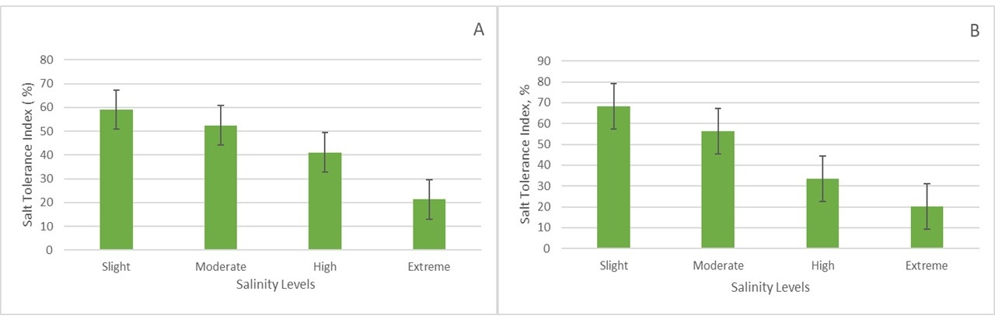

**Fig. 7** *Salt Tolerance Index (STI)* of *P. oleracea* (A - clay soil, B - clay loam soil, n = 10, P < 0.05).

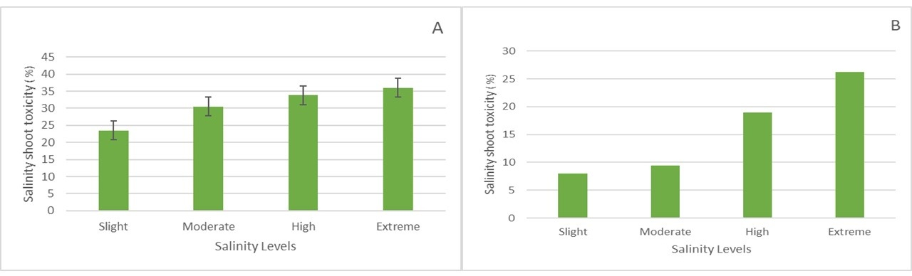

**Fig. 8** *Salinity Shoot Toxicity (%)* of *P. oleracea* (A - clay soil, B - clay loam soil, n = 10, P < 0.05).

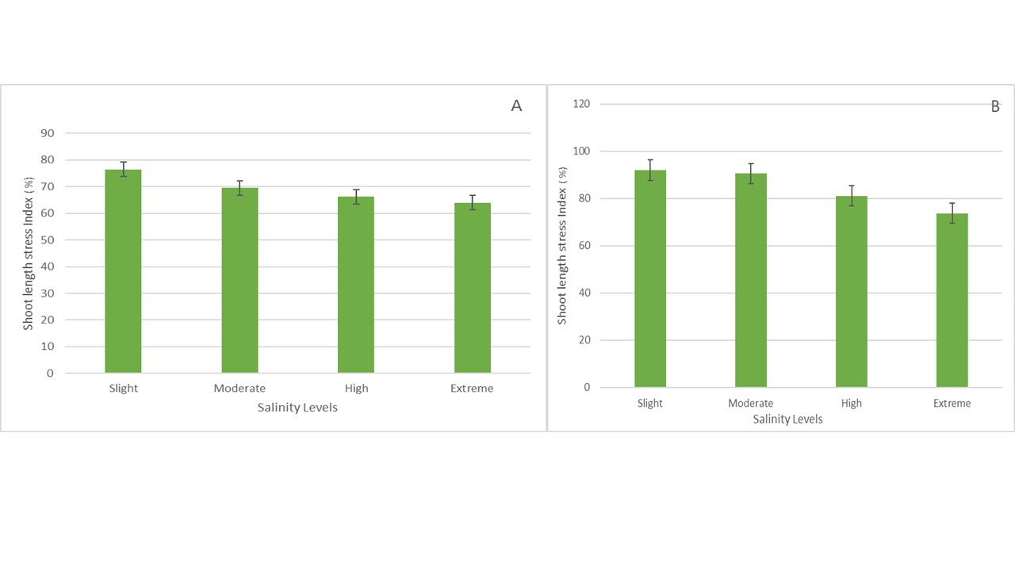

**Fig. 9** *Shoot Length Stress Index (%)* of *P. oleracea* (A - clay soil, B - clay loam soil, n = 3, P < 0.05).

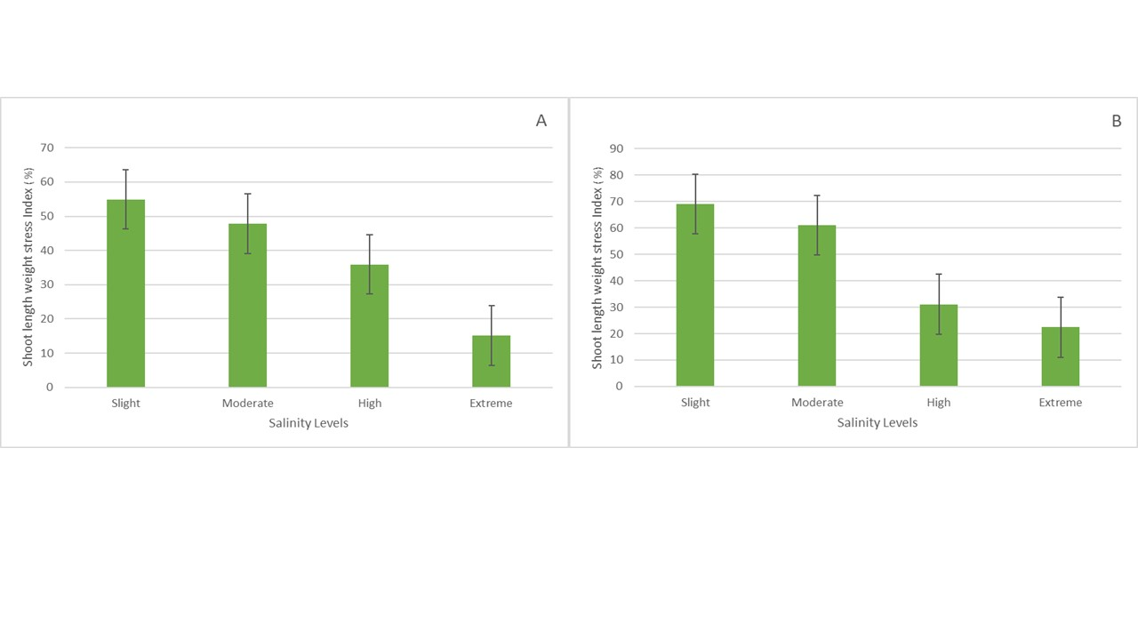

**Fig. 10** *Shoot Length Weight Stress Index (%)* of *P. oleracea* (A - clay soil, B - clay loam soil, n = 10, P < 0.05).