Neuroprotective effect of huperzine-A against cadmium chloride-induced Huntington's disease in Drosophila melanogaster model
Mamangam Subaraj^{1†*,} Selvaraj Arokiyaraj^{2†}, Pratheesh Mathew³,
¹Department of Biochemistry, Vivekanandha Arts and Science College for Women, Sankari, Tamil Nadu, India- 637 303
²Department of Food Science and Biotechnology, Sejong University, South Korea – 05005
³Department of Zoology, St. Thomas College Palai, Kottayam, Kerala, India-686 574
Corresponding Author*: rajivsuba@gmail.com;
†Authors contributed equally

Materials and Methods

2.1 Preparation of proteins
The crystal structure of proteins muscarinic acetylcholine receptor (PDB ID:3UON), dopamine receptor (PDB ID: 6CM4), gamma aminobutyric acid (B) receptor (PDB ID: 4MS4), glutamate receptor (PDB ID: 1GR2), huntingtin (PDB ID : 6X9O), monoamine oxidase -A (PDB ID: 2Z5Y), monoamine oxidase -B (PDB ID: 1GOS), 5-serotonin receptor -2AR (PDB ID: 6A93),amyloid beta (PDB ID :4PQD), amyloid precursor protein (PDB ID: 41AAP), β- secretase (PDB ID:1SGZ), parkin protein (PDB ID: 5C9V), tau protein (PDB ID: 1J1B) and α- synuclein protein (PDB ID :3Q28) were retrieved from the protein databank (PDB).

2.4.6.Extraction of RNA, Reverse Transcription and Quantitative Real-Time PCR
After the treatments, total RNA was extracted from SH-SY5Y cells using the TRIzol® reagent method. The RNA's purity was estimated using a NanoDrop-200 Spectrophotometer. The RNA to cDNA synthesized was performed (iScript™cDNA synthesis kit).The PCR reactions were as follows: The initial polymerase activation step at 95ºC for 2min, denaturation of 40 cycles at 95ºC for 5 sec, annealing at 60ºC for 5 sec, and extension 60ºC for 30 sec. The primer sequences follow: Wnt3a forward primer "TCTACGACGTGCACACCTG" and reverse primer "CCTGCCTTCAGGTAGGAGTT";TNFα forward primer "CTGGAAAGGACACCATGAGCA" and reverse primer "TCTCTCAGCTCCACGCCATT"; CAMK2A forward primer "CATGGTTTGGGTTTGCAGGG"and reverse primer "CCGGCTTTGATCTGCTGGTA" and GAPDH forward primer "GAGAAGGCTGGGGCTCATTT" and reverse primer "AGTGATGGCATGGACTGTGG". Data were performed in triplicates and Ct value was analyzed. Data are presented folding to normalized the level of internal control .
2.6.6. Extraction of RNA, Reverse Transcription and Quantitative Real-Time polymerase chain reaction (qRT-PCR)
Total RNA was isolated using TRIzol® reagent method (Thermo Fisher Scientific). The Real time PCR PCR reactions were performed using the relative standard curve method for analysis SYBR® RT-PCR master mix with Rox dye. The following qRT-PCR conditions were set: Reverse Transcription of 1 cycle at 61°C for 20 sec, denaturation of 1 cycle at 95°C for 1 min, and annealing of 45 cycles at 95̊C for 5 sec, followed by extension at 72°C for 20 sec. The primers used in qPCR were synthesized and their sequences were as follows: HTT Forward primer "TACGACCCAGGAGCACTTTC" and Reverse primer "AGCGAGATGCCGATAGAGGT"; GADH Forward primer "GACATGGCTGAGTTCCTGCT" and Reverse primer"CCGGGAAAAGGAAAAAGCGG". The level of mRNA was calculated and data are presented as fold changes to the normalized the levels of Glyceraldehyder -3-phosphate dehdrogenase (GAPDH). All reactions were performed in triplicate (15 flies per group).

Results
The binding site resides of glutamate receptor, huntingtin protein, monoamine oxidase A and B with huperzine-A, linalool, norsanguinine, tumerone, ungeremine, tetrabenazine, and astragalin molecules with binding energies depicted in Table 1-4 supporting information. GABA receptor bound to Huperzine-A interacting with PRO351, MET312, TRP278, LEU313, and PHE347; which is bound to linalool interacting with TYR54; bound to norsanguinine interacting with ALA52, VAL53, TYR54, ILE123, PRO120, ILE121 and PHE381; bound to tetrabenazine interacting with LEU313, PRO351, MET312, PHE347, and TRP278; bound to tumerone interacting with TYR206, GLU209, GLY157, GLU25, TYR73, THR103 and ARG108; bound to ungeremine interacting with LEU154, ARG108, THR103, MET212 and LEU208; that is bound to astragalin by interacting with HIS170, VAL201, PHE202, ILE276, TRP278, GLU251 and TRP65 with binding energy of -7.85, -6.24,-7.65, -7.52 -6.80, -7.26, and, -5.28 respectively (Table 5 and Fig. 1 Supporting information). Dopamine receptor bound to huperzine-A interacting with ALA379, ILE383 and PHE202; which is bound to linalool interacting with SER197, TYR119,ALA122, PHE198, THE382, TRP386, PHE390and VAL115; bound to norsanguinine interacting with PHE189, VAL115, SER197, PHE198, PHE390, PHE389, TRP386, PHE382, ALA122 and CYS118; bound to tetrabenazine interacting with TYR209, LEU206, ALA379, LEU125, PHE382, ILE383, ALA122 and PRO201, bound to tumerone interacting with SER197, VAL115, ASP114 and TRP386; bound to ungeremine interacting with LEU313, MET312, VAL311, GLN348 and LYS432; bound to astragalin by interacting with TRP386, PHE389, CYS118 and VAL115; with the binding energy of -7.30 -6.80, -7.56, -8.33-8.15, -7.19, and -4.57 respectively (Table 6 and Fig. 2 Supporting information).
Muscarinic acetylcholine receptor bound to huperzine-A interacting with CYS429, TRP400, ASN404, SER107, TYR104, ALA194 and TRP155; that is bound to linalool interacting with ILE116, MET143, ALA140,VAL57 and ARG135;bound to norsanguinine interacting with TYR403, TRP400, TYR426, CYS429, TYR430, ALA194, VAL111, SER107, TYR104 and TRP155; bound to tetrabenazine interacting with TRP155, ALA194, TYR104,TRP400, CYS429 and TYR403; bound to tumerone interacting with ARG135,VAL57, ILE126,ALA140 and MET143; bound to ungeremineinteracting with TYR403,TRP400, ALA194,CYS429,TYR104 and TRP155; and bound to astragalin by interacting with CYS429, TRP400, ASN404, SER107, TYR104, ALA194 and TRP155; with binding energy of -7.23, -5.88,-6.85, -7.74-7.13, -6.55, and-7.56 respectively (Table 7 and Fig. 3 Supporting information).Serotonin receptor bound to huperzine-A interacting with PHE168, ILE171, VAL175, ILE140 and PRO143; which is bound to linalool interacting with TRP134, VAL133, ILE130, PHE46, LEU50; bound to norsanguinine interacting with LEU50 and LEU100; bound to tetrabenazine interacting with VAL90 and SER176; bound to tumerone interacting with PHE302, VAL185, TYR188, and MET184; bound to ungeremine interacting with TRP309, VAL90, SER176; bound to astragalin by interacting with ILE23, THR22, ILE19, THR15, MET62 and PRO63 with binding energy of -6.67, -5.45, -7.30, -6.03, -5.79, -4.57, and -4.78 respectively (Table 8 and Fig. 4 Supporting information).
Parkin proteins bound to huperzine-A interacting with PHE73, GLU72 and PRO54; that is bound to linalool interacting with PRO54 andPHE73; bound to norsanguinine interacting with SER32,ASN55, ALA71 and VAL51; bound to tetrabenazine interacting with LEU206; bound to tumerone interacting with VAL155, CYS128, and VAL258; bound to ungeremine interacting with GLU72; and it bound to astragalin by interacting with LEU148, PRO146, TYR150, GLN181, ALA184, TYR180 with a binding energy of -7.29, -5.15, -6.58, -5.53, -5.27, -5.87, and -2.83 respectively (Table 9 and Fig. 5 Supporting information). Alpha-synuclein proteins bound to huperzine-A interact with TRP341, ARG345, TYR156, PHE157, MET331, ALA64, ASP66 and ARG67; which is bound to linalool interacting with TRP341, GLU154, TYR156; bound to norsanguinine interacting with THR87, GLU79 and TYR107; bound to tetrabenazine interacting with ASN101, TYR100, ALA97, ASN333, HIS65 and ILE330; bound to tumerone interacting with TRP341 and TYR156; bound to ungeremine interacting with ARG67, ASP66, TRP63, GLU112, TYR156, GLU154 and TRP341; bound to astragalin by interacting with LYS274, GLU79, THR81 and ILE80 with a binding energy of -6.32, -5.38, -6.13, -6.11, -5.85, -6.16, and -2.84 respectively (Table 10 and Fig. 6 Supporting information).
Amyloidal precursor protein bound to huperzine-A interacting with ALA9, PHE34 and TYR22; that is bound to linalool interacting with TYR22, ALA9 and TYR22; bound to norsanguinine interacting with THR26, VAL25, ASP24, TYR22, GLN8 and ALA9 ; bound to tetrabenazine interacting with THR26, ASP24, TYR22, and ALA9; bound to tumerone interacting with VAL25, TYR22, ALA9 andTYR22; bound to ungeremine interacting with THR26, VAL25, ASP24, GLN8 andASP24; and it bound to astragalin by interacting with PHE34and THR11with binding energy of -5.83, -5.42, -6.94, -6.42, -6.35, -7.22, and -5.09 respectively (Table 11 and Fig.7 Supporting information). Amyloid beta-protein bound to huperzine-A interacting with HIS87,HIS89 LYS85,TRP76 andLYS78; which is bound to linalool interacting with LYS85, TRP76 and LYS78; bound to norsanguinine interacting with HIS87, LYS85 ,TRP76, ARG19 and GLN83; bound to tetrabenazine interacting with HIS89, LYS85, TRP76, ARG19 and LYS178; bound to tumerone interacting with TYR56, PRO57,LEU59, and VAL26; bound to ungeremine interacting with VAL26 and GLU58 ; bound to astragalin by interacting with CYS17, PHE16, MET15, ILE92 and GLU66 with binding energy of -6.95, -6.13, -7.72, -6.82, -5.47, -6.30, and -5.83 respectively (Table 12 and Fig. 8 Supporting information).
Tau protein proteins bound to huperzine-A interacting with TYR288, SER215, ARG223, ARG223, ILE228; that is bound to linalool interacting with ALA143, LEU153, GLN151; It bound to norsanguinine interacting with ASP90, LYS292, GLN89; bound to tetrabenazine interacting with VAL267, PRO294, LEU88; bound to tumerone interacting with GLN265, ARG220, ILE228; bound to ungeremine interacting with ASN213; and bound to astragalin by interacting with PHE67, LEU88, ASN95 and GLU97with binding energy of -6.90, -5.46, -6.18, -5.98, -5.48, -5.62, and 4.31 respectively (Table 13 and Fig. 9 Supporting information).Beta secretase bound to huperzine-A interacting with VAL170, LEU165, ALA161, CYS159 and GLY12; which is bound to linalool interacting with ARG311, PRO312, PHE113, LEU165 and LYS13; bound to norsanguinine interacting with SER14, GLU343,ARG311 and PRO312; bound to tetrabenazine interacting with MET383 and MET292; bound to tumerone interacting with VAL295, TYR194 and TRP193; bound to ungeremine interacting with GLU108; and it bound to astragalin by interacting with ASP110, ASP110, THR76 and TYR75, GLY78with binding energy -6.87, -5.57, -6.35, -5.24, -5.19, -6.76, and -3.75 respectively (Table 10 and Fig. 14 Supporting information).

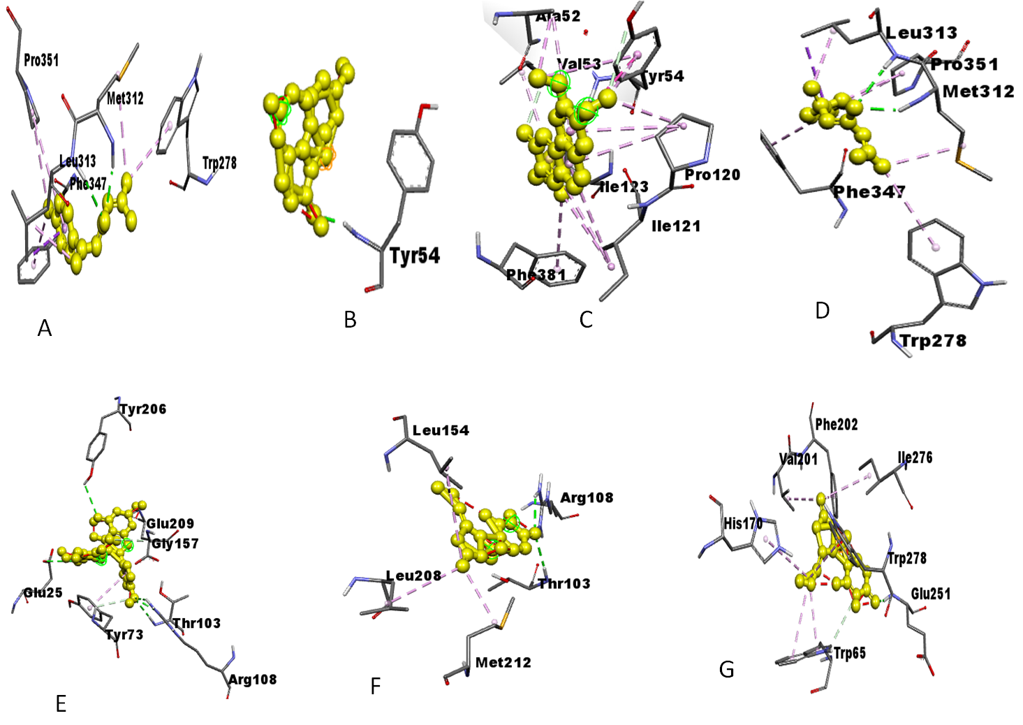
Fig. 1: Amino acids residues of gamma amino butyric acid interacting with the (a) HuperzineA , (b) Linalool, (c) Norsanguinine,(d) Tetrabenazine, (e) Tumerone,(f) Ungeremine and(g) Astragalin

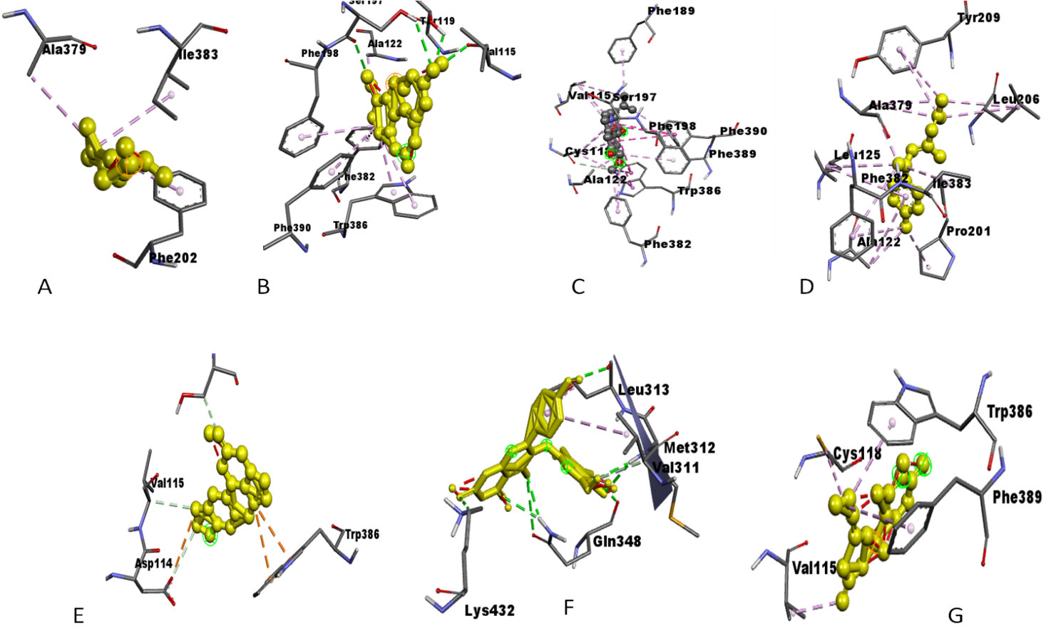
Fig. 2: Amino acids residues of dopamine receptors interacting with the (a) Huperzine A, (b)Linalool, (c) Norsanguinine, (d) Tetrabenazine, (e)Tumerone,(f)Ungeremine and (g) Astragalin

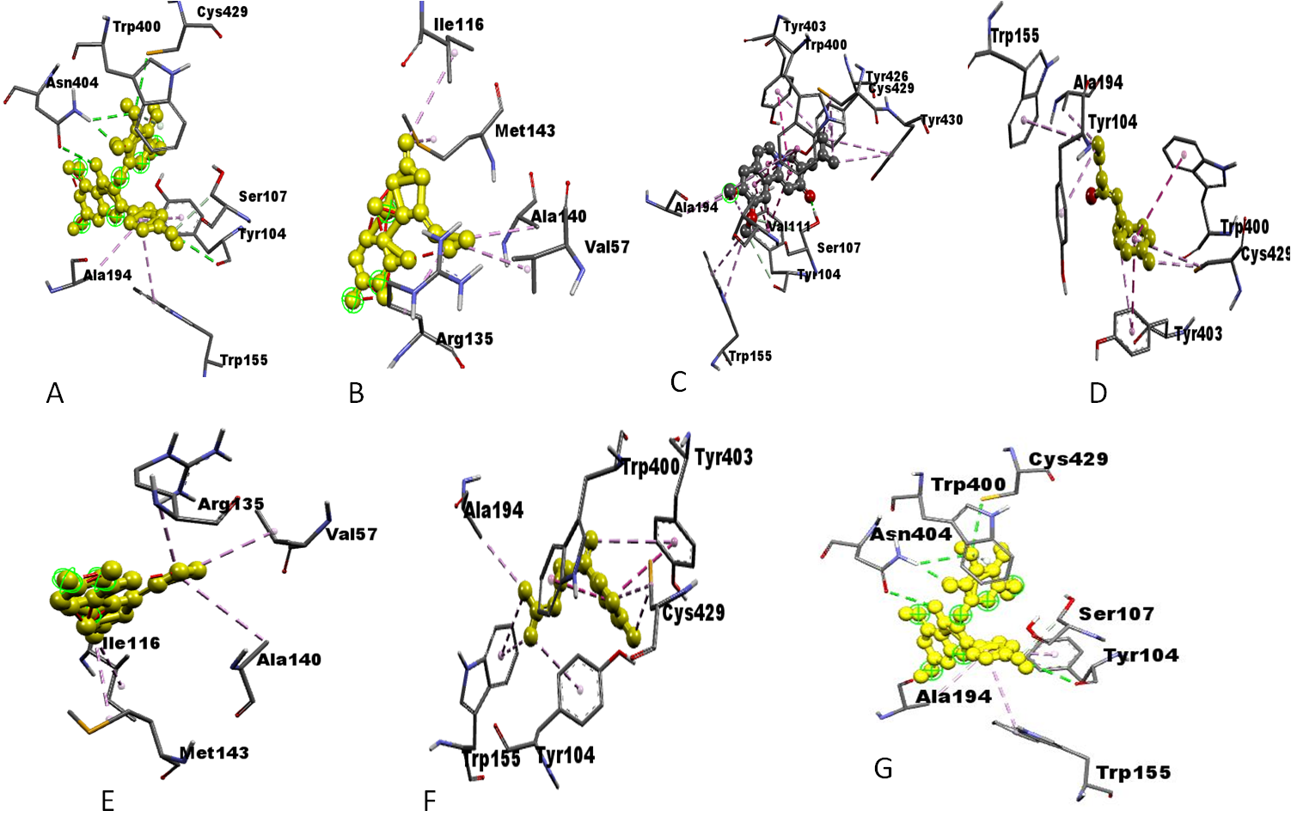

Fig. 3: Amino acids residues of acetylcholine receptor interacting with the (a) HuperzineA , (b) Linalool, (c) Norsanguinine,(d) Tetrabenazine,(e) Tumerone,(f) Ungeremine and(g) Astragalin

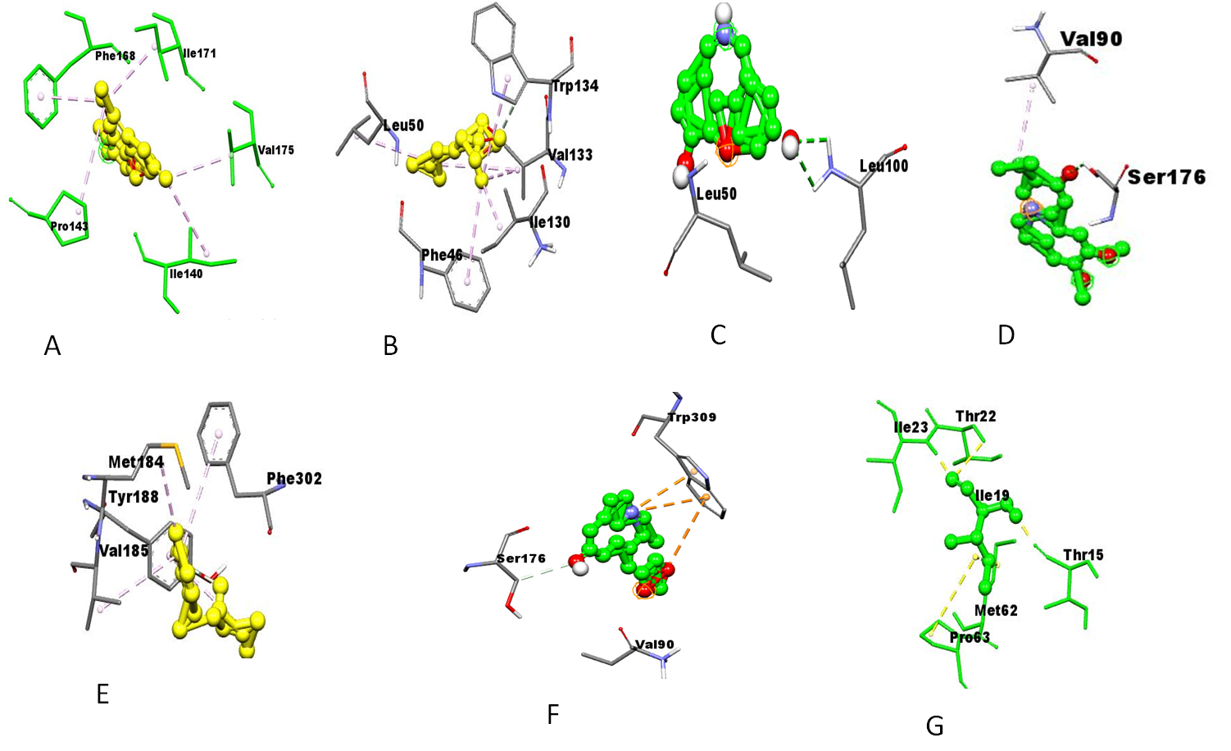

Fig. 4: Amino acids residues of Serotonin protein interacting with the (a) HuperzineA,(b) Linalool,(c) Norsanguinine,(d) Tetrabenazine,(e)Tumerone,(f) Ungeremine and(g) Astragalin

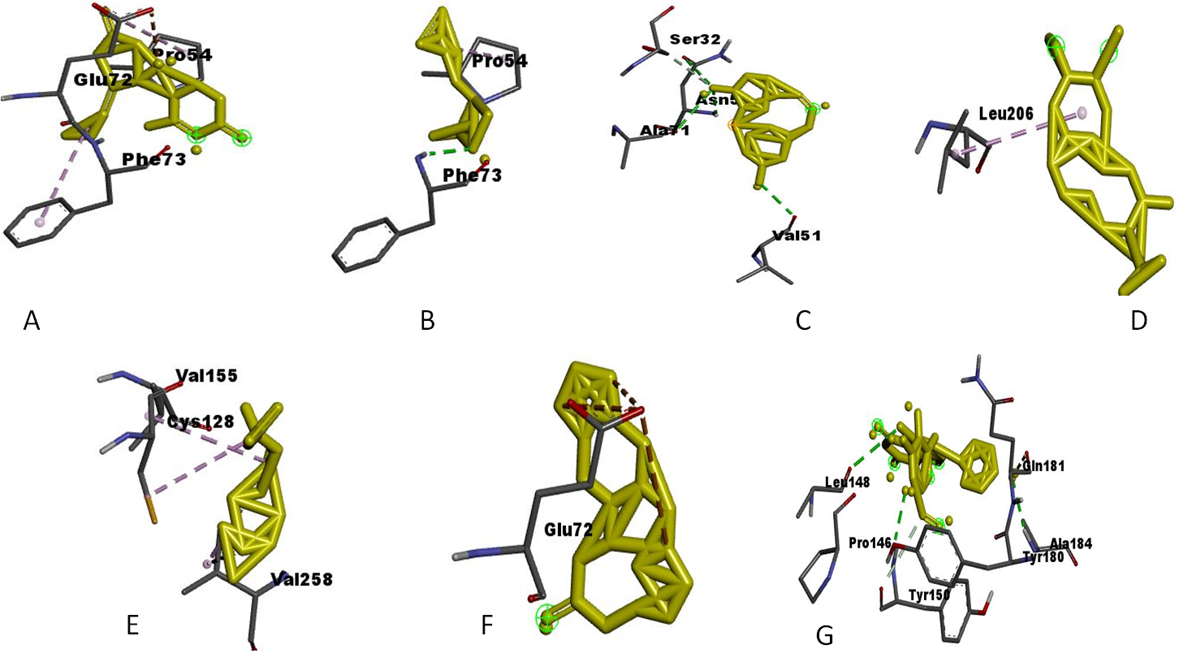

Fig. 5: Amino acids residues of parkin protein with the (a) HuperzineA,(b) Linalool, (c) Norsanguinine,(d) Tetrabenazine, (e)Tumerone, (f) Ungeremineand (g) Astragalin
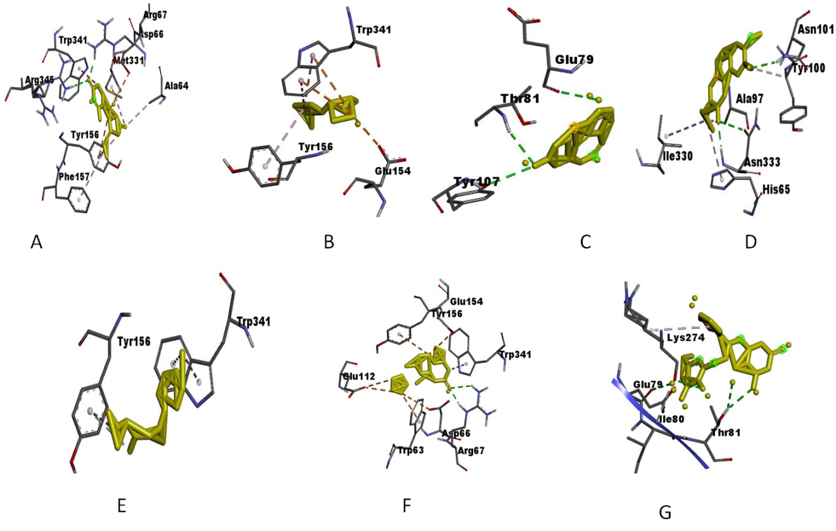
Fig. 6: Amino acids residues of alpha-synuclein with the (a) Huperzine A, (b) Linalool, (c) Norsanguinine,(d) Tetrabenazine, (e) Tumerone,(f) Ungeremine and(g) Astragalin

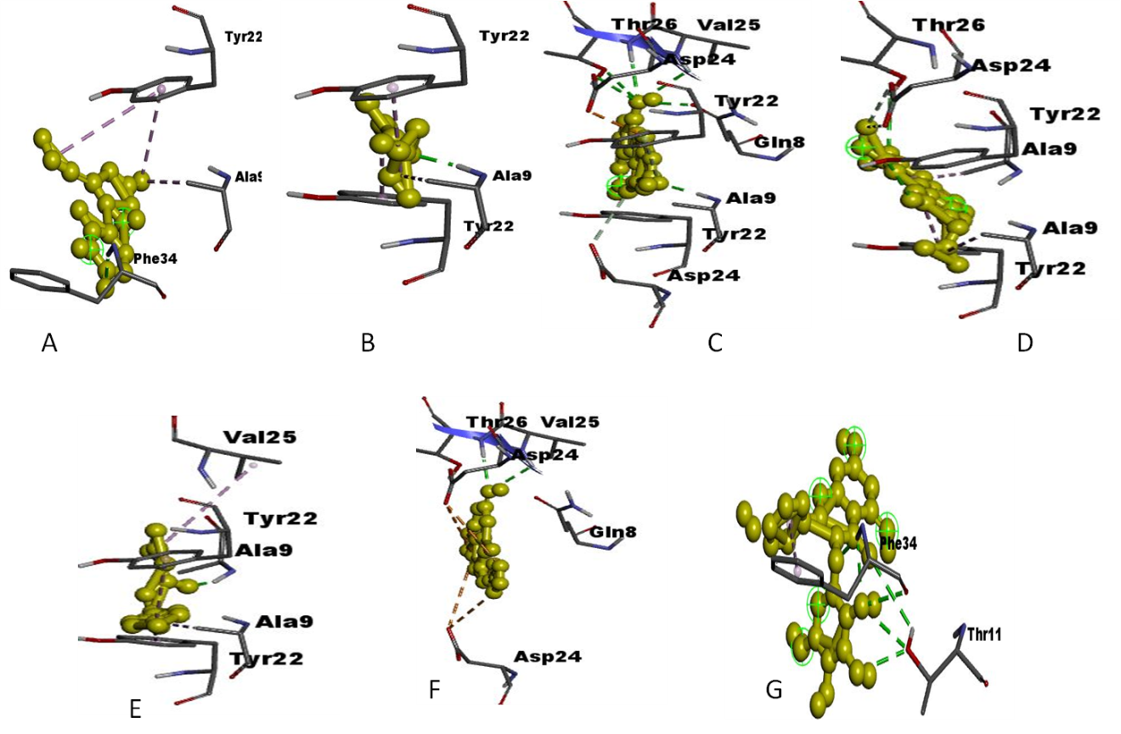
Fig. 7: Amino acids residues of amyloid precursor protein with the (a) HuperzineA,(b) Linalool,(c) Norsanguinine,(d) Tetrabenazine,(e) Tumerone,(f) Ungeremine and(g) Astragalin
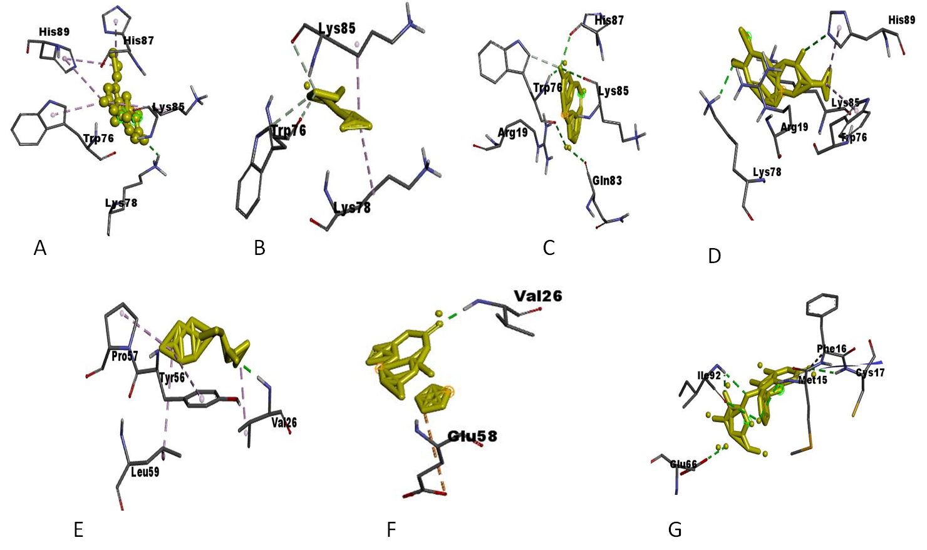
Fig. 8: Amino acids residues of amyloid beta protein with the (a) HuperzineA,(b) Linalool, (c) Norsanguinine,(d) Tetrabenazine,(e) Tumerone, (f)Ungeremine and(g) Astragalin
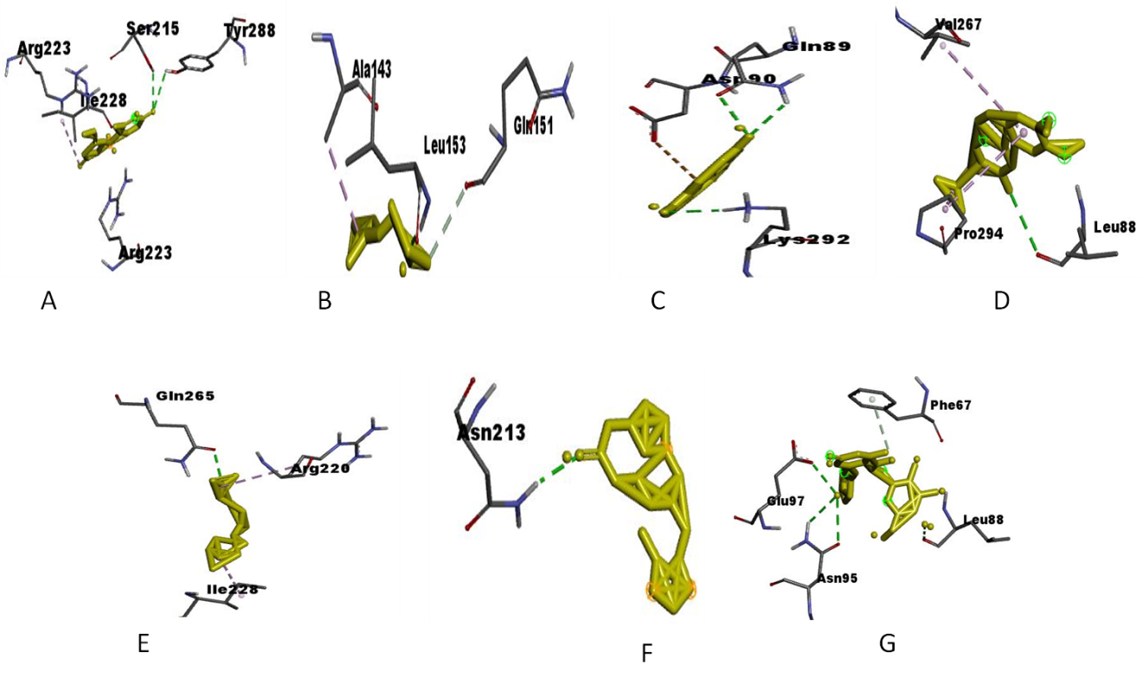
Fig. 9: Amino acids residues of tau protein with the (a) Huperzine A, (b) Linalool,(c) Norsanguinine,(d) Tetrabenazine,(e) Tumerone,(f) Ungeremine and (g) Astragalin
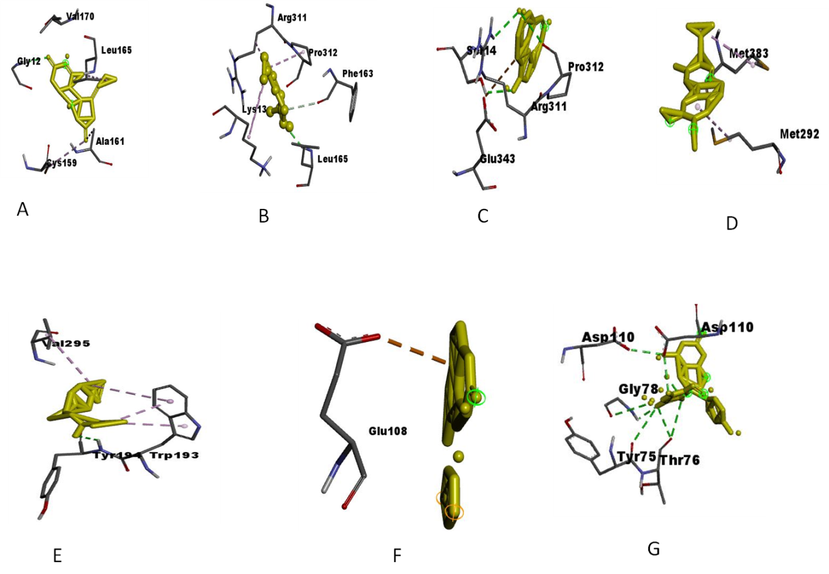
Fig. 10: Amino acids residues of beta secretase with the (a) HuperzineA,(b) Linalool,(c) Norsanguinine,(d) Tetrabenazine,(e) Tumerone,(f) Ungeremine and(g) Astragalin

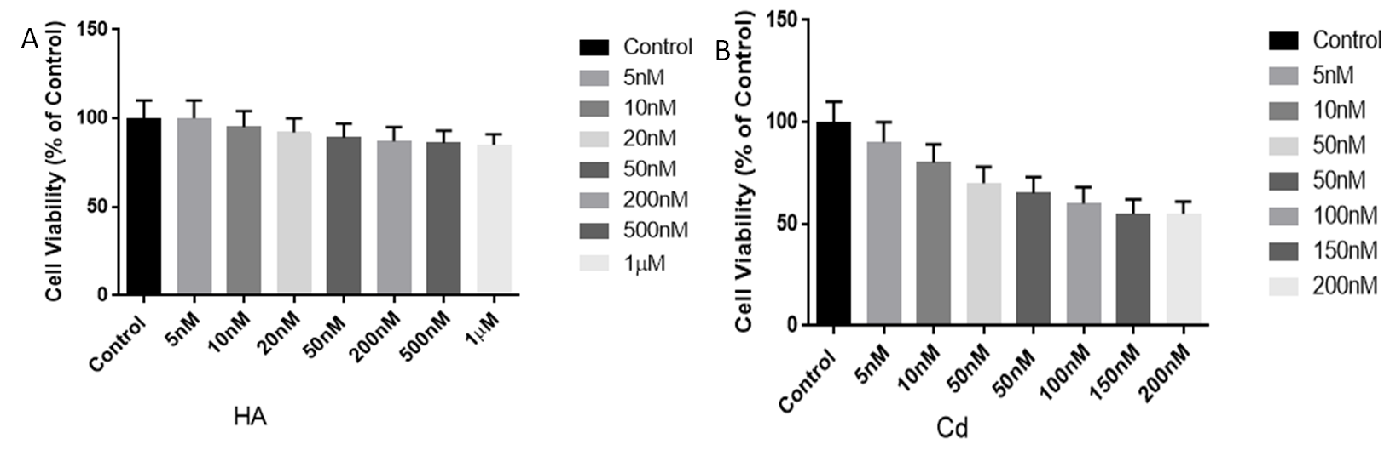
Fig. 11: Initial test concentration of (A) huperzine-A (B) cadmium on SH-SY5Y cell viability.
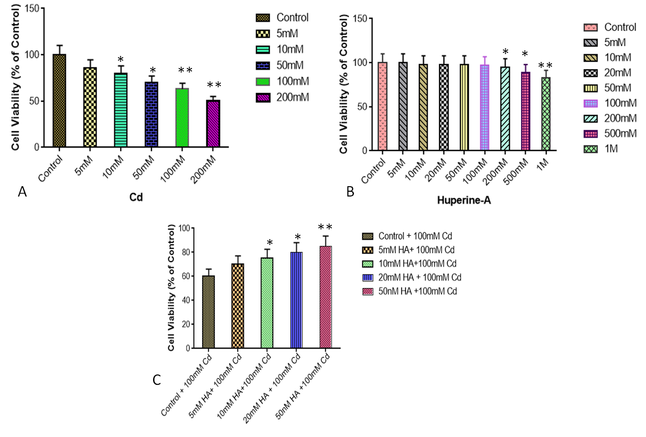

Fig. 12: Effect of (A) cadmium(B) huperzine-A and (C) cadmium with huperine-A on SH-SY5Y cell viability. Cells were treated for 24hr. Results are the means SEM of six measurements.Viabilities were expressed as a percent of control.*p ≥0.05 significantly higher as compared with control.

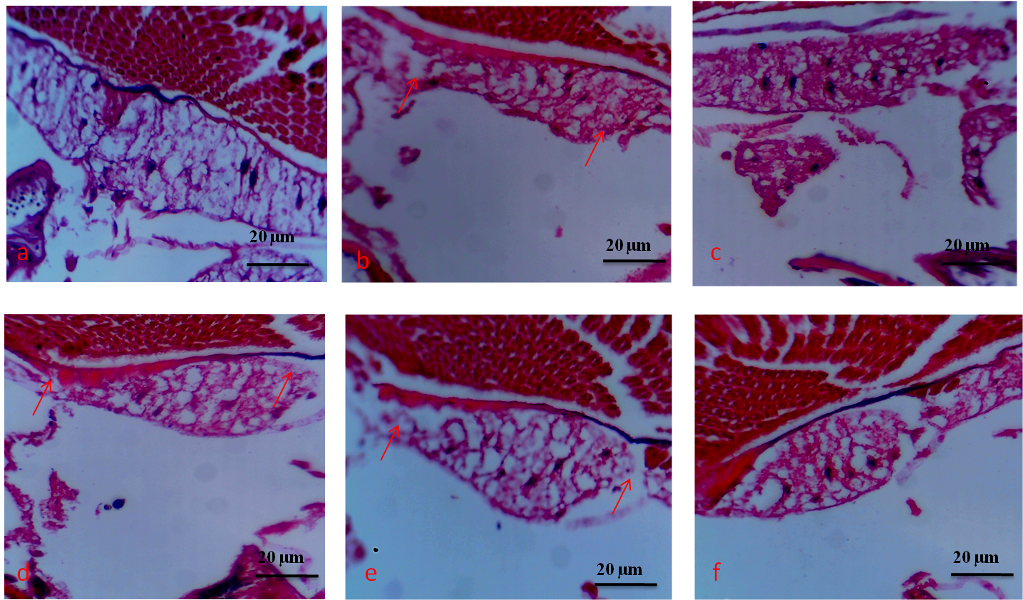

Fig. 13: Histopathological changes in the control and experimental groups of brain Drosophila melanogasters. The striking lesions are the arrows vacuoles like loss of cell bodies (Fig. 13b), and controls exhibit little or no pathology (Fig. 13a). Brain structure is preserved, including the outer cellular and cell bodies (Fig. 13c), whereas treated showed mild neuropathology including vacuolar-like lesions throughout the neuropile (Fig. 13d).

Supporting information Tables

Table-1: Molecular docking analysis showing the binding energies of glutamate receptor proteins with the target ligands

Protein | Ligand | Binding Energy (ΔG) (kcal/mol) | Ligand efficiency | Intermolecular energy | Inhibition constant, Ki | Vdw H- bond desolvation
Glutamate receptor | Huperzine A | -7.30 | -0.40 | -8.09 | 5.31 µM | -7.84
 | Linalool | -6.11 | -0.56 | -6.71 | 33.09 µM | -6.70
 | Norsangunine | -7.20 | -0.38 | -8.19 | 4.48 µM | -7.90
 | Tetrabenzaine | -6.73 | -0.29 | -7.93 | 11.61 µM | -8.00
 | Tumerone | -5.82 | -0.36 | -7.31 | 54.12 µM | -7.30
 | Ungeremine | -6.30 | -0.32 | -7.20 | 23.93 µM | -6.66
 | Astragalin | -4.77 | -0.15 | -7.46 | 316.39 µM | -7.40

Table-2: Molecular docking analysis showing the binding energies of gamma-aminobutyric acid receptor proteins with the target ligands

Protein | Ligand | Binding Energy (ΔG) (kcal/mol) | Ligand efficiency | Intermolecular energy | Inhibition constant, Ki | Vdw H- bond desolvation
Gama aminobutyric acid receptor | Huperzine A | -7.85 | -0.44 | -8.75 | 1.76 µM | -8.76
 | Linalool | -6.24 | -0.57 | -6.84 | 26.74 µM | -6.81
 | Norsangunine | -7.65 | -0.40 | -8.54 | 2.49 µM | -8.46
 | Tetrabenzaine | -7.52 | -0.33 | -8.71 | 3.08 µM | -8.71
 | Tumerone | -6.80 | -0.43 | -8.29 | 10.45 µM | -8.19
 | Ungeremine | -7.26 | -0.36 | -8.15 | 4.81 µM | -7.80
 | Astragalin | -5.28 | -0.17 | -7.97 | 133.84 µM | -7.91

Table-3: Molecular docking analysis showing the binding energies of dopamine receptor proteins with the target ligands

Protein | Ligand | Binding Energy (ΔG) (kcal/mol) | Ligand efficiency | Intermolecular energy | Inhibition constant, Ki | Vdw H- bond desolvation
Dopamine receptor | Huperzine A | -7.30 | -0.41 | -8.19 | 4.46 µM | -7.28
 | Linalool | -6.80 | -0.62 | -7.40 | 10.34 µM | -7.39
 | Norsangunine | -7.56 | -0.38 | -8.17 | 2.87 µM | -8.13
 | Tetrabenzaine | -8.33 | -0.36 | -9.52 | 787.6. nM | -9.54
 | Tumerone | -8.15 | -0.51 | -9.64 | 1.07 µM | -9.65
 | Ungeremine | -7.19 | -0.36 | -8.09 | 5.35 µM | -7.86
 | Astragalin | -4.57 | -0.14 | -7.25 | 448.15 µM | -7.28

Table-4: Molecular docking analysis showing the binding energies of acetylcholine receptor proteins with the target ligands
Protein | Ligand | Binding Energy (ΔG) (kcal/mol) | Ligand efficiency | Intermolecular energy | Inhibition constant, Ki | Vdw H- bond desolvation
Acetylcholine receptor | Huperzine A | -7.23 | -0.40 | -8.12 | 5.03 µM | -8.09
 | Linalool | -5.88 | -0.53 | -6.48 | 48.67 µM | -6.43
 | Norsangunine | -6.85 | -0.36 | -7.75 | 9.48 µM | -7.67
 | Tetrabenzaine | -7.74 | -0.34 | -8.93 | 2.12 µM | -9.1
 | Tumerone | -7.13 | -0.45 | -8.62 | 5.98 µM | -8.62
 | Ungeremine | -6.55 | -0.33 | -7.44 | 15.85 µM | -7.53
 | Astragalin | -7.56 | 0.24 | -10.24 | 2.89 µM | -10.21

Table-5: Molecular docking analysis showing the binding energies of huntingtin protein with the target ligands
Protein | Ligand | Binding Energy(ΔG) (kcal/mol) | Ligand efficiency | Intermolecular energy | Inhibition constant, Ki | Vdw H- bond desolvation
Huntingtin protein | Huperzine A | -7.85 | -0.45 | -8.51 | 43.69 µM | -7.29
 | Linalool | -5.49 | -0.50 | -6.09 | 94.13 µM | -6.01
 | Norsangunine | -6.33 | -0.33 | -7.22 | 22.92 µM | -7.16
 | Tetrabenzaine | -4.74 | -0.21 | -5.94 | 333.93 µM | -5.87
 | Tumerone | -6.06 | -0.38 | -7.55 | 36.16 µM | -7.52
 | Ungeremine | -5.88 | -0.29 | -6.78 | 48.94 µM | -6.50
 | Astragalin | -4.40 | -0.14 | -7.08 | 597.55 µM | -6.85

Table-6: Molecular docking analysis showing the binding energies of serotonin receptor with the target ligands
Protein | Ligand | Binding Energy (ΔG) (kcal/mol) | Ligand efficiency | Intermolecular energy | Inhibition constant, Ki | Vdw H- bond desolvation
Serotonin receptor | Huperzine A | -6.67 | -0.37 | -7.56 | 13.01 µM | -7.54
 | Linalool | -5.45 | -0.50 | -6.05 | 100.66 µM | -6.04
 | Norsangunine | -7.30 | -0.38 | -8.19 | 4.48 µM | -8.08
 | Tetrabenzaine | -6.03 | -0.26 | -7.23 | 37.73 µM | -7.23
 | Tumerone | -5.79 | -0.36 | -7.28 | 57.26 µM | -7.25
 | Ungeremine | -4.57 | -0.23 | -5.46 | 448.33 µM | -7.28
 | Astragalin | -4.78 | -0.15 | -7.46 | 315.78 µM | -7.43

Table-7: Molecular docking analysis showing the binding energies of parkin protein with the target ligands

Protein | Ligand | Binding Energy (ΔG) (kcal/mol) | Ligand efficiency | Intermolecular energy | Inhibition constant, Ki | Vdw H- bond desolvation
Parkin | Huperzine A | -7.29 | -0.41 | -8.19 | 4.53 uM | -8.17
 | Linalool | -5.15 | -0.47 | -5.75 | 167.83 uM | -5.72
 | Norsangunine | -6.58 | -0.35 | -7.48 | 14.97uM | -7.44
 | Tetrabenzaine | -5.53 | -0.24 | -6.72 | 88.67 uM | -6.74
 | Tumerone | -5.27 | -0.33 | -6.76 | 138.25 uM | -6.73
 | Ungeremine | -5.87 | -0.29 | -6.76 | 50.11 uM | -6.69
 | Astragalin | -2.83 | -0.09 | -5.52 | 8.39 mM | -5.39

Table-8: Molecular docking analysis showing the binding energies of alpha -synuclien protein with the target ligands
Protein | Ligand | Binding Energy (ΔG) (kcal/mol) | Ligand efficiency | Intermolecular energy | Inhibition constant, Ki | Vdw H- bond desolvation
Alpha synuclien | Huperzine A | -6.32 | -0.35 | -7.22 | 23.16 uM | -7.03
 | Linalool | -5.38 | -0.49 | -5.97 | 114.75 uM | -5.82
 | Norsangunine | -6.13 | -0.32 | -7.03 | 31.92 uM | -7.04
 | Tetrabenzaine | -6.11 | -0.27 | -7.31 | 32.94 uM | -7.25
 | Tumerone | -5.85 | -0.37 | -7.34 | 51.84 uM | -7.35
 | Ungeremine | -6.16 | -0.31 | -7.05 | 30.58 uM | -6.17
 | Astragalin | -2.84 | -0.09 | -5.52 | 8.35 mM | -5.46

Table-9: Molecular docking analysis showing the binding energies of amyloid precursor protein with the target ligands

Protein | Ligand | Binding Energy (ΔG) (kcal/mol) | Ligand efficiency | Intermolecular energy | Inhibition constant, Ki | Vdw H- bond desolvation
Amyloid Precursor protein | Huperzine A | -5.83 | -0.32 | -6.72 | 53.62 µM | -6.67
 | Linalool | -5.42 | -0.49 | -6.02 | 105.87 µM | -5.95
 | Norsangunine | -6.94 | -0.37 | -7.83 | 8.19 µM | -7.96
 | Tetrabenzaine | -6.42 | -0.28 | -7.61 | 19.79 µM | -7.56
 | Tumerone | -6.35 | -0.40 | -7.84 | 22.27 µM | -7.72
 | Ungeremine | -7.22 | -0.36 | -8.12 | 5.08 µM | -7.24
 | Astragalin | -5.09 | -0.16 | -7.78 | 185.09 µM | -7.60

Protein | Ligand | Binding Energy (ΔG) (kcal/mol) | Ligand efficiency | Intermolecular energy | Inhibition constant, Ki | Vdw H- bond desolvation
Amyloid beta | Huperzine A | -6.95 | -0.39 | -7.84 | 8.08 uM | -7.66
 | Linalool | -6.13 | -0.56 | -6.73 | 32.20 uM | -6.70
 | Norsangunine | -7.72 | -0.41 | -8.61 | 2.20 uM | -8.60
 | Tetrabenzaine | -6.82 | -0.30 | -8.01 | 10.03 uM | -8.01
 | Tumerone | -5.47 | -0.34 | -6.96 | 98.54 uM | -6.89
 | Ungeremine | -6.30 | -0.32 | -7.20 | 23.92 uM | -6.78
 | Astragalin | -5.83 | -0.18 | -8.51 | 53.28 uM | -8.38
Table-10: Molecular docking analysis showing the binding energies of amyloid beta protein with the target ligands

Table-11: Molecular docking analysis showing the binding energies of tau protein with the target ligands
Protein | Ligand | Binding Energy (ΔG) (kcal/mol) | Ligand efficiency | Intermolecular energy | Inhibition constant, Ki | Vdw H- bond desolvation
Tau protein | Huperzine A | -6.90 | -0.38 | -7.80 | 8.71 uM | -7.85
 | Linalool | -5.46 | -0.50 | -6.06 | 99.49 uM | -6.01
 | Norsangunine | -6.18 | -0.33 | -7.07 | 29.51 uM | -6.75
 | Tetrabenzaine | -5.98 | -0.26 | -7.17 | 41.56 uM | -7.16
 | Tumerone | -5.48 | -0.34 | -6.97 | 95.87 uM | -6.96
 | Ungeremine | -5.62 | -0.28 | -6.51 | 76.17 uM | -6.75
 | Astragalin | -4.31 | -0.13 | -7.00 | 691.34 uM | -7.02

Table-12: Molecular docking analysis showing the binding energies of beta-secretase with the target ligands

Protein | Ligand | Binding Energy (ΔG) (kcal/mol) | Ligand efficiency | Intermolecular energy | Inhibition constant, Ki | Vdw H- bond desolvation
Beta Secretase | Huperzine A | -6.87 | -0.38 | -7.77 | 9.20 uM | -7.72
 | Linalool | -5.57 | -0.51 | -6.16 | 83.11 uM | -6.10
 | Norsangunine | -6.35 | -0.33 | -7.24 | 22.15 uM | -7.25
 | Tetrabenzaine | -5.24 | -0.23 | -6.43 | 143.94 uM | -6.48
 | Tumerone | -5.19 | -0.32 | -6.69 | 155.62 uM | -6.67
 | Ungeremine | -6.76 | -0.34 | -7.66 | 11.00 uM | -6.20
 | Astragalin | -3.75 | -0.12 | -6.44 | 1.77 mM | -6.31

Table-13: Molecular docking analysis showing the binding energies of monoamine oxidase-A with the target ligands

Protein | Ligand | Binding Energy (ΔG) (kcal/mol) | Ligand efficiency | Intermolecular energy | Inhibition constant, Ki | Vdw H- bond desolvation
monoamine oxidase- A | Huperzine A | -7.30 | -0.41 | -8.19 | 4.46 µM | -8.25
 | Linalool | -5.73 | -0.52 | -6.32 | 63.38 µM | -6.29
 | Norsangunine | -6.86 | -0.36 | -7.76 | 9.33 µM | -7.78
 | Tetrabenzaine | -6.79 | -0.30 | -7.98 | 10.53 µM | -7.92
 | Tumerone | -6.56 | -0.41 | -8.06 | 15.43 µM | -8.09
 | Ungeremine | -6.62 | -0.33 | -7.52 | 13.99 µM | -7.46
 | Astragalin | -3.01 | -0.09 | -5.69 | 6.25 µM | -5.67
Table-14: Molecular docking analysis showing the binding energies of monoamine oxidase-B with the target ligands
Protein | Ligand | Binding Energy (ΔG) (kcal/mol) | Ligand efficiency | Intermolecular energy | Inhibition constant, Ki | Vdw H- bond desolvation
Monoamine oxidase B | Huperzine A | -7.58 | -0.42 | -8.37 | 3.3 µM | -8.36
 | Linalool | -5.78 | -0.53 | -6.38 | 57.79 µM | -6.36
 | Norsangunine | -7.31 | -0.38 | -8.2 | 4.42 µM | -8.17
 | Tetrabenzaine | -7.20 | -0.31 | -8.4 | 5.25 µM | -8.38
 | Tumerone | -7.11 | -0.44 | -8.59 | 6.29 µM | -8.55
 | Ungeremine | -6.87 | -0.34 | -7.77 | 9.18 µM | -7.76
 | Astragalin | -3.26 | -0.10 | -5.94 | 4.08 µM | -5.88

Supporting information

All protein sturcture were retrieval from protein data base (https://www.rcsb.org)

