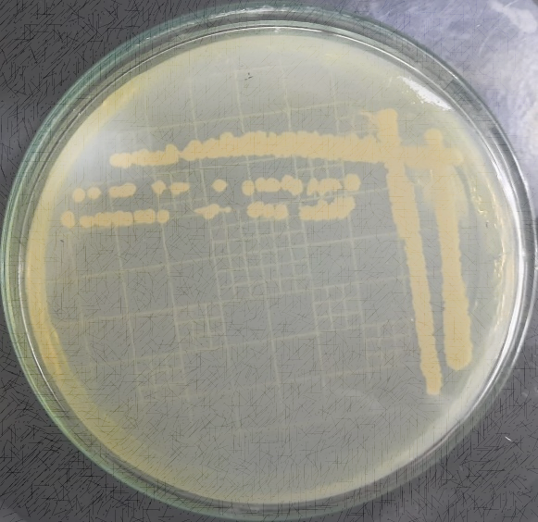

**Supplementary Figure 1.** Growth pattern of selected isolate for biosynthesis of copper nanoparticles

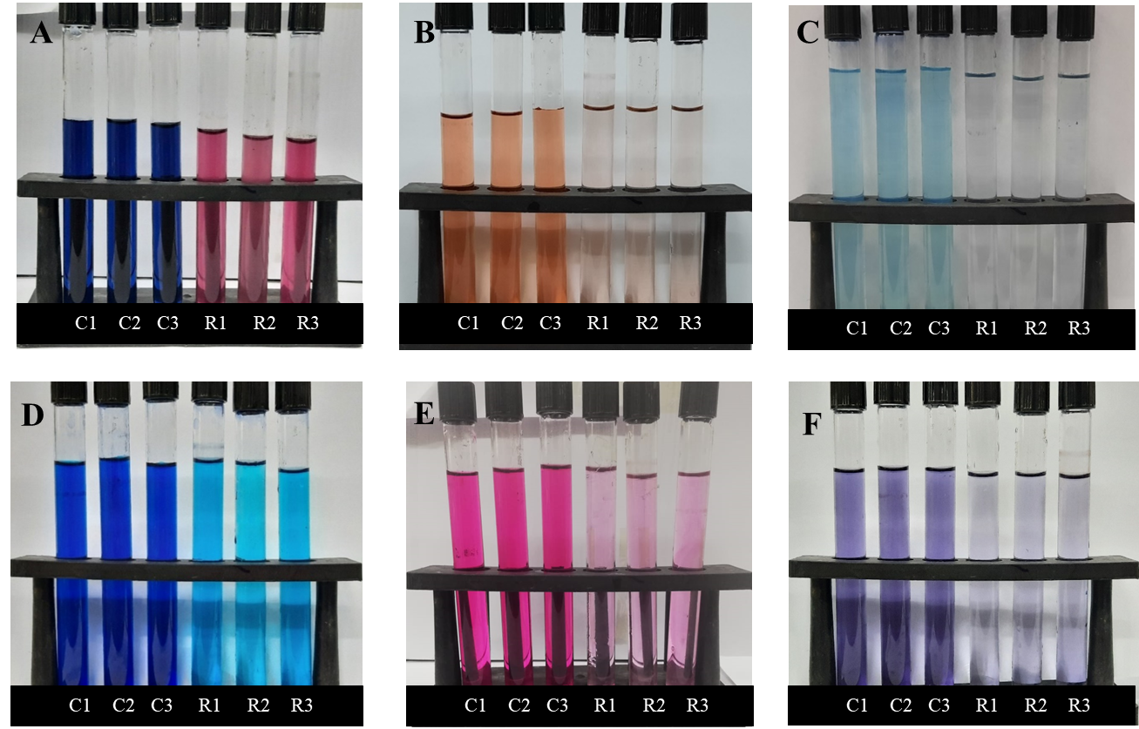

**Supplementary Figure 2.** Visual representation of RB-5 (A), CR (B), MG (C), MB (D), RR-2 (E), and BD (F), under solar irradiation of 4 hours at 50 ppm concentration of dyes.