Supplementary Materials
Suppl 1. Effect of exogenous methyl jasmonate (MeJA) treatment on the phytochemical profiles of Pogostemon cablin derived from in vitro culture.
Control Plants (0 µM MeJA)
Peak | RT | Area | Height | Name of natural compounds
1 | 1.92 | 63.55 | 31.69 | 1,2,3,3-D4-TRANS-1,2-DIHYDROXY-CYCLOPENTANE
2 | 2.18 | 12.63 | 19.59 | 1,3,5-Cycloheptatriene (CAS)
3 | 2.49 | 1.97 | 2.93 | 2-PENTANONE, 4-HYDROXY-4-METHYL-
4 | 2.77 | 2.28 | 3.11 | Benzene, 1,4-dimethyl- (CAS)
5 | 2.96 | 1.78 | 2.13 | Benzene, 1,2-dimethyl- (CAS)
6 | 3.23 | 0.41 | 1.02 | 1-TRIMETHYLSILYLOXY-2-(3'-METHOXY-4'- TRIMETHYLSILYLOXYPHENYL) ETHANE
7 | 3.31 | 0.30 | 0.88 | Oxirane, trimethyl- (CAS)
8 | 3.41 | 0.32 | 1.04 | Acetamide, N-(5-benzofuroxanyl)-
9 | 3.66 | 0.83 | 1.05 | 1-Pentene, 4,4-dimethyl-1,3-diphenyl-1-(trimethylsilyloxy)-
10 | 3.77 | 0.32 | 0.85 | 1-Octen-3-ol (CAS)
11 | 3.89 | 0.20 | 0.45 | 3,9-Dioxa-6-thiaundecane, 2,10-dimethyl-
12 | 4.08 | 0.26 | 0.49 | Benzene, 1,3,5-trimethyl- (CAS)
13 | 4.26 | 0.14 | 0.20 | DERIVATIZED MELILOTATE
14 | 4.53 | 0.12 | 0.15 | Benzene, 1,3,5-trimethyl- (CAS)
15 | 6.72 | 0.05 | 0.17 | Cyclopentasiloxane, decamethyl- (CAS)
16 | 8.17 | 0.24 | 0.97 | Neophytadiene
17 | 8.71 | 0.47 | 1.57 | Benzoic acid, 2-hydroxy-, methyl ester (CAS)
18 | 16.94 | 0.15 | 0.44 | .beta.-Patchoulene
19 | 17.76 | 0.04 | 0.14 | Tetradecane (CAS)
20 | 18.69 | 0.27 | 0.77 | TRANS(.BETA.)-CARYOPHYLLENE
21 | 19.51 | 1.31 | 3.95 | .alpha.-Guaiene
22 | 20.16 | 0.51 | 1.37 | Seychellene (CAS)
23 | 20.51 | 0.08 | 0.15 | .alpha.-Humulene (CAS)
24 | 20.81 | 0.39 | 1.08 | .alpha.-Patchoulene (CAS)
25 | 20.96 | 0.13 | 0.38 | Patchoulene (CAS)
26 | 21.15 | 0.14 | 0.32 | (-)-.alpha.-Selinene
27 | 21.63 | 0.07 | 0.18 | 2H-Pyran, 2-(7-heptadecynyloxy)tetrahydro- (CAS)
28 | 22.02 | 0.09 | 0.20 | Cyclohexanol, 4-(1,1-dimethylethyl)- (CAS)
29 | 22.72 | 0.26 | 0.66 | AZULENE, 1,2,3,4,5,6,7,8-OCTAHYDRO-1,4-DIMETHYL-7-(1-METHYLETHENYL)-, [1S-(1.ALPHA.,4.ALPHA.,7.ALPHA.)]-
30 | 22.86 | 0.05 | 0.14 | Kauren-18-ol, acetate, (4.beta.)- (CAS)
31 | 23.04 | 1.81 | 4.39 | .delta.-Guaiene (CAS)
32 | 23.13 | 1.36 | 4.26 | Pentadecane (CAS)
33 | 26.50 | 0.12 | 0.31 | Cyclohexanone, 2,3,3-trimethyl-2-(3-methyl-1,3-butadienyl)-, (Z)- (CAS)
34 | 27.02 | 0.06 | 0.15 | Pentadecane, 3-methyl- (CAS)
35 | 27.29 | 0.20 | 0.27 | 2-BUTYNYL-5-HYDROXY-3-OXO-4-HEXANOIC ACID .DELTA.- LACTONE
36 | 27.61 | 0.08 | 0.07 | 1,2-Benzenedicarboxylic acid, diethyl ester (CAS)
37 | 28.67 | 0.16 | 0.44 | Hexadecane (CAS)
38 | 31.38 | 0.19 | 0.45 | 1,1,4,7-TETRAMETHYLDECAHYDRO-1H- CYCLOPROPA[E]AZULEN-4-OL #
39 | 31.94 | 1.36 | 5.60 | Patchouli alcohol
40 | 32.19 | 0.05 | 0.08 | Hexadecane, 2,6,11,15-tetramethyl- (CAS)
41 | 32.82 | 0.07 | 0.16 | Heptadec-8-ene
42 | 33.40 | 0.12 | 0.31 | 1-Allyl-1-but-3-enyl-1-silacyclobutane
43 | 34.18 | 0.23 | 0.57 | Heptadecane (CAS)
44 | 34.47 | 2.99 | 3.56 | 2H-Pyran-2-one, 3-acetyl-4-hydroxy-6-methyl-
45 | 40.18 | 0.06 | 0.17 | 1H-Purin-6-amine, [(2-fluorophenyl)methyl]- (CAS)
46 | 41.54 | 0.05 | 0.19 | TETRACOSAMETHYLCYCLODODECASILOXANE
47 | 41.83 | 0.21 | 0.40 | TETRACOSAMETHYLCYCLODODECASILOXANE
48 | 43.96 | 0.13 | 0.16 | 1H-Purin-6-amine, [(2-fluorophenyl)methyl]- (CAS)
49 | 45.68 | 0.07 | 0.09 | QUERCETIN 7,3',4'-TRIMETHOXY
50 | 46.04 | 0.19 | 0.30 | EICOSAMETHYLCYCLODECASILOXANE

Patchouli Plants treated with 100 µM MeJA
Peak | RT | Area | Height | Natural compounds
1 | 1.92 | 67.73 | 34.91 | 1,2,3,3-D4-TRANS-1,2-DIHYDROXY-CYCLOPENTANE
2 | 2.18 | 9.14 | 20.63 | 1,3,5-Cycloheptatriene (CAS)
3 | 2.32 | 3.42 | 6.50 | Formic acid, butyl ester (CAS)
4 | 2.52 | 2.36 | 3.72 | 2-Pentanone, 4-hydroxy-4-methyl- (CAS)
5 | 2.75 | 2.30 | 3.35 | Benzene, 1,2-dimethyl- (CAS)
6 | 2.96 | 1.93 | 2.39 | Benzene, 1,2-dimethyl- (CAS)
7 | 3.24 | 0.54 | 1.13 | Butanal, 3-hydroxy- (CAS)
8 | 3.41 | 0.38 | 1.11 | O-METHOXY-ALPHA,ALPHA-DIMETHYLBENZYL ALCOHOL
9 | 3.51 | 0.45 | 0.82 | Pentanal, 3-(acetyloxy)-2,2,4-trimethyl- (CAS)
10 | 3.66 | 0.40 | 1.10 | 1-Pentene, 4,4-dimethyl-1,3-diphenyl-1-(trimethylsilyloxy)-
11 | 3.77 | 0.31 | 0.97 | 1 OCTEN 3 OL
12 | 3.91 | 0.28 | 0.47 | 4-Aminobutyraldehyde diethyl acetal
13 | 3.99 | 0.13 | 0.46 | 3-Octanol (CAS)
14 | 4.09 | 0.18 | 0.50 | Benzene, 1,3,5-trimethyl- (CAS)
15 | 4.44 | 0.31 | 0.21 | Benzene, 1,3-dichloro- (CAS)
16 | 8.17 | 0.24 | 1.10 | Neophytadiene
17 | 8.71 | 0.46 | 1.69 | Benzoic acid, 2-hydroxy-, methyl ester (CAS)
18 | 18.69 | 0.06 | 0.21 | trans-Caryophyllene
19 | 19.52 | 0.37 | 1.17 | .alpha.-Guaiene
20 | 20.16 | 0.15 | 0.44 | Seychellene (CAS)
21 | 20.81 | 0.11 | 0.36 | .alpha.-Patlimonenechoulene (CAS)
22 | 21.16 | 0.07 | 0.18 | Hexadecane, 1-chloro- (CAS)
23 | 22.04 | 0.08 | 0.25 | Cyclohexanol, 4-(1,1-dimethylethyl)- (CAS)
24 | 22.72 | 0.07 | 0.20 | .alpha.-Guaiene
25 | 23.14 | 1.93 | 4.68 | Pentadecane (CAS)
26 | 26.51 | 0.07 | 0.18 | Cyclohexanone, 2,3,3-trimethyl-2-(3-methyl-1,3-butadienyl)-, (Z)-(CAS)
27 | 27.41 | 0.14 | 0.11 | 3-2-Valeryl-5-methyl-1,2,4-cyclopentane-trione
28 | 28.68 | 0.18 | 0.52 | Octadecane (CAS)
29 | 31.94 | 0.72 | 1.83 | Patchouli alcohol
30 | 32.84 | 0.08 | 0.20 | 1-Heptadecanol (CAS)
31 | 33.41 | 0.12 | 0.31 | CYCLOHEXANE, 1,5-DIISOPROPYL-2,3-DIMETHYL-
32 | 34.18 | 0.21 | 0.62 | Octadecane (CAS)
33 | 34.47 | 2.58 | 3.67 | 2H-Pyran-2-one, 3-acetyl-4-hydroxy-6-methyl-
34 | 39.98 | 0.06 | 0.06 | Propanal,3-hexylimino-2-nitro-
35 | 40.38 | 0.14 | 0.24 | 1R-4T-ACETAMIDO-2,3T-EPOXY-CYCLOHEXANOL
36 | 40.52 | 0.09 | 0.24 | Octadecane, 5-methyl- (CAS)
37 | 40.74 | 0.18 | 0.22 | Methyl 10-methoxycarbonyl-17-oxooctadecanoate
38 | 40.86 | 0.13 | 0.34 | 1H-Purin-6-amine, [(2-fluorophenyl)methyl]- (CAS)
39 | 41.10 | 0.24 | 0.28 | 2-HYDROXY-3-(TETRADECANOYLOXY)PROPYL MYRISTATE #
40 | 41.33 | 0.12 | 0.15 | ACETONITRILE, 2-[4,6-BIS(DIMETHYLAMINO)-1,3,5-TRIAZIN-2-YLOXY]-
41 | 41.86 | 0.09 | 0.11 | 3-Methyl-1,1-cyclobutanedicarboxylic acid
42 | 42.29 | 0.12 | 0.22 | 2-HYDROXY-3-(TETRADECANOYLOXY)PROPYL MYRISTATE #
43 | 42.43 | 0.06 | 0.24 | Pentanal (CAS)
44 | 42.53 | 0.22 | 0.35 | N,N-Diethyl allylthiourea
45 | 42.68 | 0.22 | 0.39 | 2-HYDROXY-3-(TETRADECANOYLOXY)PROPYL MYRISTATE #
46 | 42.87 | 0.27 | 0.40 | 1H-Purin-6-amine, [(2-fluorophenyl)methyl]- (CAS)
47 | 44.41 | 0.06 | 0.20 | 1H-Purin-6-amine, [(2-fluorophenyl)methyl]- (CAS)
48 | 44.71 | 0.26 | 0.27 | 1H-Purin-6-amine, [(2-fluorophenyl)methyl]- (CAS)
49 | 45.18 | 0.15 | 0.20 | Hexanedioic acid, dioctyl ester (CAS)
50 | 46.03 | 0.09 | 0.10 | 1H-Purin-6-amine, [(2-fluorophenyl)methyl]- (CAS)

Patchouli Plants treated with 300 µM MeJA
Peak | RT | Area | Height | Natural compouds
1 | 1.90 | 64.19 | 31.29 | 1,2,3,3-D4-TRANS-1,2-DIHYDROXY-CYCLOPENTANE
2 | 2.18 | 8.43 | 17.81 | 1,3,5-Cycloheptatriene (CAS)
3 | 2.30 | 3.79 | 5.95 | Acetic acid, butyl ester (CAS)
4 | 2.53 | 2.25 | 2.88 | 2-PENTANONE, 4-HYDROXY-4-METHYL-
5 | 2.77 | 1.86 | 2.93 | Benzene, 1,4-dimethyl- (CAS)
6 | 2.96 | 1.77 | 2.02 | CYCLOPENTENE, 1-ETHENYL-3-METHYLENE-
7 | 3.29 | 0.71 | 0.90 | Xylopyranoside, methyl 4-azido-4-deoxy-, .beta.-L- (CAS)
8 | 3.41 | 0.70 | 0.98 | Acetamide, N-(6,7-dihydro-6-oxo-1H-purin-2-yl)-
9 | 3.66 | 0.44 | 1.01 | 1-Pentene, 4,4-dimethyl-1,3-diphenyl-1-(trimethylsilyloxy)-
10 | 3.77 | 0.34 | 1.11 | 1 OCTEN 3 OL
11 | 4.00 | 0.40 | 0.49 | ETHYL AMYL CARBINOL
12 | 4.09 | 0.16 | 0.44 | BENZENE, 1,2,4-TRIMETHYL-
13 | 4.43 | 0.38 | 0.21 | Benzene, 1,4-dichloro- (CAS)
14 | 8.17 | 0.23 | 0.98 | Neophytadiene
15 | 8.71 | 0.45 | 1.54 | Benzoic acid, 2-hydroxy-, methyl ester (CAS)
16 | 16.95 | 0.09 | 0.28 | .beta.-Patchoulene
17 | 17.77 | 0.06 | 0.17 | DODECANE, 4,6-DIMETHYL-
18 | 18.70 | 0.16 | 0.48 | TRANS(.BETA.)-CARYOPHYLLENE
19 | 19.52 | 0.74 | 2.10 | .alpha.-Guaiene
20 | 20.17 | 0.29 | 0.81 | Seychellene (CAS)
21 | 20.82 | 0.20 | 0.58 | .alpha.-Patchoulene (CAS)
22 | 20.96 | 0.06 | 0.19 | .alpha.-Gurjunene (CAS)
23 | 21.15 | 0.08 | 0.22 | (-)-.alpha.-Selinene
24 | 22.03 | 0.09 | 0.24 | Cyclohexanol, 4-(1,1-dimethylethyl)- (CAS)
25 | 22.30 | 0.06 | 0.14 | 1-Heptadec-1-ynyl-cyclohexanol
26 | 22.73 | 0.16 | 0.36 | .alpha.-Guaiene
27 | 23.05 | 0.86 | 2.43 | .delta.-Guaiene (CAS)
28 | 23.14 | 2.07 | 5.94 | Pentadecane (CAS)
29 | 26.51 | 0.14 | 0.34 | Cyclohexanone, 2,3,3-trimethyl-2-(3-methyl-1,3-butadienyl)-, (Z)- (CAS)
30 | 27.02 | 0.08 | 0.20 | Pentadecane, 3-methyl- (CAS)
31 | 27.27 | 0.23 | 0.43 | 2-BUTYNYL-5-HYDROXY-3-OXO-4-HEXANOIC ACID .DELTA.-LACTONE
32 | 28.68 | 0.21 | 0.53 | Hexadecane (CAS)
33 | 30.66 | 0.07 | 0.17 | Cyclopentaneacetic acid, 3-oxo-2-(2-pentenyl)-, methyl ester, [1.alpha.,2.alpha.(Z)]-
34 | 31.38 | 0.12 | 0.28 | POGOSTOL
35 | 31.94 | 1.39 | 3.24 | Patchouli alcohol
36 | 32.17 | 0.06 | 0.14 | Hexadecane, 2-methyl- (CAS)
37 | 32.36 | 0.05 | 0.14 | Cyclooctene, 3-methyl-
38 | 32.83 | 0.11 | 0.27 | 1-Pentadecanol (CAS)
39 | 33.41 | 0.12 | 0.31 | 1-Allyl-1-but-3-enyl-1-silacyclobutane
40 | 34.19 | 0.30 | 0.81 | Heptadecane (CAS)
41 | 34.47 | 5.39 | 7.55 | 2H-Pyran-2-one, 3-acetyl-4-hydroxy-6-methyl-
42 | 35.31 | 0.14 | 0.07 | Inacid
43 | 40.18 | 0.05 | 0.16 | 1H-Purin-6-amine, [(2-fluorophenyl)methyl]- (CAS)
44 | 40.59 | 0.05 | 0.09 | 1,2-Ethanediamine, N,N'-bis(2-aminoethyl)-
45 | 40.96 | 0.06 | 0.09 | TRANS-CYCLOPENTEN-3,4-DIOL
46 | 41.83 | 0.07 | 0.19 | 1H-Purin-6-amine, [(2-fluorophenyl)methyl]- (CAS)
47 | 42.25 | 0.07 | 0.06 | <NO NAME>
48 | 42.87 | 0.06 | 0.18 | CYCLONONASILOXANE, OCTADECAMETHYL-
49 | 45.20 | 0.07 | 0.15 | Hexanedioic acid, bis(2-ethylhexyl) ester (CAS)
50 | 46.03 | 0.14 | 0.12 | SILICONE OIL

Suppl 2. GC-MS profile of Pogostemon cablin derived from in vitro culture after treatment using methyl jasmonate (MeJA). GC-MS chromatogram for patchouli control plants (A), patchouli 100 µM MeJA treated plants (B), patchouli 300 µM MeJA treated plants (C).

A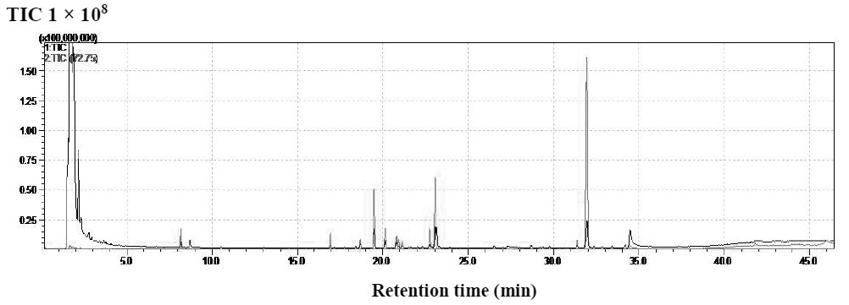
B
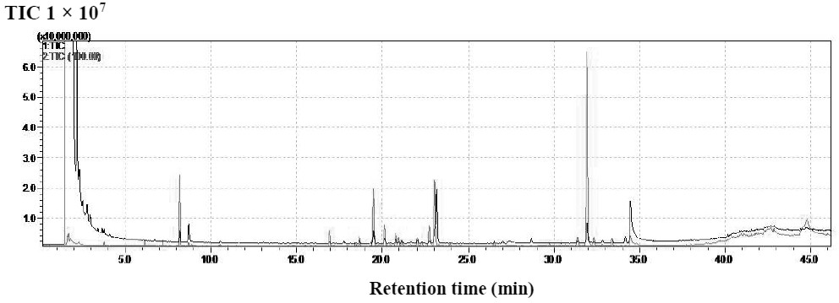
C
