Supplementary Materials
Development of Newer Generation Vascular Endothelial Growth Factor Receptor-2 Inhibitors: Pharmacophore based design, Virtual Screening, Molecular Docking, Molecular Dynamic Simulation, and DFT Analyses.

Mubarak A. Alamri¹, Mohammed Merae Alshahrani², Abdullah S. Alawam³, Souparno Paria⁴, Kalyan Kumar Sen⁵, Subhasis Banerjee^{6*}, and Supriyo Saha^{7*}
¹Department of Pharmaceutical Chemistry, College of Pharmacy, Prince Sattam Bin Abdulaziz University, Al-Kharj 11942, Saudi Arabia; m.alamri@psau.edu.sa; ORCID id: https://orcid.org/0000- 0003-0678-593X

²Department of Clinical Laboratory Sciences, Faculty of Applied Medical Sciences, Najran University, 1988, Najran, 61441, Saudi Arabia.; mmalshahrani@nu.edu.sa; ORCID id: https://orcid.org/0000-0002- 9387-5492

³Department of Biology, College of Science, Imam Mohammad Ibn Saud Islamic University, Riyadh 11623, Saudi Arabia; asalawam@imamu.edu.sa; ORCID id: https://orcid.org/0000-0003-4844-1801

⁴Bengal College of Pharmaceutical Sciences and Research, Durgapur; souparno1997@gmail.com

⁵Department of Pharmaceutical Sciecnes, Gupta College of Technological Sciences, Asansol, West Bengal; kkskpa@gmail.com ; https://orcid.org/0000-0003-1914-9238

⁶Department of Pharmaceutical Chemistry, Gupta College of Technological Sciences, Asansol, West Bengal; subhasisbanerjee864@yahoo.com ; https://orcid.org/0000-0003-0716-6508

⁷Department of Pharmaceutical Chemistry, Uttaranchal Institute of Pharmaceutical Sciences, Uttaranchal University, Premnagar, Dehradun- 248007, Uttarakhand, India; supriyo9@gmail.com ; https://orcid.org/0000-0003-1365-4698

Correspondence: subhasisbanerjee864@yahoo.com (S.B.); supriyo9@gmail.com (S.S.)

Table S1. List of established VEGFR2 inhibitors

SN | Name | Pubchem id
1. | Apatinib | 11315474
2. | Axitinib | 6450551
3. | Cabozantinib | 25102847
4. | Cediranib | 9933475
5. | CYC-116 | 6420138
6. | Dovitinib | 135398510
7. | Foretinib | 42642645
8. | Golvatinib | 16118392
9. | Ki8751 | 11317348
10. | Lenvatinib | 9823820
11. | Linifanib | 11485656
12. | LY2874455 | 46944259
13. | Metatinib | 44155856
14. | MGCD-265 | 24901704
15. | Motesanib | 11667893
16. | Nintedanib | 135423438
17. | Orantinib | 5329099
18. | Pazopanib | 10113978
19. | PD173074 | 1401
20. | Ponatinib | 24826799
21. | RAF265 | 11656518
22. | Regorafenib | 11167602
23. | Semaxanib | 5329098
24. | SKLB1002 | 71461003
25. | Sorafenib | 216239
26. | Sunitinib | 5329102
27. | Telatinib | 9808844
28. | Tivozanib | 9911830
29. | Vandetanib | 3081361
30. | ZM323881 | 16759369

Table S2. Parameters of Molecular dynamics simulation.

Ligand molecules interacted with 2OH4 | Water molecules (TIP3) | Counter ion | Counter ion concentration
B3 | 12115 | 37 Na⁺ 34 Cl⁻ | Na⁺: 55.528 mM, Cl⁻: 51.026 mM
B5 | 12117 | 37 Na⁺ 34 Cl⁻ | Na⁺: 55.519 mM, Cl⁻: 51.018 mM
B7 | 12063 | 37 Na⁺ 34 Cl⁻ | Na⁺: 55.768 mM, Cl⁻: 51.246 mM

Table S3. Molecular docking interaction scores and interacting residues of virtually screened molecules, designed molecules and Sorafenib VEGFR2 receptor (PDB id: 2OH4)
Sr. No | Name  of the Molecules | Docking Score  (kcal/mol)  Glide | Interacting Amino Acid  Residues  Glide | Docking Score  (kcal/mol)  Autodock  Vina | Interacting Amino Acid  Residues  Autodock  Vina
1. | ZINC21052778 | -6.971 | LEU 838ª, ASN 921ª | -6.8 | ARG 1049ª, LEU 838^{b}, ALA 864^{b}, VAL 846^{b}, LEU 1033^{b}, PHE 1045^{b}
2. | ZINC33271702 | -8.035 | CYS 917ª, ASP 1044ª | -7.2 | CYS 917ª, VAL 897^{b}, CYS 1043^{b}
3. | ZINC6550301 | -8.525 | GLU 883ª, CYS 1043ª, ASP 1044ª  LYS 866^{b} | -8.1 | HIS 889ª, ARG 1025ª, HIS 814^{b}, ILE 886^{b}, LEU 887^{b}, ILE 890^{b}, GLU 883^{b}
4. | ZINC40139090 | -6.608 | ASN 921ª | -7.2 | ASN 1031ª, ILE 1051ª, ARG 1030^{b}, ALA 1048^{b}, PRO 1066^{b}
5. | ZINC8873603 | -8.420 | CYS 917ª, ASP 1044ª, PHE 1045^{b} | -8.6 | ALA 1048ª, ARG 1049ª, ASP 1050ª, ARG 1025^{b}
6. | ZINC70466461 | -7.958 | GLU 883ª, ASP 1044ª | -8.9 | ASP 1026ª, ARG 1030ª, ASP 1044ª, ARG 1049ª, ALA 1048^{b}
7. | ZINC65320952 | -6.873 | GLU 883ª, ASP 1044ª, LYS 866^{b} | -8.6 | ASP 1044ª, ARG 1049ª, ALA 1048^{b}
8. | ZINC94047399 | -5.388 | GLU 883ª, ASP 1044ª | -8.5 | GLU 883^{b}, CYS 1043^{b}, VAL 897^{b}, ASP 1044ª
9. | ZINC87484001 | -7.550 | GLU 883ª, ASP 1044ª, LYS 866^{b} | -7.3 | ARG 1025ª, CYS 1022^{b}, ASP 1044^{b}
10. | ZINC5847770 | -6.982 | GLU 883ª, ASP 1044ª | -8.1 | HIS 1024^{b}, ASP 1044^{b}, ILE 886^{b}, GLU 883ª
11. | B1 | -8.373 | GLU 883ª, CYS 917ª, ASP 1044ª | -8.6 | ALA 879^{b}, LEU 880^{b}, GLU 883^{b}, ILE 886^{b}, LEU 1017^{b}, HIS 1024^{b}
12. | B2 | -6.241 | CYS 917ª, LYS 918ª | -9.0 | ALA 879^{b}, LEU 880^{b}, GLU 883^{b}, LEU 886^{b}, LEU 1017^{b}, HIS 1024^{b}, ASP 1044^{b}, ARG 1025ª
13. | B3 | -10.274 | GLU 883ª, CYS 917ª, ASP 1044ª | -10.6 | LEU 887^{b}, VAL 897^{b}, VAL 846^{b}, LEU 838^{b}, ALA 864^{b}, CYS 1043^{b}, ASP 1044ª, GLU 883^{b}
14. | B4 | -7.867 | GLU 883ª, CYS 917ª | -8.1 | ILE 886^{b}, ILE 890^{b}, VAL 897^{b}, VAL 896^{b}, LEU 1017^{b}, ASP 1044^{b}
15. | B5 | -10.539 | GLU 883ª, ASP 1044ª, PHE 1045^{b} | -10.2 | CYS 917ª, ASN 921ª, ARG 1049ª, ALA 864^{b}, PHE 916^{b}, LEU 1033^{b}, LEU 838^{b}, GLU 883^{b}
16. | B6 | -8.150 | GLU 915ª , ASP 1044ª | -8.9 | ILE 886^{b}, LEU 1017^{b}, CYS 1022^{b}, HIS 1024^{b}, ASP 1044^{b}
17. | B7 | -9.515 | GLU 883ª, CYS 917ª, ASP 1044ª,  LYS 866^{b} | -9.3 | ASN 921ª, ARG 1030ª, ARG 1049ª, ASP 1062ª, LEU 887^{b}, VAL 897^{b}, VAL 846^{b}, LEU 838^{b}, ALA 864^{b}, CYS 1043^{b}, ASP 1044^{b}, GLU 883^{b}
-18. | B8 | -8.206 | GLU 883ª, ASP 1044ª | -7.1 | GLU 883ª, ASP 1044ª, ASN 921ª, ARG 1030a, ARG 1049ª, ASP 1062ª, LEU 887^{b}, VAL 897^{b}, VAL 846^{b}, LEU 838^{b}, ALA 864^{b}
19. | Sorafenib | -10.791 | GLU 883ª, CYS 917ª, ASP 1044ª | -9.4 | GLU 883^{b}, VAL 897^{b}, LYS 866ª, ASP 1044ª
ªHydrogen bond interaction; ^{b}pi-pi interaction
Table S4: Drug Ability profiling of virtually screened molecules, designed molecules and Sorafenib standard.
SN | Name of the Molecules | MW | TPSA | LogS | LogP | GI absorption | Molar Refractivity | Pgp substrate | BBB penetration | CYP  1A2 inhibitor | CYP  2C19 inhibitor | CYP  2C9 inhibitor | CYP  2D6 inhibitor | CYP  3A4 inhibitor | Lipinski  rule | Oral Bioavailability  Score | Synthetic accessibility
1. | ZINC21052778 | 330.35 | 91.79 | -3.53 | 2.27 | High | 85.17 | Yes | No | Yes | Yes | No | No | No | Accepted  Number of violations: 0 | 0.55 | 3.59
2. | ZINC33271702 | 274.28 | 68.95 | -1.37 | 2.09 | High | 77.77 | No | No | No | No | No | No | No | Accepted  Number of violations: 0 | 0.55 | 4.22
3. | ZINC6550301 | 452.99 | 84.09 | -5.54 | 3.96 | High | 121.80 | Yes | No | Yes | No | No | No | No | Accepted  Number of violations: 0 | 0.55 | 3.06
4. | ZINC40139090 | 450.51 | 126.74 | -5.27 | 3.94 | High | 126.11 | Yes | No | No | No | Yes | Yes | Yes | Accepted  Number of violations: 0 | 0.55 | 2.86
5. | ZINC8873603 | 385.38 | 112.54 | -4.94 | 2.15 | High | 105.64 | No | No | Yes | No | Yes | Yes | Yes | Accepted  Number of violations: 0 | 0.55 | 3.11
6. | ZINC70466461 | 420.41 | 133.06 | -2.58 | 1.68 | High | 109.26 | Yes | No | No | No | No | No | No | Accepted  Number of violations: 0 | 0.55 | 2.88
7. | ZINC65320952 | 397.47 | 90.70 | -4.84 | 3.14 | High | 116.56 | Yes | No | Yes | Yes | Yes | Yes | Yes | Accepted  Number of violations: 0 | 0.55 | 3.78
8. | ZINC94047399 | 383.51 | 90.77 | -5.25 | 3.66 | High | 114.22 | No | No | No | Yes | Yes | No | Yes | Accepted  Number of violations: 0 | 0.55 | 2.97
9. | ZINC87484001 | 313.20 | 24.92 | -4.55 | 3.21 | High | 80.89 | No | Yes | No | Yes | No | Yes | Yes | Accepted  Number of violations: 0 | 0.55 | 2.60
10. | ZINC5847770 | 301.30 | 109.63 | -1.88 | 1.56 | High | 79.94 | Yes | No | No | No | No | No | No | Accepted  Number of violations: 0 | 0.55 | 2.47
11. | B1 | 341.4 | 71.53 | -3.24 | 3.26 | High | 96.66 | No | Yes | No | Yes | Yes | No | Yes | Accepted  Number of violations: 0 | 0.55 | 2.86
12. | B2 | 423.8 | 145.06 | -4.42 | 2.48 | Low | 104.10 | No | No | Yes | Yes | Yes | No | Yes | Accepted  Number of violations: 0 | 0.55 | 3.94
13. | B3 | 391.38 | 128.94 | -3.90 | 2.10 | High | 110.21 | No | No | No | No | No | Yes | Yes | Accepted  Number of violations: 0 | 0.55 | 2.93
14. | B4 | 401.38 | 84.32 | -2.23 | 2.64 | High | 104.35 | Yes | No | No | No | No | No | No | Accepted  Number of violations: 0 | 0.55 | 3.47
15. | B5 | 396.40 | 119.94 | -4.13 | -3.28 | High | 111.26 | Yes | No | No | No | No | No | No | Accepted  Number of violations: 0 | 0.55 | 4.96
16. | B6 | 366.46 | 79.00 | -3.90 | 2.89 | High | 115.27 | No | No | No | No | No | Yes | Yes | Accepted  Number of violations: 0 | 0.55 | 4.41
17. | B7 | 446.25 | 104.81 | -3.69 | 2.74 | High | 111.29 | No | No | Yes | Yes | Yes | No | Yes | Accepted  Number of violations: 0 | 0.55 | 2.59
18. | B8 | 343.32 | 120.43 | -3.45 | 2.78 | High | 89.95 | No | No | Yes | No | No | No | Yes | Accepted  Number of violations: 0 | 0.55 | 3.30
19. | Sorafenib | 464.82 | 92.35 | -5.11 | 3.42 | Low | 112.48 | No | No | Yes | Yes | Yes | Yes | Yes | Accepted  Number of violations: 0 | 0.55 | 2.87
MW: Molecular weight; MR: Molar refractivity; TPSA: Topological polar surface area; GI: Gastrointestinal; BBB: Blood brain barrier; CYP: Cytochrome. +: Inhibitor require further experiment. ++: Moderate Inhibitor. +++: Inhibitor. ---/--: Non Inhibitor. -: Inhibitor require further experiment.

Table S5. Toxicity analysis of the virtually screened VEGFR2 inhibitotrs, designed VEGFR2 inhibitors and sorafenib
Name of the Molecules | Mutagenic | Tumorigenic | Irritant | Reproductive effective
ZINC21052778
ZINC33271702
ZINC6550301
ZINC40139090
ZINC8873603
ZINC70466461
ZINC65320952
ZINC94047399
ZINC87484001
ZINC5847770
B1
B2
B3
B4
B5
B6
B7
B8
Sorafenib

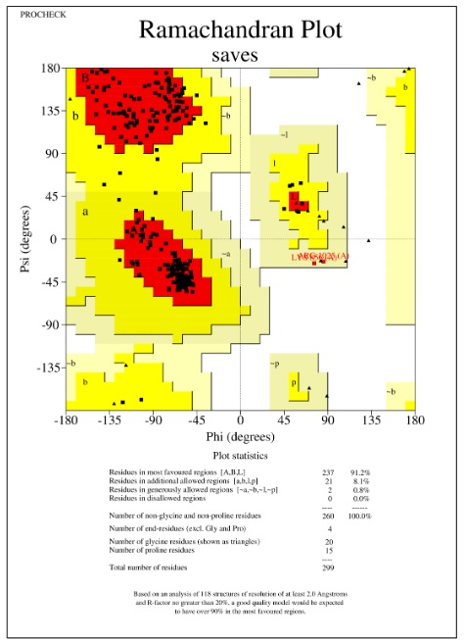
Figure S1. Ramachandran Plot of VEGFR2 receptor (PDB id: 2OH4)

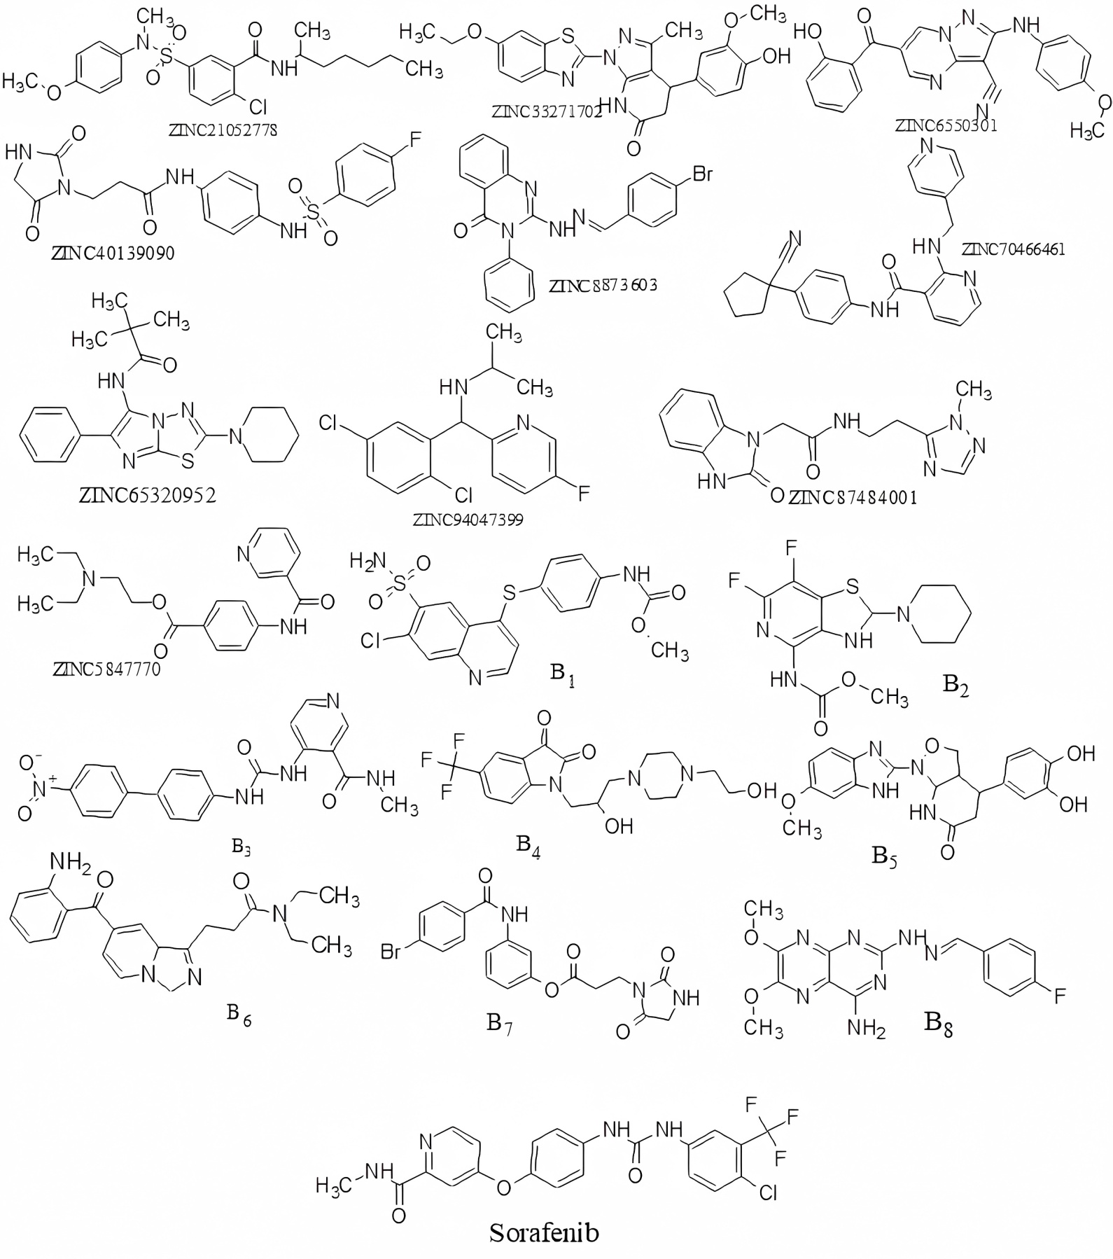

Figure S2. 2D Chemical structures of the virtually screened and designed VEGFR2 inhibitors.
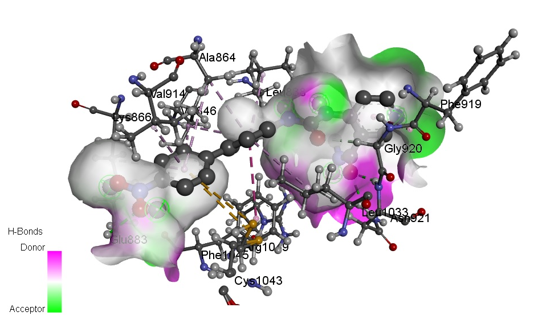
B3
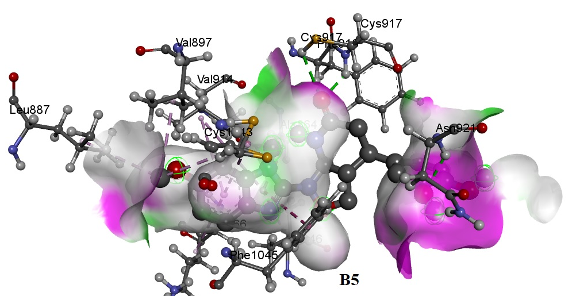
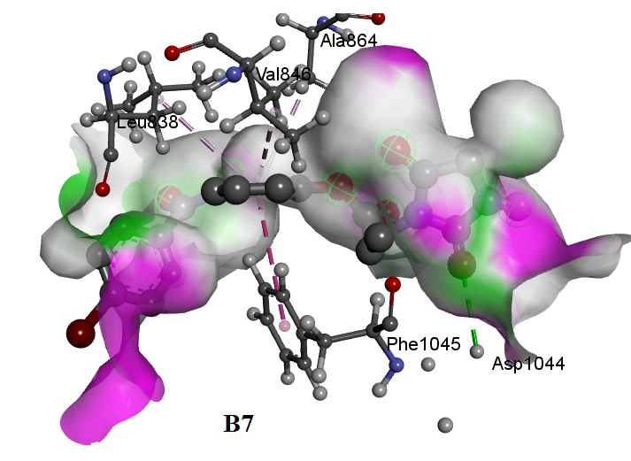
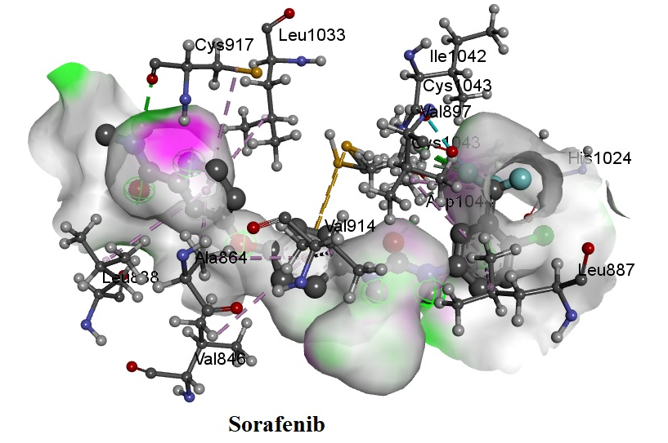
Figure S3. 3D interaction image of B3, B5, B7, and Sorafenib with VEGFR2 receptor (PDB id: 2OH4).

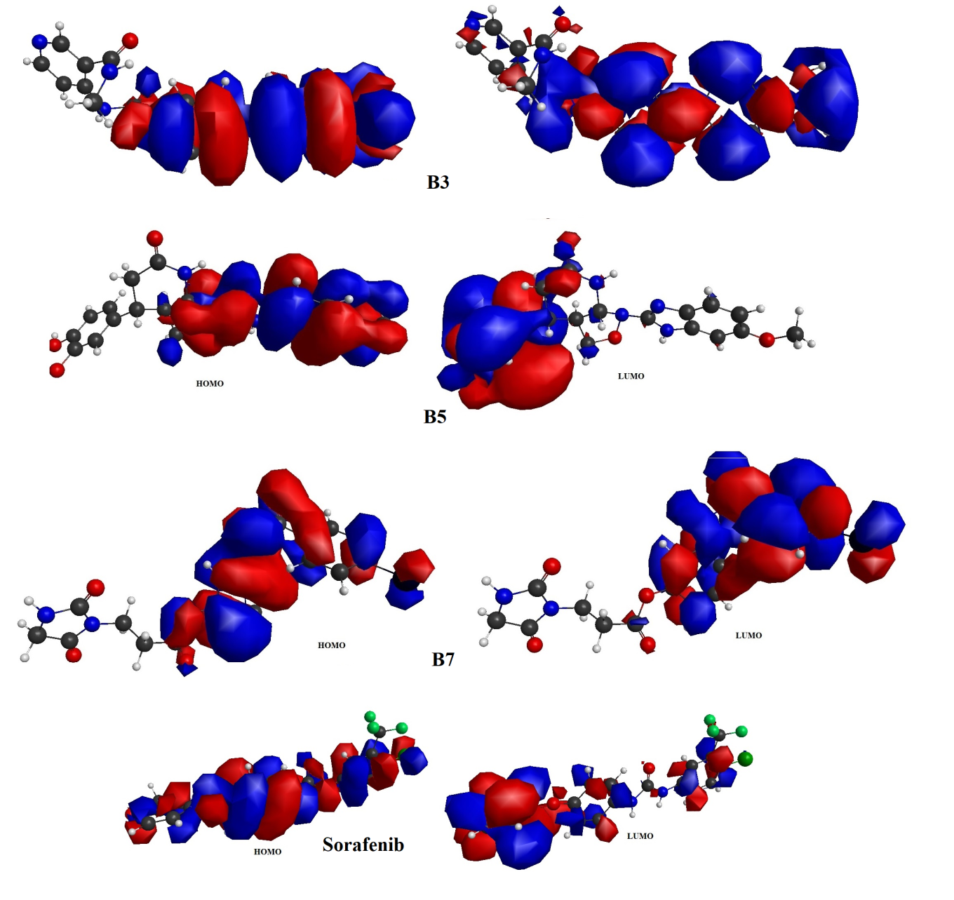
Figure S4. FMO analysis of B3, B5, B7, and Sorafenib.

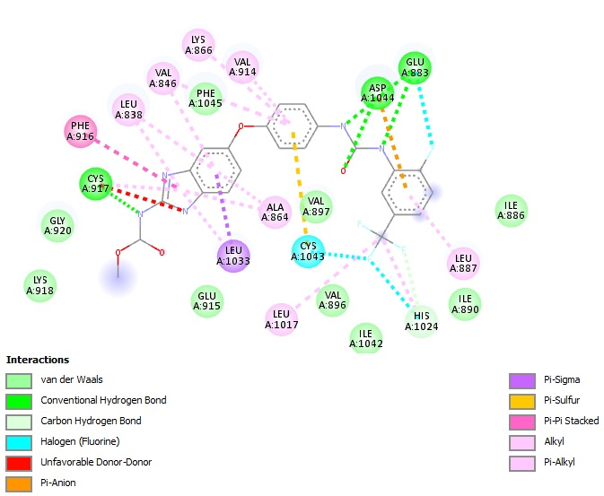

Figure S5. Complexed ligand GIG interacted with VEGFR2 receptor (PDB id: 2OH4).

