|  |  |  |  |
| --- | --- | --- | --- |
| **Table S1: Maize field survey in panchmahal and mahisagar districts** | | | |
| **Blocks** | **Villages** | **Latitude** | **Longitude** |
| **Godhra** | Ambali | 22°45'37.4"N | 73°33'57.6"E |
| Acchala | 22°43'16.5"N | 73°42'49.1"E |
| Dholi | 22°49'53.8"N | 73°45'43.0"E |
| Kevadiya | 22°48'46.6"N | 73°44'39.5"E |
| Rampura | 22°43'39.5"N | 73°29'10.6"E |
| **Shehera** | Bhadrala | 22°57'11.6"N | 73°37'38.9"E |
| Limbodra | 23°22'59.0"N | 73°32'59.7"E |
| Boriavi | 22°57'46.2"N | 73°37'16.1"E |
| Nada | 22°57'15.0"N | 73°38'03.1"E |
| Sambhali | 22°58'51.3"N | 73°35'47.1"E |
| **Santrampur** | Chitva | 23°17'22.3"N | 73°52'14.8"E |
| Kanzara | 23°18'57.1"N | 73°52'36.8"E |
| Paniyar | 23°19'12.5"N | 73°53'31.0"E |
| Babrai | 23°11'41.3"N | 73°57'00.9"E |
| Nalai | 23°15'53.1"N | 73°54'01.1"E |
| **Lunawada** | Aritha | 23°08'55.8"N | 73°37'38.2"E |
| Gadh | 24°07'44.0"N | 72°15'56.7"E |
| Jokha | 23°02'58.1"N | 73°36'32.5"E |
| Kaslal | 23°06'52.4"N | 73°29'42.3"E |
| Tentoi | 22°59'51.0"N | 73°28'43.9"E |
| **Halol** | Halol | 22°30'17.0"N | 73°27'24.4"E |
| Navaria | 22°34'48.8"N | 73°28'52.0"E |
| Varsada | 22°34'26.5"N | 73°32'30.2"E |
| Ravaliya | 22°24'14.5"N | 73°30'46.4"E |
| Sonipur | 22°22'09.3"N | 73°31'55.9"E |
| **Kalol** | Ved | 22°28'38.0"N | 73°37'40.7"E |
| Ghoda | 22°36'31.3"N | 73°29'12.0"E |
| Fansi | 22°39'02.8"N | 73°36'53.9"E |
| Palasa | 22°36'00.3"N | 73°23'02.9"E |
| Paruna | 22°40'27.7"N | 73°35'26.0"E |
| **Morwa** | Dangariya | 22°52'50.2"N | 73°49'16.4"E |
| Gajipur | 22°58'33.9"N | 73°48'06.1"E |
| Parabiya | 22°55'23.1"N | 73°51'13.9"E |
| Sagwada | 23°00'58.1"N | 73°49'55.4"E |
| Saliya | 22°47'39.2"N | 73°48'40.7"E |
| **Kadana** | Bhuki | 22°38'26.4"N | 73°35'33.0"E |
| Ghaswada | 23°20'21.9"N | 73°46'58.9"E |
| Divada | 23°16'41.5"N | 73°50'08.2"E |
| Karvai | 23°18'17.8"N | 73°15'01.1"E |
| Mahapur | 23°14'05.1"N | 73°50'36.2"E |
| **Khanpur** | Dolariya | 23°12'39.9"N | 73°35'48.1"E |
| Kolambi | 23°16'43.4"N | 73°41'43.6"E |
| Jethala | 23°07'59.0"N | 73°25'36.6"E |
| Gangata | 23°15'29.4"N | 73°35'36.6"E |
| Vanka | 23°14'54.2"N | 73°36'36.9"E |
| **Jambughoda** | Chalvad | 22°26'17.2"N | 73°41'49.0"E |
| Zarva | 22°25'48.1"N | 73°42'10.9"E |
| Pipiya | 22°19'12.2"N | 73°43'08.6"E |
| Gondhra | 22°27'02.5"N | 73°41'21.8"E |
| Borkach | 22°24'30.7"N | 73°39'23.3"E |
| **Ghoghamba** | Vangarva | 22°43'53.6"N | 73°44'21.8"E |
| Sajora | 22°40'09.2"N | 73°44'25.2"E |
| Albeta | 22°40'50.8"N | 73°45'25.4"E |
| Gundi | 22°36'13.3"N | 73°50'13.0"E |
| Kanpur | 22°36'14.3"N | 73°38'44.8"E |

| **Table S2: Larval population of NPV-infected fall armyworm (*S. frugiperda*) in maize fields of Panchmahal and Mahisagar districts** | | | | | | | | | | | | | |
| --- | --- | --- | --- | --- | --- | --- | --- | --- | --- | --- | --- | --- | --- |
| **Blocks** | **Villages** | **Months** | | | | | | | | | | | |
| **July** | | | | **August** | | | | **September** | | | |
| **No. of**  **larvae**  **collected** | **No. of**  **NPV**  **infected**  **larvae**  **observed** | **NPV**  **infection**  **(%)** | **POB’s**  **/ml** | **No. of**  **larvae**  **collected** | **No. of**  **NPV**  **infected**  **larvae**  **observed** | **NPV**  **infection**  **(%)** | **POB’s**  **/ml** | **No. of larvae**  **collected** | **No. of**  **NPV**  **infected**  **larvae**  **observed** | **NPV**  **infection**  **(%)** | **POB’s**  **/ml** |
| **Godhra** | Ambali | 9 | 1 | 11.11 | 2 × 101 | 14 | 4 | 28.57 | 2.9 × 102 | 17 | 7 | 41.18 | 3.3 × 103 |
| Acchala | 13 | 2 | 15.38 | 2.3 × 102 | 21 | 6 | 28.57 | 2.3 × 102 | 24 | 8 | 33.33 | 3.1 × 103 |
| Dholi | 11 | 2 | 18.18 | 1.5 × 101 | 17 | 2 | 11.76 | 1.9 × 102 | 21 | 6 | 28.57 | 3.1 × 103 |
| Kevadiya | 4 | 0 | 0.00 | 0 | 18 | 5 | 27.78 | 2.4 × 102 | 28 | 10 | 35.71 | 1.9 × 102 |
| Rampura | 5 | 1 | 20.00 | 1.3 **×** 101 | 8 | 1 | 12.50 | 1.6 × 102 | 0 | 0 | 0.00 | 0 |
| **Total** | | **42** | **6** | **--** | **--** | **78** | **18** | **--** | **--** | **90** | **31** | **--** | **--** |
| **Mean** | | **8.4** | **1.2** | **14.29** | **--** | **15.6** | **3.6** | **23.08** | **--** | **18** | **6.2** | **34.44** | **--** |
| **Shehera** | Bhadrala | 3 | 0 | 0.00 | 0 | 19 | 3 | 15.79 | 1.7 × 102 | 0 | **0** | 0 | 0 |
| Limbodra | 5 | 1 | 20.00 | 1.3 × 101 | 9 | 1 | 11.11 | 1.2 × 101 | 19 | **5** | 26.32 | 1.5 × 103 |
| Boriavi | 0 | 0 | 0.00 | 0 | 12 | 2 | 16.67 | 2.3 × 103 | 22 | **7** | 31.82 | 3.4 × 102 |
| Nada | 12 | 2 | 16.67 | 2.3 × 102 | 0 | 0 | 0 | 0 | 18 | **5** | 27.78 | 2.8 × 102 |
| Sambhali | 7 | 1 | 14.29 | 2.1 × 101 | 16 | 3 | 18.75 | 1.9 × 103 | 0 | **0** | 0.00 | 0 |
| **Total** | | **27** | **4** | **--** | **--** | **56** | **9** | **--** | **--** | **59** | **17** | **--** | **--** |
| **Mean** | | **5.4** | **0.8** | **14.81** | **--** | **11.2** | **1.8** | **16.07** | **--** | **11.8** | **3.4** | **28.81** | **--** |
| **Santrampur** | Chitva | 8 | 1 | 12.50 | 1.3 × 101 | 13 | 2 | 15.38 | 2.1 × 102 | 21 | 5 | 23.81 | 2.7 × 102 |
| Kanzara | 3 | 0 | 0.00 | 0 | 19 | 3 | 15.79 | 2.2 × 103 | 16 | 4 | 25.00 | 3.1 × 102 |
| Paniyar | 12 | 1 | 8.33 | 1.2 × 101 | 0 | 0 | 0 | 0 | 12 | 3 | 25.00 | 1.9 × 103 |
| Babrai | 9 | 1 | 11.11 | 1.8 × 101 | 14 | 2 | 14.29 | 2.4 × 103 | 18 | 5 | 27.78 | 1.4 × 101 |
| Nalai | 0 | 0 | 0 | 0 | 11 | 2 | 18.18 | 2.6 × 103 | 14 | 5 | 35.71 | 3.2 × 102 |
| **Total** | | **32** | **3** | **--** | **--** | **57** | **9** | **--** | **--** | **81** | **22** | **--** | **--** |
| **Mean** | | **6.4** | **0.6** | **9.38** | **--** | **11.4** | **1.8** | **15.79** | **--** | **16.2** | **4.4** | **27.16** | **--** |
| **Lunawada** | Aritha | 6 | 0 | 0.00 | 0 | 21 | 6 | 28.57 | 3.1 × 103 | 0 | 0 | 0 | 0 |
| Gadh | 11 | 2 | 18.18 | 2.4 × 102 | 9 | 2 | 22.22 | 2.6 × 103 | 23 | 6 | 26.09 | 2.3 × 102 |
| Jokha | 10 | 2 | 20.00 | 2.2 × 102 | 13 | 1 | 7.69 | 1.2 × 101 | 16 | 4 | 25.00 | 2.2 × 103 |
| Kaslal | 8 | 1 | 12.50 | 1.5 × 101 | 0 | 0 | 0 | × | 13 | 4 | 30.77 | 3.3 × 101 |
| Tentoi | 10 | 1 | 10.00 | 1.1 × 101 | 17 | 3 | 17.65 | 2.4 × 103 | 18 | 5 | 27.78 | 2.8 × 103 |
| **Total** | | **45** | **6** | **--** | **--** | **60** | **12** | **--** | **--** | **70** | **19** | **--** | **--** |
| **Mean** | | **9** | **1.2** | **13.33** | **--** | **12** | **2.4** | **20.00** | **--** | **14** | **3.8** | **27.14** | **--** |
| **Halol** | Halol | 9 | 1 | 11.11 | 1.2 × 102 | 16 | 4 | 25.00 | 2.8 × 103 | 17 | 5 | 29.41 | 2.4 × 103 |
| Navaria | 3 | 0 | 0.00 | 0 | 13 | 2 | 15.38 | 1.9 × 102 | 19 | 6 | 31.58 | 3.6 × 103 |
| Varsada | 5 | 0 | 0.00 | 0 | 18 | 4 | 22.22 | 2.7 × 103 | 0 | 0 | 0.00 | 0 |
| Ravaliya | 9 | 1 | 11.11 | 1.2 × 102 | 9 | 1 | 11.11 | 1.3 × 101 | 21 | 5 | 23.81 | 1.5 × 101 |
| Sonipur | 11 | 2 | 18.18 | 1.6 × 102 | 14 | 3 | 21.43 | 2.2 × 102 | 13 | 4 | 30.77 | 1.8 × 103 |
| **Total** | | **37** | **4** | **--** | **--** | **70** | **14** | **--** | **--** | **70** | **20** | **--** | **--** |
| **Mean** | | **7.4** | **0.8** | **10.81** | **--** | **14** | **2.8** | **20.00** | **--** | **14** | **4** | **28.57** | **--** |
| **Kalol** | Ved | 4 | 0 | 0.00 | 0 | 15 | 3 | 20.00 | 2.6 × 103 | 18 | 5 | 27.78 | 3.1 × 101 |
| Ghoda | 7 | 1 | 14.29 | 1.8 × 102 | 0 | 0 | 0 | 0 | 24 | 6 | 25.00 | 3.3 × 103 |
| Fansi | 0 | 0 | 0 | 0 | 19 | 4 | 21.05 | 2.3 × 103 | 11 | 3 | 27.27 | 2.5 × 101 |
| Palasa | 8 | 1 | 12.50 | 1.3 × 102 | 22 | 3 | 13.64 | 1.8 × 102 | 22 | 6 | 27.27 | 2.6 × 103 |
| Paruna | 12 | 1 | 8.33 | 1.1 × 102 | 13 | 2 | 15.38 | 1.7 × 102 | 14 | 4 | 28.57 | 3.2 × 103 |
| **Total** | | **31** | **3** | **--** | **--** | **69** | **12** | **--** | **--** | **89** | **24** | **--** | **--** |
| **Mean** | | **6.2** | **0.6** | **9.68** | **--** | **13.8** | **2.4** | **17.39** | **--** | **17.8** | **4.8** | **26.97** | **--** |
| **Morwa** | Dangariya | 6 | 1 | 16.67 | 2.3 × 101 | 17 | 2 | 11.76 | 1.4 × 102 | 17 | 5 | 29.41 | 3.3 × 102 |
| Gajipur | 4 | 0 | 0.00 | 0 | 15 | 2 | 13.33 | 1.4 × 102 | 19 | 6 | 31.58 | 1.5 × 103 |
| Parabiya | 0 | 0 | 0 | 0 | 14 | 3 | 21.43 | 2.7 × 103 | 23 | 0 | 0.00 | 0 |
| Sagwada | 10 | 1 | 10.00 | 1.8 × 101 | 21 | 4 | 19.05 | 2.2 × 103 | 0 | 3 | 0.00 | 0 |
| Saliya | 7 | 1 | 14.29 | 1.4 × 102 | 0 | 0 | 0 | 0 | 14 | 4 | 28.57 | 1.6 × 103 |
| **Total** | | **27** | **3** | **--** | **--** | **67** | **11** | **--** | **--** | **73** | **18** | **--** | **--** |
| **Mean** | | **5.4** | **0.6** | **11.11** | **--** | **13.4** | **2.2** | **16.42** | **--** | **14.6** | **3.6** | **24.66** | **--** |
| **Kadana** | Bhuki | 11 | 2 | 18.18 | 2.6 × 101 | 20 | 3 | 15.00 | 1.3 × 101 | 20 | 6 | 30.00 | 2.2 × 103 |
| Ghaswada | 0 | 0 | 0 | 0 | 14 | 2 | 14.29 | 1.7 × 103 | 19 | 5 | 26.32 | 2.8 × 103 |
| Divada | 8 | 0 | 0.00 | 0 | 12 | 2 | 16.67 | 1.5 × 102 | 11 | 3 | 27.27 | 2.3 × 103 |
| Karvai | 8 | 1 | 12.50 | 1.4 × 101 | 16 | 3 | 18.75 | 1.4 × 102 | 0 | 0 | 0.00 | 0 |
| Mahapur | 11 | 2 | 18.18 | 1.6 × 101 | 0 | 0 | 0 | 0 | 13 | 3 | 23.08 | 3.2 × 103 |
| **Total** | | **38** | **5** | **--** | **--** | **62** | **10** | **--** | **--** | **63** | **17** | **--** | **--** |
| **Mean** | | **7.6** | **1** | **13.16** | **--** | **12.4** | **2** | **16.13** | **--** | **12.6** | **3.4** | **26.98** | **--** |
| **Khanpur** | Dolariya | 2 | 0 | 0.00 | 0 | 18 | 4 | 22.22 | 2.4 × 103 | 19 | 5 | 26.32 | 3.3 × 103 |
| Kolambi | 6 | 1 | 16.67 | 1.7 × 101 | 13 | 3 | 23.08 | 2.6 × 103 | 21 | 6 | 28.57 | 2.5 × 103 |
| Jethala | 7 | 1 | 14.29 | 1.3 × 102 | 11 | 3 | 27.27 | 2.9 × 103 | 14 | 3 | 21.43 | 1.8 × 101 |
| Gangata | 3 | 0 | 0.00 | 0 | 15 | 2 | 13.33 | 1.1 × 101 | 18 | 5 | 27.78 | 1.6 × 103 |
| Vanka | 4 | 0 | 0.00 | 0 | 11 | 2 | 18.18 | 2.1 × 102 | 14 | 4 | 28.57 | 3.3 × 103 |
| **Total** | | **22** | **2** | **--** | **--** | **68** | **14** | **--** | **--** | **86** | **23** | **--** | **--** |
| **Mean** | | **4.4** | **0.4** | **9.09** | **--** | **13.6** | **2.8** | **20.59** | **--** | **17.2** | **4.6** | **26.74** | **--** |
| **Jambughoda** | Chalvad | 12 | 3 | 25.00 | 2.8 × 103 | 16 | 4 | 25.00 | 3.1 × 103 | 16 | 6 | 37.50 | 3.2 × 103 |
| Zarva | 10 | 2 | 20.00 | 2.2 × 101 | 23 | 6 | 26.09 | 3.3 × 103 | 23 | 7 | 30.43 | 2.8 × 103 |
| Pipiya | 6 | 1 | 16.67 | 1.9 × 102 | 20 | 3 | 15.00 | 2.1 × 103 | 20 | 6 | 30.00 | 1.9 × 103 |
| Gondhra | 13 | 3 | 23.08 | 2.6 × 102 | 25 | 7 | 28.00 | 3.9 × 103 | 27 | 7 | 25.93 | 3.1 × 101 |
| Borkach | 8 | 1 | 12.50 | 2.1 × 102 | 13 | 3 | 23.08 | 2.4 × 102 | 0 | 0 | 0.00 | 0 |
| **Total** | | **49** | **10** | **--** | **--** | **97** | **23** | **--** | **--** | **86** | **26** | **--** | **--** |
| **Mean** | | **9.8** | **2** | **20.41** | **--** | **19.4** | **4.6** | **23.71** | **--** | **17.2** | **5.2** | **30.23** | **--** |
| **Ghoghamba** | Vangarva | 15 | 4 | 26.67 | 2.9 × 102 | 14 | 4 | 28.57 | 3.4 **×** 103 | 18 | 4 | 22.22 | 2.1 × 103 |
| Sajora | 11 | 2 | 18.18 | 2.1 × 102 | 21 | 7 | 33.33 | 3.6 × 103 | 24 | 8 | 33.33 | 1.9 × 103 |
| Albeta | 8 | 1 | 12.50 | 1.4 × 101 | 18 | 4 | 22.22 | 2.8 × 103 | 0 | 0 | 0.00 | 0 |
| Gundi | 11 | 2 | 18.18 | 1.6 × 102 | 23 | 7 | 30.43 | 3.2 × 103 | 28 | 10 | 35.71 | 3.8 × 103 |
| Kanpur | 7 | 1 | 14.29 | 1.3 × 101 | 15 | 3 | 20.00 | 2.1 × 103 | 26 | 9 | 34.62 | 4.1 × 103 |
| **Total** | | **52** | **10** | **--** | **--** | **91** | **25** | **--** | **--** | **96** | **31** | **--** | **--** |
| **Mean** | | **10.4** | **2** | **19.23** | **--** | **18.2** | **5** | **27.47** | **--** | **19.2** | **6.2** | **32.29** | **--** |

POB’s/ml- Polyhedral Occlusion Bodies per milliliter %- Percentage; hr.- hours;mm- milli meter; Data was subjected to analysis using SPSS software 21.

**Table S3: Association between weather parameters and nucleopolyhedrovirus (NPV) infection in fall armyworm (*S. frugiperda*) infesting maize of panchmahal and mahisagar district**

|  |  |  |  |  |  |  |  |  |  |
| --- | --- | --- | --- | --- | --- | --- | --- | --- | --- |
| **Months** | **Weather parameters** | | | | | | **No of**  **larvae**  **collected**  **(Mean± SE)** | **NPV**  **infected**  **larvae**  **observed**  **(Mean± SE)** | **NPV**  **infection**  **(%)**  **(Mean± SE)** |
| **Temperature**  **(0C)** | | **Relative Humidity**  **(%)** | | **Sunshine**  **(hr.)** | **Rainfall/**  **(mm)**  **week** |
| **Max.** | **Min.** | **Morning** | **Evening** |
| **July** | 34.67 | 26.66 | 86.36 | 69.84 | 3.90 | 154.00 | 7.32 ± 0.558 | 1.02 ± 0.157 | 13.93 ± 1.101 |
| **August** | 32.44 | 26.13 | 88.60 | 69.20 | 3.23 | 2.55 | 14.09 ± 0.765 | 2.85 ± 0.310 | 20.23 ± 1.09 |
| **September** | 31.17 | 25.43 | 92.05 | 79.37 | 1.76 | 9.97 | 15.69 ± 0.695 | 4.51 ± 0.292 | 28.74 ± 0.807 |

SE: Standard Error; 0C- Degree Celsius; %- Percentage; hr.- hours;mm- milli meter; Data was subjected to analysis using SPSS software 21.

**Table S4: Binding energy values (kcal/mol) from docking simulations between polyhedrin *of S. frugiperda* and chitinase enzyme**

|  |  |  |  |
| --- | --- | --- | --- |
| **3D structure** | **Compound name** | **Molecular formula** | **Binding energy to polyhedrin of *S. frugiperda* (kcal/mol)** |
|  | Chitinase-IN-1 | C18H16N4O2S | -9.4 |

|  |  |  |  |  |  |  |  |  |
| --- | --- | --- | --- | --- | --- | --- | --- | --- |
| **Table S5: Calculated LC50 values of different concentrations of Spfr NPV AAUBC1 strain evaluated against second, third and fourth larval instar of fall armyworm, *S. frugiperda*, under laboratory conditions** | | | | | | | | |
| **Instar** | **Observation period** | **N** | **χ2** | **Df** | **LC50 (95%CL)** | **Fiducial limit 95%** | | **P value** |
| **Lower** | **Upper** |
| **Second** | 3rd day | 30 | 1.000 | 5 | **3.9 × 1012** | 5.7 × 109 | 2.6 × 1015 | 0.004 |
| 4th day | 30 | 0.998 | 5 | 1.7 × 1010 | 7.5 × 107 | 4.1 × 1012 | 0.005 |
| 5th day | 30 | 0.978 | 5 | 3.8 × 107 | 1.7 × 105 | 8.7 × 108 | 0.001 |
| 6th day | 30 | 0.992 | 5 | **4.5 × 106** | 2.7 × 105 | 7.7× 107 | 0.002 |
| 7th day | 30 | 0.993 | 5 | 6.8 × 104 | 2.8 × 103 | 1.6 ×106 | 0.010 |
| 8th day | 30 | 0.626 | 5 | 2.3 × 104 | 1.9 × 103 | 2.8 ×105 | 0.006 |
| 9th day | 30 | 0.838 | 5 | 1.1 × 104 | 8.7 × 102 | 1.6 ×105 | 0.010 |
| **Third** | 3rd day | 30 | 0.999 | 5 | **9.3 × 1013** | 3.5 × 1010 | 2.4 × 1015 | 0.002 |
| 4th day | 30 | 0.997 | 5 | 2.5 × 1011 | 1.9 × 109 | 3.4 × 1013 | 0.002 |
| 5th day | 30 | 0.803 | 5 | 8.0 × 108 | 2.5 × 107 | 2.5 × 1010 | 0.001 |
| 6th day | 30 | 0.982 | 5 | **1.5 × 107** | 1.1 × 106 | 2.1 × 108 | 0.001 |
| 7th day | 30 | 0.980 | 5 | 3.0 × 105 | 1.3 × 104 | 6.5 × 106 | 0.005 |
| 8th day | 30 | 0.943 | 5 | 6.6 × 104 | 4.1 × 103 | 1.0 × 106 | 0.006 |
| 9th day | 30 | 0.822 | 5 | 3.4 × 104 | 3.2 × 103 | 3.6 × 105 | 0.004 |
| **Fourth** | 3rd day | 30 | 0.991 | 5 | **1.1 × 1014** | 3.5 × 1011 | 3.7 × 1016 | 0.002 |
| 4th day | 30 | 0.990 | 5 | 1.3 × 1012 | 1.2 × 1010 | 1.3 × 1014 | 0.001 |
| 5th day | 30 | 0.942 | 5 | 4.1 × 109 | 1.7 × 108 | 9.8 × 1010 | 0.001 |
| 6th day | 30 | 0.963 | 5 | **1.2× 108** | 8.3 × 106 | 1.8 × 109 | 0.001 |
| 7th day | 30 | 0.962 | 5 | 4.9 × 106 | 2.4 × 105 | 1.1 × 108 | 0.002 |
| 8th day | 30 | 0.966 | 5 | 5.4 × 105 | 2.5 × 104 | 1.2 × 107 | 0.004 |
| 9th day | 30 | 0.905 | 5 | 1.7 × 105 | 1.0 × 104 | 2.6 × 106 | 0.004 |

N-number of insects per treatment; χ2-chi-square value; CL-Confidence; LC50 Lethal concentration; The larvae were exposed to NPV treated leaf disc for 24 hours, following which they were separated in culture vials and mortality was recorded after 72 h. The corrected mortality data was subjected to probit analysis using PoloPlus software.

**Fig. S1: Geographic distribution of surveyed blocks in panchmahal and mahisagar districts of Gujrat state, India**

**Mahisagar District**

**Panchmahal District**

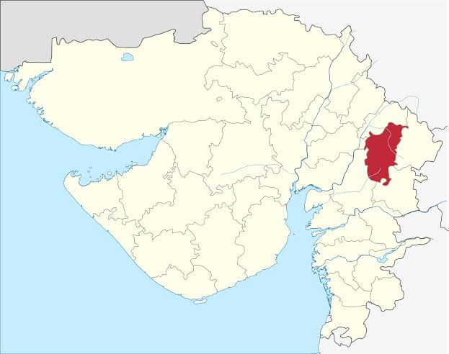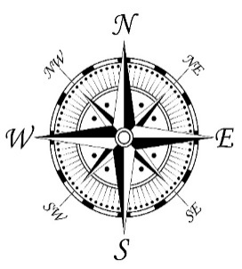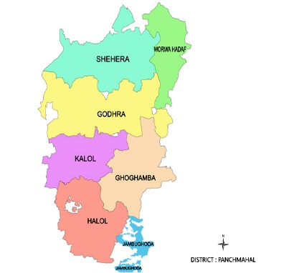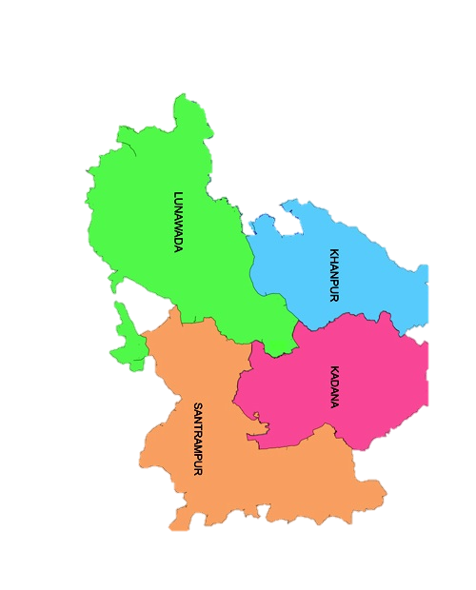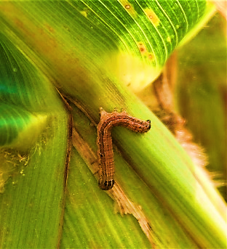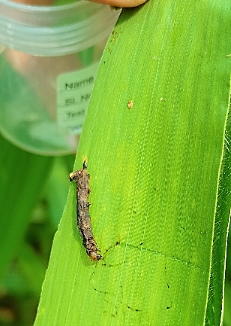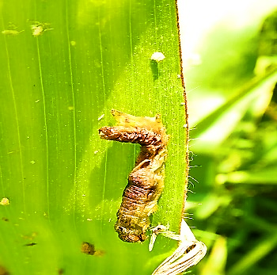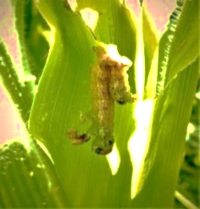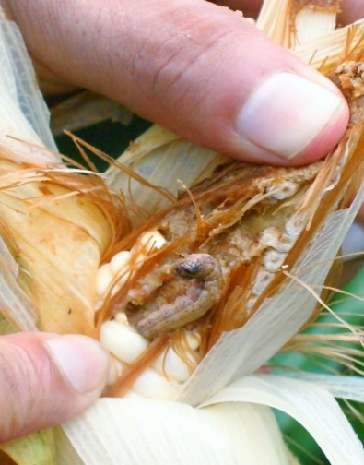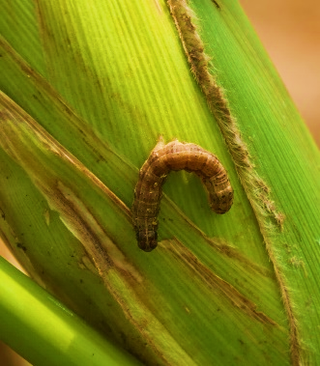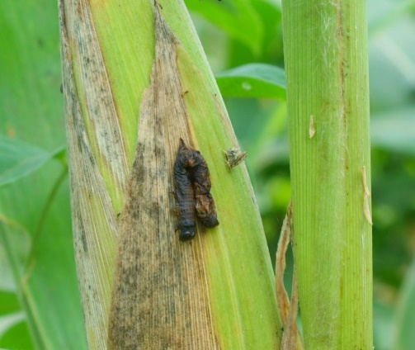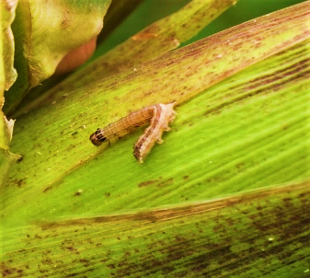

**Fig. S2: Nucleopolyhedrovirus (NPV) infection in fall Armyworm (*Spodoptera frugiperda*) larvae across maize crop stages**

These above figures represent the prevalence of NPV-infected larvae at different developmental stages of maize crops during the survey period in Panchmahal and Mahisagar District, July to September 2021.



**Fig.S3 Showing function of the identified domains in CDS protein sequences of polyhedrin of Spfr NPV strain AAUBC1 and AP2.** functional annotation of polyhedrin superfamily with id GO:0005198. SMART (a Simple Modular Architecture Research Tool) for domain identification and Quick GO EMBL tool to deduce functions were used).

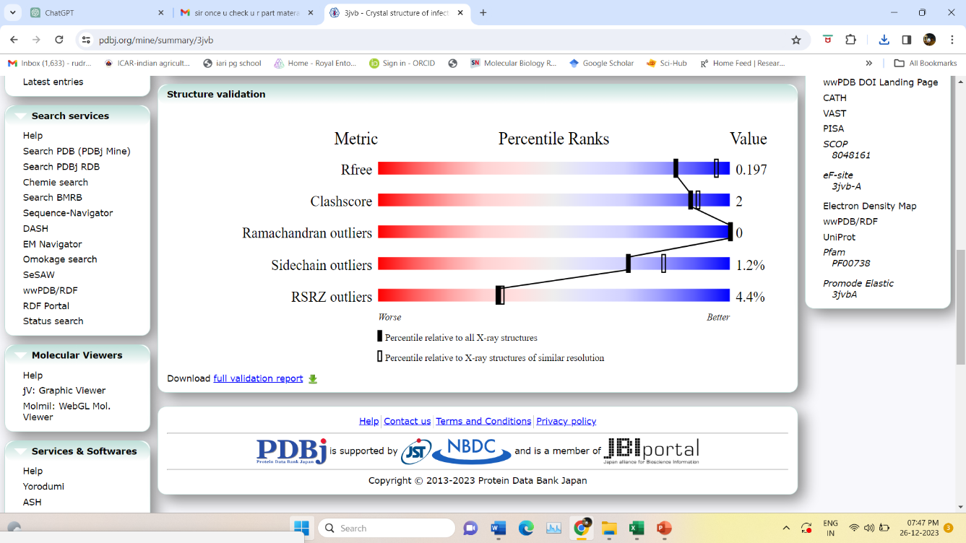

**Figure. S4: Structure validation report of polyhedrin protein of Spfr AAUBC1 and AP2**