**SUPPLEMENTARY MATERIALS**

**Table S1**: Primers for the mutational analysis of QRDR region of *gyrase A* and *B* genes

|  |  |  |  |  |  |  |
| --- | --- | --- | --- | --- | --- | --- |
| S.No | | Primer | Nucleotide sequence (5’-3’) | Annealing Temperature (°C) | Amplicon position | Product size (bp) |
| 1. | *gyrA pri9*  *gyrA pri8* | CGCCGGGTGCTCTATGCAATG  CGGTGGGTCATTGCCTGGCGA | 59 | 7457- 7672 | 216 |
| 2. | *gyrB A*  *gyrB E* | GAGTTGGTGCGGCGTAAGAGC  CGGCCATCAGCACGATCTTG | 58 | 6511- 6832 | 322 |

**Table S2:** Primers developed to investigate BDQ medication target gene mutations

|  |  |  |  |  |  |  |
| --- | --- | --- | --- | --- | --- | --- |
| S.No | Primera | Nucleotide sequence (5’-3’) | Annealing Temperature (°C) | | Amplicon positionb | Product-size (bp) |
| 1. | atpE-F  atpE-R | GGAGCTCGAAGAGGAACACC GACAATCGCGCTCACTTCAC | | 56.2 | 1460977- 1461349 | 373 |
| 2. | pepQ-S1 F pepQ-S1 R | GTCGATTACCAGGACCAGCC  GATATGACCCGCACCTTCGT | | 56.2 | 2859252- 2859734 | 483 |
| 3. | pepQ-S2 F  pepQ-S2 R | ACGAAGGTGCGGGTCATATC  GTAGCGAGTACCGTCAAGGG | | 56.2 | 2859715- 2860449 | 735 |
| 4. | Rv0678 F  Rv0678 R | TCTGGTGACGCATACCGAAC  CTCGGTCAGATTGCGAGGTT | | 56.2 | 778943- 779514 | 572 |

a F, forward; R, reverse.

b According to the complete sequence of *M. tuberculosis* H37Rv genome (Accession no. NC_000962.3).

**Fig. S1:** Total number of first line resistant suspects enrolled for the study on gender wise.

(H-isoniazid, R-Rifampicin, MDR-Multi drug resistant)

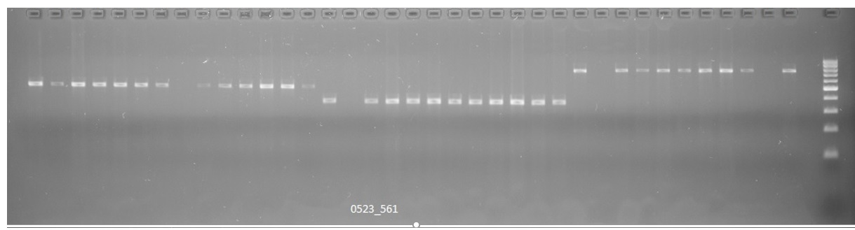

**pepQ-S1 483bp**

**atpE 373bp**

**pepQ-S2 735bp M**

**Rv0678 572bp M**

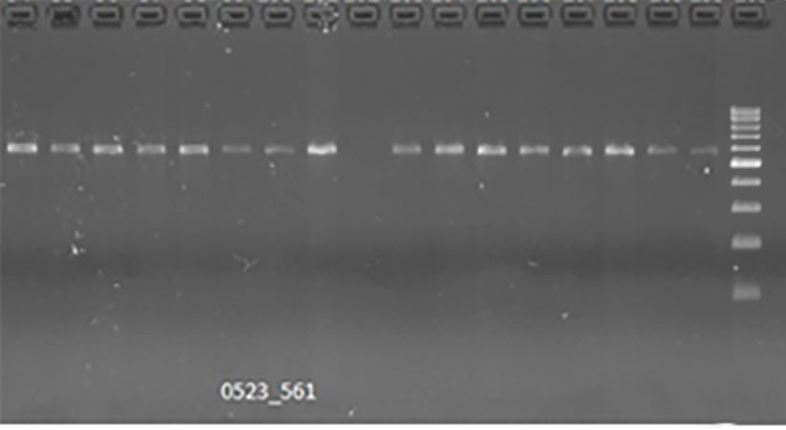

**Fig. S2:** *atpE* band is at 373 bp, *pepQ* S1 is at 483 bp, *pepQ* S2 is at 735 bp, and *Rv0678* is at 572 bp. LANE M indicates marker (ladder).

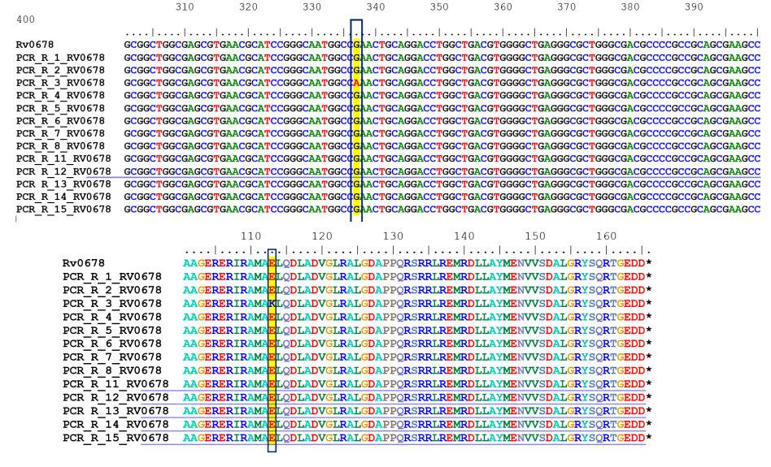

**Fig. S3:** Sequence alignment *Rv0678* gene depicting the mutation in the codon 113- Transition-Non synonymous mutation of G337A, Leads to codon change E113K: Glu to Lys