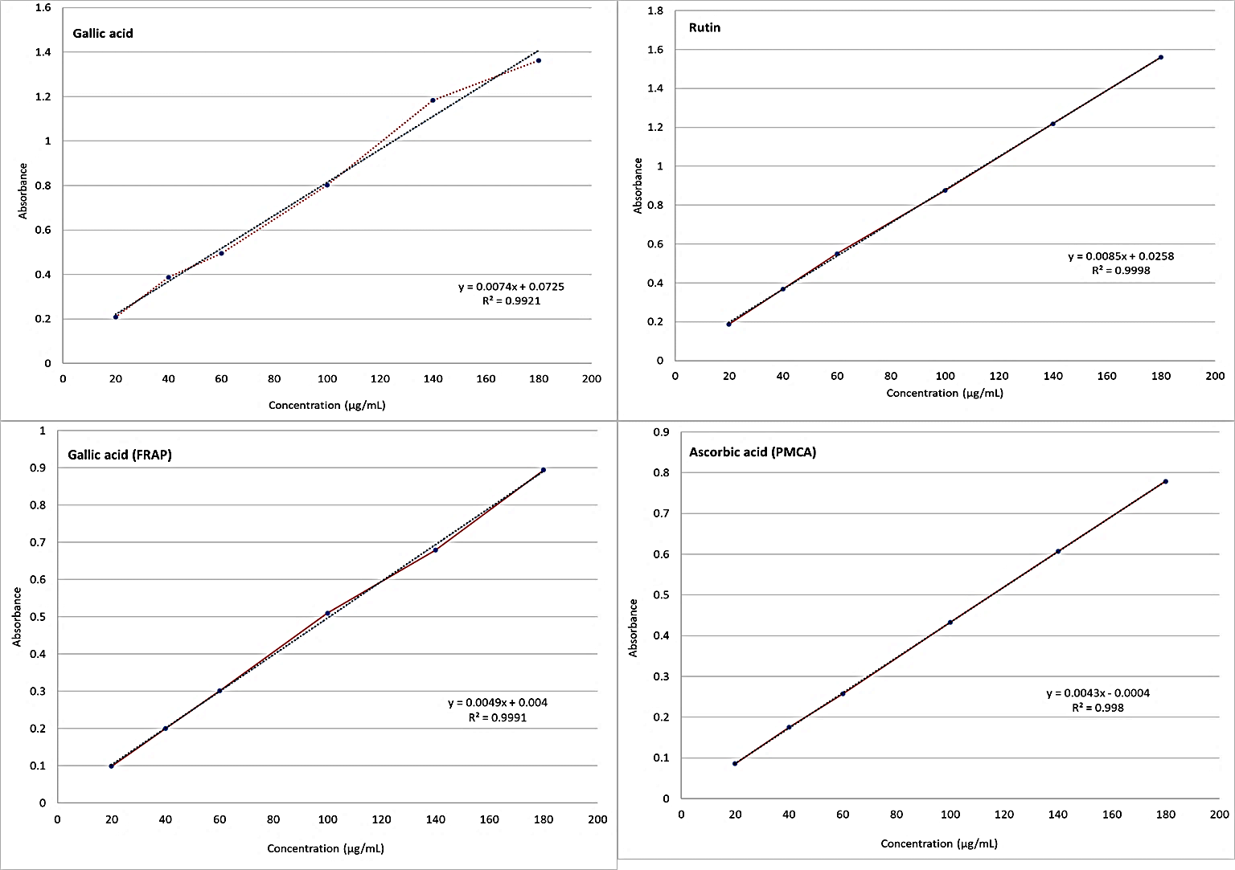
Figure S1.
Table S1 Principal component analysis of polyphenolics and antioxidant activities in N. officinale
Variables | PC1 | PC2 | PC3
Variance (%) | 54.48 | 30.19 | 8.54
Cumulative (%) | 54.48 | 84.39 | 91.46
Eigen values | 7.03 | 3.94 | 1.06
TPC | 0.767 | -0.622 | -0.014
TFC | 0.531 | -0.837 | 0.009
CA | 0.413 | 0.653 | -0.171
FA | 0.554 | 0.380 | 0.709
pCA | 0.913 | 0.223 | 0.128
GA | 0.934 | 0.230 | 0.132
QE | 0.656 | 0.687 | -0.305
KEM | 0.841 | 0.395 | 0.166
RUT | 0.843 | 0.368 | 0.351
DPPH | -0.825 | 0.487 | -0.077
H2O2 | 0.781 | 0.374 | -0.487
FRAP | 0.689 | -0.716 | -0.036
PMCA | 0.633 | -0.729 | -0.064

