**Supplementary Information**

**FITR analysis of Pure Ionic Liquids.**

The pure ionic liquids of PIL-1, (2-hydroxyethylammonium formate (2-HEAF)) shows a broad O-H functional groups in their infrared spectrum, with peaks displaying at 3352, 3155, and 3070 cm−1. This functional group directly increases the mobility of the protons through the polymer membrane, enabling proton conductivity [1].

Similarly, the C=N functional groups exhibit a peak around 1670 cm−1, whereas the N-H functional groups are seen in lower intensity portions between 1590 and 1540 cm−1 range. This confirming the existence of ammonium carboxylate structure of the ionic liquids. Nonetheless, the IR spectra of this sample shows a broad band in the range of 3500-2400 cm−1, also supporting existence of typical ammonium structure. However, it can be observed that the carbonyl stretching and N-H planar bonding vibrations overlapped and are visible about 1600 cm−1[2,3].

In the FTIR spectrum of PIL-2 (Diethylmethylammonium triflate), the high intensity peaks between 638 and 1028 cm−1 and the absorption bands above 1350 cm−1 are attributed to the diethylmethylammonium cation’s vibration modes [4]. While vibration modes of triflate (TfO) anion can be indicated by the intense peak at 512, 576, 1060, 1160, 1224, 1260 cm−1 [5]. Moreover, N-H stretching vibration can be attributed to two peaks at 3066 and 2799 cm−1. There are additional distinctive bands about 1150 and 1300 cm−1 that link to the N-H bond. The weak intensity of C-­H vibrational modes of alkyl side chains is appearing around 2955 cm−1. The weak intensity of C-H peaks in triflate anion is due to strong peak originate from N-­H out of plane bending deformation coupled with neighboring S-­O stretching vibrations, and C-­H bending which causes masking of the C-­H vibration signals by strong N­-H vibration [6].

Similarly, PIL-3 (1-Ethylimidazolium bis(trifluoromethylsulfonyl)imide) and PIL-4 (1,2-Dimethylimidazolium bis(trifluoromethylsulfonyl)imide) both have similar functional groups. In their FTIR spectra, the bands/peaks appearing between the range of 700 and 900 cm−1 can be ascribed to contributions from ring bending modes of the imidazolium cation [EI]+. Besides, the peaks appear at 855 cm−1 in the spectra of [EI]+ which may be attributed to the ring NC (H) N CH bending vibration and differentiated of ethylated and non-ethylated cations. Also, the peaks of the spectral range of 1000–1400 cm−1 are dominated by vibrations of the trifluoromethylsulfonyl)imide [TFSI]− anion. Additionally, important functional groups and their position have been tabulated in Table S1.

The pure ionic liquid i.e. PIL-5, specifically Diethylmethylammonium methanesulfonate, exhibits peaks at high wavenumbers attributed to the low absorptivity of the C–H and N–H groups in its FTIR spectrum. Conversely, strong peaks are observed at low wavenumbers, primarily resulting from the vibrations of the anion, particularly for the S-O and C–H stretching modes [12]. Furthermore, the broadening of bands between 2200-3200 cm−1 reveals an effective hydrogen-bonded network in PIL-5 [13]. Also, the presence of wide O-H stretching bands between 3400 and 3500 cm−1 suggests that the samples consist of some moisture content. It is also corroborated by the data sheet of the samples, which specifies that this samples have less than one percent of moisture.

|  |  |
| --- | --- |
|  | https://iolitec.de/sites/iolitec.de/files/2017-04/IL_0034.gif |
| Sulfonated poly(ether ether ketone) | 2-Hydroxyethylammonium formate |
| https://iolitec.de/sites/iolitec.de/files/2017-09/IL_0326.gif | https://iolitec.de/sites/iolitec.de/files/2017-09/il_0269.gif |
| Diethylmethylammonium triflate | 1-Ethylimidazolium bis(trifluoromethylsulfonyl)imide |
| https://iolitec.de/sites/iolitec.de/files/2017-09/il_0278.gif | https://iolitec.de/sites/iolitec.de/files/2017-09/il_0325.gif |
| 1,2-Dimethylimidazolium bis(trifluoromethylsulfonyl)imide | Diethylmethylammonium methanesulfonate |

Figure S1: Chemical structure of the SPEEK polymer and the various protic ionic liquids (PILs).

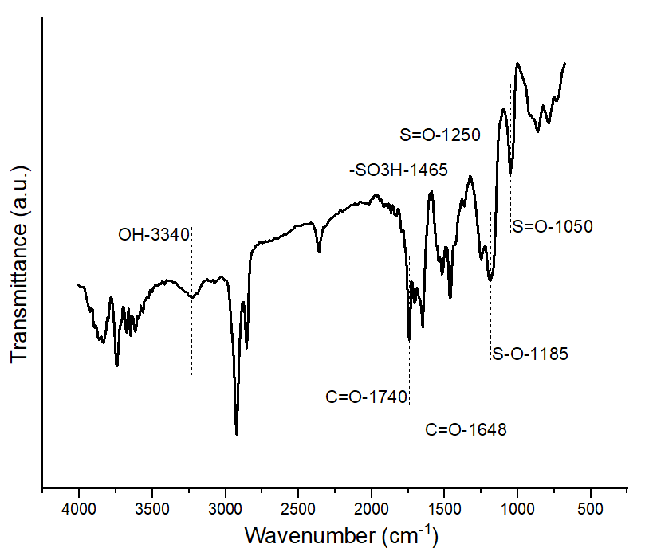

Figure S2: FTIR spectrum of Pure SPEEK membrane 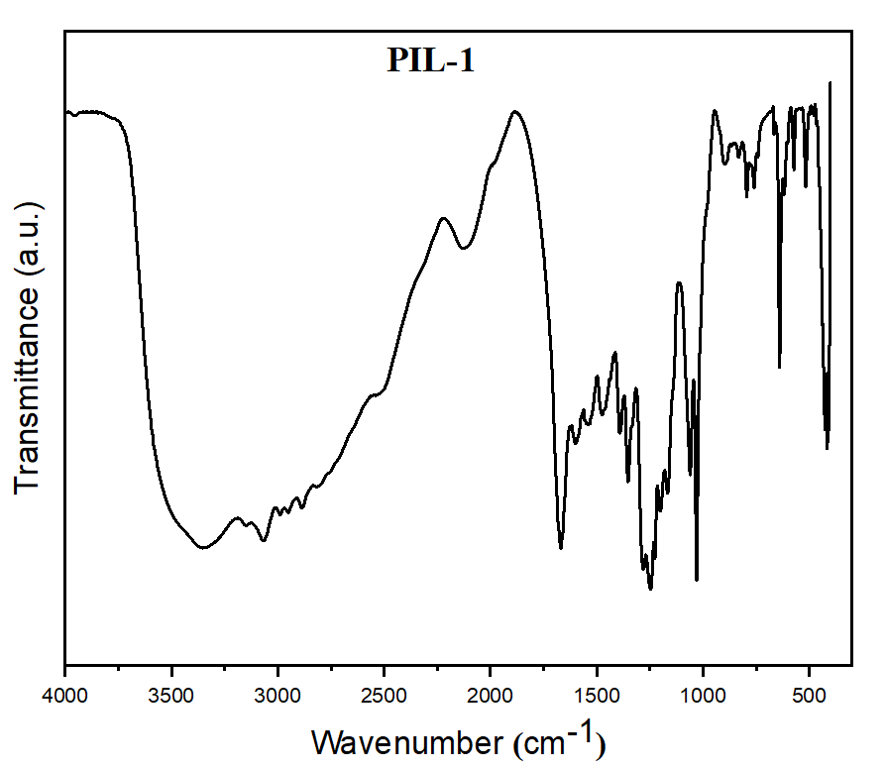

Figure S3: FTIR spectrum of PIL-1 (2-hydroxyethylammonium formate)

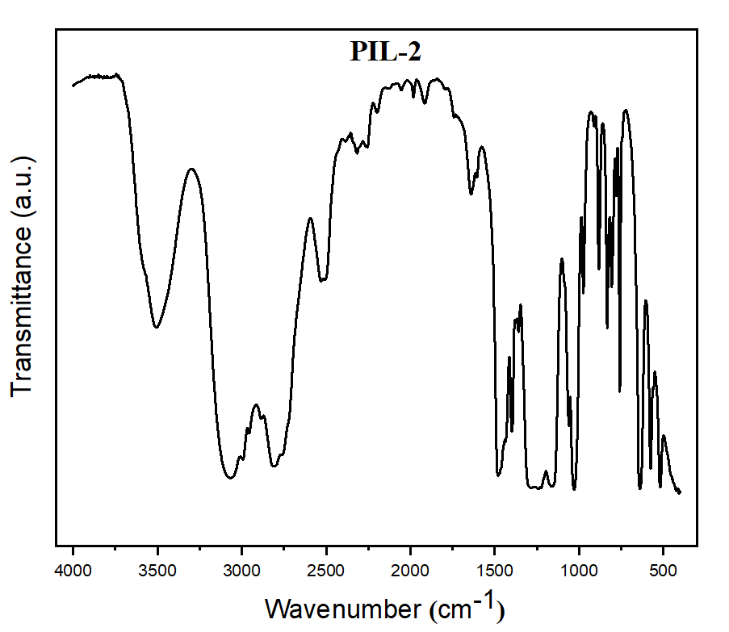

Figure S4: FTIR spectrum of PIL-2 (Diethylmethylammonium triflate)

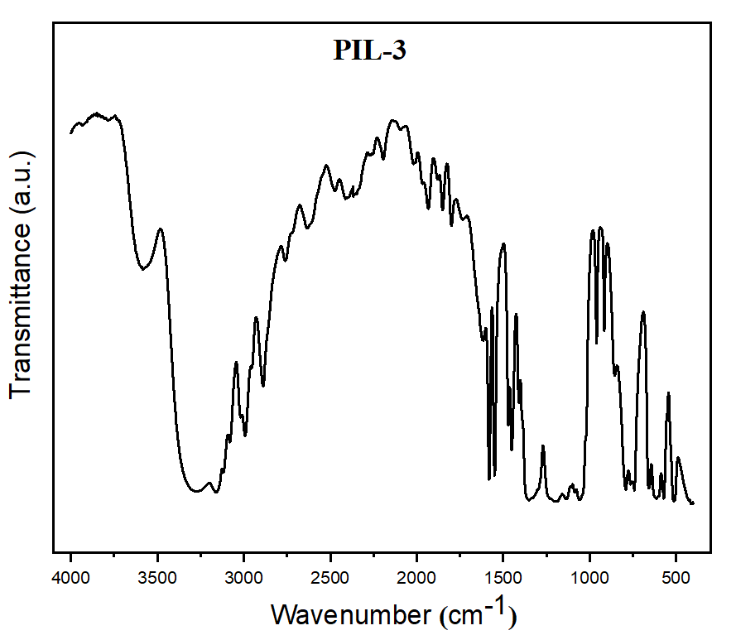

Figure S5: FTIR spectrum of PIL-3 (1-Ethylimidazolium bis(trifluoromethylsulfonyl)imide)

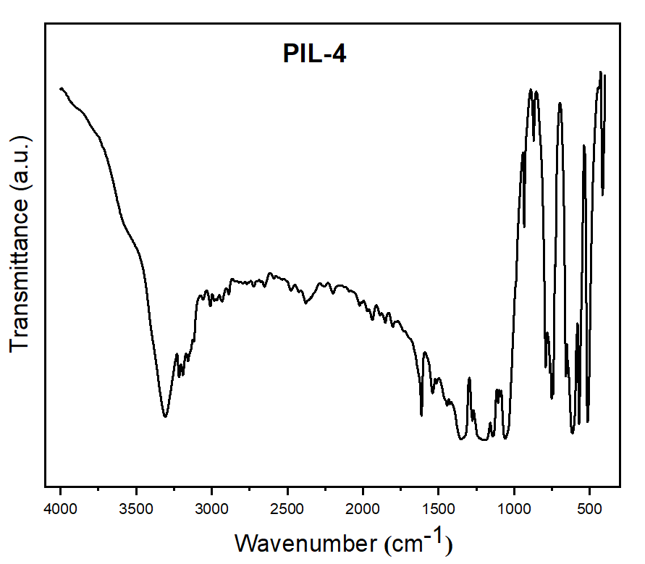

Figure S6: FTIR spectrum of PIL-4 (1,2-Dimethylimidazolium bis(trifluoromethylsulfonyl)imide)

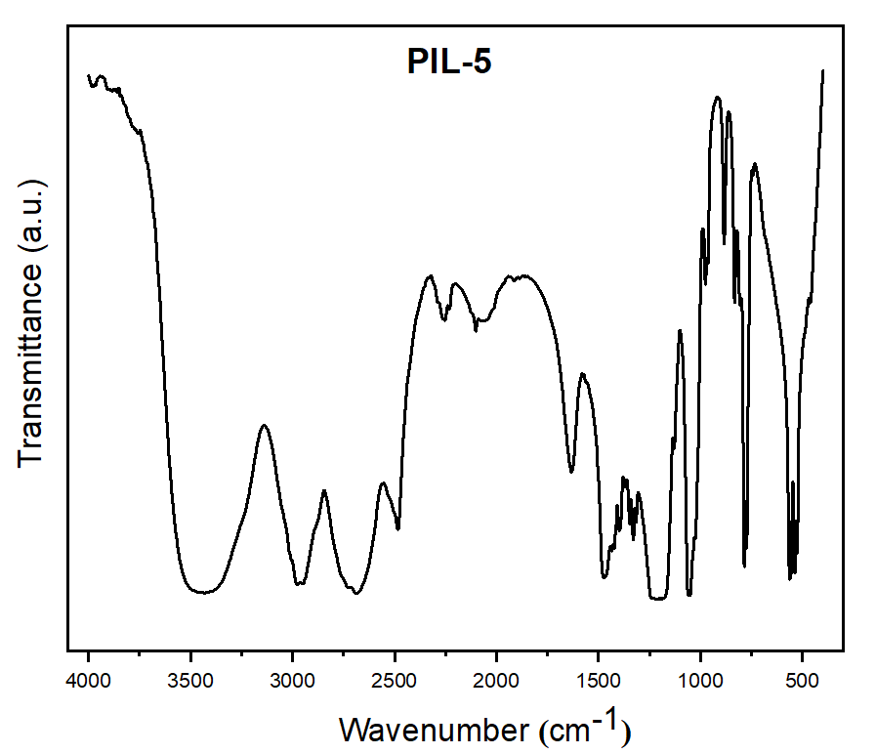

Figure S7: FTIR spectra of PIL-5 (Diethylmethylammonium methanesulfonate)

Table S1: Assignment of functional groups of PIL-3 and PIL-4 (1-Ethylimidazolium bis(trifluoromethylsulfonyl)imide and 1,2-Dimethylimidazolium bis(trifluoromethylsulfonyl)imide).

|  |  |  |
| --- | --- | --- |
| **Vibrational modes** | **Wavenumber (cm−1)** | **References** |
| Asymmetric CF3 bending group | 571 | [7] [8] [9] [10] [11] |
| CF3 symmetric stretching | 1235 |
| Asymmetric SO3 bending group | 650 |
| SO2 symmetric stretching | 1134 |
| Symmetric CF3 bending group | 754 |
| SO2 asymmetric stretching, ring in-plane symmetric stretching butyl chain stretching, CH2 (N) | 1330 |
| CH3 (N) CN stretching ring out of plane asymmetric bending, | 615 |
| Ring in-plane bending, CH2 (N) and CH3 (N) CN bend, CF3 asymmetric bend, ring in-plane HCCH | 741 |
| Ring HCCH asymmetric bend SNS symmetric stretching | 763 |
| Ring HCCH asymmetric bend, CS stretching | 791 |
| Ring NC(H) N CH, bend, CCH bending | 855 |
| Ring in-plane asymmetric stretching, CH2 (N) and NCH3 twist, SNS asymmetric stretching | 1058 |
| C-C stretching, ring in-plane symmetric, stretching | 1084 |
| Ring in-palne symmetric stretching, CH2 (N) and CH3 (N) CN stretching, SO2 asymmetric stretching, CC stretching | 1350 |
| C=C and C–F stretching vibration | 1409 |
| CH3 (N) HCH symmetric bend, terminal CH3, HCH asymmetric bend | 1451 |
| Ring in-plane asymmetric stretching, CH3 (N) CN stretching | 1470 |
| Ring in-palne symmetric/asymmetric stretching, CH2 (N) and CH3 (N) CN stretching | 1580 |
| C2–H stretching | 3117 |
| In-plane and out of plane C4,5– H stretching | 3159 |
|  |  |

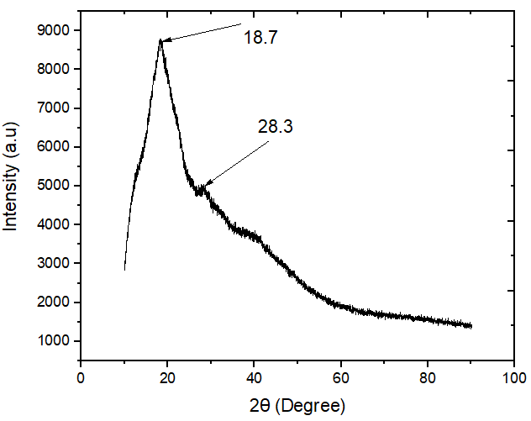

Figure S8: XRD pattern of the SPEEK-PIL2 composites membrane sample.

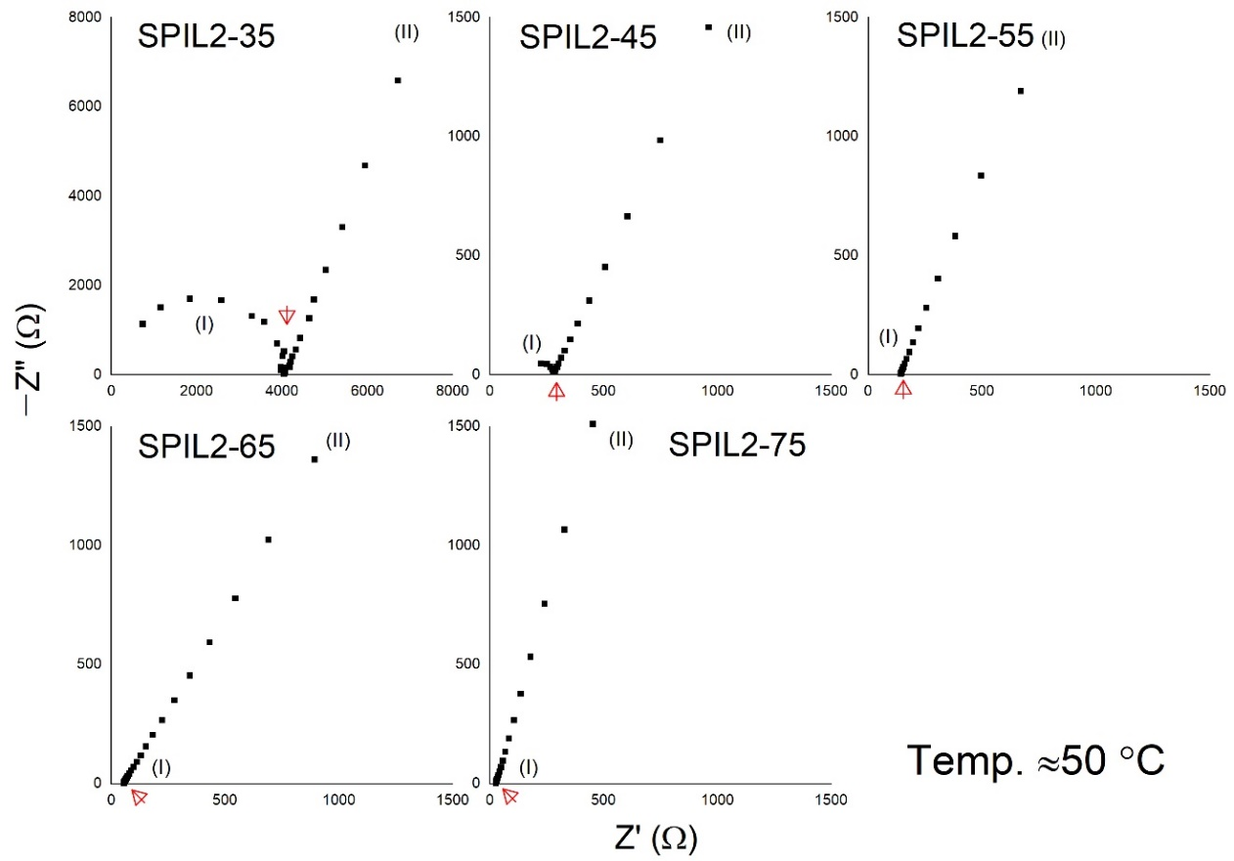

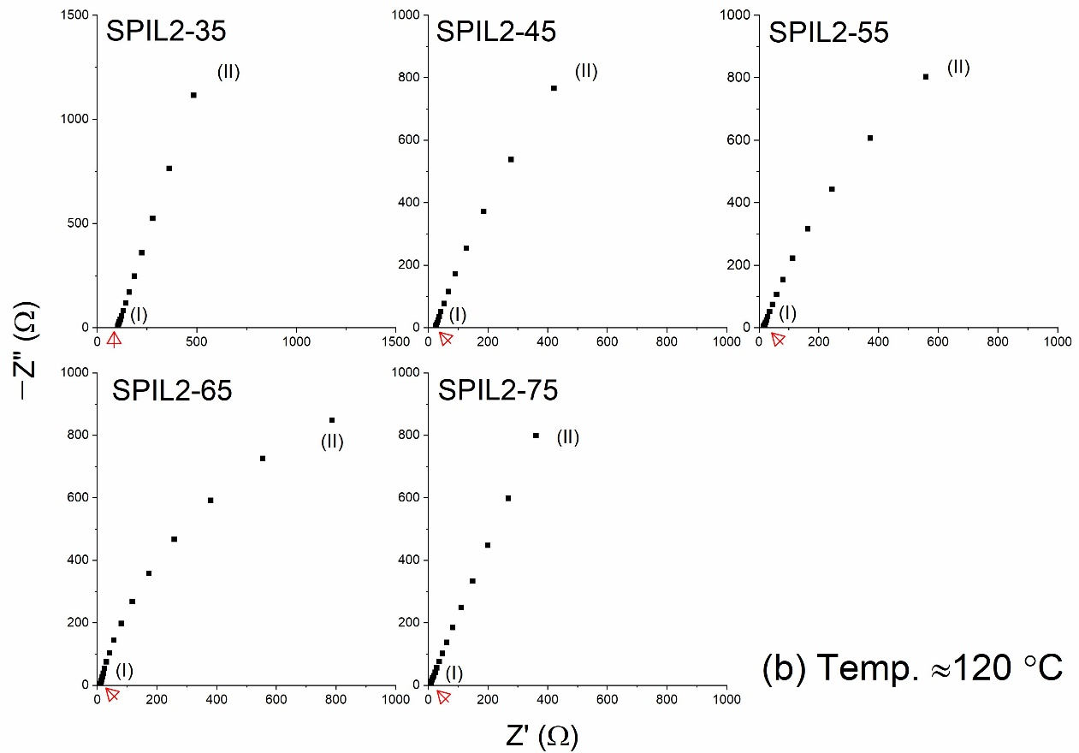

Figure S9. Nyquist plot of the composite PEM with different loading of PIL-2 at (a) ≈50 °C and (b) ≈120 °C.

**References:**

1. Goh, J.T.E.; Abdul Rahim, A.R.; Masdar, M.S.; Shyuan, L.K. Enhanced Performance of Polymer Electrolyte Membranes via Modification with Ionic Liquids for Fuel Cell Applications. *Membranes* **2021**, *11*, 395.

2. Azum, N.; Ali, M. Exploring solvation behaviour of biocompatible ionic liquid 2-hydroxyethylammonium formate + polyethylene glycols mixtures: Role of oxyethylene and hydroxyl units of PEGs. *Journal of Molecular Liquids* **2023**, *382*, 121922.

3. Bicak, N. A new ionic liquid: 2-hydroxy ethylammonium formate. *Journal of Molecular Liquids* **2005**, *116*, 15-18.

4. Umebayashi, Y.; Fujimori, T.; Sukizaki, T.; Asada, M.; Fujii, K.; Kanzaki, R.; Ishiguro, S. Evidence of conformational equilibrium of 1-ethyl-3-methylimidazolium in its ionic liquid salts: Raman spectroscopic study and quantum chemical calculations. *J Phys Chem A* **2005**, *109*, 8976-8982.

5. Trequattrini, F.; Celeste, A.; Capitani, F.; Palumbo, O.; Cimini, A.; Paolone, A. Temperature and Pressure Dependence of the Infrared Spectrum of 1-Ethyl-3-Methylimidazolium Trifluoromethanesulfonate Ionic Liquid. *Applied Sciences* **2020**, *10*, 4404.

6. Mori, K.; Hashimoto, S.; Yuzuri, T.; Sakakibara, K. Structural and Spectroscopic Characteristics of a Proton-Conductive Ionic Liquid Diethylmethylammonium Trifluoromethanesulfonate [dema][TfOH]. *Bulletin of the Chemical Society of Japan* **2010**, *83*, 328-334.

7. Rathika, R.; Suthanthiraraj, S.A. Influence of 1-ethyl-3-methylimidazolium bis (trifluoromethyl sulfonyl) imide plasticization on zinc-ion conducting PEO/PVdF blend gel polymer electrolyte. *Journal of Materials Science: Materials in Electronics* **2018**, *29*, 19632-19643.

8. Rathika, R.; Padmaraj, O.; Suthanthiraraj, S.A. Electrical conductivity and dielectric relaxation behaviour of PEO/PVdF-based solid polymer blend electrolytes for zinc battery applications. *Ionics* **2018**, *24*, 243-255.

9. Noack, K.; Schulz, P.S.; Paape, N.; Kiefer, J.; Wasserscheid, P.; Leipertz, A. The role of the C2 position in interionic interactions of imidazolium based ionic liquids: a vibrational and NMR spectroscopic study. *Physical Chemistry Chemical Physics* **2010**, *12*, 14153-14161.

10. Singh, V.K.; Shalu; Balo, L.; Gupta, H.; Singh, S.K.; Singh, R.K. Solid polymer electrolytes based on Li+/ionic liquid for lithium secondary batteries. *Journal of Solid State Electrochemistry* **2017**, *21*, 1713-1723.

11. Pandey, G.P.; Hashmi, S.A.; Agrawal, R.C. Experimental investigations on a proton conducting nanocomposite polymer electrolyte. *Journal of Physics D: Applied Physics* **2008**, *41*, 055409.

12. Pan, H.; Geysens, P.; Putzeys, T.; Gennaro, A.; Yi, Y.; Li, H.; Atkin, R.; Binnemans, K.; Luo, J.; Wübbenhorst, M. Physicochemical study of diethylmethylammonium methanesulfonate under anhydrous conditions. *The Journal of Chemical Physics* **2020**, *152*.

13. Luo, J.; Hu, J.; Saak, W.; Beckhaus, R.; Wittstock, G.; Vankelecom, I.F.J.; Agert, C.; Conrad, O. Protic ionic liquid and ionic melts prepared from methanesulfonic acid and 1H-1,2,4-triazole as high temperature PEMFC electrolytes. *Journal of Materials Chemistry* **2011**, *21*, 10426-10436.