**Supplementary Figure 2**

f

e

d

c

b

a

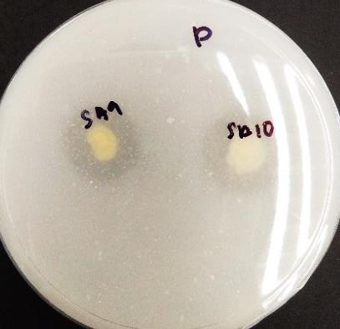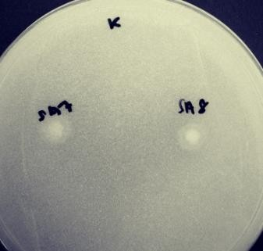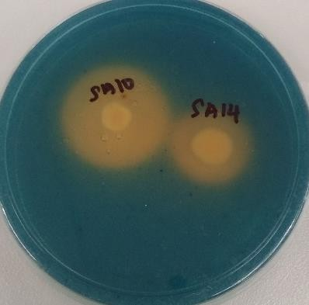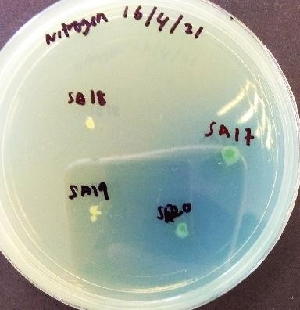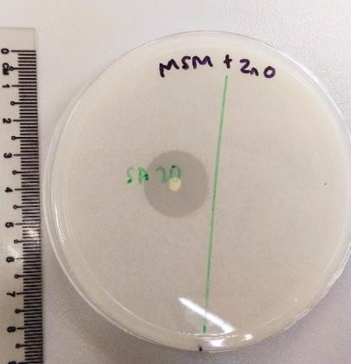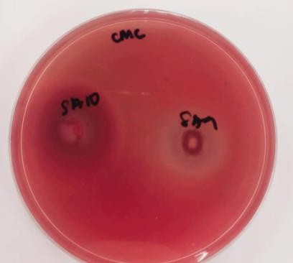

**Supplementary Figure 2.** The characterization test of plant growth-promoting rhizobactera: a) nitrogen fixation test, b) NBRIP test for phosphate solubilization c) Alexandrov medium test for potassium solubilization, d) MSM test for zinc solubilization test e) Chrome Azurol-S test for siderophore production and f) Cellulose degradation test.