Supplementary Figure 1

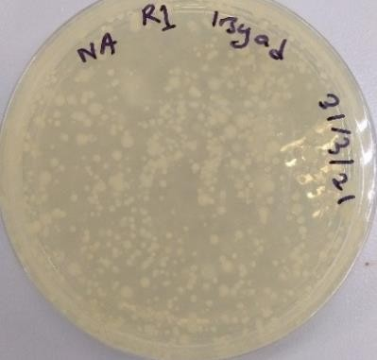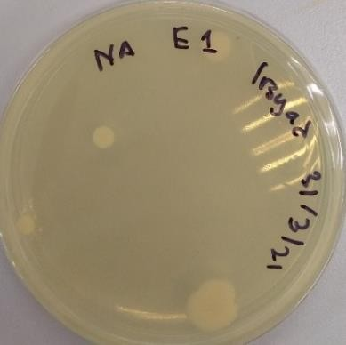

**Supplementary Figure 1**. More than 300 colonies of rhizosphere isolates from rice soil (left) and four endospheric isolates from rice plant roots (Right)