Computational insight into the Spectroscopic and Molecular docking analysis of Estrogen receptor with Ligand 2,3-Dimethyl-N[2-(Hydroxy)Benzylidene] aniline
A. Prabakaran^{a*}, C. Uma Maheswari^{b}, Noureddine ISSAOUI^{c*}, Omar M. Al-Dossary^{d},
T. Rajamani^{e}, T. Gnanasambandan^{f}, · P. Saravanan^{f}, M. Vimalan^{f}, A. Manikandan^{g,h}

^{a*}Department of Physics, Vel Tech Rangarajan Dr. Sagunthala R&D Institute of Science and Technology, Avadi, Chennai, 600062, India.
.^{b}Department of Physics, Vel Tech HighTech Dr. Rangarajan Dr. Sakunthala Engineering College, Avadi, Chennai, 600062, India.
^{c}Laboratory of Quantum and Statistical Physics (LR18ES18),University of Monastir, 5079, Tunisia
^{d}Department of Physics and Astronomy, College of Science, King Saud University, PO Box 2455, Riyadh 11451, Saudi Arabia.
^{e}Department of Physics, Priyadarshini Engineering College, Chettiyappanur, Vaniyambadi, Tamil Nadu, India.
^{f}Department of Physics, Saveetha School of Engineering, Saveetha Institute of Medical and Technical Sciences, Saveetha University, Chennai,602105, Tamilnadu, India.
^{g} Department of Chemistry, Karpagam Academy of Higher Education, Coimbatore - 641021, Tamil Nadu, India.
^{h}Centre for Material Chemistry, Karpagam Academy of Higher Education, Coimbatore -641021, Tamil Nadu, India.

*Corresponding author
Email ID: issaoui_noureddine@yahoo.fr (Prof. N. ISSAOUI)
draprabakaran@veltech.edu.in (Dr. A. Prabakaran)

*Corresponding author
Email ID: draprabakaran@veltech.edu.in (Dr. A Prabakaran)

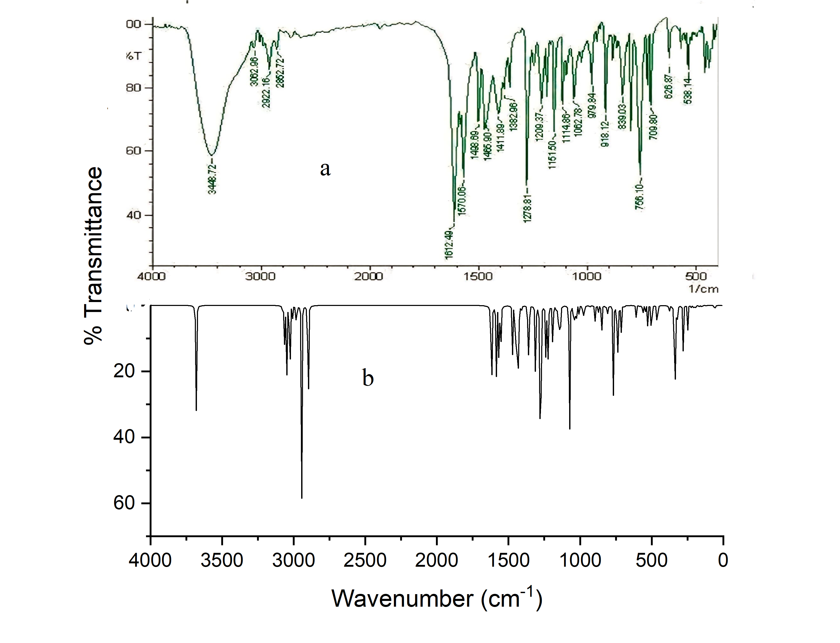
Figure S1. Experimental (a) and calculated (b) FT-IR spectra of DNHBA

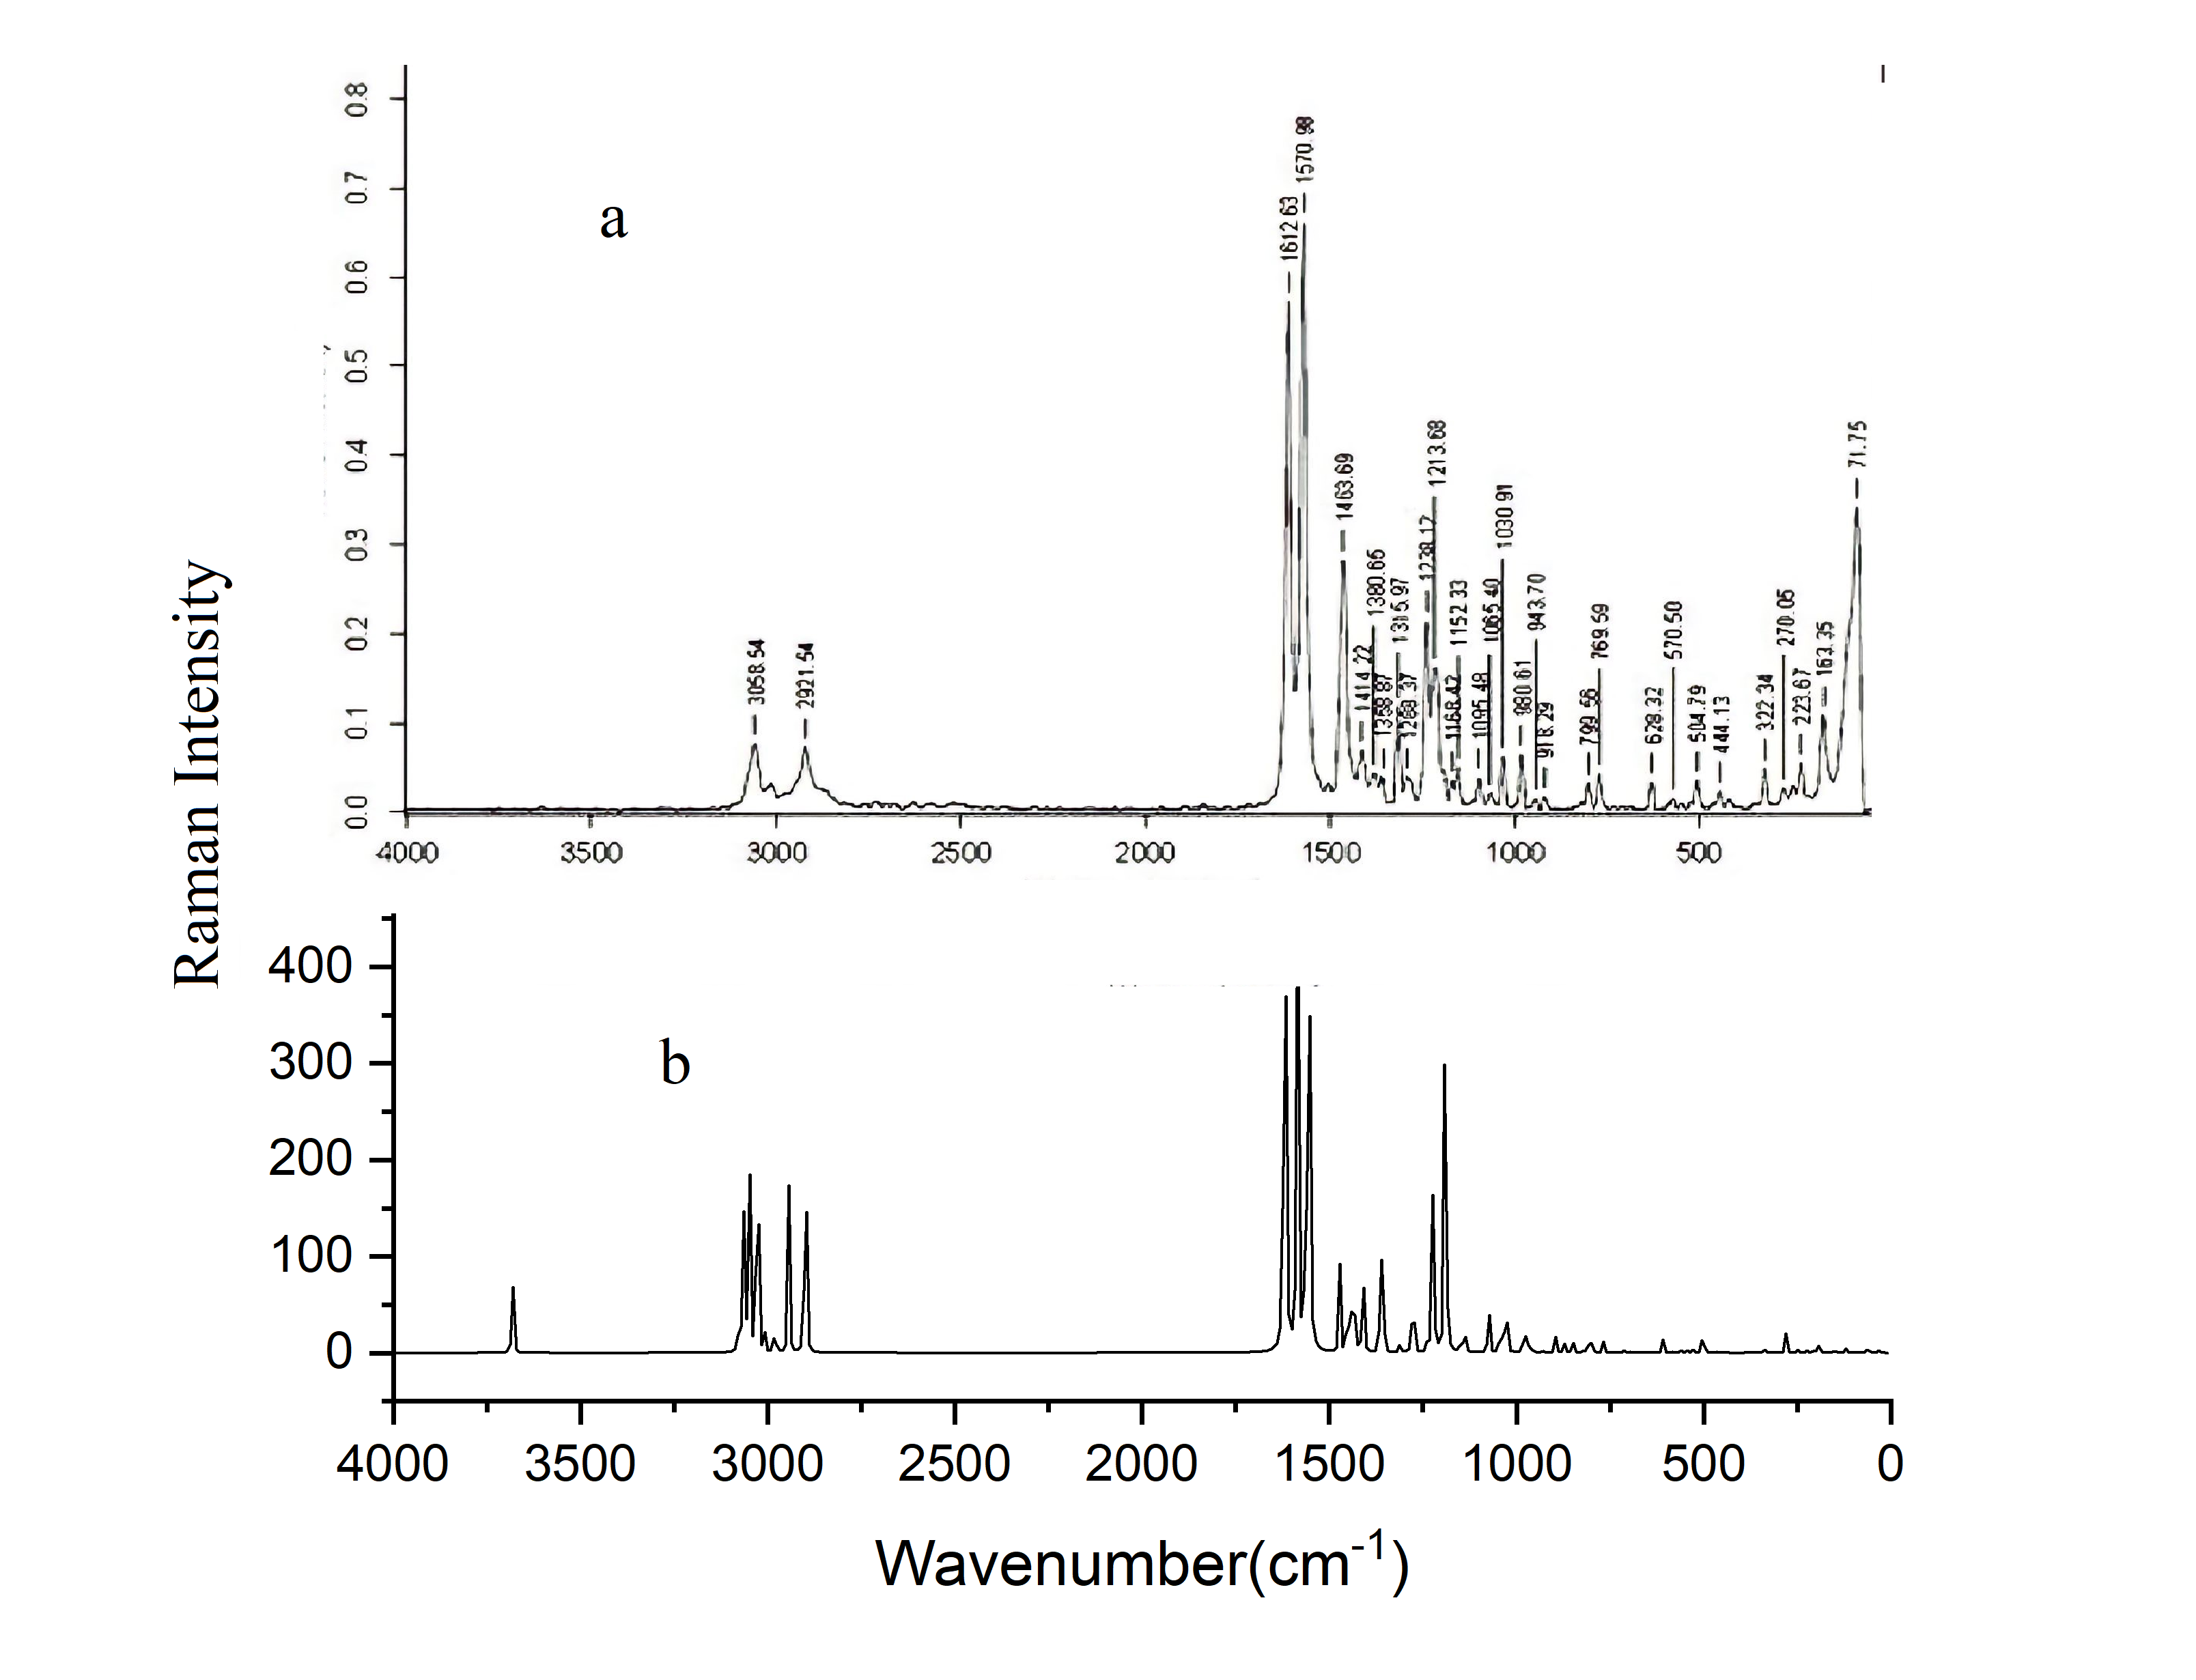

Figure S2. Experimental (a) and Calculated (b) FT-Raman spectra of DNHBA

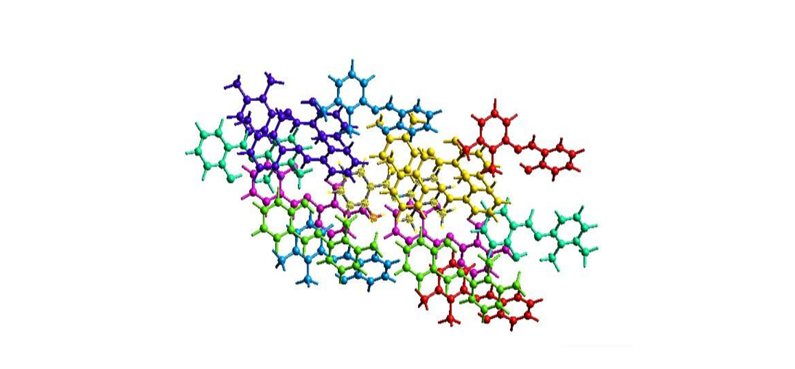
Figure. S3. Interaction energies between the selected molecules and the symmetry-related molecule positioned at x+1/2,-y+1/2,-z, with a substantial energy of -31.3 KJ/mol,making it is the strongest interaction among the neighboring molecules

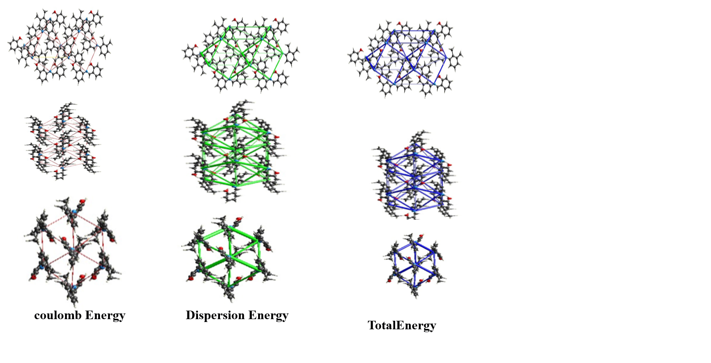

Figure. S4. Energy framework of the compound are illustrated as coulombenergy, Dispersion energy,Total energy framework along the ‘a’axis,’b’axis,’c’axis, respectively

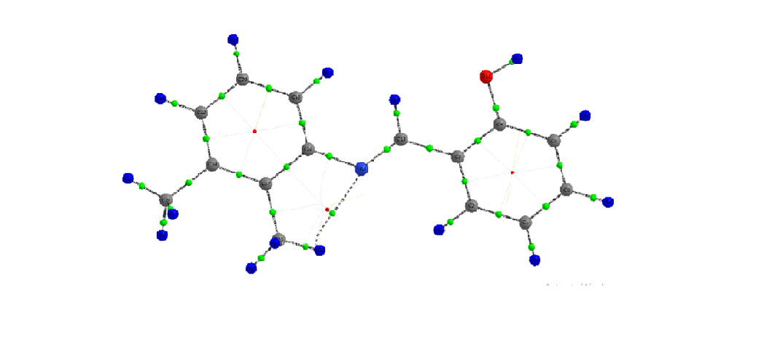
Figure. S5. Molecular graph of DNHBA

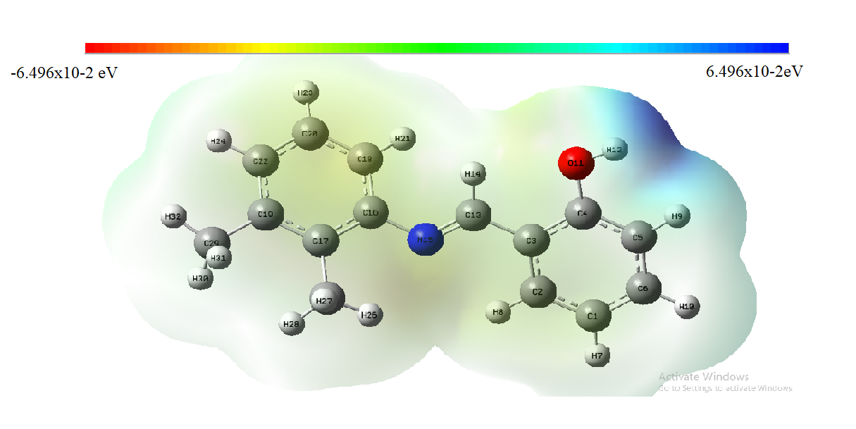

Figure. S6. Molecular Electrostatic Potential (MEP) calculated at B3LYP/6-11G(d,p)

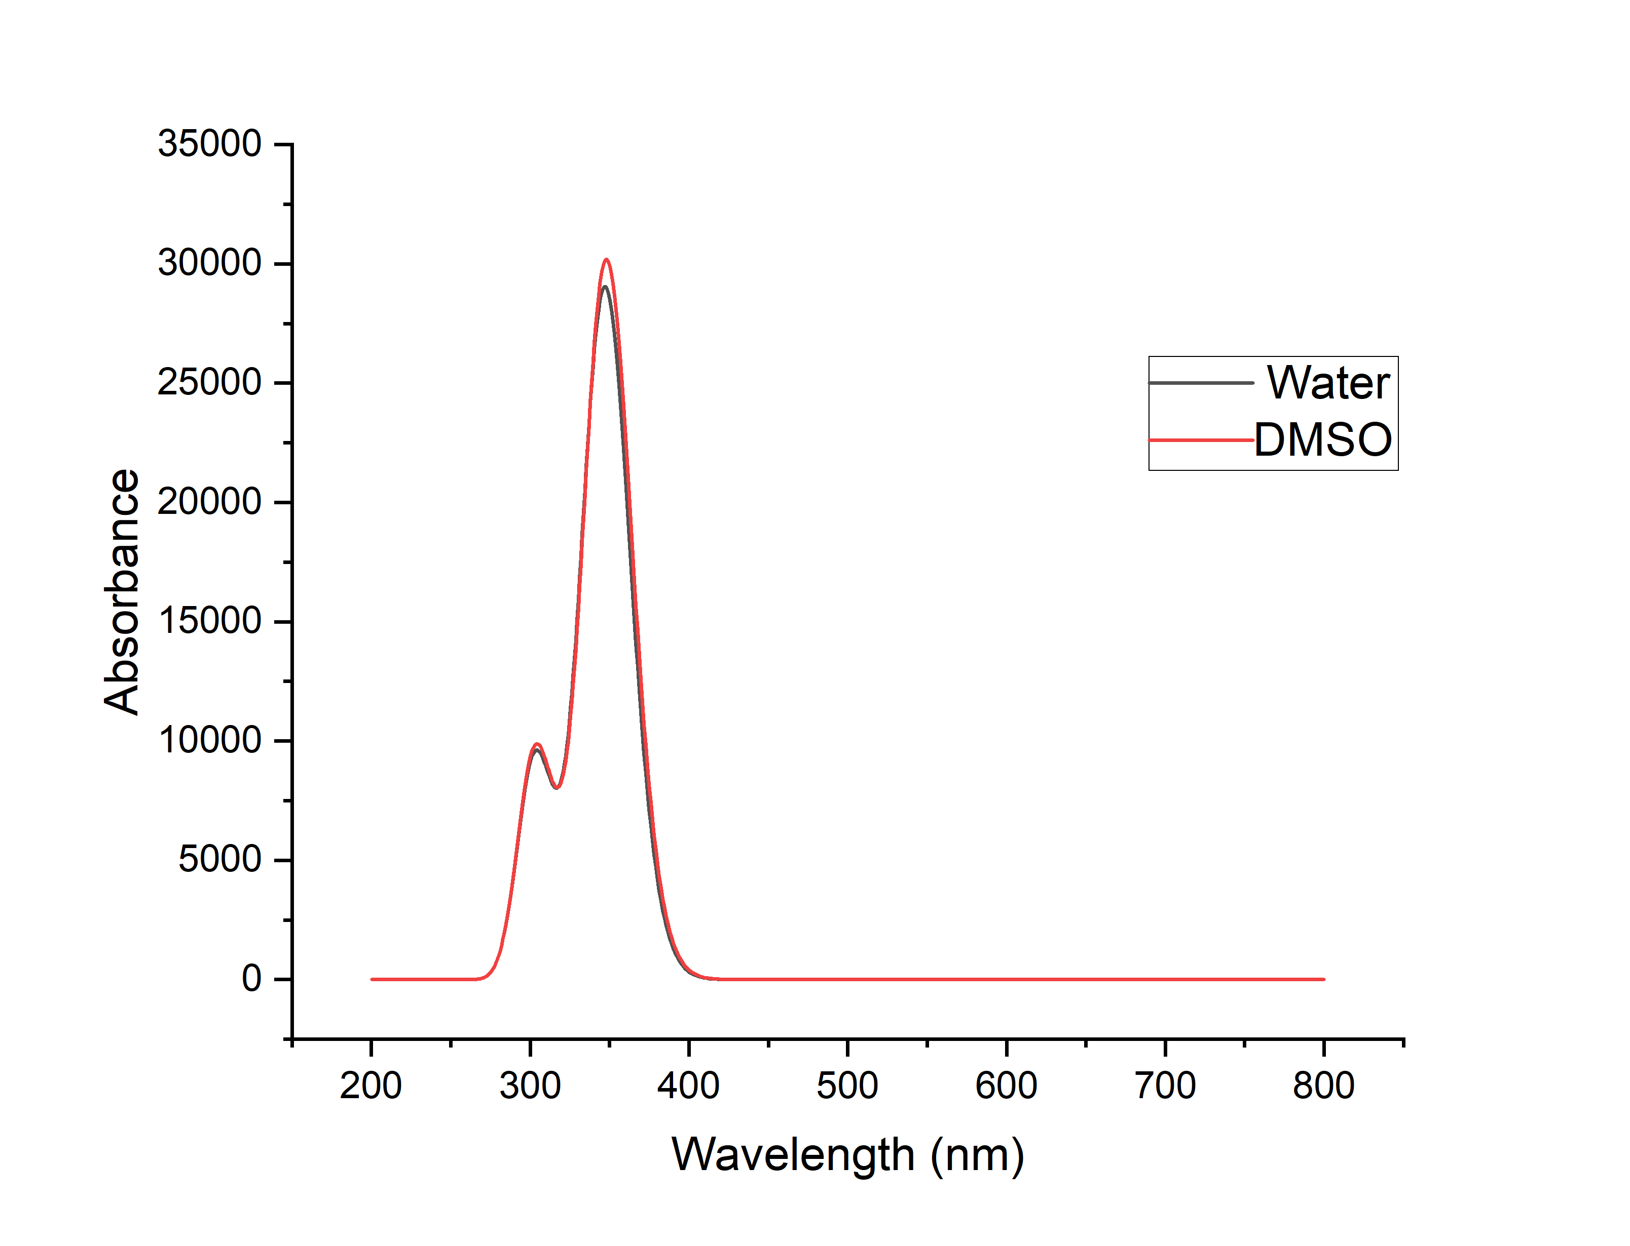
Figure S7. Calculated absorbance spectra of DNHBA
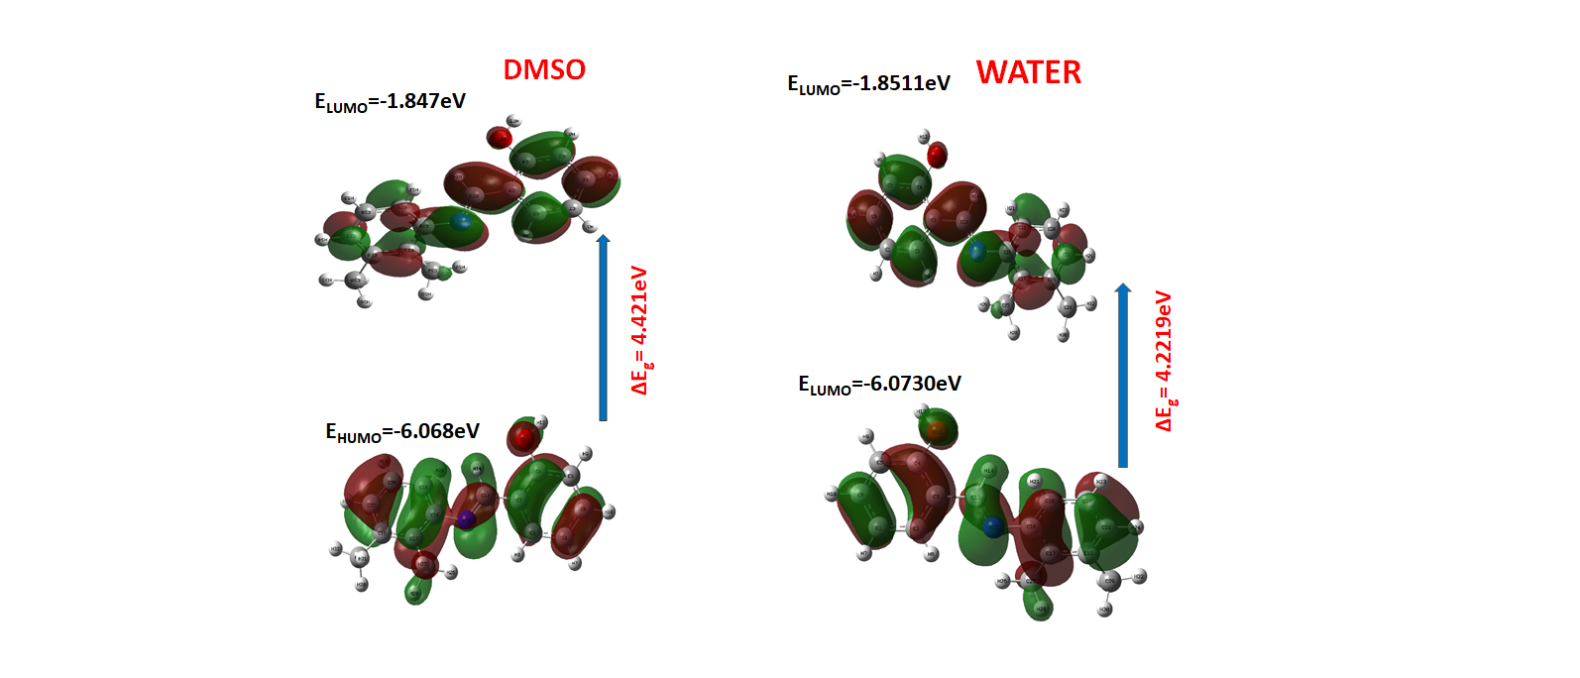

Figure. S8.

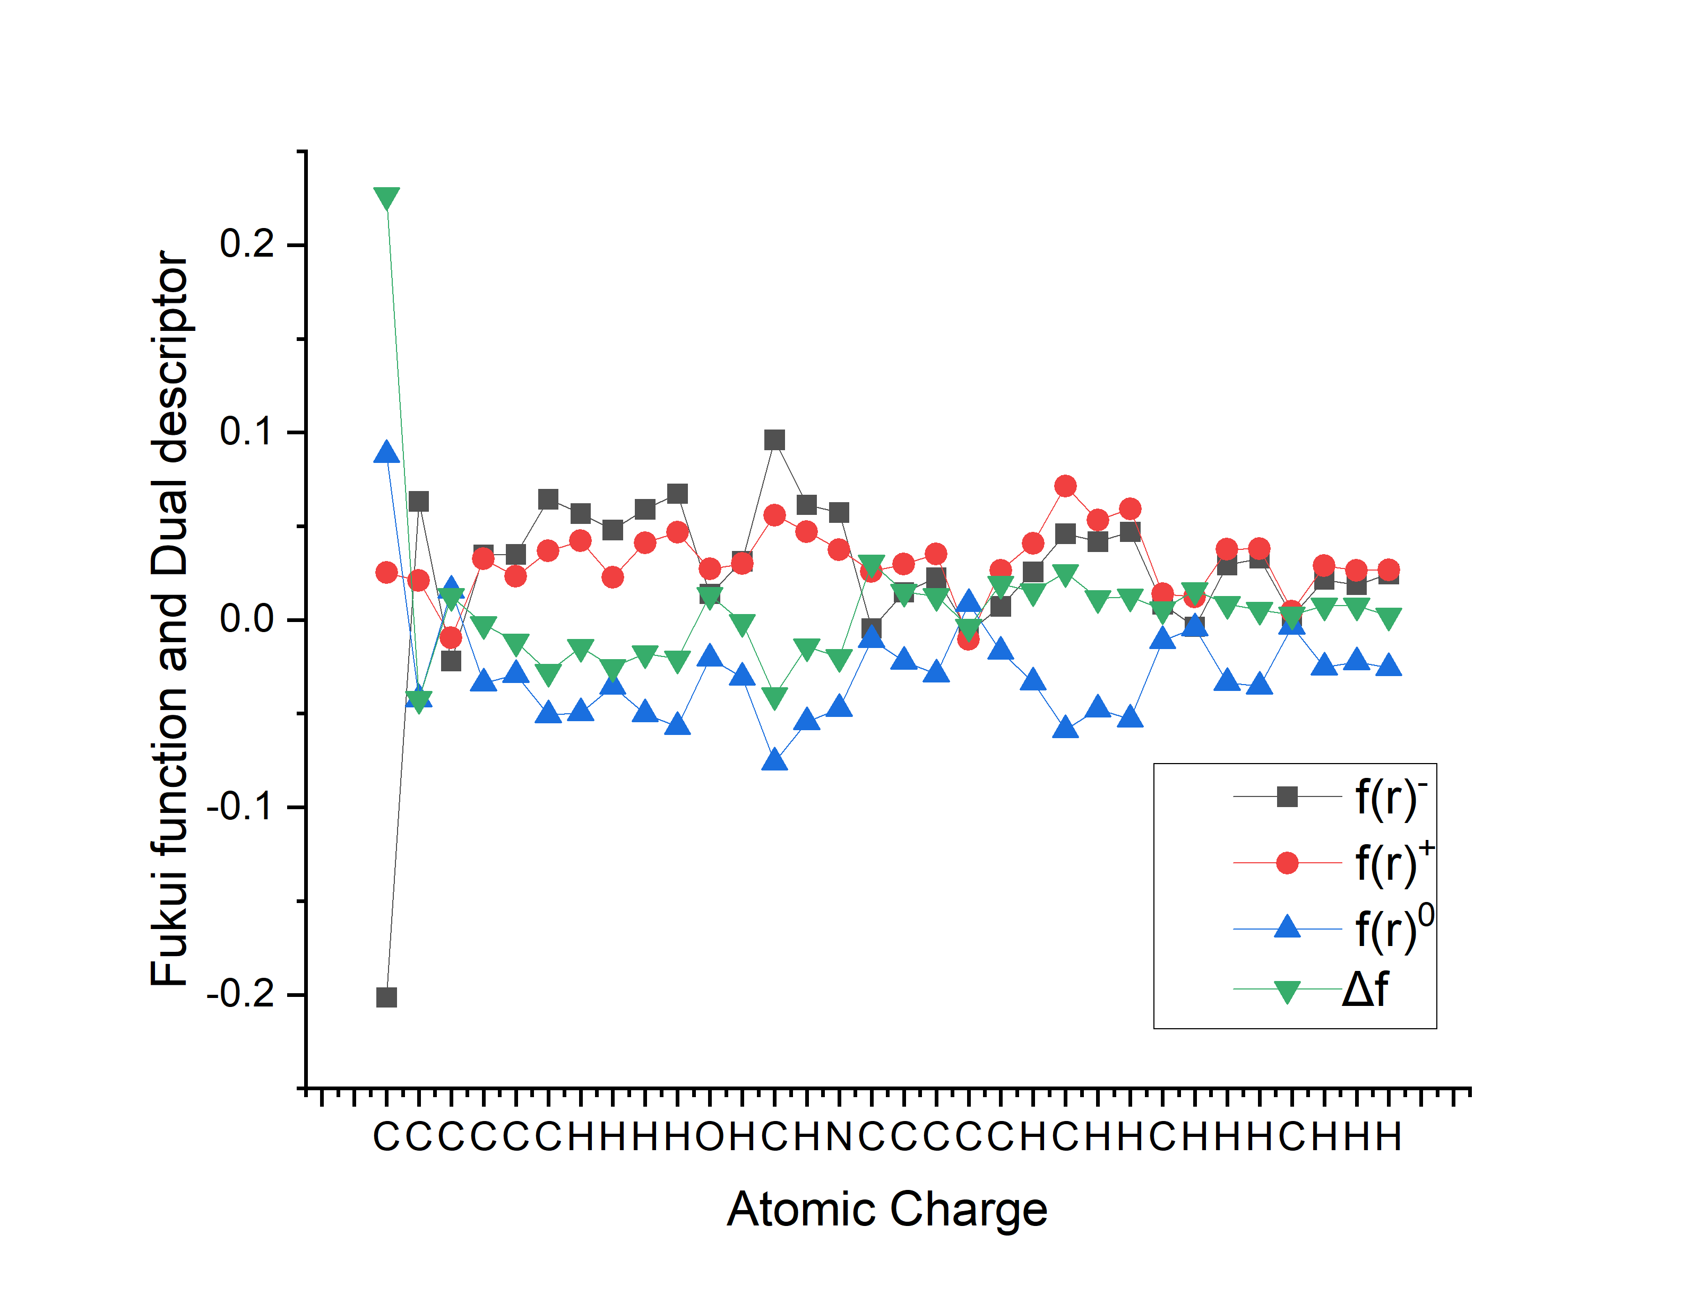
Figure. S7. Condensed Fukui function and dual reactivity descriptor of DNHBA by Mulliken population analysis using B3LYP/6‒311G(d,p) level of theory.

Table S1: Optimized geometrical parameters of DNHBA.

Bond length (A⁰) |  |  | Bond Angles (⁰)
Atom position | Experimental | Theoretical | Atom position | Experimental | Theoretical
C1-C2 | 1.37 | 1.387 | C2-C1-C6 | 119.5 | 119.5
C1-C6 | 1.366 | 1.396 | C2-C1-H7 | 120 | 120.3
C1-H7 | 0.93 | 1.083 | C1-C2-C3 | 121.5 | 121.5
C2-C3 | 1.389 | 1.403 | C1-C2-H8 | 119 | 121.1
C2-H8 | 0.93 | 1.083 | C6-C1-H7 | 120 | 120.2
C3-C4 | 1.392 | 1.409 | C1-C6-C5 | 120.6 | 120.2
C3-C13 | 1.435 | 1.467 | C1-C6-H10 | 120 | 120.3
C4-C5 | 1.37 | 1.396 | C3-C2-H8 | 119 | 117.4
C4-O11 | 1.352 | 1.366 | C2-C3-C4 | 118 | 118.2
C5-C6 | 1.382 | 1.39 | C2-C3-C13 | 120.2 | 121.5
C5-H9 | 0.93 | 1.086 | C4-C3-C13 | 121.8 | 120.3
C6-H10 | 0.93 | 1.084 | C3-C4-C5 | 120.7 | 120.4
O11-H12 | 0.82 | 0.963 | C3-C4-O11 | 120.7 | 117.9
C13-H14 | 0.93 | 0.94 | C3-C13-H14 | 119 | 116.1
C13-N15 | 1.281 | 1.278 | C3-C13-N15 | 122.3 | 122
N15-C16 | 1.42 | 1.407 | C5-C4-O11 | 118.6 | 121.7
C16-C17 | 1.394 | 1.412 | C4-C5-C6 | 119.8 | 120.1
C16-C18 | 1.389 | 1.404 | C4-C5-H9 | 120 | 119.5
C17-C19 | 1.376 | 1.407 | C4-O11-H12 | 109 | 109.3
C17-C25 | 1.511 | 1.508 | C6-C5-H9 | 120 | 120.3
C18-C20 | 1.368 | 1.387 | C5-C6-H10 | 120 | 119.5
C18-H21 | 0.93 | 1.084 | H14-C13-N15 | 119 | 121.8
C19-C22 |  | 1.397 | C13-N15-C16 | 120.2 | 120.1
C19-C29 | 1.51 | 1.511 | N15-C16-C17 | 119 | 118.6
C20-C22 | 1.379 | 1.391 | N15-C16-C18 |  | 121.3
C20-H23 | 0.93 | 1.084 | C17-C16-C18 | 120 | 120
C22-H24 | 0.93 | 1.085 | C16-C17-C19 |  | 119.1
C25-H26 | 0.96 | 1.089 | C16-C17-C25 | 118.8 | 120.2
C25-H27 | 0.96 | 1.096 | C16-C18-C20 | 119.9 | 120.3
C25-H28 | 0.96 | 1.094 | C16-C18-H21 | 120 | 119.3
C29-H30 | 0.96 | 1.095 | C19-C17-C25 | 121.7 | 120.7
C29-H31 | 0.96 | 1.095 | C17-C19-C22 | 120.2 | 119.8
C29-H32 | 0.96 | 1.091 | C17-C19-C29 | 122 | 120.5
Bond Angles (⁰) |  |  | C17-C25-H26 | 110 | 110.5
C19-C29-H31 | 109 | 111.7 | C17-C25-H27 | 109 | 111.3
C19-C29-H32 | 109 | 110.9 | C17-C25-H28 | 109 | 111.4
C22-C20-H23 | 120 | 120.2 | C20-C18-H21 | 120 | 120.4
C20-C22-H24 | 120 | 119.8 | C18-C20-C22 | 119.8 | 119.8
H26-C25-H27 | 109 | 107.7 | C18-C20-H23 | 120 | 120
H26-C25-H28 | 109 | 108.8 | C22-C19-C29 | 117.9 | 119.7
H27-C25-H28 | 109 | 106.9 | C19-C22-C20 | 119.9 | 120.9
H30-C29-H31 | 109 | 106.8 | C19-C22-H24 | 120 | 119.2
H30-C29-H32 | 109 | 107.7 | C19-C29-H30 | 109 | 111.6
H31-C29-H32 | 109 | 107.9

Table-S2 The spectral data for DHBA, including FT-IR, FT-Raman, and B3LYP/6-311G(d,p) computed frequencies, as well as its potential energy distribution (PED)
Mode | Experimental |  | Theoretical Frequency (cm⁻¹) |  |  |  | Vibrational Assignment (PED>10%)^{d}
Mode | FTIR | FT-Raman | Unscaled | Scaled ª | I_{IR}^{b} | I_{RAMAN}^{c} | Vibrational Assignment (PED>10%)^{d}
1 | 3448.72 |  | 3834.50 | 3681 | 74 | 8.95 | ʋ O-H (100)
2 |  |  | 3201.94 | 3074 | 8 | 6.97 | ʋ C-H (20), ʋ C-H (76)
3 | 3062.96 |  | 3188.15 | 3061 | 16 | 12.45 | ʋ C-H (37), ʋ C-H (19), ʋ C-H (41)
4 |  | 3058.54 | 3186.41 | 3059 | 18 | 8.97 | ʋ C-H (60),
5 |  |  | 3173.70 | 3047 | 7 | 5.91 | ʋ C-H (42),
6 |  |  | 3171.59 | 3045 | 26 | 9.02 | ʋ C-H (35), ʋ C-H (32), ʋ C-H (33))
7 |  |  | 3156.70 | 3030 | 5 | 4.16 | ʋ C-H (34), ʋ C-H (61)
8 |  |  | 3148.29 | 3022 | 16 | 7.44 | ʋ C-H (91)
9 |  |  | 3132.67 | 3007 | 6 | 1.91 | ʋ C-H (89)
10 |  |  | 3102.86 | 2979 | 23 | 4.43 | ʋ C-H (83)
11 |  |  | 3066.45 | 2944 | 5 | 1.17 | ʋ C-H (15), ʋ C-H (44), ʋ C-H (18),  ʋ C-H (20)
12 |  |  | 3064.33 | 2942 | 26 | 1.71 | ʋ C-H (98)
13 | 2922.16 | 2921.54 | 3063.63 | 2941 | 37 | 9.56 | ʋ C-H (27), ʋ C-H (29), ʋ C-H (32)
14 |  |  | 3019.96 | 2899 | 38 | 13.10 | ʋ C-H (46), ʋ C-H (38), ʋ C-H (16)
15 | 2862.72 |  | 3015.25 | 2895 | 29 | 9.41 | ʋ C-H (74), ʋ C-H (19)
16 | 1612.49 | 1612.63 | 1681.46 | 1614 | 100 | 100.00 | ʋ N-C (67)
17 | 1570.06 | 1570.98 | 1646.70 | 1581 | 46 | 58.72 | ʋ C-C (10), ʋ C-C (27)
18 |  |  | 1628.07 | 1563 | 13 | 1.74 | ʋ C-C (20), ʋ C-C (12), β C-C-C (11)
19 |  |  | 1625.85 | 1561 | 4 | 0.19 | ʋ C-C (18), ʋ C-C (10), ʋ C-C (18),  β C-C-C (11)
20 | 1498.69 |  | 1614.68 | 1550 | 52 | 95.89 | ʋ C-C (17), ʋ C-C (11), ʋ C-C (21)
21 | 1465.9 | 1463.69 | 1528.28 | 1467 | 14 | 5.10 | β H-C-C (14), β H-C-C (17), β H-C-C (21)
22 |  |  | 1507.67 | 1447 | 28 | 5.18 | β H-C-H (10), β H-C-H (21), β H-C-H (21)
23 |  |  | 1503.56 | 1443 | 8 | 0.79 | β H-C-H (13), β H-C-H (25), β H-C-H (16)
24 |  |  | 1496.12 | 1436 | 15 | 3.11 | β H-C-C (11), β H-C-H (24), β H-C-H (20),  ꚍ H-C-C-C (10)
25 |  |  | 1489.21 | 1430 | 66 | 6.43 | ʋ C-C (11), ʋ C-C (10), ʋ C-C (11),  β H-C-C (16), β H-C-C (22)
26 |  |  | 1487.63 | 1428 | 5 | 0.83 | β H-C-H (22), β H-C-H (31), ꚍ H-C-C-C (11)
27 | 1411.89 | 1414.92 | 1480.05 | 1421 | 7 | 0.35 | β H-C-C (10), β H-C-H (15), β H-C-H (10),  β H-C-H (11)
28 |  |  | 1463.31 | 1405 | 3 | 9.97 | β H-C-C (12), β H-C-H (11), β H-C-H (15)
29 | 1382.96 | 1380.65 | 1419.88 | 1363 | 4 | 1.05 | β H-C-H (19), β H-C-H (40), β H-C-H (21)
30 |  | 1358.87 | 1411.23 | 1355 | 14 | 5.25 | β H-C-N (41)
31 |  |  | 1401.74 | 1346 | 4 | 1.19 | β H-C-N (27), β H-C-H (15), β H-C-H (18),  β H-C-H (15)
32 |  | 1315.97 | 1359.17 | 1305 | 47 | 1.05 | ʋ C-C (18), ʋ C-C (15), ʋ C-C (13),  β H-O-C (25), β H-C-C (13)
33 | 1278.81 |  | 1329.13 | 1276 | 61 | 3.00 | ʋ C-C (11), β H-C-C (11), β H-C-C (11),  β H-C-C (16)
34 |  | 1268.37 | 1319.58 | 1267 | 26 | 1.66 | ʋ C-C (15), ʋ C-C (12), ʋ C-C (19), ʋ C-C (13)
35 |  | 1238.12 | 1283.46 | 1232 | 51 | 1.42 | ʋ O-C (16), ʋ N-C (12), ʋ C-C (13)
36 |  |  | 1273.32 | 1222 | 1 | 0.80 | ʋ C-C (17), ʋ C-C (11), β H-C-C (12),  β H-C-C (20)
37 | 1209.37 | 1213.68 | 1267.37 | 1217 | 36 | 21.10 | ʋ O-C (22)
38 |  |  | 1233.82 | 1184 | 27 | 43.21 | ʋ C-C (12), ʋ C-C (17), β H-O-C (13),  β C-C-C (10)
39 | 1151.5 | 1168.42 | 1206.52 | 1158 | 6 | 0.12 | ʋ C-C (33), β C-C-C (13)
40 |  | 1152.33 | 1190.83 | 1143 | 1 | 0.67 | ʋ C-C (10),ʋ C-C (10),β H-C-C (14),  β H-C-C (47)
41 |  |  | 1189.68 | 1142 | 37 | 1.31 | ʋ C-C (11), β H-O-C (28), β H-C-C (13),  β H-C-C (18)
42 | 1114.86 |  | 1180.25 | 1133 | 25 | 3.67 | ʋ C-C (11), β H-C-C (24), β H-C-C (10),  β H-C-C (12), β H-C-C (35)
43 |  | 1095.48 | 1116.69 | 1072 | 13 | 1.14 | ʋ C-C (10), β H-C-C (14)
44 | 1062.78 | 1065.4 | 1110.04 | 1066 | 39 | 2.29 | ʋ C-C (12), ʋ C-C (11)
45 |  |  | 1080.81 | 1038 | 26 | 4.87 | ʋ N-C (10), ʋ C-C (11), ꚍ H-C-C-C (14)
46 |  | 1030.91 | 1069.38 | 1027 | 3 | 1.16 | ꚍ H-C-C-C (19), ꚍ H-C-C-C (15)
47 |  |  | 1061.10 | 1019 | 4 | 1.95 | ʋ C-C (12), ʋ C-C (13), ʋ C-C (37),  β H-C-C (13), β H-C-C (11)
48 |  |  | 1042.49 | 1001 | 4 | 0.05 | ꚍ H-C-C-C (27), ꚍ H-C-C-C (20)
49 | 979.84 | 980.61 | 1014.69 | 974 | 7 | 2.78 | ꚍ H-C-N-C (66)
50 |  |  | 1006.73 | 966 | 13 | 4.05 | ꚍ H-C-N-C (10), ꚍ H-C-C-C (19),  ꚍ H-C-C-C (14)
51 |  | 943.7 | 990.50 | 951 | 0 | 0.64 | ꚍ H-C-C-C (31), ꚍ H-C-C-C (36)
52 |  |  | 970.46 | 932 | 0 | 0.08 | ꚍ H-C-C-C (18), ꚍ H-C-C-C (52),  ꚍ H-C-C-C (12), ꚍ C-C-C-C (12)
53 | 918.12 | 918.29 | 958.48 | 920 | 1 | 0.21 | ꚍ H-C-C-C (23), ꚍ H-C-C-C (10),  ꚍ H-C-C-C (56)
54 |  |  | 925.25 | 888 | 9 | 1.84 | ʋ N-C (12), β C-C-C (14)
55 |  |  | 903.07 | 867 | 3 | 0.82 | ꚍ H-C-C-C (34), ꚍ H-C-C-C (31)
56 | 839.03 |  | 878.57 | 843 | 17 | 1.29 | ʋ C-C (10), ʋ C-C (12), ꚍ H-C-C-C (14)
57 |  |  | 851.39 | 817 | 0 | 0.08 | ꚍ H-C-C-C (27), ꚍ H-C-C-C (13), ꚍ H-C-C-C (45)
58 |  |  | 837.41 | 804 | 8 | 1.42 | ʋ O-C (16), β C-C-C (27), β C-C-C (10)
59 |  | 799.56 | 824.42 | 791 | 1 | 1.66 | ʋ C-C (21), β C-C-C (37), β C-C-C (14)
60 | 756.1 | 769.59 | 792.36 | 761 | 35 | 0.84 | ꚍ H-C-C-C (25), ꚍ H-C-C-C (13), ꚍ C-C-C-C (14)
61 |  |  | 762.87 | 732 | 64 | 0.02 | ꚍ H-C-C-C (31),ꚍ H-C-C-C (18),ꚍ H-C-C-C (24),  ω O-C-C-C (14)
62 |  |  | 747.04 | 717 | 4 | 0.04 | ꚍ H-C-C-C (12),ꚍ C-C-C-C (16),ꚍ C-C-C-C (13),ω O-C-C-C (12),ω C-C-C-C (11)
63 | 709.8 |  | 735.82 | 706 | 11 | 0.19 | ꚍ H-C-C-C (14),ꚍ C-C-C-C (12),ꚍ C-C-C-C (10),ꚍ C-C-C-C (16)
64 |  |  | 714.66 | 686 | 2 | 0.26 | β C-C-C (17),β C-C-C (12)
65 | 626.87 | 628.32 | 627.41 | 602 | 5 | 1.21 | β C-C-C (17),β C-C-C (12)
66 |  | 570.5 | 598.72 | 575 | 1 | 0.17 | ꚍ C-C-C-N (14),ꚍ C-C-C-C (12),ω C-C-C-C (14)
67 |  |  | 578.50 | 555 | 7 | 0.43 | β C-C-C (13),β C-C-C (10),β C-C-C (13)
68 | 538.14 |  | 560.40 | 538 | 2 | 0.20 | ꚍ C-C-C-C (19)
69 |  |  | 542.32 | 521 | 6 | 0.17 | ω O-C-C-C (14)
70 |  | 504.79 | 520.01 | 499 | 1 | 0.22 | ꚍ C-C-C-C (19),ω C-C-C-C (16)
71 |  |  | 518.20 | 497 | 6 | 0.73 | β C-C-N (11)
72 |  |  | 508.18 | 488 | 4 | 0.39 | β C-C-N (11)
73 |  |  | 474.29 | 455 | 8 | 0.09 | β O-C-C (20)
74 |  | 444.13 | 470.35 | 452 | 7 | 0.06 | β O-C-C (14),ω C-C-C-C (11)
75 |  |  | 386.41 | 371 | 5 | 0.07 | β O-C-C (19),β C-C-C (18)
76 |  |  | 348.12 | 334 | 32 | 0.17 | ꚍ H-O-C-C (37),ꚍ C-C-C-C (10)
77 |  | 322.34 | 340.30 | 327 | 53 | 0.40 | ꚍ H-O-C-C (51)
78 |  |  | 324.23 | 311 | 6 | 0.06 | β C-C-C (25),β C-C-C (44)
79 |  | 270.05 | 284.57 | 273 | 16 | 1.34 | ꚍ C-C-C-C (12),ꚍ C-C-N-C (10),ω C-C-C-C (10),ω C-C-C-C (13)
80 |  | 233.67 | 250.43 | 240 | 7 | 0.16 | ꚍ C-C-C-C (11),ω C-C-C-C (18),ω C-C-C-C (15)
81 |  |  | 223.71 | 215 | 1 | 0.33 | β C-C-C (10)
82 |  |  | 204.89 | 197 | 4 | 0.67 | ꚍ C-C-C-C (25),ꚍ C-C-C-C (12),ꚍ C-C-N-C (11)
83 |  |  | 190.65 | 183 | 1 | 0.75 | β C-N-C (10),β N-C-C (11),β C-C-C (14),  ꚍ C-C-C-C (11)
84 |  | 161.35 | 165.33 | 159 | 1 | 0.02 | ꚍ H-C-C-C (24),ꚍ H-C-C-C (28),ꚍ H-C-C-C (10),ω C-C-C-C (16)
85 |  |  | 146.69 | 141 | 2 | 0.52 | ꚍ C-C-C-C (14),ꚍ C-C-N-C (11)
86 |  |  | 117.36 | 113 | 0 | 0.28 | ꚍ N-C-C-C (10)
87 |  |  | 96.90 | 93 | 0 | 0.02 | ꚍ H-C-C-C (13),ꚍ H-C-C-C (27),ꚍ H-C-C-C (13),ꚍ N-C-C-C (13)
88 |  |  | 58.60 | 56 | 1 | 0.17 | β C-N-C (33),β N-C-C (20),β C-C-C (10),  ꚍ C-C-C-N (13)
89 |  |  | 48.38 | 46 | 2 | 0.24 | ꚍ C-C-C-N (18),ꚍ C-N-C-C (43),ω C-C-C-C (15)
90 |  |  | 27.59 | 26 | 0 | 0.46 | ꚍ N-C-C-C (44),ꚍ C-C-N-C (38)
 | ªScaling factor-0.961 for B3LYP/6-311G(d,p).
 | ^{b}Relative absorption intnsity normalized with highest peak absorption equal to 100
 | ^{c}Relative Raman intensities normalized to 100
 | ^{d} Assignments -Potential Energy Distribution - ʋ-Stretching, β -Bending, ꚍ-Torsion, ω-out of plane bending.

Table S3. Calculated Topological parameters (in a.u.) at the BCPs bonds in DNHBA
S.No | Atoms | ρ_{BCP} | ∇2ρ_{BCP} | ε | G (a.u) | V (a.u) | H=(G+H) (a.u) | MOD  (V)/G | E_{int}  ( kcal/mol)
1 | C2 - C3 | 0.3036 | -0.8328 | 0.1908 | 0.0966 | -0.4014 | -0.3048 | 4.1560 | -1.2458
2 | C1 - H7 | 0.2815 | -0.9675 | 0.0229 | 0.0392 | -0.3203 | -0.5859 | 8.1647 | -1.5608
3 | C1 - C2 | 0.3125 | -0.8803 | 0.2090 | 0.1035 | -0.4270 | -0.9094 | 4.1270 | -1.1710
4 | C5 - C6 | 0.3093 | -0.8609 | 0.2163 | 0.1022 | -0.4196 | -0.9220 | 4.1063 | -1.1917
5 | C3 - C13 | 0.2734 | -0.7034 | 0.1172 | 0.0682 | -0.3123 | -0.8850 | 4.5772 | -1.6009
6 | C3 - C4 | 0.3045 | -0.8439 | 0.2360 | 0.0957 | -0.4024 | -0.8682 | 4.2047 | -1.2427
7 | C4 - C5 | 0.3099 | -0.8661 | 0.2453 | 0.1021 | -0.4208 | -0.8694 | 4.1205 | -1.1883
8 | C6 - H10 | 0.2821 | -0.9741 | 0.0145 | 0.0381 | -0.3197 | -0.9069 | 8.3920 | -1.5638
9 | C5 - H9 | 0.2772 | -0.9367 | 0.0273 | 0.0413 | -0.3169 | -0.8758 | 7.6636 | -1.5780
10 | C1 - C6 | 0.3074 | -0.8568 | 0.1982 | 0.0990 | -0.4122 | -0.8704 | 4.1633 | -1.2129
11 | C2 - H8 | 0.2849 | -0.9938 | 0.0124 | 0.0359 | -0.3202 | -0.8731 | 8.9279 | -1.5616
12 | C4 - O11 | 0.2833 | -0.3675 | 0.0157 | 0.3090 | -0.7099 | -0.9984 | 2.2973 | -0.7043
13 | O11 - H12 | 0.3672 | -2.5332 | 0.0224 | 0.0719 | -0.7771 | -1.3904 | 10.8102 | -0.6434
14 | C13 - N15 | 0.3754 | -0.8417 | 0.1819 | 0.3778 | -0.9659 | -1.6943 | 2.5570 | -0.5176
15 | C13 - H14 | 0.2818 | -0.9677 | 0.0171 | 0.0347 | -0.3112 | -1.5700 | 8.9787 | -1.6064
16 | N15 - C16 | 0.2954 | -0.8586 | 0.0380 | 0.1469 | -0.5085 | -1.2263 | 3.4611 | -0.9833
17 | C16 - C17 | 0.3011 | -0.8139 | 0.2332 | 0.0943 | -0.3922 | -0.9360 | 4.1570 | -1.2750
18 | C17 - C19 | 0.3028 | -0.8187 | 0.2172 | 0.0972 | -0.3991 | -0.9613 | 4.1059 | -1.2530
19 | C16 - C18 | 0.3037 | -0.8296 | 0.2202 | 0.0975 | -0.4023 | -0.9045 | 4.1280 | -1.2428
20 | C22 - H24 | 0.2802 | -0.9571 | 0.0226 | 0.0403 | -0.3198 | -0.8863 | 7.9412 | -1.5634
21 | C20 - C22 | 0.3099 | -0.8697 | 0.2046 | 0.1006 | -0.4186 | -0.9024 | 4.1613 | -1.1944
22 | C18 - C20 | 0.3119 | -0.8768 | 0.2133 | 0.1032 | -0.4255 | -0.9199 | 4.1249 | -1.1750
23 | C18 - H21 | 0.2809 | -0.9603 | 0.0239 | 0.0402 | -0.3204 | -0.9206 | 7.9788 | -1.5607
24 | C19 - C22 | 0.3074 | -0.8485 | 0.2158 | 0.0998 | -0.4117 | -0.9145 | 4.1258 | -1.2145
25 | C20 - H23 | 0.2807 | -0.9637 | 0.0179 | 0.0393 | -0.3195 | -0.8724 | 8.1285 | -1.5647
26 | N15 - H26 | 0.0156 | 0.0634 | 1.8308 | 0.0131 | -0.0103 | -0.5894 | 0.7874 | -48.5484
27 | C17 - C25 | 0.2495 | -0.5843 | 0.0369 | 0.0593 | -0.2647 | -0.4828 | 4.4630 | -1.8891
28 | C25 - H28 | 0.2724 | -0.8976 | 0.0116 | 0.0440 | -0.3124 | -0.4710 | 7.1006 | -1.6005
29 | C25 - H26 | 0.2789 | -0.9416 | 0.0084 | 0.0410 | -0.3174 | -0.7502 | 7.7431 | -1.5754
30 | C25 - H27 | 0.2692 | -0.8771 | 0.0122 | 0.0442 | -0.3077 | -0.8083 | 6.9577 | -1.6248
31 | C19 - C29 | 0.2494 | -0.5868 | 0.0383 | 0.0578 | -0.2624 | -0.7444 | 4.5364 | -1.9056
32 | C29 - H32 | 0.2752 | -0.9169 | 0.0092 | 0.0431 | -0.3154 | -0.7404 | 7.3182 | -1.5852
33 | C29 - H30 | 0.2712 | -0.8902 | 0.0111 | 0.0435 | -0.3095 | -0.7429 | 7.1166 | -1.6153
34 | C29 - H31 | 0.2719 | -0.8950 | 0.0108 | 0.0433 | -0.3104 | -0.8054 | 7.1676 | -1.6110

Table S4: Calculated absorption wavelengths, energies and oscillator strengths of DNHBA using TD-DFT method.
Calculated values
Water |  |  | DMSO |  |  | Major contribution
Wavelength  (nm) | Energy (cm⁻¹) | Osc.strength  (a.u) | Wavelength (nm) | Energy  (cm⁻¹) | Osc strength(a.u)
346.78 | 28836.13 | 0.4003 | 347.68 | 28761.93 | 0.4161 | HOMO->LUMO (90%)
303.62 | 32935.07 | 0.121 | 303.84 | 32911.68 | 0.1244 | H-1->LUMO (83%)
296.79 | 33693.24 | 0.0113 | 296.9 | 33681.14 | 0.012 | H-2->LUMO (87%)

Table. S5. Distribution of the natural population, the Fukui functions, and the dual descriptor of the title compound
 | Atoms | Mulliken Charge |  |  | Fukui Function |  |  | Dual descriptor
S.No | Atoms | Netural (0,1) | Anion (-1,2) | Cation(1,2) | f(r)⁻ | f (r) ⁺ | F(r)⁰ | Δf(r)
1 | C | -0.09754 | 0.1039 | -0.0723 | -0.2014 | 0.0252 | 0.0881 | 0.2267
2 | C | -0.01978 | -0.0831 | 0.0012 | 0.0633 | 0.0210 | -0.0421 | -0.0423
3 | C | -0.18459 | -0.1626 | -0.1940 | -0.0220 | -0.0094 | 0.0157 | 0.0125
4 | C | 0.17256 | 0.1378 | 0.2051 | 0.0348 | 0.0325 | -0.0336 | -0.0022
5 | C | -0.10706 | -0.1421 | -0.0838 | 0.0350 | 0.0232 | -0.0291 | -0.0118
6 | C | -0.08266 | -0.1471 | -0.0459 | 0.0644 | 0.0367 | -0.0506
  -0.0277
7 | H | 0.09562 | 0.0389 | 0.1378 | 0.0567 | 0.0422 | -0.0494 | -0.0145
8 | H | 0.10913 | 0.0611 | 0.1318 | 0.0480 | 0.0226 | -0.0353 | -0.0254
9 | H | 0.08668 | 0.0276 | 0.1279 | 0.0590 | 0.0412 | -0.0501 | -0.0178
10 | H | 0.09818 | 0.0309 | 0.1449 | 0.0673 | 0.0467 | -0.0570 | -0.0206
11 | O | -0.36635 | -0.3802 | -0.3392 | 0.0139 | 0.0271 | -0.0205 | 0.0133
12 | H | 0.25169 | 0.2204 | 0.2816 | 0.0313 | 0.0300 | -0.0306 | -0.0013
13 | C | 0.15945 | 0.0634 | 0.2154 | 0.0961 | 0.0559 | -0.0760 | -0.0401
14 | H | 0.09939 | 0.0379 | 0.1466 | 0.0615 | 0.0472 | -0.0543 | -0.0143
15 | N | -0.34584 | -0.4031 | -0.3083 | 0.0573 | 0.0375 | -0.0474 | -0.0198
16 | C | 0.06843 | 0.0730 | 0.0943 | -0.0046 | 0.0259 | -0.0107 | 0.0304
17 | C | -0.06090 | -0.0756 | -0.0312 | 0.0147 | 0.0297 | -0.0222 | 0.0151
18 | C | -0.05946 | -0.0819 | -0.0243 | 0.0224 | 0.0352 | -0.0288 | 0.0127
19 | C | -0.11259 | -0.1059 | -0.1231 | -0.0067 | -0.0105 | 0.0086 | -0.0038
20 | C | -0.09610 | -0.1033 | -0.0697 | 0.0072 | 0.0264 | -0.0168 | 0.0192
21 | H | 0.09645 | 0.0708 | 0.1373 | 0.0257 | 0.0409 | -0.0333 | 0.0152
22 | C | -0.06219 | -0.1082 | 0.0093 | 0.0460 | 0.0715 | -0.0588 | 0.0255
23 | H | 0.08657 | 0.0448 | 0.1398 | 0.0418 | 0.0533 | -0.0475 | 0.0115
24 | H | 0.07646 | 0.0295 | 0.1358 | 0.0469 | 0.0593 | -0.0531 | 0.0124
25 | C | -0.24979 | -0.2582 | -0.2359 | 0.0084 | 0.0139 | -0.0111 | 0.0055
26 | H | 0.13074 | 0.1344 | 0.1430 | -0.0036 | 0.0123 | -0.0043 | 0.0159
27 | H | 0.11750 | 0.0883 | 0.1551 | 0.0292 | 0.0376 | -0.0334 | 0.0083
28 | H | 0.10831 | 0.0755 | 0.1463 | 0.0328 | 0.0380 | -0.0354 | 0.0052
29 | C | -0.25701 | -0.2590 | -0.2523 | 0.0020 | 0.0047 | -0.0034 | 0.0027
30 | H | 0.12206 | 0.1006 | 0.1510 | 0.0214 | 0.0289 | -0.0252 | 0.0075
31 | H | 0.11899 | 0.1003 | 0.1454 | 0.0187 | 0.0264 | -0.0226 | 0.0077
32 | H | 0.10364 | 0.0791 | 0.1304 | 0.0245 | 0.0267 | -0.0256 | 0.0022

Table.S6. NBO/NLMO Analysis of DNHBA
Donor  (i) | Acceptor  (j) | E(2)ª kJ/mol | % From Parent NBO | Hybrid atoms Contribution
N1-C8 | C2-C3 | 20.27 | 92.60 | 7.36
C2-C3 | C4-C5 | 20.58 | 78.42 | 20.74
C4-C5 | C6-C7 | 20.62 | 80.82 | 18.35
C9-C10 | N1-C8 | 23.05 | 79.54 | 20.15
C11-C12 | C9-C10 | 21.01 | 81.81 | 18.15
C13-C14 | C11-C12 | 22.26 | 82.34 | 17.58
N1-C8 | C2-C3 | 36.20 | 85.52 | 18.89
N1-C8 | C9-C10 | 173.77 | 88.65 | 20.03
C6-C7 | C2-C3 | 195.84 | 89.03 | 19.48

Table 7 Docking Best Affinity of Protein 1L2I and 2, 3-dimethyl-N-[2-(hydroxy) benzylidene] aniline.
Ligand | UFF  (kcal/mol) | Exhaustiveness= 8  Grid center: x=6.0770, y=-8.4410, z=22,0080 |  |  |  |  |  |  |  |  | Best pose kcal/mol
Ligand | UFF  (kcal/mol) | Protein: 1L2I | 1 | 2 | 3 | 4 | 5 | 6 | 7 | 8 | Best pose kcal/mol
2, 3-dimethyl-N-[2-(hydroxy) benzylidene] aniline | 266.03 | Binding Affinity kcal/mol | -7.8 | -7.4 | -6.6 | -6.6 | -6.6 | -6.4 | -6.3 | -6.2 | -7.8
2, 3-dimethyl-N-[2-(hydroxy) benzylidene] aniline | 266.03 | RMSD/Upper Bound (Å) | 0 | 14.4 | 17.80 | 28.8 | 28.8 | 28.8 | 29.3 | 27.3 | -
2, 3-dimethyl-N-[2-(hydroxy) benzylidene] aniline | 266.03 | RMSD/Lower Bound (Å) | 0 | 12.05 | 15.9 | 27.0 | 27.3 | 28.16 | 27.3 | 26.16 | -

