**Supplementary files**

**Fig. S1: Phylogenetic analysis of *bla*TEMgene**

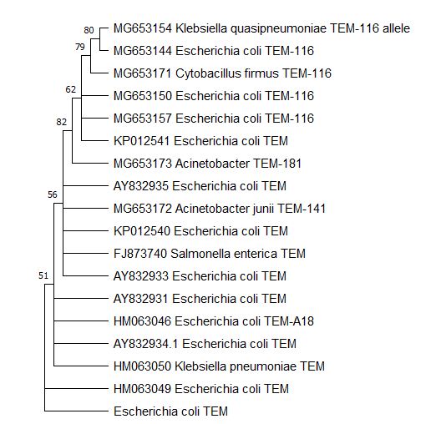

**Fig. S2: Phylogenetic analysis of *bla*SHVgene** 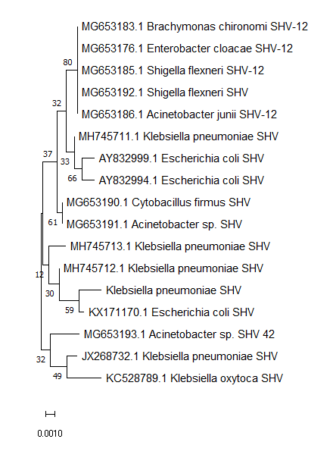

**Table S1: Sample collection data for broiler and backyard chickens in four districts in Tamil Nadu**

|  |  |  |  |
| --- | --- | --- | --- |
| **Districts** | **Sample Collection Areas** | **No. of samples from broiler chickens** | **No. of samples from backyard chickens** |
| Chennai  (37 broiler shops) | Aminjikarai | 8 | 5 |
| Perambur | 7 | 5 |
| Triplicane | 12 | 7 |
| Thiruverkadu | 10 | 6 |
| Cuddalore   (24 broiler shops) | Manapatthur | 6 | 5 |
| Palapattu | 7 | 3 |
| Pudupet | 6 | 4 |
| Sirugirammam | 5 | 3 |
| Villupuram  (25 broiler shops) | Arasur | 6 | 2 |
| Kedilam | 5 | 3 |
| Pidagam | 8 | 3 |
| Tindivanam | 6 | 2 |
| Namakkal   (39 broiler shops) | Bodupatty | 7 | 6 |
| Ernapuram | 8 | 4 |
| Mohanur | 9 | 7 |
| Valavanthi | 15 | 5 |
| Total |  | 125 | 70 |

**Table S2: Percentage of antibiotic resistance of bacterial isolates from broiler chickens**

|  |  |  |  |  |  |  |  |  |  |  |  |  |  |  |  |  |  |  |
| --- | --- | --- | --- | --- | --- | --- | --- | --- | --- | --- | --- | --- | --- | --- | --- | --- | --- | --- |
| **Organism** | **AK** | **AMP** | **C** | **CTX** | **CAZ** | **CIP** | **ETP** | **FOS** | **GEN** | **IMP** | **MRP** | **NIT** | **PI** | **PIT** | **PB** | **TE** | **NA** | **COT** |
| *Escherichia coli* | 0.0 | 100.0 | 14.8 | 23.0 | 13.1 | 14.8 | 23.0 | 0.0 | 26.2 | 6.6 | 14.8 | 14.8 | 100.0 | 100.0 | 24.6 | 14.8 | 36.1 | 29.5 |
| *Proteus vulgaris* | 0.0 | 100.0 | 58.3 | 33.3 | 25.0 | 25.0 | 50.0 | 0.0 | 41.7 | 8.3 | 8.3 | 8.3 | 100.0 | 100.0 | 8.3 | 8.3 | 33.3 | 41.7 |
| *Proteus mirabilis* | 0.0 | 100.0 | 23.5 | 11.8 | 11.8 | 17.6 | 17.6 | 0.0 | 52.9 | 11.8 | 23.5 | 29.4 | 100.0 | 100.0 | 5.9 | 29.4 | 47.1 | 17.6 |
| *Klebsiella pneumoniae* | 0.0 | 100.0 | 28.6 | 14.3 | 28.6 | 14.3 | 57.1 | 100.0 | 42.9 | 14.3 | 28.6 | 42.9 | 100.0 | 100.0 | 42.9 | 42.9 | 28.6 | 42.9 |
| *Serratia sp.* | 0.0 | 100.0 | 16.7 | 0.0 | 16.7 | 16.7 | 16.7 | 0.0 | 33.3 | 16.7 | 33.3 | 16.7 | 100.0 | 100.0 | 16.7 | 16.7 | 16.7 | 16.7 |
| *Salmonella sp.* | 0.0 | 100.0 | 0.0 | 0.0 | 0.0 | 20.0 | 40.0 | 0.0 | 100.0 | 0.0 | 20.0 | 0.0 | 100.0 | 100.0 | 40.0 | 0.0 | 0.0 | 0.0 |
| *Citrobacter sp..* | 0.0 | 100.0 | 20.0 | 0.0 | 20.0 | 40.0 | 0.0 | 0.0 | 20.0 | 20.0 | 20.0 | 0.0 | 100.0 | 100.0 | 0.0 | 0.0 | 20.0 | 20.0 |
| *Klebsiella oxytoca* | 0.0 | 100.0 | 0.0 | 50.0 | 50.0 | 50.0 | 50.0 | 0.0 | 50.0 | 0.0 | 0.0 | 50.0 | 100.0 | 100.0 | 0.0 | 0.0 | 100.0 | 0.0 |

*Note: AK – amikacin, AMP - ampicillin, C - chloramphenicol, CTX – cefotaxime, CAZ – ceftazidime, CIP - ciprofloxacin, ETP - ertapenem, FOS - fosfomycin, GEN - gentamicin, IMP – imipenem, MRP – meropenem, NIT – nitrofurantoin, PI - piperacillin, PIT - piperacillin-tazobactam, PB - polymyxin-B, TE – tetracycline, NA- nalidixic acid, COT - trimethoprim-sulfamethoxazole

**Table S3: Percentage of antibiotic resistance of bacterial isolates from backyard chickens**

|  |  |  |  |  |  |  |  |  |  |  |  |  |  |  |  |  |  |  |
| --- | --- | --- | --- | --- | --- | --- | --- | --- | --- | --- | --- | --- | --- | --- | --- | --- | --- | --- |
| **Organism** | **AK** | **AMP** | **C** | **CTX** | **CAZ** | **CIP** | **ETP** | **FOS** | **GEN** | **IMP** | **MRP** | **NIT** | **PI** | **PIT** | **PB** | **TE** | **NA** | **COT** |
| *Escherichia coli* | 0.0 | 100.0 | 27.0 | 21.6 | 13.5 | 54.1 | 27.0 | 0.0 | 21.6 | 8.1 | 10.8 | 21.6 | 100.0 | 100.0 | 18.9 | 21.6 | 45.9 | 32.4 |
| *Proteus vulgaris* | 0.0 | 100.0 | 50.0 | 25.0 | 25.0 | 37.5 | 25.0 | 0.0 | 25.0 | 12.5 | 25.0 | 25.0 | 100.0 | 100.0 | 37.5 | 25.0 | 37.5 | 37.5 |
| *Klebsiella pneumoniae* | 0.0 | 100.0 | 0.0 | 50.0 | 100.0 | 50.0 | 50.0 | 0.0 | 50.0 | 0.0 | 50.0 | 50.0 | 100.0 | 100.0 | 50.0 | 0.0 | 100.0 | 50.0 |
| *Serratia sp.* | 0.0 | 100.0 | 50.0 | 16.7 | 50.0 | 0.0 | 0.0 | 0.0 | 33.3 | 16.7 | 33.3 | 33.3 | 100.0 | 100.0 | 16.7 | 0.0 | 50.0 | 16.7 |
| *Salmonella sp.* | 0.0 | 100.0 | 100.0 | 50.0 | 0.0 | 0.0 | 0.0 | 0.0 | 0.0 | 0.0 | 0.0 | 50.0 | 100.0 | 100.0 | 50.0 | 0.0 | 0.0 | 0.0 |
| *Klebsiella oxytoca* | 0.0 | 100.0 | 50.0 | 0.0 | 0.0 | 100.0 | 50.0 | 0.0 | 50.0 | 50.0 | 0.0 | 0.0 | 100.0 | 100.0 | 0.0 | 0.0 | 100.0 | 50.0 |

*Note: AK – amikacin, AMP - ampicillin, C - chloramphenicol, CTX – cefotaxime, CAZ – ceftazidime, CIP - ciprofloxacin, ETP - ertapenem, FOS - fosfomycin, GEN - gentamicin, IMP – imipenem, MRP – meropenem, NIT – nitrofurantoin, PI - piperacillin, PIT - piperacillin-tazobactam, PB - polymyxin-B, TE – tetracycline, NA- nalidixic acid, COT - trimethoprim-sulfamethoxazole