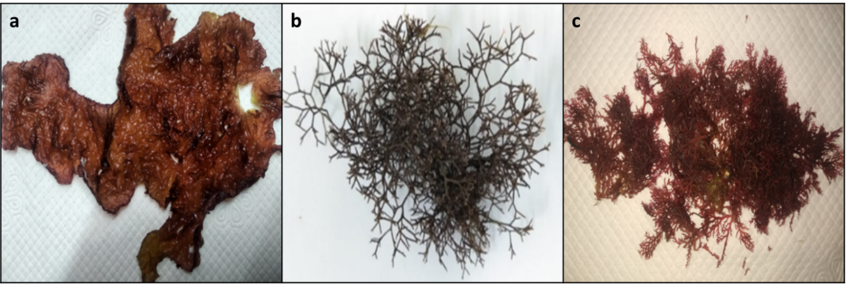

**a**

**b**

Supplementary Figure. S1. Collected Marine red seaweeds. (a) *Halymeniadilatata*; (b) *Portieria hornemannii*

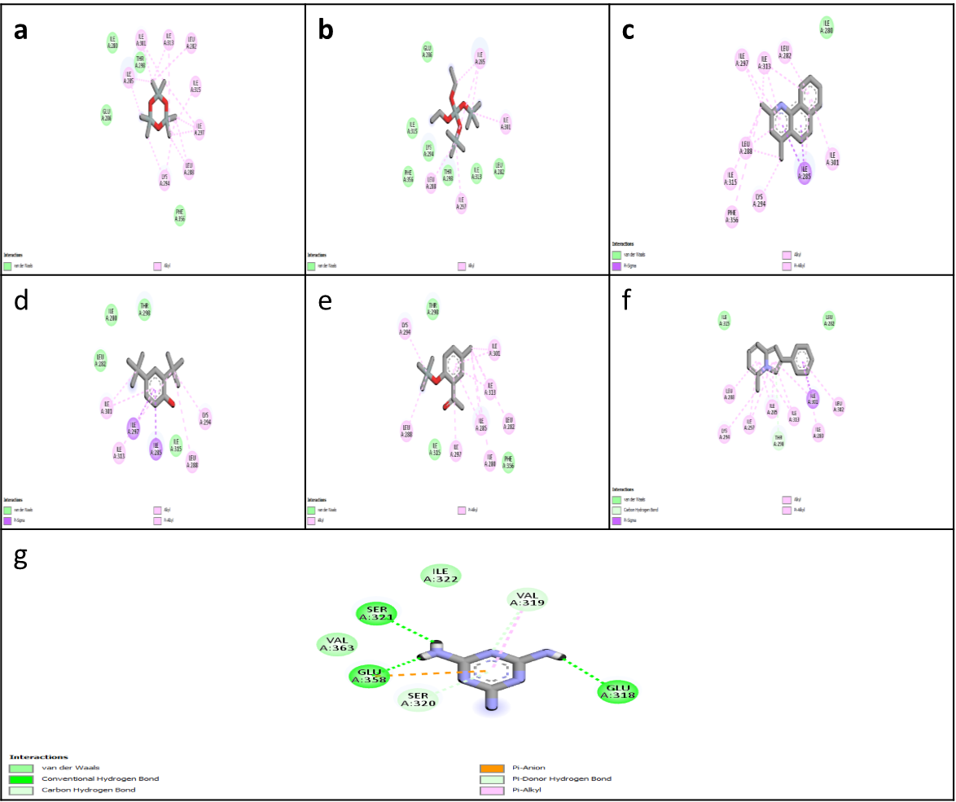

**g**

**f**

**e**

**d**

**c**

**b**

**a**

Supplementary Figure. S2. 4BXI Protein docked with selected compounds (a) Hexamethyl Cyclotrisiloxane; (b)diethyl bis (trimethylsilyl) silicate; (c)Benzo[h]quinoline, 2,4-dimethyl; (d)Phenol, 2,4-bis(1,1-dimethylethyl; (e)4-Methyl-2-trimethylsilyloxy-acetophenone; (f)5-Methyl-2-phenylindolizine; (g)1,3,5-Triazine-2,4,6-triamine

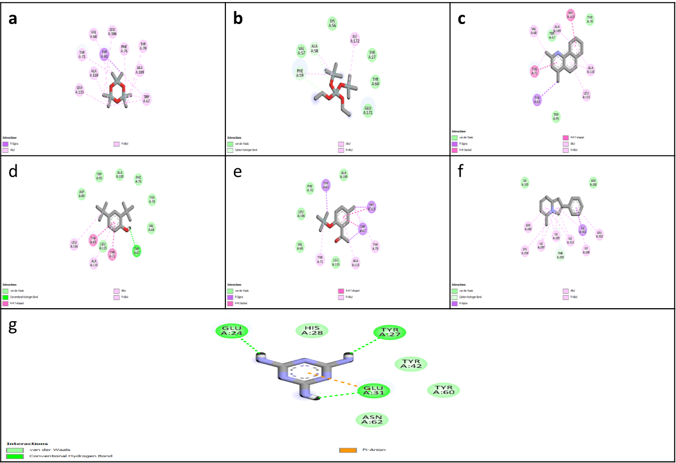

Supplementary Figure. S3. 4LFU Protein docked with selected compounds (a)Hexamethyl Cyclotrisiloxane; (b)diethyl bis (trimethylsilyl) silicate; (c)Benzo[h]quinoline, 2,4-dimethyl; (d)Phenol, 2,4-bis(1,1-dimethylethyl; (e)4-Methyl-2-trimethylsilyloxy-acetophenone; (f)5-Methyl-2-phenylindolizine; (g)1,3,5-Triazine-2,4,6-triamine

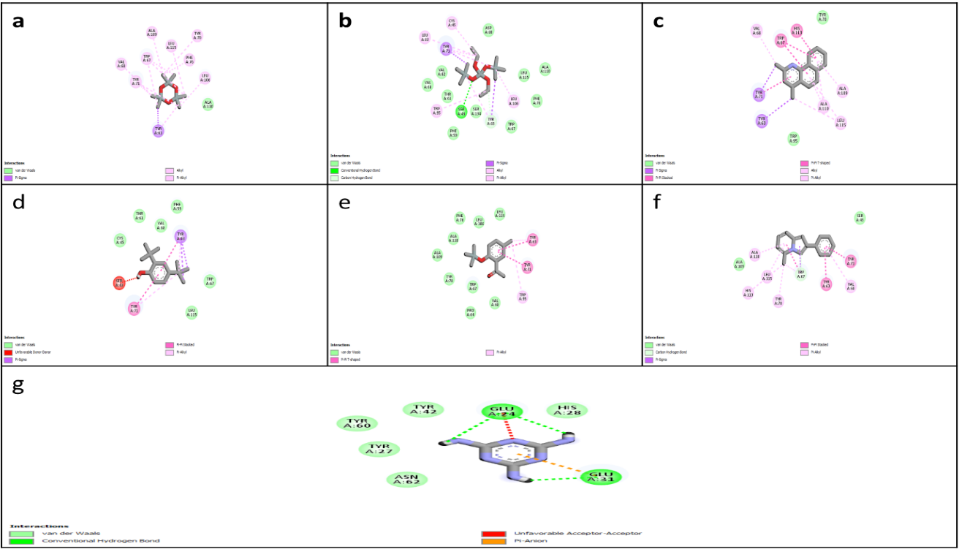

Supplementary Figure. S4. Modelled SdiA Protein docked with selected compounds (a)Hexamethyl Cyclotrisiloxane; (b)diethyl bis (trimethylsilyl) silicate; (c)Benzo[h]quinoline, 2,4-dimethyl; (d)Phenol, 2,4-bis(1,1-dimethylethyl; (e)4-Methyl-2-trimethylsilyloxy-acetophenone; (f)5-Methyl-2-phenylindolizine; (g)1,3,5-Triazine-2,4,6-triamine

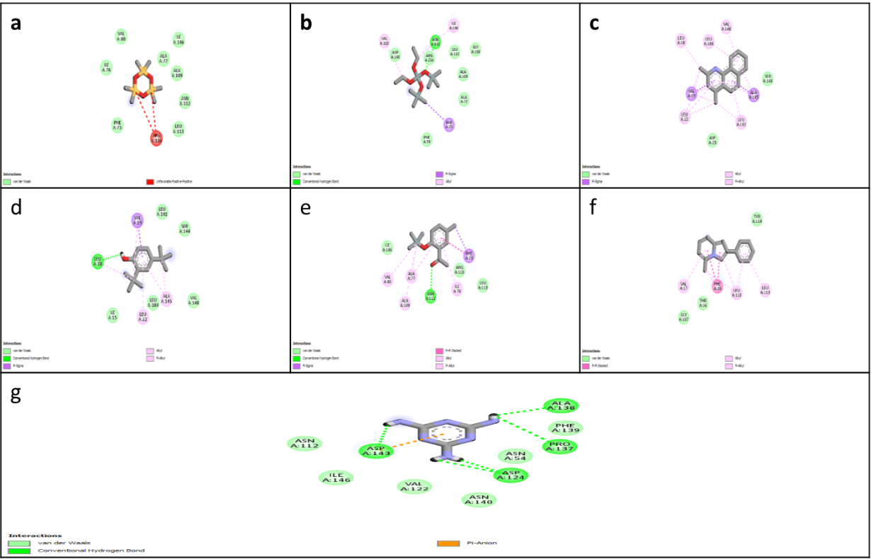

Supplementary Figure. S5. Modelled AbaR Protein docked with selected compounds(a)Hexamethyl Cyclotrisiloxane; (b)diethyl bis (trimethylsilyl) silicate; (c)Benzo[h]quinoline, 2,4-dimethyl; (d)Phenol, 2,4-bis(1,1-dimethylethyl; (e)4-Methyl-2-trimethylsilyloxy-acetophenone; (f)5-Methyl-2-phenylindolizine; (g)1,3,5-Triazine-2,4,6-triamine

|  |  |  |  |  |
| --- | --- | --- | --- | --- |
| Peak no | Retention time | Peak area | Peak percentage | Compounds |
| 1 | 4.698 | 5795 | 2.75 | Propiophenone, 2'-(trimethylsiloxy) |
| 2 | 12.219 | 10768 | 5.11 | Phenol, 2,4-bis(1,1-dimethylethyl) |
| 3 | 16.407 | 6729 | 3.20 | Phthalic acid, ethyl tetradecyl ester |
| 4 | 19.074 | 21811 | 10.36 | Cyclotrisiloxane, hexamethyl- |
| 5 | 19.629 | 11706 | 5.5 | Hexanedioic acid, bis(2-ethylhexyl) ester |
| 6 | 21.173 | 6173 | 2.93 | 2,4,6-Cycloheptatrien-1-one bis-trimethylsilyl |
| 7 | 21.473 | 6598 | 3.13 | 1,2-Bis(trimethylsilyl)benzene |
| 8 | 21.873 | 7163 | 3.40 | Cyclotrisiloxane, hexamethyl |
| 9 | 22.518 | 75861 | 36.04 | 5-Methyl-2-phenylindolizine |
| 10 | 22.784 | 57915 | 27.51 | Benzo[h]quinoline, 2,4-dimethyl |

Supplementary Table. S1. GC MS compounds of *H. dilatata*

|  |  |  |  |  |
| --- | --- | --- | --- | --- |
| Peak no | Retention time (Min) | Peak area | Peak (%) | Compound |
| 1 | 5.776 | 1954 | 3.19 | Pyrido[2,3-d]pyrimidine, 4-phenyl- |
| 2 | 10.220 | 1904 | 3.11 | 2-[4-(Dimethylamino)styryl]-3-(4-nitrophenyl)-4(3H)-quinazolinone |
| 3 | 12.219 | 14316 | 23.40 | Phenol, 2,4-bis(1,1-dimethylethyl) |
| 4 | 13.364 | 5069 | 8.29 | - |
| 5 | 16.019 | 2627 | 4.29 | 1H-1,2,4-Triazole-5(4H)-thione, allyl-3-(3-furyl)- |
| 6 | 16.119 | 3250 | 5.31 | Pentadecanoic acid, 14-methyl-, methyl ester |
| 7 | 16.408 | 4159 | 6.80 | Phthalic acid, ethyl isoporpyl ester |
| 8 | 19.629 | 4803 | 7.85 | 5-Methyl-2-phenylindolizine |
| 9 | 20.096 | 2660 | 4.35 | Silane, 1,4-phenylenebis[trimethyl |
| 10 | 20.463 | 1916 | 3.13 | Cyclotrisiloxane, hexamethyl |
| 11 | 21.329 | 1945 | 3.18 | Silane, 1,4-phenylenebis[trimethyl |
| 12 | 21.629 | 3317 | 5.42 | Cyclotrisiloxane, hexamethyl- |
| 13 | 21.729 | 2280 | 3.73 | Silane, trimethyl[5-methyl-2-(1-methylethyl)phenoxy]- |
| 14 | 22.529 | 3846 | 6.29 | 1,2-Bis(trimethylsilyl)benzene |
| 15 | 22.796 | 7131 | 11.66 | 4-Methyl-2-trimethylsilyloxy-acetophenone |

Supplementary Table. S2**.** GC MS compounds of *P. hornemannii*

|  |  |  |  |  |  |  |  |  |
| --- | --- | --- | --- | --- | --- | --- | --- | --- |
| *H. dilatata* - Methanolic extract compounds | | | | | | | | |
| S.no | Compounds | Pubchem ID | SMILES | IUPAC | MF | MWg/mol | structure |
| 1 | Cyclotrisiloxane, hexamethyl- | [10914](https://pubchem.ncbi.nlm.nih.gov/compound/10914) | C[Si]1(O[Si](O[Si](O1)(C)C)(C)C)C | 2,2,4,4,6,6-hexamethyl-1,3,5,2,4,6-trioxatrisilinane | C6H18O3Si3 | 222 |  |
| 2 | 5-Methyl-2-phenylindolizine | 610180 | CC1=CC=CC2=CC(=CN12)C3=CC=CC=C3 | 5-methyl-2-phenylindolizine | [C15H13N](https://pubchem.ncbi.nlm.nih.gov/#query=C15H13N) | 207 |  |
| 3 | Benzo[h]quinoline, 2,4-dimethyl | 610182 | CC1=CC(=NC2=C1C=CC3=CC=CC=C32)C | 2,4-dimethylbenzo[h]quinoline | [C15H13N](https://pubchem.ncbi.nlm.nih.gov/#query=C15H13N) | 207 |  |
| *P. hornemanni* - Aqueous extract compounds | | | | | | | | |
| 1 | 1,3,5-Triazine-2,4,6-triamine | [7955](https://pubchem.ncbi.nlm.nih.gov/compound/7955) | C1(=NC(=NC(=N1)N)N)N | 1,3,5-triazine-2,4,6-triamine | [C3H6N6](https://pubchem.ncbi.nlm.nih.gov/#query=C3H6N6) | 126 |  |
| 2 | Silicic acid, diethyl bis(trimethylsilyl) ester | [77092](https://pubchem.ncbi.nlm.nih.gov/compound/77092) | CCO[Si](OCC)(O[Si](C)(C)C)O[Si](C)(C)C | diethyl bis(trimethylsilyl) silicate | [C10H28O4Si3](https://pubchem.ncbi.nlm.nih.gov/#query=C10H28O4Si3) | 296 | Bis(trimethylsilyl) diethyl silicate.png |

Supplementary Table. S3. Selected compounds for docking study

|  |  |  |  |  |  |  |  |  |
| --- | --- | --- | --- | --- | --- | --- | --- | --- |
| *H. dilatata* - Methanolic extract compounds | | | | | | | | |
| S.no | Compounds | Pubchem ID | SMILES | IUPAC | MF | MWg/mol | structure |
| 1 | Cyclotrisiloxane, hexamethyl- | [10914](https://pubchem.ncbi.nlm.nih.gov/compound/10914) | C[Si]1(O[Si](O[Si](O1)(C)C)(C)C)C | 2,2,4,4,6,6-hexamethyl-1,3,5,2,4,6-trioxatrisilinane | C6H18O3Si3 | 222 |  |
| 2 | 5-Methyl-2-phenylindolizine | 610180 | CC1=CC=CC2=CC(=CN12)C3=CC=CC=C3 | 5-methyl-2-phenylindolizine | [C15H13N](https://pubchem.ncbi.nlm.nih.gov/#query=C15H13N) | 207 |  |
| 3 | Benzo[h]quinoline, 2,4-dimethyl | 610182 | CC1=CC(=NC2=C1C=CC3=CC=CC=C32)C | 2,4-dimethylbenzo[h]quinoline | [C15H13N](https://pubchem.ncbi.nlm.nih.gov/#query=C15H13N) | 207 |  |
| *P. hornemanni* - Aqueous extract compounds | | | | | | | | |
| 1 | 1,3,5-Triazine-2,4,6-triamine | [7955](https://pubchem.ncbi.nlm.nih.gov/compound/7955) | C1(=NC(=NC(=N1)N)N)N | 1,3,5-triazine-2,4,6-triamine | [C3H6N6](https://pubchem.ncbi.nlm.nih.gov/#query=C3H6N6) | 126 |  |
| 2 | Silicic acid, diethyl bis(trimethylsilyl) ester | [77092](https://pubchem.ncbi.nlm.nih.gov/compound/77092) | CCO[Si](OCC)(O[Si](C)(C)C)O[Si](C)(C)C | diethyl bis(trimethylsilyl) silicate | [C10H28O4Si3](https://pubchem.ncbi.nlm.nih.gov/#query=C10H28O4Si3) | 296 | Bis(trimethylsilyl) diethyl silicate.png |

|  |  |  |  |  |  |  |  |  |
| --- | --- | --- | --- | --- | --- | --- | --- | --- |
| S.no | Ligand | Binding energy | Inhibitor constant | Intermol energy | Vdw_hb_desolv energy | Electrostatic energy | H-bonding | Vander waals and other interactions |
| 1 | Hexamethyl Cyclotrisiloxane | -6.52 | 16.63 µM | -6.52 | -6.52 | 0.00 | - | Ile 280; Ile 301; Ile 313; Leu 282; Thr 298; Ile 285; Ile 315; Ile 297; Glu 286; Lys 294; Leu 288; Phe 356 |
| 2 | diethyl bis (trimethylsilyl) silicate | -5.26 | 140.19 µM | -7.64 | -7.67 | 0.02 | - | Ile 301; Ile 313; Leu 282; Thr 298; Ile 285; Ile 315; Ile 297; Glu 286; Lys 294; Leu 288; Phe 356 |
| 3 | Benzo[h]quinoline, 2,4-dimethyl | -6.18 | 29.58 µM | -6.18 | -6.19 | 0.01 | - | Ile 301; Ile 313; Leu 282; Ile 285; Ile 315; Ile 297; Lys 294; Leu 288; Phe 356 |
| 4 | 5-Methyl-2-phenylindolizine | -6.49 | 17.64 µM | -6.78 | -6.79 | 0.01 | Thr 298 | Ile 280; Ile 301; Ile 313; Leu 282; Thr 298; Ile 285; Ile 315; Ile 297; Lys 294; Leu 288 |
| 5 | 1,3,5-Triazine-2,4,6-triamine | -6.85 | 9.5 µM | -7.75 | -3.47 | -4.27 | Ser 321; Glu 318; Glu 358; Val 319; Ser 320 | Ile 322; Val 363; Glu 358; Val 319 |

Supplementary Table. S4. 4BXI protein -ligand interactions generated from AutoDock tools

|  |  |  |  |  |  |  |  |  |
| --- | --- | --- | --- | --- | --- | --- | --- | --- |
| S.no | Ligand | Binding energy | Inhibitor constant | Intermol energy | Vdw_hb_  desolv energy | Electrostatic energy | H-bonding | Vander vaals and other intercations |
| 1 | Hexamethyl Cyclotrisiloxane | -8.32 | 791.7 nM | -8.32 | -8.32 | 0.00 | - | Val 68; Leu 106; Phe 76; Tyr 70; Tyr 63; Tyr 71; Ala 110; Ala 109; Trp 67; Leu 115 |
| 2 | diethyl bis (trimethylsilyl) silicate | -4.76 | 321.58 µM | -7.15 | -7.09 | -0.06 | Phe 59; Ala 58 | Val 57; Lys 56; Ile 172; Tyr 27; Tyr 60; Glu 171 |
| 3 | Benzo[h]quinoline, 2,4-dimethyl | -7.81 | 1.88 µM | -7.81 | -7.81 | 0.00 | - | Val 68; Trp 67; Ala 109; His 113; Tyr 70; Tyr 71; Ala 110; Tyr 63; Leu 115; Trp 95 |
| 4 | 5-Methyl-2-phenylindolizine | -8.08 | 1.2 µM | -8.38 | -8.37 | -0.01 | Trp 67 | Ala 110; Leu 115; Ala 109; Ser 43; Thr 61; His 113; Tyr 70; Tyr 71; Tyr 63; Val 68 |
| 5 | 1,3,5-Triazine-2,4,6-triamine | -6.54 | 16.16 µM | -7.43 | -2.65 | -4.78 | Tyr 27; Glu 24; Glu 31 | His 28; Tyr 42; Tyr 60; Asn 62 |

Supplementary Table. S5. 4LFU protein -ligand interactions generated from AutoDock tools

|  |  |  |  |  |  |  |  |  |  |  |  |  |  |  |  |
| --- | --- | --- | --- | --- | --- | --- | --- | --- | --- | --- | --- | --- | --- | --- | --- |
| S.no | Ligand | Binding energy | | Inhibitor constant | | Intermol energy | | Vdw_hb_desolv energy | | Electrostatic energy | | H-bonding | | Vander Vaals And Other Intercations | |
| 1 | Hexamethyl Cyclotrisiloxane | -8.29 | 831.22 nM | | -8.29 | | -8.29 | | 0.00 | | - | | Ala 110; Tyr 63; Tyr 71; Val 68; Trp 67; Ala 109; Leu 115; Phe 76; Tyr 70; Leu 106; | |
| 2 | diethyl bis (trimethylsilyl) silicate | -6.28 | 25.12 µM | | -8.66 | | -8.73 | | 0.07 | | Ser 43; tyr 63 | | Ser 134; Phe 59; Trp 67; Thr 61; Trp 95; Leu 106; Phe 76; Val 82; Val 68; Leu 115; Ala 110; Tyr 71; Cys 45; Leu 83; Asp 80 | |
| 3 | Benzo[h]quinoline, 2,4-dimethyl | -7.81 | 1.88 µM | | -7.81 | | -7.81 | | 0.00 | | - | | Tyr 71; Tyr 63; Tyr 70; Trp 95; Trp 67; His 113; Val 68; Ala 109; Ala 110; Leu 115 | |
| 4 | 5-Methyl-2-phenylindolizine | -8.07 | 1.21 µM | | -8.37 | | -8.36 | | -0.01 | | Trp 67 | | Ala 109; Ala 110; Leu 115; His 113; Tyr 70; Tyr 71; Tyr 63; Val 68; Ser 43 | |
| 5 | 1,3,5-Triazine-2,4,6-triamine | -6.08 | 34.68 µM | | -6.98 | | -2.15 | | -4.83 | | Glu 31; glu 24 | | His 28; Tyr 42; Tyr 60; Tyr 27; Asn 62 | |

Supplementary Table. S6. Modelled SdiA protein -ligand interactions generated from AutoDock tools

|  |  |  |  |  |  |  |  |  |  |  |  |  |  |  |
| --- | --- | --- | --- | --- | --- | --- | --- | --- | --- | --- | --- | --- | --- | --- |
| Supplementary Table. S7. Modelled AbaR protein -ligand interactions generated from AutoDock tools | | | | | | | | | | | | | | |
| S.no | Ligand | Binding energy | | Inhibitor constant | | Intermol energy | | Vdw_hb_desolv energy | | Electrostatic energy | | H-bonding | | Vander vaals and other intercations | |
| 1 | Hexamethyl Cyclotrisiloxane | -6.85 | 9.52nM | | -6.85 | | -6.85 | | 0.00 | | - | | Val 80; Ile 146; Ala 77; Ala 109; Asn 112; Leu 113; Ile 76; Phe 73 | |
| 2 | diethyl bis (trimethylsilyl) silicate | -5.11 | 180.73 µM | | -7.49 | | -7.22 | | -0.27 | | Asn 112 | | Val 122; Ile 146; Phe 73; Asp 143; Arg 116; Leu 113; Gly 108; Ala 109; Ala 77; Phe 59 | |
| 3 | Benzo[h]quinoline, 2,4-dimethyl | -5.84 | 52.13 µM | | -5.84 | | -5.83 | | -0.01 | | - | | Val 19; Ala 145; Asp 23; Ser 144; Leu 22; Leu 141; Leu 18; Leu 104; Val 148 | |
| 4 | 5-Methyl-2-phenylindolizine | -5.68 | 68.66 µM | | -5.98 | | -5.98 | | 0.00 | | - | | Tyr 114; Thr 16; Gly 107; Leu 110; Leu 113; Val 17; Phe 20 | |
| 5 | 1,3,5-Triazine-2,4,6-triamine | -5.13 | 173.25 µM | | -6.03 | | -1.32 | | -4.71 | | Asp 143; Asp 124; Pro 137; Ala 138 | | Phe 139; Asn 54; Asn 140; Val 122; Ile 146; Asn 112 | |