**Structures of the known compounds isolated from MP**

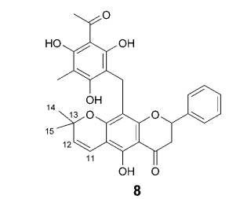 Isorotlerin

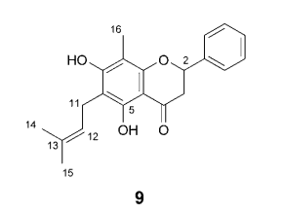5,7-Dihydroxy-8-methyl-6-prenylflavanone

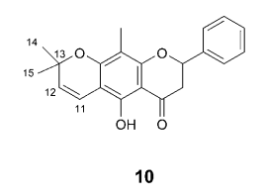6",6"-Dimethylepyrano (2",3,"7,6)-5-hydroxyl-8-methylflavanone

**Data: IR (A4)**

**Data: LCMS (A4)**



**Data: NMR (A4)**



