**Synthesis of a Cd(II) metal complex template with 2-amino-5-methylpyridinium organic cation, (C6H9N2)2[CdCl4]: Structure, DFT-calculated descriptors and molecular docking survey**

Ikram Jomaaa, Fehmi Bardakb, Noureddine ISSAOUIc, Aurelio Cabezad, Duane Choquesillo-Lazartee, Ahmet Atacb, Houda Marouania, Omar M. Al-Dossaryf

aLaboratory of Material Chemistry (LR13ES08), Faculty of Sciences of Bizerte, University of Carthage,7021, Tunisia

bDepartment of Physics, ManisaCelal Bayar University, Manisa, Turkey

cLaboratory of Quantum and Statistical Physics (LR18ES18), Faculty of Sciences of Monastir, University of Monastir, 5079, Tunisia

dDepartment of Inorganic Chemistry, Crystallography and Mineralogy, Faculty of Sciences, University of Málaga, Campus Teatinos s/n, 29071 Málaga, Spain

eLaboratory of Crystallographic Studies, IACT, CSIC-University of Granada, Avda. de las Palmeras 4,18100 Armilla, Spain.

fDepartment of Physics and Astronomy, College of Science, King Saud University, PO Box 2455, Riyadh 11451, Saudi Arabia.

* Corresponding authors: Noureddine Issaoui, email: issaoui_noureddine@yahoo.fr

**Figure captions**

**Fig. S1.** Observed, and calculated X-ray diffraction patterns of (C6H9N2)2[CdCl4].

**Fig. S2.** SEM images of (C6H9N2)2[CdCl4] compound with different magnifications (a 500×, b 1000×, c 2000×, and d 5000×).

**Fig. S3.** 2D fingerprint plots of the primary intercontacts of (C6H9N2)2[CdCl4] displaying the percentage distribution of various intermolecular contacts engaged in the Hirshfeld surface.

**Fig. S4.** DFT-calculated, and experimental IR spectrum of (C6H9N2)2[CdCl4].

**Fig. S5.** Theoretical TD-DFT UV-Visible spectra of (C6H9N2)2[CdCl4] at BLYP and B3LYP levels.

**Fig. S6.** Solid-state UV-Vis spectrum (a) of (C6H9N2)2[CdCl4] and the corresponding energy gap (b) determined using the Tauc model.

**Fig. S7.** Comparative visualization of the frontier molecular orbitals of the (C6H9N2)2[CdCl4] molecule in the gaseous phase and across various solvents.

**Fig. S8.** Molecular electrostatic potential surfaces (MEPs) of (C6H9N2)2[CdCl4] in the gaseous phase and across various solvents.

**Fig. S9.** AIM molecular graph screening the different bond critical points (BCPs) of (C6H9N2)2[CdCl4]. The BCPs are depicted as small orange spheres and the connecting paths by orange lines.

**Fig. S10.** Lowest energy docked poses of the ligands: FC1, H4B, HBI and (C6H9N2)2[CdCl4] with iNOS protein.

**Fig. S11.** Different types of interactions between the HBI (a), H4B (b) and FC1 (c) ligands and active site residues of the iNOS protein.



**Fig. S1.** Observed, and calculated X-ray diffraction patterns of (C6H9N2)2[CdCl4].

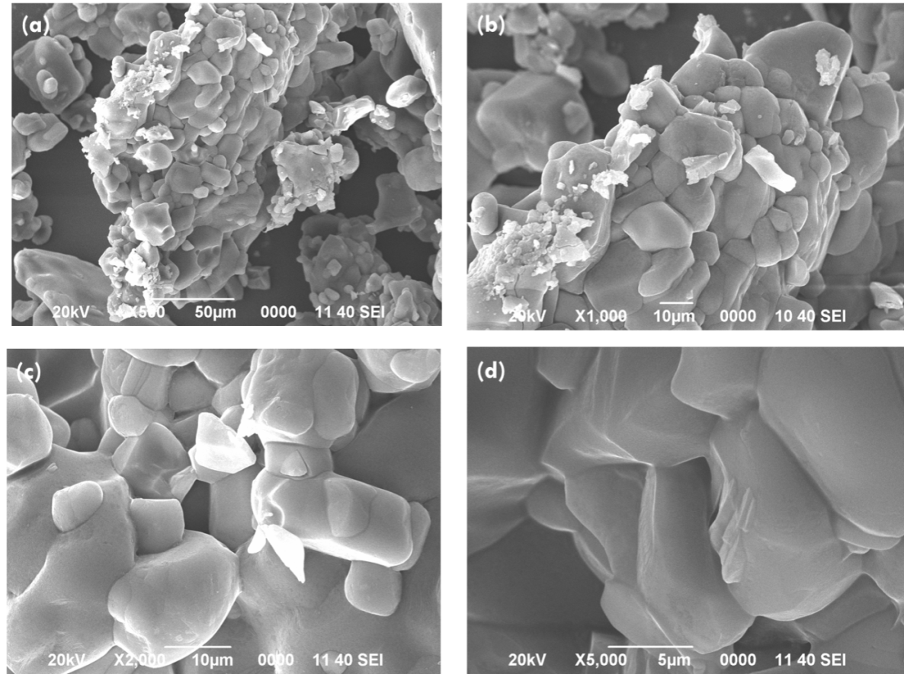

**Fig. S2.** SEM images of (C6H9N2)2[CdCl4] compound with different magnifications (a 500×, b 1000×, c 2000×, and d 5000×).

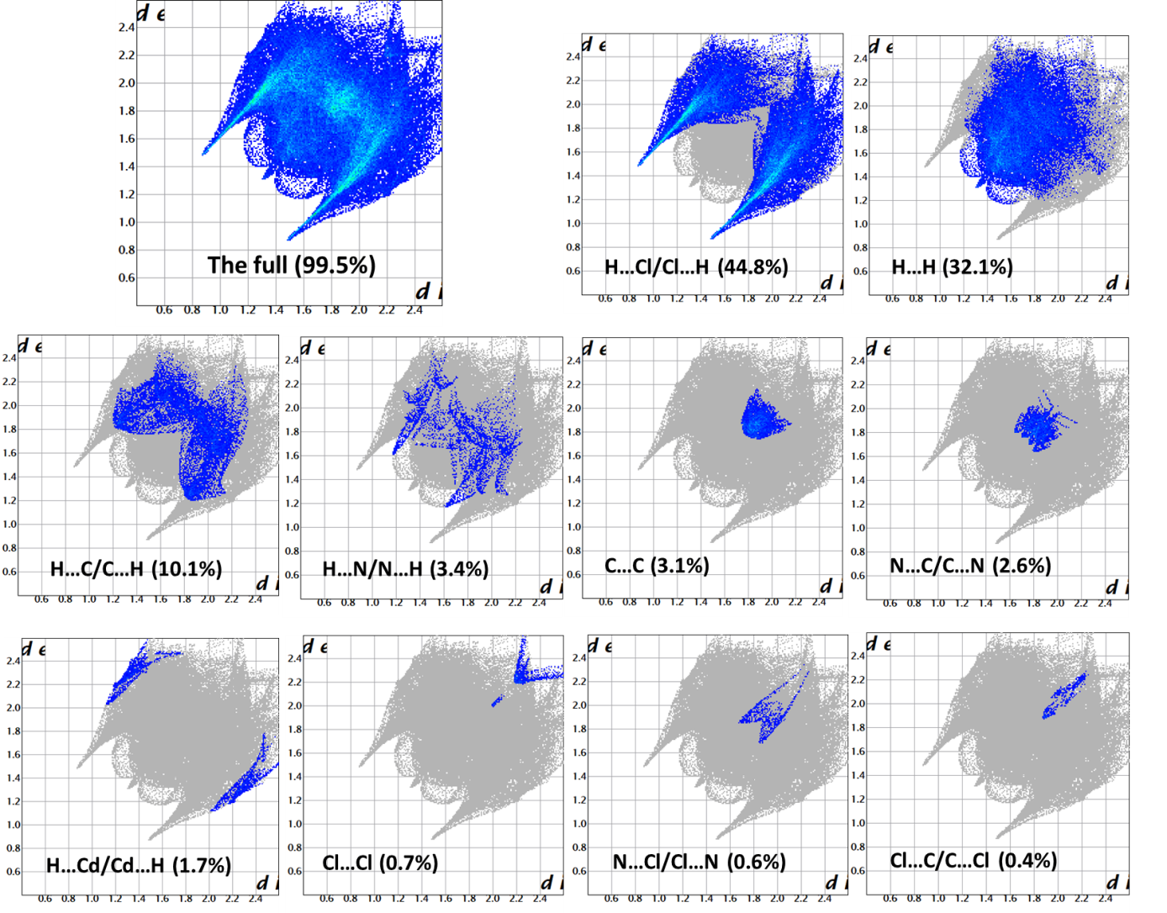

**Fig. S3.** 2D fingerprint plots of the primary intercontacts of (C6H9N2)2[CdCl4] displaying the percentage distribution of various intermolecular contacts engaged in the Hirshfeld surface.

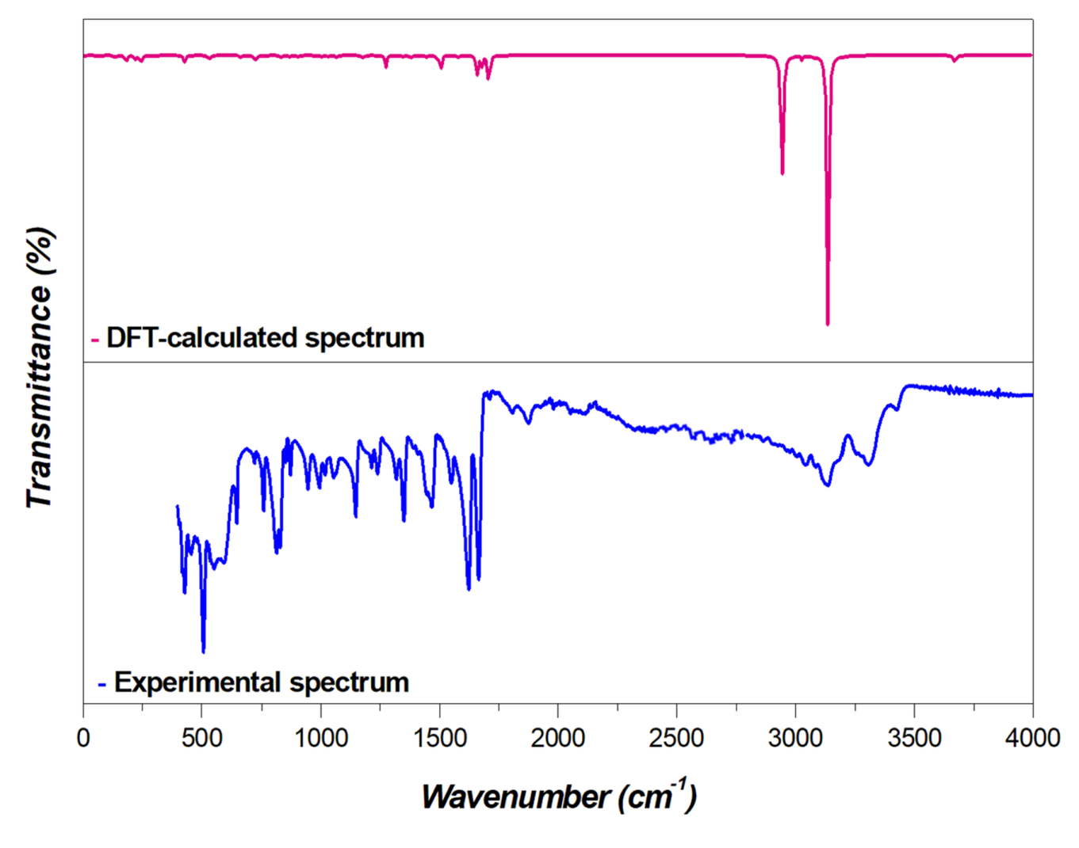

**Fig. S4.** DFT-calculated, and experimental IR spectrum of (C6H9N2)2[CdCl4].

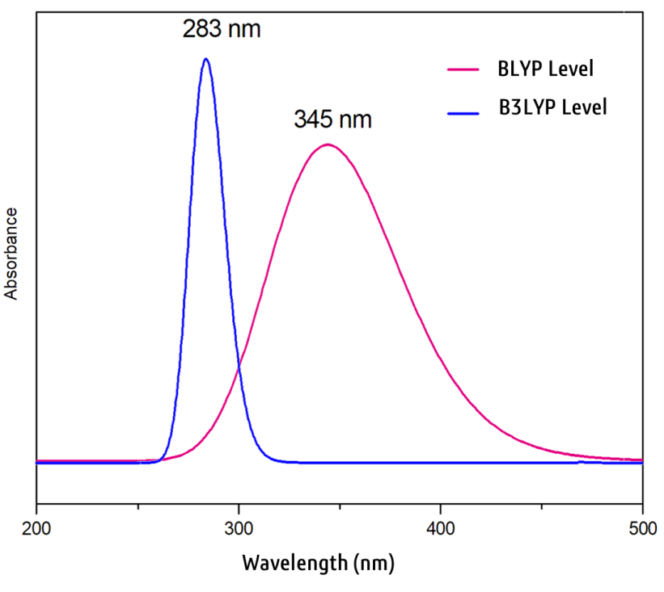

**Fig. S5.** Theoretical TD-DFT UV-Visible spectra of (C6H9N2)2[CdCl4] at BLYP and B3LYP levels.

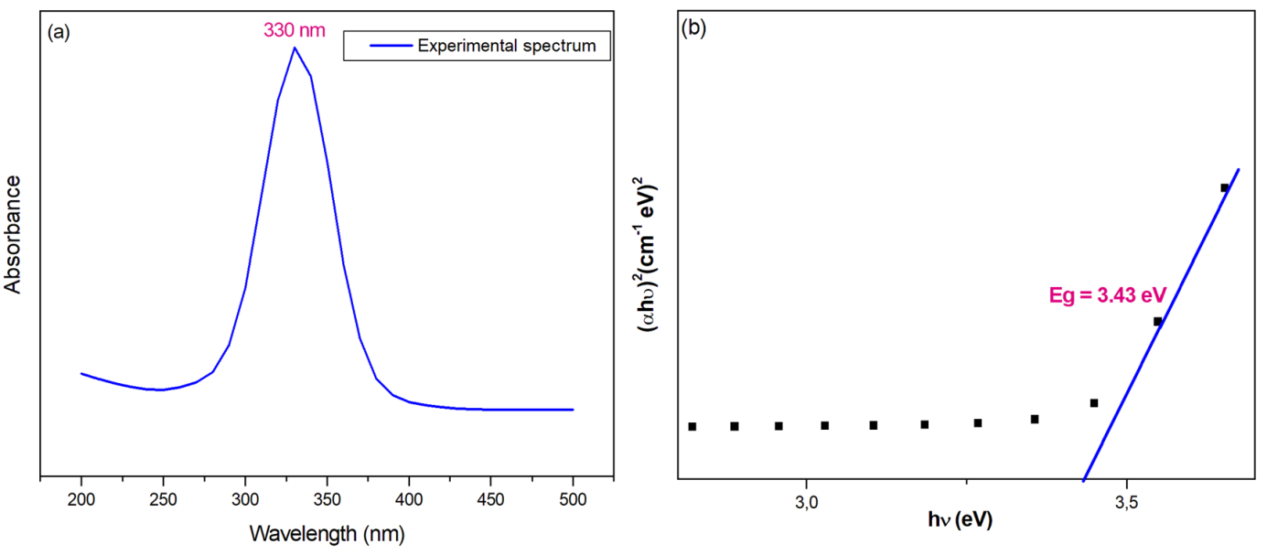

**Fig. S6.** Solid-state UV-Vis spectrum (a) of (C6H9N2)2[CdCl4] and the corresponding energy gap (b) determined using the Tauc model.

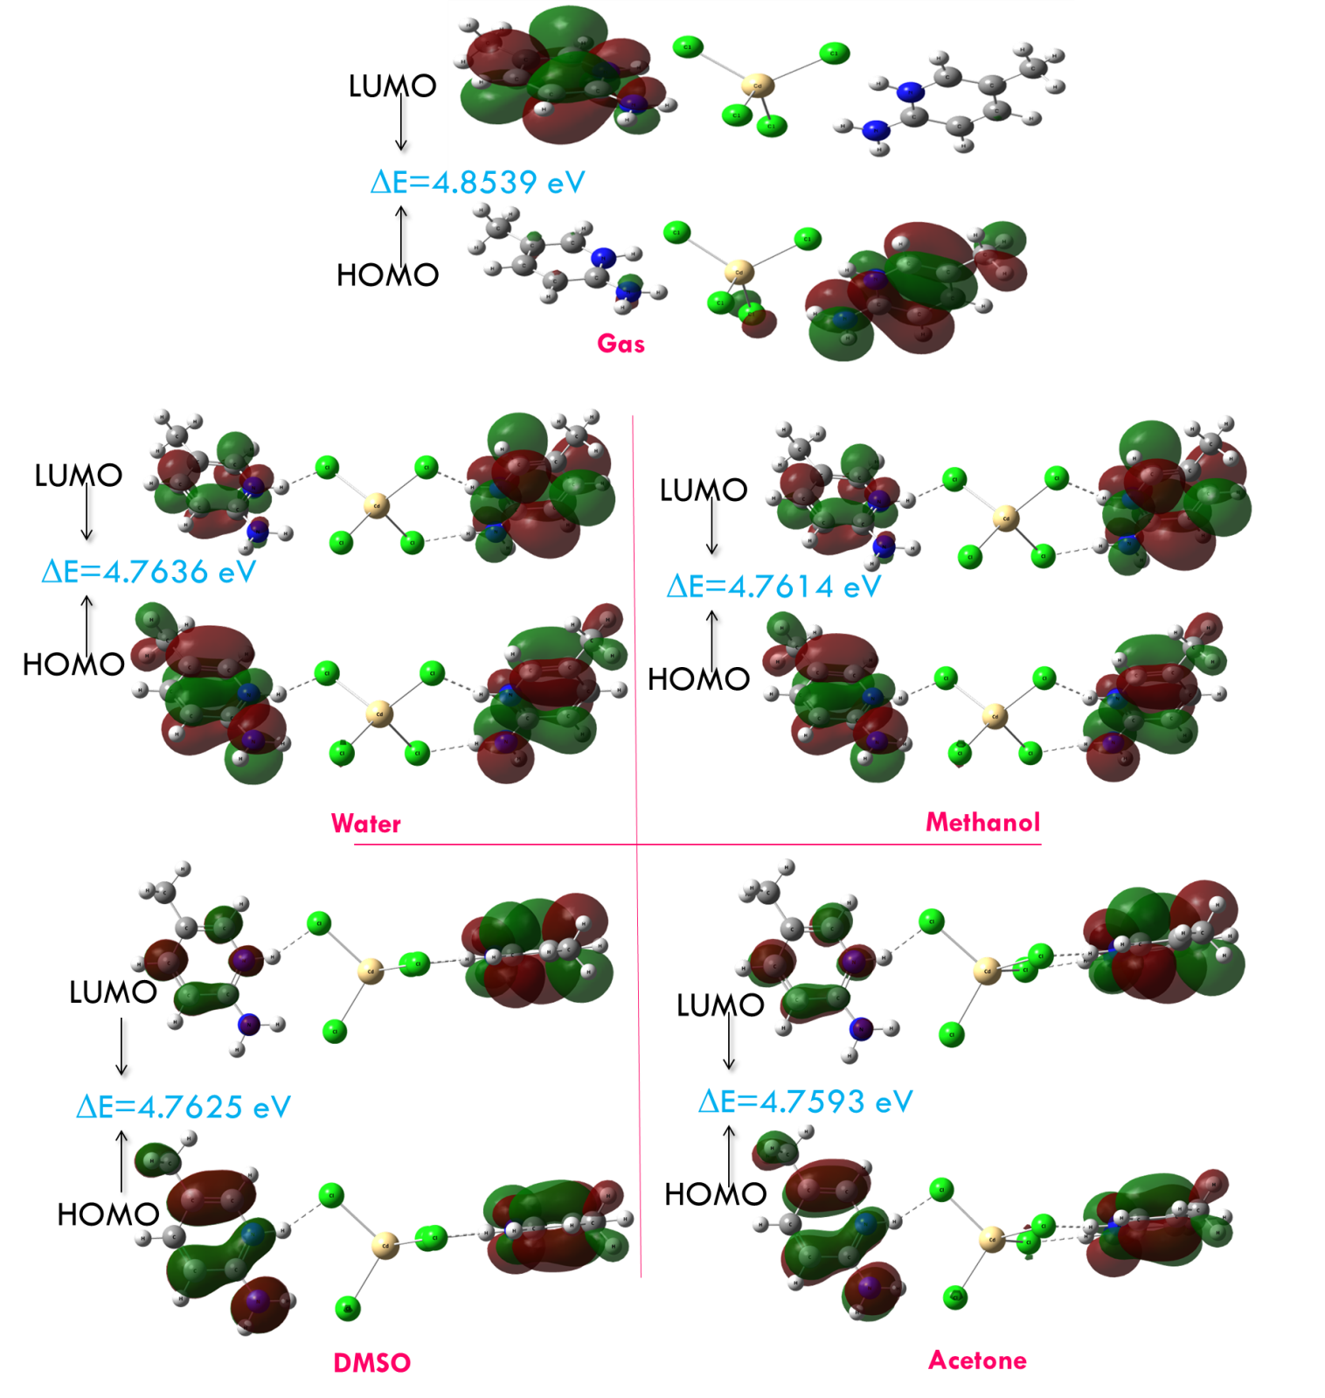

**Fig. S7.** Comparative visualization of the frontier molecular orbitals of the (C6H9N2)2[CdCl4] molecule in the gaseous phase and across various solvents.

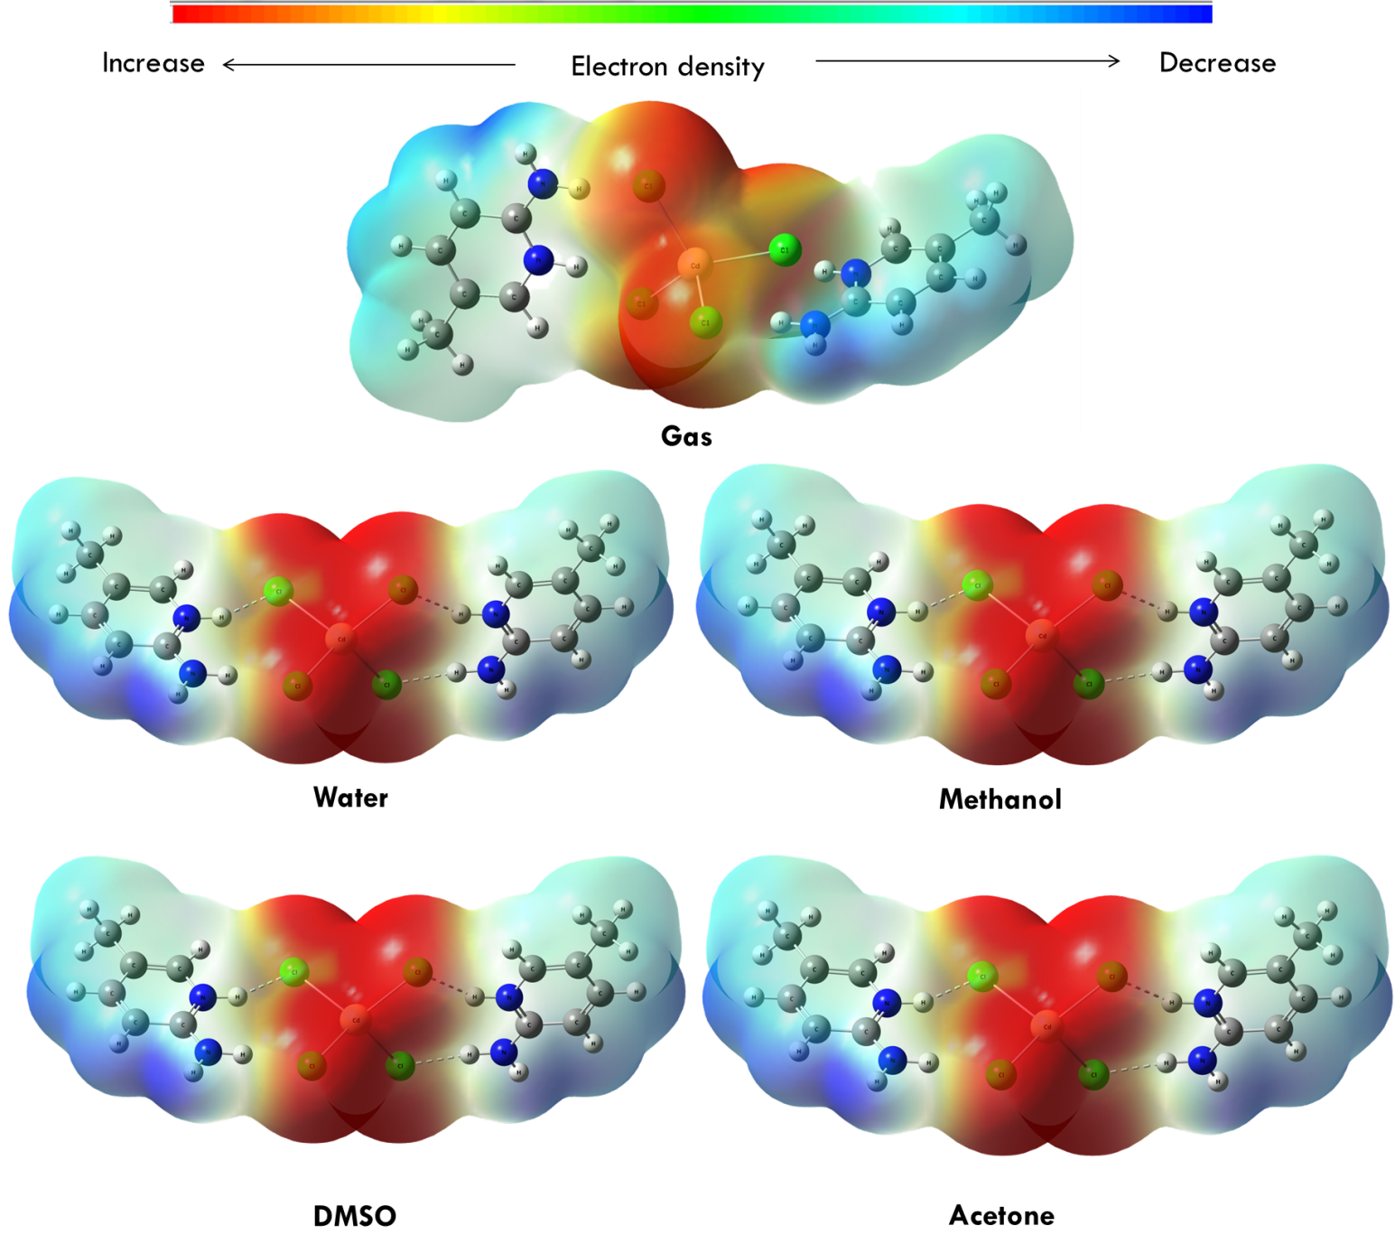

**Fig. S8.** Molecular electrostatic potential surface (MEPs) of (C6H9N2)2[CdCl4] in the gaseous phase and across various solvents.

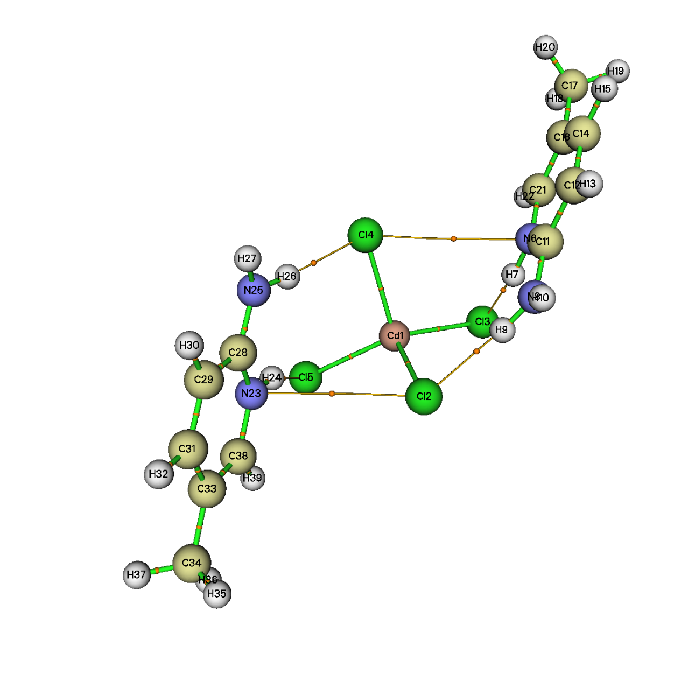

**Fig. S9.** AIM molecular graph screening the different bond critical points (BCPs) of (C6H9N2)2[CdCl4]. The BCPs are depicted as small orange spheres and the connecting paths by orange lines.

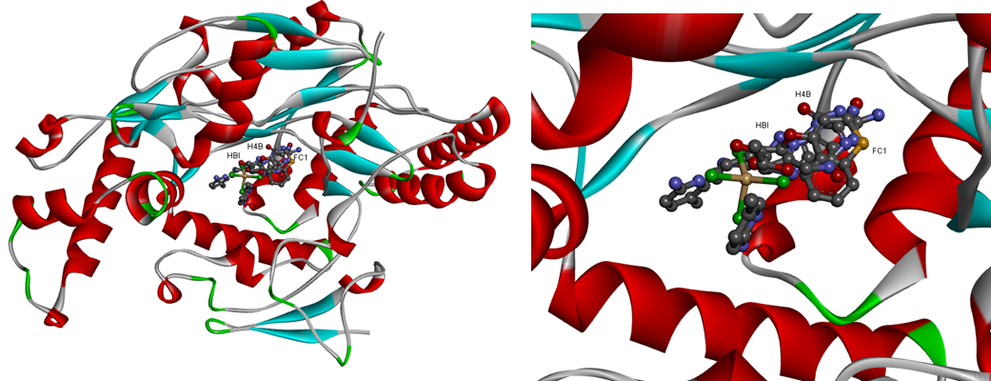

**Fig. S10.** Lowest energy docked poses of the ligands: FC1, H4B, HBI and (C6H9N2)2[CdCl4] with iNOS protein.

|  |  |
| --- | --- |
| **(a)** |  |
| **(b)** |  |
| **(c)** |  |

**Fig. S11.** Different types of interactions between the HBI (a), H4B (b) and FC1 (c) ligands and active site residues of the iNOS protein.

**Table captions**

**Table S1.** Selected intermolecular distances (Å) and bond angles (°) in (C6H9N2)2[CdCl4], obtained from X-ray data (with estimated standard deviation in parentheses) and theoretical calculations.

**Table S2.** Hydrogen-bonds details (Å, °) of (C6H9N2)2[CdCl4].

**Table S3.** Observed and calculated wavenumbers (cm-1) and assignments for (C6H9N2)2[CdCl4].

**Table S4.** Global reactivity descriptors and calculated frontier molecular orbital parameters of (C6H9N2)2[CdCl4] calculated using DFT/LANL2DZ level.

**Table S1.** Selected intermolecular distances (Å) and bond angles (°) in (C6H9N2)2[CdCl4], obtained from X-ray data (with estimated standard deviation in parentheses) and theoretical calculations.

|  |  |  |  |  |  |  |
| --- | --- | --- | --- | --- | --- | --- |
| **Bond lengths(Å)** | | | | **Bond angles(°)** | | |
| Calculated  B3LYP  /LanL2DZ | | | X-Ray | Calculated  B3LYP  /LanL2DZ | | X-Ray |
| **Inorganic atom position** | | |  |  | | |
| Cd1—Cl1 | 2.5444 | | 2.4745 (15) | Cl1—Cd1—Cl4 | 112.89 | 107.41 (6) |
| Cd1—Cl2 | 2.5670 | | 2.4356 (16) | Cl2—Cd1—Cl1 | 102.41 | 103.79 (6) |
| Cd1—Cl3 | 2.5442 | | 2.4236 (15) | Cl2—Cd1—Cl4 | 113.05 | 109.00 (6) |
| Cd1—Cl4 | 2.5667 | | 2.4934 (15) | Cl3—Cd1—Cl1 | 113.01 | 115.27 (6) |
|  |  | |  | Cl3—Cd1—Cl2 | 113.48 | 117.20 (7) |
|  |  | |  | Cl3—Cd1—Cl4 | 102.42 | 103.80 (6) |
| **Organic atom position** | | |  |  | |  |
| N1—C1 | | 1.354 | 1.340 (8) | C1—N1—C6 | 123.4 | 123.4 (5) |
| N1—C6 | | 1.359 | 1.357 (9) | N1—C1—C2 | 116.6 | 117.1 (6) |
| N2—C1 | | 1.333 | 1.328 (8) | N2—C1—N1 | 119.9 | 119.7 (6) |
| C1—C2 | | 1.420 | 1.407 (8) | N2—C1—C2 | 123.4 | 123.2 (6) |
| C2—C3 | | 1.371 | 1.367 (9) | C3—C2—C1 | 120.1 | 119.4 (6) |
| C3—C4 | | 1.417 | 1.397 (9) | C2—C3—C4 | 121.9 | 122.1 (6) |
| C4—C5 | | 1.505 | 1.499 (10) | C3—C4—C5 | 121.8 | 121.8 (6) |
| C4—C6 | | 1.370 | 1.356 (9) | C6—C4—C3 | 116.1 | 116.6 (6) |
| N3—C7  N3—C12  N4—C7  C7—C8  C8—C9  C9—C10  C10—C11  C10—C12 | | 1.354  1.358  1.333  1.419  1.371  1.417  1.505  1.370 | 1.335 (8)  1.382 (9)  1.333 (8)  1.401 (9)  1.347 (10)  1.404 (11)  1.494 (10)  1.332 (11) | C6—C4—C5  C4—C6—N1  C7—N3—C12  N3—C7—C8  N4—C7—N3  N4—C7—C8  C9—C8—C7  C8—C9—C10  C9—C10—C11  C12—C10—C9  C12—C10—C11  C10—C12—N3 | 122.1  121.9  123.4  116.6  119.8  123.4  120  121.8  121.8  116  122.1  121.9 | 121.6 (6)  121.4 (6)  121.8 (6)  117.7 (6)  119.4 (6)  122.9 (6)  119.5 (6)  122.9 (7)  121.7 (8)  115.8 (6)  122.6 (8)  122.4 (7) |

**Table S2.** Hydrogen-bonds details (Å, °) of (C6H9N2)2[CdCl4].

|  |  |  |  |  |
| --- | --- | --- | --- | --- |
| ***D—H···A*** | ***D—H(Å)*** | ***H···A(Å)*** | ***D···A(Å)*** | ***D—H···A(°)*** |
| ***N1—H1···Cl2*** | 0.86 | 2.33 | 3.174 (5) | 167 |
| ***N2—H2A···Cl1*** | 0.86 | 2.78 | 3.433 (6) | 134 |
| ***N2—H2B···Cl4i*** | 0.86 | 2.52 | 3.378 (7) | 174 |
| ***N3—H3A···Cl4*** | 0.86 | 2.30 | 3.134 (6) | 162 |
| ***N4—H4A···Cl3*** | 0.86 | 2.51 | 3.286 (6) | 150 |
| ***N4—H4B···Cl1ii*** | 0.86 | 2.50 | 3.350 (7) | 170 |
| ***C9—H9···Cl1iii*** | 0.93 | 2.75 | 3.670 (7) | 168 |

Symmetry codes: (i) *x*, *y*−1, *z*; (ii) *x*−1, *y*, *z*; (iii) −*x*, −*y*+1, −*z*.

**Table S3.** Observed and calculated wavenumbers (cm-1) and assignments for (C6H9N2)2[CdCl4].

|  |  |  |  |  |
| --- | --- | --- | --- | --- |
|  | Calculated frequencies | |  |  |
| Experimental  IR | Unscaled | **Scaled** | **Ii** | Vibrational assignments (% **PED**) |
| 3421 | 3660 | 3506 | 93.59 | ʋNH (30) |
| 3318 | 3660 | 3506 | 35.22 | δHCCC (27) |
| 3140 | 3247 | 3111 | 2807.88 | ʋNH (35) βHNH (10) δHNCN (26) |
| 3140 | 3244 | 3107 | 395.05 | ʋNH (17) δCNHCl (37) |
| 3082 | 3214 | 3079 | 5.05 | ʋNH (20) δHNCN (12) δCNHCl (15) δHNCC (16) |
| 3082 | 3214 | 3079 | 5.39 | ʋNH (49) |
| 3042 | 3199 | 3064 | 1.77 | βHNC (29) δHNCN (10) |
| 3042 | 3199 | 3064 | 1.89 | ʋNH (13) βHNC (26) δCNHCl (17) |
| 3042 | 3168 | 3035 | 9.51 | ʋCH (16) βHNH (32) βHCC (12) δCNHCl (17) |
| 3042 | 3168 | 3035 | 11.97 | ʋNH (17) ʋCH (38) βHCC (28) |
| 2967 | 3113 | 2983 | 11.30 | ʋNH (11) βHNC (10) βHCC (18) βClHN (26) δClCdClH (10) |
| 2967 | 3113 | 2983 | 10.45 | ʋClH (15) βCdClH (10) δHCCC (36) |
| 2967 | 3080 | 2951 | 12.01 | ʋCH (20) βHNH (14) βHCC (11) |
| 2967 | 3079 | 2951 | 11.52 | βHCC (15) δCNHCl (13) δHCCC (30) |
| 2907 | 3037 | 2910 | 1654.06 | ʋCH (29) βHCH (15) δHCCC (11) |
| 2907 | 3030 | 2903 | 98.67 | βHCH (37) δHCCC (25) |
| 2907 | 3029 | 2902 | 33.61 | δHCCC (28) |
| 2907 | 3027 | 2900 | 823.32 | βHCC (10) δHCCC (53) |
| 1667 | 1707 | 1635 | 52.89 | βHCC (53) |
| 1667 | 1707 | 1636 | 515.21 | ʋCH (11) βHCH (28) δHCCC (16) |
| 1667 | 1678 | 1650 | 121.77 | γHCCC (17) |
| 1667 | 1677 | 1648 | 0.88 | δNHClCd (11) |
| 1622 | 1663 | 1635 | 165.00 | ʋCH (29) βHNH (11) |
| 1662 | 1663 | 1634 | 143.70 | ʋCH (33) |
| 1552 | 1581 | 1554 | 21.14 | ʋCH (44) |
| 1552 | 1581 | 1554 | 14.02 | βHNH (25) |
| 1464 | 1508 | 1482 | 61.53 | ʋCH (24) δHCCC (12) |
| 1464 | 1508 | 1482 | 65.23 | βHCC (23) |
| 1464 | 1494 | 1468 | 20.50 | βHCC(12) δHNHCl (11) |
| 1464 | 1494 | 1468 | 51.11 | ʋNH (10) δHNHCl (21) |
| 1464 | 1486 | 1461 | 9.07 | ʋClH (10) δNHClCd (11) |
| 1464 | 1486 | 1461 | 8.24 | δHCCC (19) |
| 1464 | 1436 | 1411 | 11.81 | βHCC (12) δHCCC (12) |
| 1464 | 1436 | 1411 | 28.41 | βHNC |
| 1350 | 1423 | 1398 | 5.86 | βHCH (11) |
| 1350 | 1423 | 1398 | 4.31 | ʋCH (45) δHCCC (10) |
| 1350 | 1379 | 1355 | 11.36 | βNHCl |
| 1350 | 1379 | 1355 | 52.59 | ʋCH (12) δHCCC (10) |
| 1350 | 1350 | 1327 | 13.65 | ʋCH (10) δHCCC (28) |
| 1350 | 1350 | 1326 | 16.74 | ʋCH (29) |
|  | 1278 | 1256 | 47.76 | βHClCd (18) |
|  | 1277 | 1255 | 70.89 | βHCC (20) |
|  | 1242 | 1221 | 1.82 | βHCH |
| 1222 | 1242 | 1221 | 1.53 | ʋCC (14) βCNC (22) |
| 1151 | 1177 | 1157 | 10.70 | γNNCC (17) |
| 1151 | 1177 | 1157 | 36.96 | ʋNC (31) |
|  | 1080 | 1061 | 17.07 | ʋNC (18) δCNHCl (14) γNNCC (10) |
|  | 1079 | 1061 | 3.40 | ʋNC (25) |
|  | 1070 | 1052 | 1.81 | ʋNC (20) βNCC (17) |
|  | 1070 | 1052 | 2.39 | δCNCC (16) |
|  | 1036 | 1018 | 5.45 | βCCC (25) δCNHCl (21) |
|  | 1036 | 1018 | 6.91 | βCCN |
| 989 | 1007 | 990 | 5.11 | δHCCC |
| 989 | 1007 | 990 | 16.67 | δHCCC |
| 989 | 1002 | 985 | 7.58 | βHCH (16) |
| 989 | 1002 | 985 | 3.42 | ʋCH (10) |
| 989 | 980 | 963 | 0.87 | ʋClH (15) |
| 989 | 980 | 963 | 32.25 | ʋNC (24) |
|  | 902 | 886 | 3.74 | ʋNC (12) βNHCl (12) |
|  | 901 | 886 | 43.04 | ʋClH (20) |
|  | 870 | 856 | 7.93 | δHNCN (11) δCCCN(10) γNNCC (13) |
|  | 870 | 855 | 0.24 | δCCCN(15) δHNCC(13) |
| 810 | 831 | 816 | 2.82 | δHClCdCl |
| 810 | 830 | 816 | 59.26 | δClHNC |
| 763 | 773 | 760 | 1.08 | ʋCC (11) βCCC (46) |
| 763 | 773 | 760 | 5.03 | ʋCdCl (10) γNNCC (10) |
| 763 | 732 | 720 | 0.17 | ʋCdCl (18) γNNCC (14) |
| 763 | 732 | 719 | 0.12 | δCCCC |
|  | 680 | 668 | 37.42 | δHCCC(12) |
|  | 675 | 664 | 226.22 | ʋCC (10) βHCC (20) δHCCC(11) |
|  | 661 | 650 | 8.79 | βHCC (11) βCNH (12) |
|  | 661 | 649 | 35.09 | ʋCC (14) |
| 507 | 528 | 519 | 1.98 | βCNH (11) |
| 507 | 527 | 518 | 67.41 | ʋCH (18) βHCC (19) |
| 507 | 485 | 476 | 1.21 | ʋCH (36) ʋCC (12) |
| 484 | 484 | 476 | 0.24 | ʋCH (14) |
| 447 | 448 | 441 | 1.86 | δHCCC(16) |
| 447 | 447 | 439 | 98.36 | γCCCC (27) |
|  | 376 | 370 | 1.94 | δHCCC(15) |
|  | 335 | 329 | 9.66 | γCCCC (16) |
|  | 270 | 265 | 0.05 | ʋClH (11) δCNHCl (10) |
|  | 237 | 233 | 0.04 | βCCC (11) |
|  | 177 | 174 | 3.80 | ʋCdCl (18) βClCdCl (27) |
|  | 152 | 149 | 0.63 | ʋCC (11) ʋCdCl (19) βClHN (11) |
|  | 143 | 141 | 0.32 | δCNHCl |
|  | 134 | 132 | 1.43 | δClCdClH (16) |
|  | 130 | 128 | 61.57 | ʋClH (44) |
|  | 128 | 126 | 0.99 | βNCC (11) δCNHCl (16) |
|  | 120 | 118 | 49.71 | ʋCH (34) |
|  | 117 | 115 | 36.06 | ʋCC (16) δCCCC (10) |
|  | 116 | 114 | 43.34 | ʋNC (39) βNCC (21) |
|  | 113 | 111 | 108.91 | βCCC (11) |
|  | 110 | 108 | 7.19 | βCCC (16) |
|  | 109 | 107 | 4.43 | ʋCH (10) ʋCC (24) βCCC (13) |
|  | 108 | 106 | 0.00 | βHCH (10) δHCCC (12) δCNCC (14) |
|  | 100 | 98 | 6.62 | ʋCC (13) ʋNC (15) βNCC (19) |
|  | 97 | 95 | 0.48 | ʋCC (35) |
|  | 95 | 93 | 0.54 | βHCC (10) |
|  | 90 | 88 | 10.46 | ʋNH (14) ʋCH (10) ʋNC (10) |
|  | 88 | 86 | 1.02 | βCCC (14) δCCCC (15) |
|  | 85 | 83 | 1.27 | ʋNC (20) |
|  | 69 | 68 | 0.34 | ʋClH (12) |
|  | 66 | 65 | 0.33 | δCNHCl |
|  | 64 | 63 | 4.08 | γCCCC |
|  | 45 | 44 | 1.59 | ʋCC (46) |
|  | 39 | 38 | 2.96 | ʋNC (16) |
|  | 29 | 28 | 1.51 | ʋCH (12) βCCC (21) |
|  | 21 | 21 | 3.06 | ʋCC (23) |
|  | 17 | 17 | 0.14 | βCCC (16) |
|  | 13 | 13 | 2.38 | ʋCC (20) |
|  | 11 | 11 | 0.89 | δHCCC (15) |

**Ii**: infrared intensity (km.mol-1). ʋ, β, δ and γ denote stretching, in-plane bending, torsion and out-of-plane bending modes, respectively.

**PED**: potential energy distribution data are taken fromVEDA4

**Scaling factor**: from 4000 to 1700 cm-1 are scaled with 0.983 and lower than 1700 cm-1 are scaled with 0.958.

**Table S4.** Global reactivity descriptors and calculated frontier molecular orbital parameters of (C6H9N2)2[CdCl4] calculated using DFT/LANL2DZ level.

|  |  |  |  |  |  |  |  |  |  |  |
| --- | --- | --- | --- | --- | --- | --- | --- | --- | --- | --- |
|  | EHOMO (eV) | ELUMO (eV) | |EHOMO-ELUMO| (eV) | I | A | χ | η | S | μ | ω |
| Gas | -6.5462 | -2.3266 | 4.2196 | 6.5462 | 2.3266 | 4.4364 | 2.1098 | 0.2369 | -4.4364 | 4.6643 |
| Water | -6.3362 | -1.5725 | 4.7636 | 6.3362 | 1.5725 | 3.9543 | 2.3818 | 0.2099 | -3,9543 | 3,2825 |
| Methanol | -6.3459 | -1.5845 | 4.7614 | 6.3459 | 1.5845 | 3.9652 | 2.3807 | 0.2100 | -3,9652 | 3,3021 |
| DMSO | -6.3408 | -1.5783 | 4.7625 | 6.3408 | 1.5783 | 3.9595 | 2.3812 | 0.2099 | -3,9595 | 3,2919 |
| Acetone | -6.3557 | -1.5965 | 4.7692 | 6.3557 | 1.5965 | 3.9761 | 2.3796 | 0.2101 | -3,9761 | 3,3218 |

(I): Ionization potential; (A): Electron affinity ; (ω): Global electrophilicity; (χ): Electronegativity; (μ): Global chemical potential; (η): Global hardness; (S): Global softness.