**Supplementary Information**

**Integrated Computational analysis, *in vitro*, *in vivo* investigation on *Myritica Fragrans* Houtt. essential oils for potential anti rheumatic activities.**

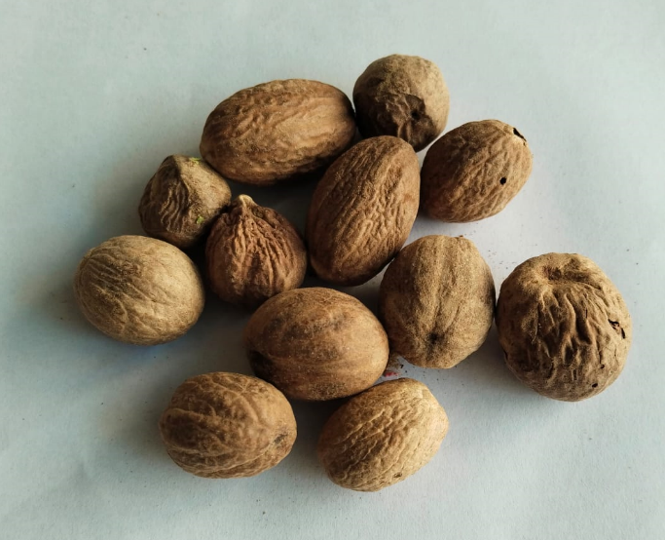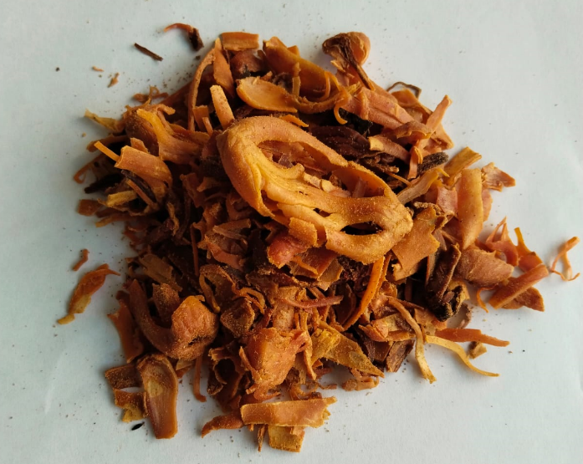

Figure S1. Myrictica fragrans outer covering (mace) and Seed

(Fig. S2) Correlation of DPPH assay and protein Inhibition

Fig. S3. Correlation of DPPH assay and proteinase inhibition

(Fig. S4) Correlation of DPPH assay and heat induced haemolysis