Evaluation of the Capability of Coumarin Dye as a Liquid Scintillator for Gamma Ray Detection and Compton Edge Localization.

**Saradh Prasad1,Nassar N. Asemi1,Saad Aldawood1, and Mohamad S. AlSalhi1,** **\***

1. Department of Physics and Astronomy, College of Science, King Saud University, 11451 Riyadh, Saudi Arabia ;[srajendra@ksu.edu.sa](mailto:srajendra@ksu.edu.sa), [malsalhi@ksu.edu.sa](mailto:malsalhi@ksu.edu.sa); [nasemi@ksu.edu.s](mailto:nasemi@ksu.edu.s)a and [sdawood@ksu.edu.sa](mailto:sdawood@ksu.edu.sa) .

Correspondence to E-mail: malsalhi@ksu.edu.sa

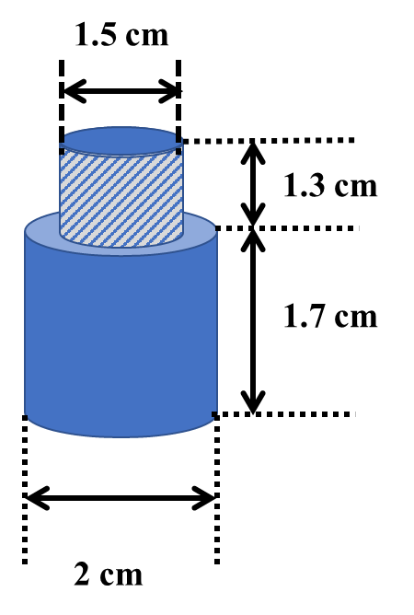

Fig. S1 dimensions of the glass container of LS

Table.S1. The count rate observed by fabricated cells using Cs-137 gamma source

|  |  |  |
| --- | --- | --- |
| **Scintillator** | **C450 Concentration (wt%)** | **Count rate minute (CRM) C/min** |
| LS1 | 0.11 | 24,266 ± 7.8 |
| LS2 | 0.22 | 34006 ± 9.2 |
| LS3 | 0.33 | 15574 ± 6.2 |



Fig. S2 the plot of calculated values of Gaussian fitting (Compton peak) such as mean energy $(\overline{N)},$ standard deviation (S.D), calculated CE, ratio (ρ) of CE to Maximum pulse Hight, curve goodness (χ2) using LS1, LS2, and LS3 for different voltages.

Table.S2. Mean Energy (channel), SD $\left(σ\right)$ [channel], calculated CE, the ratio of CE to Max Hight, and fitness of curve 2 of the Cs-137 pulse height distribution spectra obtained for LSs at different voltages of PMT.

|  |  |  |  |  |  |  |
| --- | --- | --- | --- | --- | --- | --- |
| **Type of cell** | **HV**  **(V)** | **Mean Energy $\overline{N}$**  **(channel)** | **S.D ( $σ)$ (channel)** | **CE *NCE* (channel)** | ***NCE* to Max Hight** | **2** |
| **LS1** | 865 | 1653.31 | 272.8956 | 1974.508107 | 0.5001 | 0.9933 |
| 885 | 2005.38 | 329.0782 | 2392.705071 | 0.4997 | 0.9912 |
| 905 | 2477.98 | 404.8 | 2954.43 | 0.4996 | 0.9892 |
| 925 | 2950.57 | 480.525 | 3516.147974 | 0.4994 | 0.9872 |
| 945 | 3509.31 | 611.1592 | 4228.644411 | 0.5005 | 0.9811 |
| 965 | 4239.44 | 736.8843 | 5106.752861 | 0.5013 | 0.9734 |
| 985 | 5108.96 | 865.2593 | 6127.370224 | 0.5014 | 0.9576 |
| **LS2** | 865 | 1340.40 | 229.5037 | 1610.525898 | 0.5070 | 0.9963 |
| 885 | 1711.95 | 287.5167 | 2050.357112 | 0.4971 | 0.9957 |
| 905 | 2052.24 | 353.5769 | 2468.400026 | 0.5008 | 0.9943 |
| 925 | 2500.15 | 420.6903 | 2995.302507 | 0.5003 | 0.9925 |
| 945 | 3002.58 | 513.1432 | 3606.5496 | 0.4985 | 0.9909 |
| 965 | 3586.64 | 631.1438 | 4329.496217 | 0.49801 | 0.988 |
| 985 | 4309.7 | 756.9496 | 5200.629634 | 0.5005 | 0.927 |
| **LS3** | 865 | 1289 | 221.8768 | 1550.149026 | 0.5011 | 0.9923 |
| 885 | 1571.28 | 271.0865 | 1890.348848 | 0.4998 | 0.9905 |
| 905 | 1908.34 | 326.3392 | 2292.441194 | 0.5015 | 0.98812 |
| 925 | 2293.16 | 392.8028 | 2755.488942 | 0.5004 | 0.9857 |
| 945 | 2786.98 | 451.3721 | 3318.244927 | 0.5008 | 0.98259 |
| 965 | 3369.72 | 561.2531 | 4030.314874 | 0.5008 | 0.9745 |
| 985 | 4081.22 | 649.4551 | 4845.628709 | 0.5019 | 0.9660 |