**Supplementary information for**

**Sunlight-driven photocatalytic and anticancer properties of biogenically synthesized gold nanoparticles (AuNPs) employing Polygala Elongata**

M. Elangovana, Murali Santhoshkumarb, Kumar Selvarajc,d, Kuppusamy Sathishkumare Manimaran Kumarf, , Mukesh Kumar Dharmalingam Jothinathane, Mansour K. Gatashehg, Gajendra Kumar Gauravh, K. Rajeshi*

a PG & Research Department of Chemistry, Indian arts and Science College, Kondam, Tamil Nadu, India

b Department of Biotechnology, Thiruvalluvar University, Serkkadu, Vellore, Tamil Nadu, 632 115, India

c Instituto de Desarrollo Tecnológico para la Industria Química (INTEC), CONICET, Ruta Nacional 168, Km. 0, Santa Fe, 3000, Argentina.

d Facultad de Ingeniería Química, Universidad Nacional del Litoral (UNL), Santiago del Estero 2829, Santa Fe, 3000, Argentina.

e Center for Global Health Research, Saveetha Medical College and Hospitals, Saveetha Institute of Medical and Technical Sciences (SIMATS), Saveetha University, Chennai, Tamil Nadu 602 105 India

f Research Center for Applied Microbiology, National Research and Innovation Agency (BRIN), Cibinong, 16911, Indonesia.

gDepartment of Biochemistry, College of Science, King Saud University, P.O Box 2455 Riyadh 11451 Saudi Arabia

h Schools of Physics and Electronic Information, Yan’an University, Yan’an 716000, China

i PG & Research Department of Chemistry, Arignar Anna Govt. Arts College, Cheyyar, Tamil Nadu, India

Corresponding authors: skumar21393@gmail.com; [Krisrajesh1977@gmail.com](mailto:Krisrajesh1977@gmail.com)

**Figure. S1 Synthesis of bio functionalized Au NPs using Polygala Elongata leaf extracts**

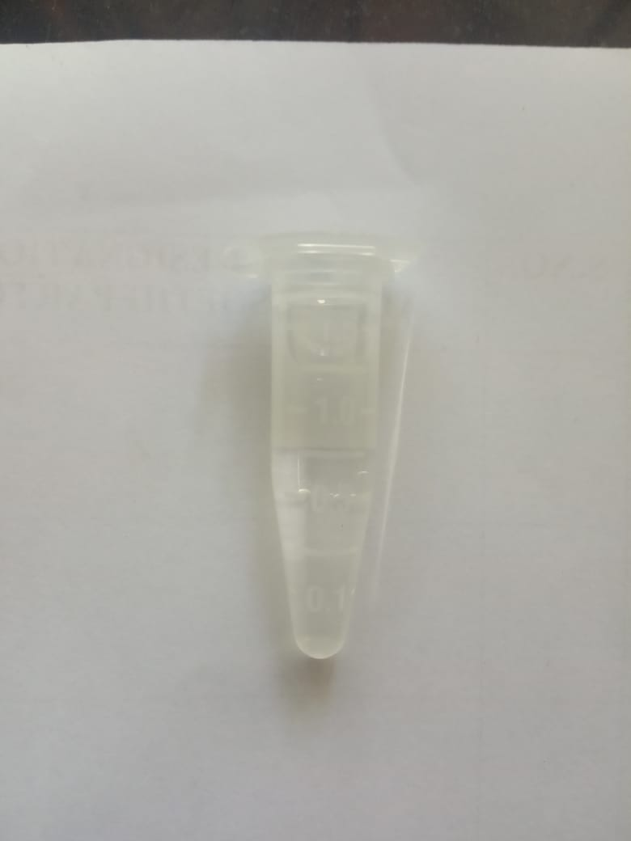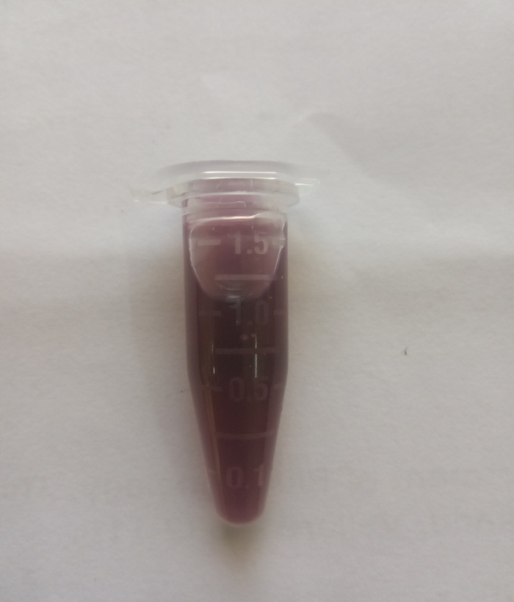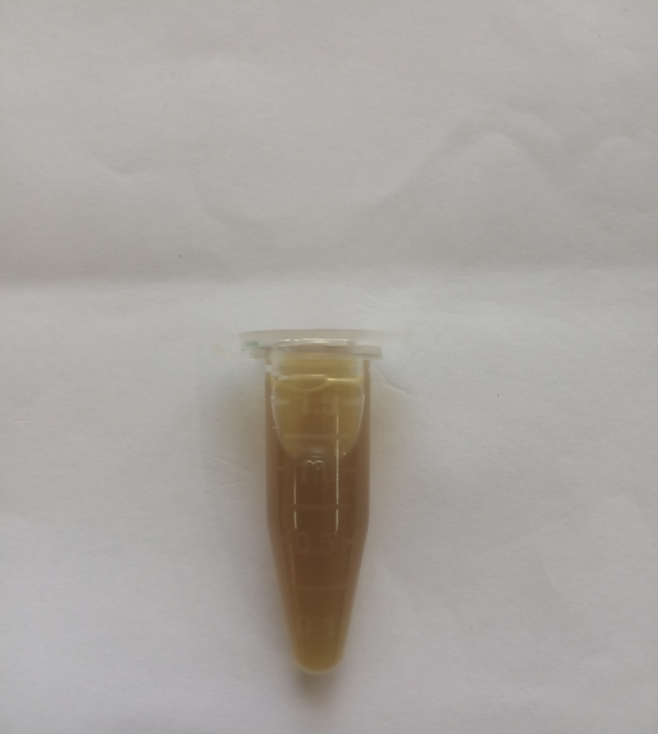

**1 mM Auric chloride Plant leaf extract AuNPs**