**Supplementary Tables**

**Table S1.** Preliminary phytochemical screening of *S. aromaticum* leaves extract.

|  |  |
| --- | --- |
| **Tests** | **Result** |
| **Alkaloids** | |
| Mayer | **+** |
| Wagner | ***+*** |
| Hager | ***+*** |
| Tannic acid | ***+*** |
| Dragendroff | ***+*** |
| **Flavonoids** | |
| Shinoda | **-** |
| Alkaline reagent | **+** |
| Ammonium | **+** |
| Lead acetate | **+** |
| **Saponins** | |
| Emulsion | **+** |
| Frothing | **+** |
| **Steroids and triterpenoids** | |
| Salkowski | **-** |
| **Tannins and phenols** | |
| Ferric Chloride | **-** |
| Gelatin | **+** |
| Braemer | **-** |
| **Glycosides** | |
| Legal | **+** |
| Keller-kiliani | **+** |
| Baljet’s | **-** |
| Borntrager’s | **-** |
| **Carbohydrates** | |
| Benedict’s | **-** |
| **Anthraquinones** | |
| Borntrager’s | **-** |
| KOH | **+** |
| **Coumarins** | |
| Cumarins | **+** |
| **Diterpenes** | |
| Copper acetate | **+** |
| **Catechins** | |
| Matchstick | **-** |
| **Anthocyanoside** | |
| Anthocyanosides | **-** |
| **Resins** | |
| Acetone water | **+** |
| **Oils and fats** | |
| Volatile oil | **+** |

Table S2: Anti-bacterial activity of *S. aromaticum* leaf extract

|  |  |  |  |
| --- | --- | --- | --- |
| **Pathogens** | **Zone of Inhibition (mm)** | | |
| **Plant extract** | **Standard (antibiotic)** | **Plant extract + antibiotic** |
| *E. coli* | 19±0.8 | 22±1.4*  (Streptomycin) | 22±0.6* |
| *B. subtilis* | 18±1.1 | 22±0.9**  (Streptomycin) | 23±1.5** |
| *P. aeruginosa* | 13±0.9 | 23±1***  (Streptomycin) | 23±1.3*** |
| *S. aureus* | 13±1.2 | 23±0.7*** (Linezolid) | 23±1.2*** |
| Z. mobilis | 17±0.6 | 20±0.9*  (Cefixime) | 20±0.5* |
| B. nakamurai | 14±0.4 | 13±0.3  (Cefixime) | 13±0.9 |
| C. albicans | 35±1.7 | 33±1.8  (Ketoconazole) | 40±2.2 **$, #** |

Values are means of triplicate determination (n = 3) ± standard deviations. Symbols in the same row indicate statistically significant differences; * p < 0.05; ** p < 0.01; *** p < 0.010 compared to plant extract. $ p < 0.01 compared to plant extract; # p < 0.001 compared to standard.

**Table S3:** MBC by *S. aromaticum*leaves extract against pathogenic microorganisms.

|  |  |  |
| --- | --- | --- |
| **Pathogens** | **MBC/MFC (µg/mL)** | **IC50 Value (µg/mL)** |
| *E. coli* | 100 | 90 |
| *B. subtilis* | 80 | 85 |
| *P. aeruginosa* | 80 | 64 |
| *S. aureus* | 100 | 120 |
| *Z. mobilis* | 120 | 80 |
| *B. nakamuria* | 120 | 124 |
| *C. albicans* | 80 | 83 |

**Table S4.** TLC of *S. aromaticum* leaf extract showing the distance of compounds from base line

|  |  |  |
| --- | --- | --- |
| **Distance of compound from base line (cm)** | **Name of compounds** | **Rf Value** |
| 6.2 | **A** | 0.578 |
| 7.8 | **B** | 0.469 |
| 8.2 | **C** | 0.442 |
| 8.4 | **D** | 0.428 |
| 9.5 | **E** | 0.353 |
| 10.5 | **F** | 0.285 |
| 12.4 | **G** | 0.156 |
| 14.5 | **H** | 0.013 |
| **Distance of solvent front: 14.7 cm** | | |

Table S5. UV spectrum peaks of *S. aromaticum* leaf extract.

|  |  |  |  |
| --- | --- | --- | --- |
| **No.** | **P/V** | **Wavelength (nm)** | **Abs** |
| 1 | Peak | 335.00 | 3.365 |
| 2 | Peak | 310.00 | 3.346 |
| 3 | Peak | 295.00 | 3.726 |
| 4 | Peak | 275.00 | 3.733 |
| 5 | Peak | 250.00 | 3.800 |
| 6 | Peak | 240.00 | 3.800 |

**Table S6**. GC-MS peaks and compounds name of *S. aromaticum* leaves extract.

|  |  |  |  |  |  |  |  |
| --- | --- | --- | --- | --- | --- | --- | --- |
| **Peak#** | **R. Time** | **Area** | **Area%** | **Height** | **Height%** | **Name** | **Base m/z** |
| 1 | 15.414 | 96423387 | 67.56 | 15753112 | 53.94 | Phenol, 2-methoxy-4-(2-propenyl)- | 164.10 |
| 2 | 17.010 | 5086212 | 3.56 | 1884121 | 6.45 | (-)-beta-caryophyllen | 93.15 |
| 3 | 18.581 | 8300812 | 5.82 | 2843044 | 9.73 | Germacrene-d | 161.15 |
| 4 | 21.110 | 3844083 | 2.69 | 1090973 | 3.74 | Caryophyllene, epoxide | 79.10 |
| 5 | 23.515 | 1559846 | 1.09 | 313062 | 1.07 | 6-isopropenyl-4,8a-dimethyl-1,2,3,5,6,7,8,8a-octahydro-2-naphthalenol | 159.10 |
| 6 | 26.473 | 2283329 | 1.60 | 576896 | 1.98 | Neophytadiene | 68.10 |
| 7 | 27.227 | 6617519 | 4.64 | 946935 | 3.24 | 1,2-benzenedicarboxylic acid, bis(2-methylpropyl) ester | 149.05 |
| 8 | 33.643 | 1569337 | 1.10 | 470595 | 1.61 | Phytol, acetate | 68.10 |
| 9 | 38.636 | 5029452 | 3.52 | 996470 | 3.41 | Anethole | 148.10 |
| 10 | 43.031 | 12014841 | 8.42 | 4331212 | 14.83 | Squalene | 69.10 |
|  |  | 142728818 | 100.00 | 29206420 | 100.00 |  |  |

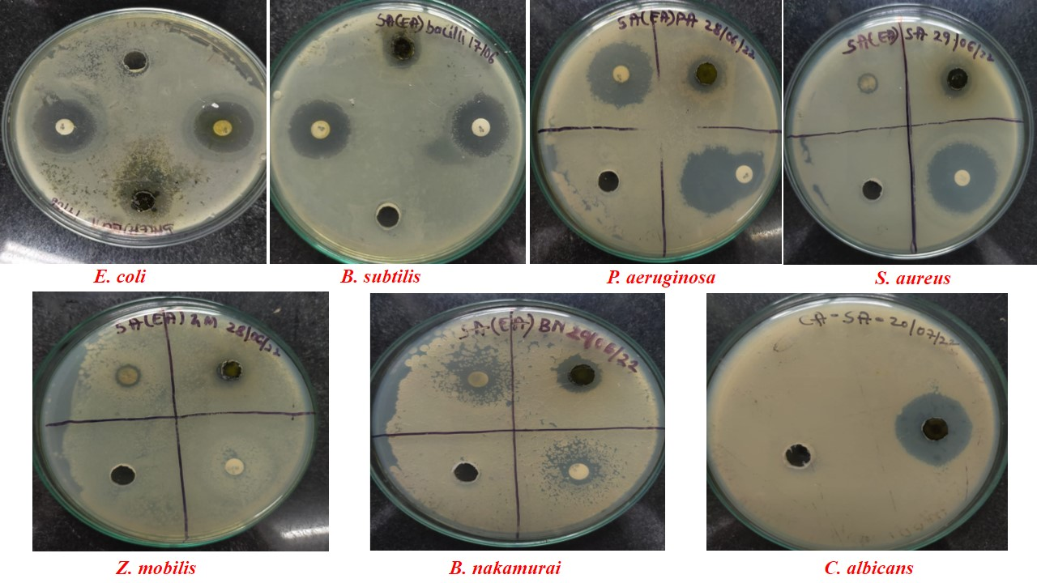

Figure S1: The antimicrobial activity of *S. aromaticum* leaf extract depicted by the zone of inhibition against pathogenic microorganisms.

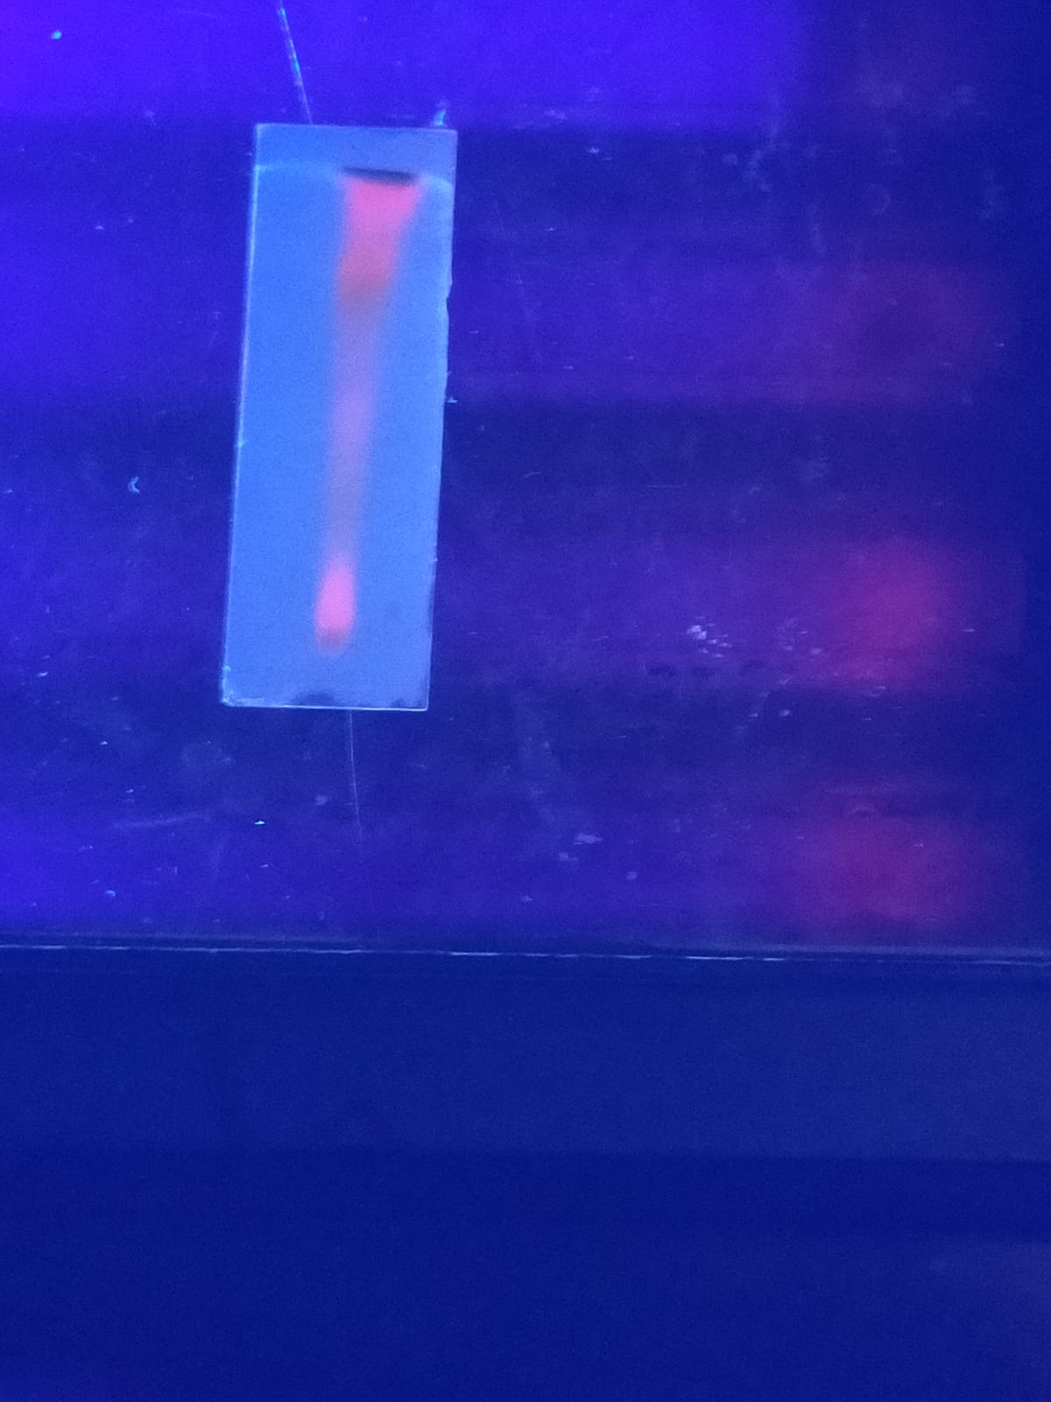

**Figure S2:** TLC photo documentation of *S. aromaticum* leaf extract