**Supplementary Data**

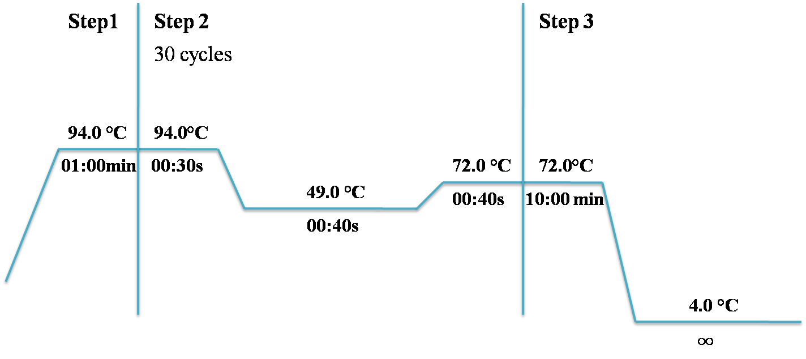

**Figure 1:** Optimized thermocycler conditions for the amplification of 16S rRNA of S.aureus. The 1-minute long initial denaturation (Step1) was followed by 30 cycles of denaturation, annealing, and extension (as outlined in Step2) terminating with a 10-minute long final extension (Step3).

**Table 1: Properties Of Plant Being Selected For The Study**

|  |  |  |  |  |
| --- | --- | --- | --- | --- |
| **Plant Name** | **Family** | **Habit** | **Part Used** | **Voucher No.** |
| *Bismarckia nobilis* | Arecaceae | Tree | Leaves | LAH#03919A |
| *Choysia ternata* | Arecaceae | Shrub | Leaves | LAH#03919E |
| *Beaucarnea recurvata* | Asparagaceae | Shrub | Leaves | LAH#03919B |
| *Chamaedora cataractarum* | Arecaceae | Shrub | Leaves | LAH#03919C |

**Table 2: Biochemical Characterization of Bacterial Strains**

|  |  |  |
| --- | --- | --- |
| **Sr No** | **Test** | **Result** |
| 1. | Growth on MSA | Golden Yellow colonies |
| 2. | Gram Staining | Gram positive cocci |
| 3. | Catalase Test | Catalase positive |
| 4. | Oxidase Test | Oxidase Negative |