**Harmonized Tripartite Approach: Enhancing Nutrient Accessibility, Uptake, and Wheat Productivity through *Trichoderma harzianum*, Compost, and Phosphorus Synergy**

Hamida Bibi1, 2*, Hafeez Ur Rahim3 *, Adnan Anwar Khan4, Muhammad Haris5, Mudassar Iqbal6,2, Roshan Ali7, Mohamed A. El-Sheikh8 and Prashant Kaushik9

1Department of Environmental Science, Abdul Wali Khan University Mardan, Pakistan.

2Department of Soil, Water, and Climate, University of Minnesota, United States of America.

3Department of Chemical, Pharmaceutical and Agricultural Sciences (DOCPAS), University of Ferrara, 44121 Ferrara, Italy.

4College of Natural Resources and Environment, Northwest A & F University, Yangling, Shaanxi, 712100, China.

5Department of Soil and Environmental Sciences, The University of Agriculture Peshawar, Pakistan.

6Department of Agriculture Chemistry and Biochemistry, The University of Agriculture Peshawar, Pakistan

7Agriculture Research Institute Mingora, Swat, Khyber Pakhtunkhwa, Pakistan.

8Botany and Microbiology Department, College of Science, King Saud University, Riyadh 11451, Saudi Arabia.

9 Instituto de Conservación y Mejora de la Agrodiversidad Valenciana, Universitat Politècnica de València, 46022 Valencia, Spain

*Corresponding author’s email: [drhamida@awkum.edu.pk](mailto:drhamida@awkum.edu.pk), hbibi@umn.edu

[hafeezur.rahim@unife.it](mailto:hafeezur.rahim@unife.it)

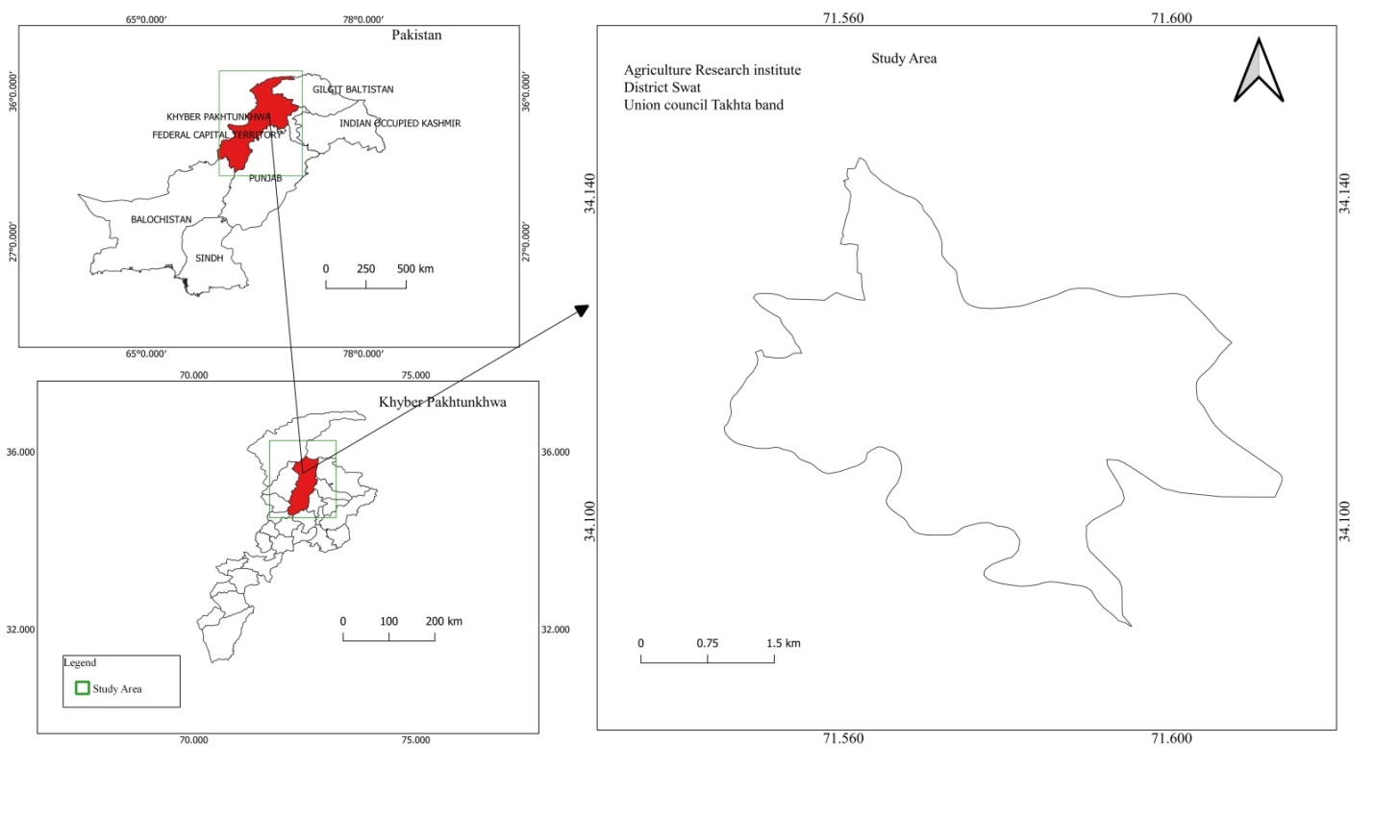

**Fig.S1:** Geographical location of study site (Agricultural Research Institute Swat, Khyber Pakhtunkhwa, Pakistan).

**Fig.S2**: Monthlyweather data recorded during the experimental period (from wheat sowing to harvesting).