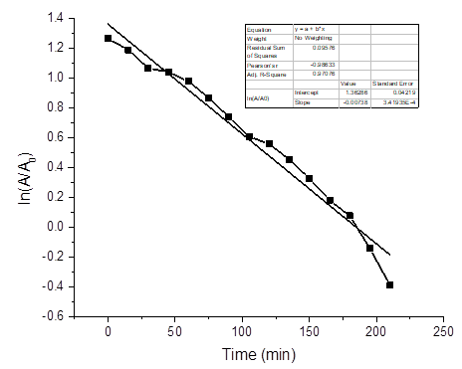

Fig. S1: First-order-kinetic plot for the degradation of MB dye using CuO NPs

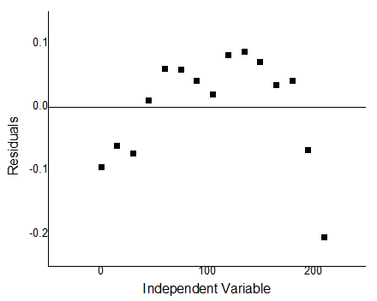

Fig. **S2:** First-order-kinetic plot: Residual versus independent variable

**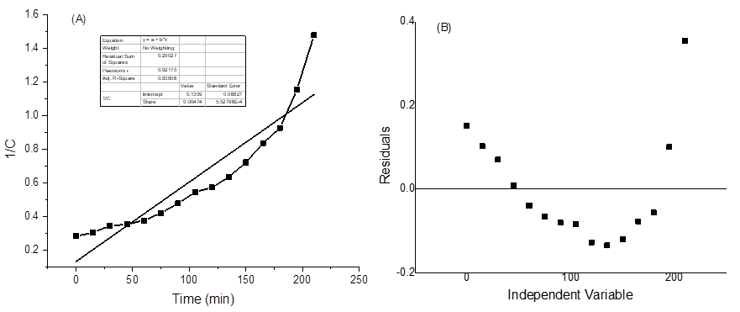**

Fig. **S3:** Second-order-kinetic plot for the degradation of MB dye using CuO NPs



Fig. S4. Reusability and recyclability of the of the CuO nanoparticle up to 5 cycles

Table S1: Effect of CuO NPs dose on the MB dye degradation

|  |  |  |
| --- | --- | --- |
| **Dose** | **UV Visible Spectra** | **Visual Observation** |
| **10 mg** |  | 20181129_101643 20181126_095554 50 mg 50 ppm copy 20181130_091930 100 mg 3 0min 30min 60min 90min 120min |
| **20 mg** |  | 20181129_101643 20181126_095554 20181126_095554 20181130_092035 20181130_091557  0min 30min 60min 90min 120min |
| **30 mg** |  | 20181129_101643 20181127_100520 50 mg 50 ppm copy 50 ppm 20181127_100216  0min 30min 60min 90min 120min |
| **40 mg** |  | 20181129_101643 10 mg 20181130_091808 20181130_092035 20181130_091957  0min 30min 60min 90min 120min |
| **50 mg** |  | 20181129_101643 20181126_095554 50 mg 50 ppm copy 100 mg 3 10 ppm after 2 hours  0min 30min 60min 90min 120min |

Table S2: Effect of dye initial concentration on the MB dye degradation using CuO NPs

|  |  |  |
| --- | --- | --- |
| **Conc.** | **UV Visible Spectra** | **Visual Observation** |
| **(a) 10 ppm** |  | **10ppm 10ppm 0,1g 5ppm 0.1 10 ppm 10 ppm 10 ppm 5ppm 0.01 g**  0min 15min 30min 45min 60min 75min 90min |
| **(b)20 ppm** |  | 10 mg 10 mg 20181130_091930 20181127_090944 20181130_092035 20181129_100655 20181129_100655  0min 15min 30min 45min 60min 75min 90min |
| **(c) 30 ppm** |  | 20181126_095554 20181130_091930 20181127_100312 20181127_100216 20181127_100239 20181127_100151 20181127_100130  0min 15min 30min 45min 60min 75min 90min |
| **d) 40 ppm** |  | 20181129_101643 20181126_095502 100 mg 3 50 ppm 50 mg 50 ppm copy 20181130_091653 20181130_0915570min 15min 30min 45min 60min 75min 90min |
| **(e) 50 ppm** |  | 20181129_101643 20181126_095554 20181126_095554 20181126_095502 50 mg 50 ppm copy 20181130_091930 100 mg 3  0min 15min 30min 45min 60min 75min 90min |