**Supplementary Material**

**Comprehensive In Silico Discovery of c-Src Tyrosine Kinase Inhibitors in cancer Treatment: A Unified Approach Combining Pharmacophore Modeling, 3D QSAR, DFT, and Molecular Dynamics Simulation**

Saida Khamouli1\*, Md. Tabish Rehman2\*, Nadjiba Zegheb3, Afzal Hussain2, Meraj A Khan4

1Group of Computational and Pharmaceutical Chemistry, LMCE Laboratory, University of Biskra, BP 145 Biskra, 07000, Algeria

2Department of Pharmacognosy, College of Pharmacy, King Saud University, Riyadh, 11451, Saudi Arabia

3VTRS Laboratory, University of El Oued B.P.789, 39000, El Oued, Algeria

4Program in Translational Medicine, Peter Gilgan Centre for Research and Learning, The Hospital for Sick Children, Toronto, Ontario, M5G 0A4, Canada and DigiBiomics Inc., Ontario, L5M 6W5, Canada

**\*Corresponding authors**

Dr. Md Tabish Rehman

Department of Pharmacognosy

College of Pharmacy

King Saud University

Riyadh, 11451, Saudi Arabia

E-mail: [mrehman@ksu.edu.sa](mailto:mrehman@ksu.edu.sa)

Dr. Saida Khamouli

Professor

Group of Computational and Pharmaceutical Chemistry

LMCE Laboratory

University of Biskra

BP 145 Biskra, 07000, Algeria

E-mail: [s.khamouli@univ-biskra.dz](mailto:s.khamouli@univ-biskra.dz)

**Table S1.**Chemical structures for the data set of 34 compounds with corresponding pIC50 values**.**

|  |  |  |  |
| --- | --- | --- | --- |
| Compounds 1-2 | Compounds 3-11 | Compounds 12-23 | Compounds 24-34 |

|  |  |  |  |  |  |  |
| --- | --- | --- | --- | --- | --- | --- |
| **S. No.** | **R1** | **R2** | **R3** | **Experimental activity** | **Predicted activity** | **Residual** |
| 1T |  |  | H | 5.614 | 5.646 | 0.032 |
| 2 |  |  | H | 5.616 | 5.631 | 0.015 |
| 3 | 3-Methoxy | H | H | 5.917 | 5.973 | 0.056 |
| 4 | 4-Chloro | H | H | 5.928 | 5.892 | -0.036 |
| 5T | 4-Bromo | H | H | 5.754 | 5.840 | 0.086 |
| 6 | 4-Nitro | H | H | 5.853 | 5.802 | -0.050 |
| 7T | 3-Nitro | H | H | 6.022 | 5.834 | -0.187 |
| 8 | 4-Aminosulfonyl | H | H | 5.739 | 5.825 | 0.086 |
| 9 | 3-Aminosulfonyl | H | H | 7.000 | 6.927 | -0.072 |
| 10 | 4-Carbamoyl | H | H | 5.657 | 5.562 | -0.094 |
| 11T | 4-Acetamido | H | H | 5.978 | 6.100 | 0.122 |
| 12 | H | H | H | 6.124 | 6.348 | 0.224 |
| 13 | 4-Methoxy | H | H | 6.886 | 6.677 | -0.208 |
| 14 | 3-Methoxy | H | H | 6.031 | 6.018 | -0.012 |
| 15T | 3-Methyl | H | H | 6.080 | 6.030 | -0.049 |
| 16 | 4-Chloro | H | H | 6.468 | 6.251 | -0.216 |
| 17 | 4-Bromo | H | H | 6.346 | 6.158 | -0.187 |
| 18 | 4-Nitro | H | H | 6.408 | 6.459 | 0.051 |
| 19 | 3-Nitro | H | H | 6,886 | 6.876 | -0.009 |
| 20 | 4-Aminosulfonyl | H | H | 7.698 | 7.766 | 0.068 |
| 21T | 3-Aminosulfonyl | H | H | 6.920 | 6.896 | -0.023 |
| 22 | 4-Carbamoyl | H | H | 5.696 | 5.845 | 0.149 |
| 23 | 4-Acetamido | H | H | 6.187 | 6.328 | 0.141 |
| 24 | H | H | H | 5.503 | 5.843 | 0.340 |
| 25 | 4-Methoxy | H | H | 5,876 | 5.934 | 0.058 |
| 26 | 3-Methoxy | H | H | 5.920 | 5.619 | -0.300 |
| 27 | 3-Methyl | H | H | 5.602 | 5.722 | 0.120 |
| 28T | 4-Chloro | H | H | 6.161 | 5.940 | -0.220 |
| 29T | 4-Nitro | H | H | 6.107 | 6.155 | 0.048 |
| 30 | 3-Nitro | H | H | 6.468 | 6.453 | -0.014 |
| 31 | 4-Aminosulfonyl | H | H | 6.585 | 6.553 | -0.031 |
| 32T | 3-Aminosulfonyl | H | H | 6.468 | 6.362 | -0.105 |
| 33 | 4-Carbamoyl | H | H | 5.913 | 5.776 | -0.136 |
| 34 | 4-Acetamido | H | H | 5.798 | 5.854 | 0.056 |

**T:** Test set molecules

**Table S2.** Intersite distances and angles between the pharmacophoric points of DDRRR\_1.

|  |  |  |  |  |  |  |
| --- | --- | --- | --- | --- | --- | --- |
| **Site 1** | **Site 2** | **Distance** | **Site 1** | **Site2** | **Site 3** | **Angle** |
| D6 | R10 | 3.94 | R9 | D6 | R10 | 92.6 |
| D6 | R8 | 3.80 | R9 | D6 | R8 | 36.0 |
| D6 | D5 | 6.64 | R9 | D6 | D9 | 37.4 |
| R9 | R10 | 5.69 | D6 | R10 | R9 | 43.7 |
| R9 | R8 | 2.39 | D6 | R10 | R8 | 25.2 |
| R9 | D5 | 4.25 | R10 | R9 | R8 | 112.5 |
| R8 | R10 | 6.67 | R8 | R9 | D6 | 39.6 |
| R8 | D5 | 2.85 | D6 | R9 | D5 | 18.6 |
|  |  |  | R9 | D5 | R8 | 32.4 |

**Table S3.** q2 and r2 values after several Y-randomization test.

|  |  |  |
| --- | --- | --- |
| **Iteration** | **R2** | **q2** |
| Random\_1 | 0.921 | 0.120 |
| Random\_2 | 0.962 | -0.116 |
| Random\_3 | 0.938 | -0.022 |
| Random\_4 | 0.927 | 0.397 |
| Random\_5 | 0.885 | 0.419 |
| Random\_6 | 0.945 | 0.230 |
| Random\_7 | 0.950 | -0.104 |
| Random\_8 | 0.939 | 0.329 |
| Random\_9 | 0.909 | 0.224 |
| Random\_10 | 0.929 | 0.103 |

**Table S4.** Frontier molecular orbitals (FMO) of studied compounds and their energy gaps.

|  |  |  |  |
| --- | --- | --- | --- |
| **PubChem ID** | **EHOMO(eV)** | **ELUMO(eV)** | **ΔE (eV)** |
| CID\_70144047 | -6.122 | -1.469 | 4.653 |
| CID\_11291395 | -4.136 | -2.258 | 1.877 |
| CID\_22844919 | -6.095 | -1.251 | 4.843 |
| CID\_134165918 | -7.319 | -2.530 | 4.789 |
| CID\_60151031 | -6.204 | -1.224 | 4.979 |

**Table S5.** ADME prediction of top five hits and reference compound.

|  |  |  |  |  |  |  |  |  |  |  |
| --- | --- | --- | --- | --- | --- | --- | --- | --- | --- | --- |
| **Pubchem ID** | **QPlog**  **Po/w** | **QPlogS** | **MW** | **QPlog**  **BB** | **QPlog**  **HERG** | **QPP**  **caco** | **QPP**  **MDCK** | **QPlog**  **KP** | **% HOA** | **QPlog**  **khsa** |
| CID\_70144047 | 1.135 | -3.688 | 385.422 | -1.727 | -5.971 | 218.275 | 95.476 | -3.051 | 75.457 | -0.502 |
| CID\_11291395 | 1.474 | -3.802 | 361.787 | -0.997 | -5.557 | 410.245 | 465.650 | -2.867 | 82.345 | -0.424 |
| CID\_22844919 | 1.085 | -3.580 | 381.449 | -1.670 | -5.083 | 202.217 | 155.445 | -3564 | 74.562 | -0.541 |
| CID\_134165918 | 1.650 | -4.439 | 394.405 | -1.620 | -5.063 | 179.402 | 114484 | -4.074 | 76.944 | -0.238 |
| CID\_60151031 | 2.039 | -4.378 | 461.535 | -1.890 | -5.898 | 202.905 | 147.887 | -3..003 | 80.179 | -0.332 |
| Co-Crystal ligand | 1.703 | -4.851 | 479.583 | -0.131 | -0.131 | 2683.504 | 1437.892 | -2.622 | 85.327 | -0.348 |

QPlogPo/w, predicted octanol/water partition coefficient (-2.0 to 6.5); QPlogS, predicted aqueous solubility in mol dm-3 (-6.5 to 0.5); QPlogHERG, HERG K+ channels (acceptable range below -6.0); QPPCaco, predicted apparent Caco-2 cell (gut-blood barrier model) permeability in nm/sec (,25 poor; .500 excellent); QPlogBB, predicted brain/blood partition coefficient (-3 to 1.2); QPlogKhsa, prediction of binding to human serum albumin (-1.5 to 0.5); percent human oral absorption (<25 poor; >80 high)

**Table S6.** Toxicity prediction of top five hits and reference compound.

|  |  |  |  |  |  |
| --- | --- | --- | --- | --- | --- |
| **Pubchem ID** | **Mutagenicity** | **Carcinogenicity** | **Hepatotoxicity** | **Cytotoxicity** | **Immunotoxicity** |
| CID\_70144047 | No | No | No | No | No |
| CID\_11291395 | No | No | Yes | No | No |
| CID\_22844919 | No | No | No | No | No |
| CID\_134165918 | No | No | Yes | No | No |
| CID\_60151031 | Yes | Yes | No | No | No |
| Co-Crystal ligand | No | No | Yes | No | Yes |

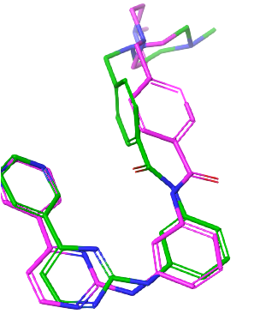

**Figure S1.** Re-docking pose and RMSD value of 1.735 A˚ (purple = Original, Green = Docked).

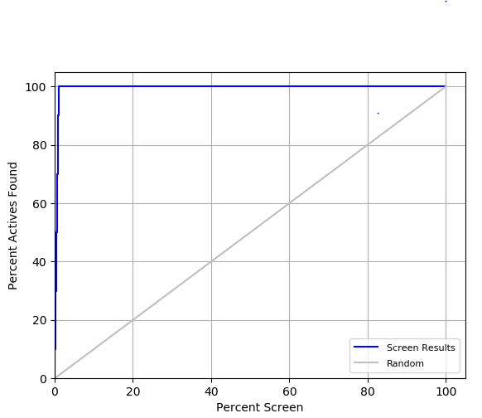

**Figure S2.** ROC curve obtained by DDRRR\_1 model against randomly curve.

C:\Users\mrehman\Google Drive\Dr. Sadia Khamouli\Article 1_Final\KSU-Science J\Supp.tif

**Figure S3.** Plots of experimental activities against predicted activities of the (A) training set, and (B) test set.