**Supplementary Table S1** Characteristics of the reactive dyes used in this study.

|  |  |  |  |  |  |
| --- | --- | --- | --- | --- | --- |
| Azo dyes | Molecular weight | Color index number | Dye content (%) | λ*max* | Structure |
| Reactive Yellow 2 | 873.00 | 18972 | 65 | 404 | C.I.Reactive Yellow 2,C.I.18972,CAS 50662-99-2,872.97,C25H15Cl3N9Na3O10S3,Reactive Brilliant Yellow K-4GL,Reactive Yellow P-5G,Reactive Brilliant Yellow K-6G |
| Reactive Black 5 | 991.80 | 20505 | 55 | 597 | Reactive Black 5 Dye content 55 % |
| Reactive Orange 16 | 601.54 | 17757 | 70 | 494 | Reactive Orange 16 Dye content ≥70 % |
| Reactive Red 120 | 1469.98 |  | 50-70 | 535 | Reactive Red 120 |

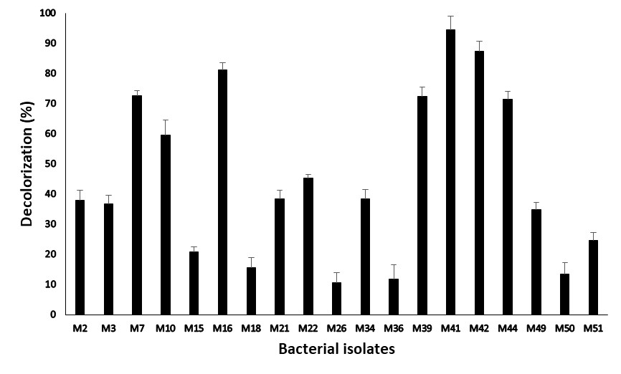

**Supplementary Fig. S1** Decolorization of reactive black-5 by various bacteria isolated from different textile wastewater samples in the presence of a mixture of Cd (10 mg L-1), Pb (10 mg L-1) and Ni (10 mg L-1) in mineral salt medium.

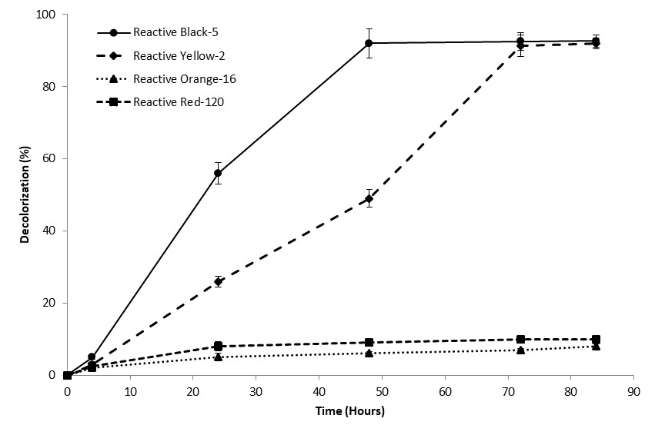

**Supplementary Fig. S2** Decolorization of different selected reactive azo dyes by *Citrobacter* sp. M41 in the presence of a mixture of Cd (10 mg L-1), Pb (10 mg L-1) and Ni (10 mg L-1) in mineral salt medium.