Table S1. List of localities, their respective number of sequences (NS), their accession numbers to GenBank, and references of *Coptodon rendalli* populations per location.

|  |  |  |  |
| --- | --- | --- | --- |
| localities | NS | Sequences reference number (COI) | Reference |
| South Africa | 21 | HQ959717, HQ959715, HQ567376, HM914644, HM914635, HM914634, HM914633, HM914631. (PP352615, PP352616, PP352617, PP352618, PP352619, PP352620, PP352621, PP352622, PP352623, PP352624, PP352625, PP352626, PP352627) | Van der Bank et al., 2010, Unpublished; (Current study) |
| Namibia | 1 | HM394826 | Van der Bank et al., 2009, Unpublished |
| Democratic Republic of the Congo | 2 | KT193490, KT193036 | Decru et al., 2015. |
| Thailand | 6 | MK049496, MK049495, MK448081, MG438463, MG438462, MG438461, | Panprommin et al., 2019 |
| Mauritania | 1 | KJ938227, | Kide et al., 2016 |
| Colombia | 3 | KY454446, KY454445, KY454444, | Montoya et al., 2017; Unpublished |
| Tanzania | 6 | KU193980, OP680724, OP680725, OP680726, OP680727, OP680728 | Breman et al., 2016; Chuhila et al., 2022 |
| Brazil | 9 | JN989250, JN989249, JN989248, JN989247, JN989246, JN989245, JN989244, JN989243, MN879922, | Pereira et al., 2013 |
| Madagascar | 36 | ON604143, ON604142, ON604141, ON604140, ON604139, ON604138, ON604137, ON604136, ON604135, ON604134, ON604133, ON604132, ON604131, ON604130, ON604129, ON604128, ON604127, ON604126, ON604125, ON604124, ON604123, ON604122, ON604121, ON604120, ON604119, ON604118, ON604117, ON604116, ON604115, ON604114, ON604113, ON604112, ON604111, ON604110, ON604109, ON604108. | Vences et al., 2022 |
| Mozambique | 1 | MZ269459 | Ferrari et al., 2021; Unpublished |
| Panama | 4 | MT418502, MT418503, MZ269460, MT418504, | Diaz-Ferguson, 2021; Unpublished |

Table S1. List of localities, their respective number of sequences (NS), references, and their accession numbers to GenBank

|  |  |  |  |
| --- | --- | --- | --- |
| localities | NS | Sequences reference number (D-loop) | Reference |
| South Africa | 20 | PP350705, PP350706, PP350707, PP350708, PP350709, PP350710, PP350711, PP350712, PP350713, PP350714, PP350715, PP350716, PP350717, PP350718, PP350719, PP350720, PP350721, PP350722, PP350723, PP350724 | Current study |
| Zimbabwe | 3 | AF296505, AF296503, AF328854 | Nagl et al., 2001 |
| Mauritania | 1 | KJ925075 | Durand et al., 2015 |
| Tanzania | 6 | MH644435, MH644434, MH644433, MH644432, MH644431, MH644430. | Moser et al., 2018 |

Table S3. Heatmap of pairwise FST values estimated from mitochondrial DNA COI sequence data. *indicates significant difference (P < 0.05)

|  |  |  |  |  |  |  |  |  |  |  |  |
| --- | --- | --- | --- | --- | --- | --- | --- | --- | --- | --- | --- |
|  | South Africa | Namibia | D.R. Congo | Mauritania | Tanzania | Madagascar | Mozambique | Colombia | Brazil | Panama | Thailand |
| South Africa | 0 |  |  |  | * |  |  |  | * |  | * |
| Namibia | -0.9479 | 0 |  |  |  |  |  |  |  |  |  |
| D.R. Congo | 0.3672 | -1 | 0 |  |  | * |  |  | * |  | * |
| Mauritania | -0.9479 | 0 | -1 | 0 |  |  |  |  |  |  |  |
| Tanzania | 0.79484 | 0.63118 | 0.44533 | 0.63118 | 0 | * |  | * | * | * | * |
| Madagascar | 0.06064 | 0 | 0.89729 | 0 | 0.94808 | 0 |  |  | * |  | * |
| Mozambique | -0.9479 | 0 | -1 | 0 | 0.63118 | 0 | 0 |  |  |  |  |
| Colombia | -0.17588 | 0 | 0.25 | 0 | 0.74763 | 0 | 0 | 0 | * |  | * |
| Brazil | 0.66997 | 0.55354 | 0.44841 | 0.55354 | 0.61116 | 0.90549 | 0.55354 | 0.6691 | 0 | * |  |
| Panama | -0.11863 | 0 | 0.38462 | 0 | 0.77594 | 0 | 0 | 0 | 0.69587 | 0 | * |
| Thailand | 0.73459 | 1 | 0.73383 | 1 | 0.73561 | 1 | 1 | 1 | -0.05109 | 1 | 0 |

|  |  |  |  |  |
| --- | --- | --- | --- | --- |
|  | South Africa | Zimbabwe | Mauritania | Tanzania |
| South Africa | 0 | * |  | * |
| Zimbabwe | 0.88833 | 0 |  |  |
| Mauritania | 0.84254 | 0.9375 | 0 |  |
| Tanzania | 0.91436 | 0.67568 | 1 | 0 |

Table S4. Heatmap of pairwise FST values estimated from mitochondrial DNA D-loop sequence data. *indicates significant difference (P < 0.05)

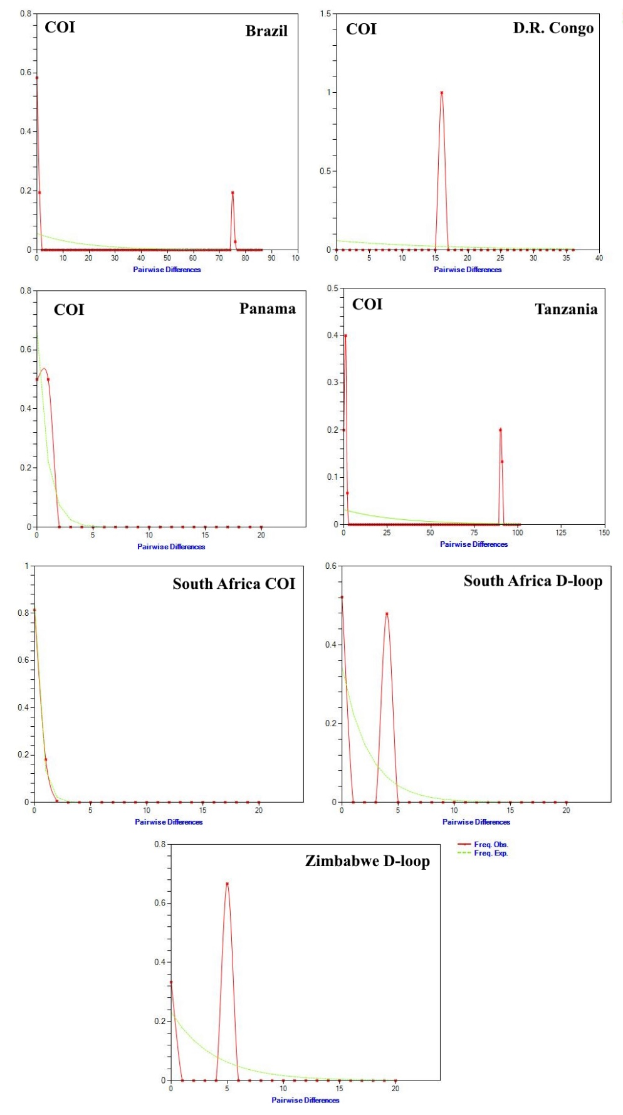

**Fig. S1.** Mismatch distributions from COI and D-loop sequences for *Coptodon rendalli* populations per location.

**Reference**

Breman, F. C., Loix, S., Jordaens, K., Snoeks, J., & Steenberge, M. V. (2016). Testing the potential of DNA barcoding in vertebrate radiations: The case of the littoral cichlids (Pisces, Perciformes, Cichlidae) from Lake Tanganyika. *Molecular Ecology Resources*, *16*(6), 1455-1464. https://doi.org/10.1111/1755-0998.12523

Chuhila, Y. J., Chibwana, F. D., Katandukila, J. V., & Mwita, C. J. (2022). DNA barcoding and delimitation of critically endangered indigenous and introduced tilapias (pisces cichlidae) of Pangani catchment, Northern Tanzania. *Mitochondrial DNA Part A*, *33*(1–8), 40–52. <https://doi.org/10.1080/24701394.2023.2299394>

Decru, E., Moelants, T., Gelas, K. D., Vreven, E., Verheyen, E., & Snoeks, J. (2015). Taxonomic challenges in freshwater fishes: A mismatch between morphology and DNA barcoding in fish of the north-eastern part of the Congo basin. *Molecular Ecology Resources*, *16*(1), 342-352. <https://doi.org/10.1111/1755-0998.12445>

Kide, N. G., Dunz, A., Agnèse, F., Dilyte, J., Pariselle, A., Carneiro, C., Correia, E., Brito, J. C., Yarba, L. O., Kone, Y., & Durand, D. (2016). Cichlids of the Banc d'Arguin National Park, Mauritania: Insight into the diversity of the genus Coptodon. *Journal of Fish Biology*, *88*(4), 1369-1393. <https://doi.org/10.1111/jfb.12899>

Moser FN, van Rijssel JC, Mwaiko S, Meier JI, Ngatunga B, Seehausen O. The onset of ecological diversification 50 years after colonization of a crater lake by haplochromine cichlid fishes. Proc Biol Sci. 2018 Aug 15;285(1884):20180171. doi: 10.1098/rspb.2018.0171. Erratum in: Proc Biol Sci. 2018 Sep 5;285(1886):20181910. doi: 10.1098/rspb.2018.1910. PMID: 30111604; PMCID: PMC6111161.

Nagl, S., Tichy, H., Mayer, W. E., Samonte, I. E., McAndrew, B. J., & Klein, J. (2001). Classification and Phylogenetic Relationships of African Tilapiine Fishes Inferred from Mitochondrial DNA Sequences. *Molecular Phylogenetics and Evolution*, *20*(3), 361-374. https://doi.org/10.1006/mpev.2001.0979

Panprommin, D., Soontornprasit, K., Tuncharoen, S., Pithakpol, S., & Keereelang, J. (2019). DNA barcodes for the identification of species diversity in fish from Kwan Phayao, Thailand. *Journal of Asia-Pacific Biodiversity*, *12*(3), 382-389. https://doi.org/10.1016/j.japb.2019.05.003

Pereira, L.H., Hanner, R., Foresti, F. *et al.* Can DNA barcoding accurately discriminate megadiverse Neotropical freshwater fish fauna?. *BMC Genet* **14**, 20 (2013). https://doi.org/10.1186/1471-2156-14-20

Vences, M., Stützer, D., Raminosoa, N. R., & Ziegler, T. (2022). Towards a DNA barcode library for Madagascar’s threatened ichthyofauna. *PLOS ONE*, *17*(8), e0271400. https://doi.org/10.1371/journal.pone.0271400