**Supplementary information**

**Table S1.**  **Optimized geometrical parameters of 24DCA on HF/B3LYP/CAM-B3LYP Methods with 6-311++G (d, p) Basis set**

|  |  |  |  |  |
| --- | --- | --- | --- | --- |
| **Bond length (Å)** | **HF/**  **6-311++G(d,p)** | **B3LYP/**  **6-311++G(d,p)** | **CAM- B3LYP/**  **6-311++G(d,p)** | **XRD (Å)** |
| C1-C2 | 1.388 | 1.402 | 1.395 | 1.390 |
| C1-C6 | 1.393 | 1.405 | 1.397 | 1.396 |
| C1-C12 | 1.514 | 1.513 | 1.509 | 1.468 |
| C2-C3 | 1.385 | 1.394 | 1.388 | 1.370 |
| C2-CL11 | 1.745 | 1.760 | 1.748 | 1.736 |
| C3-C4 | 1.379 | 1.389 | 1.383 | 1.399 |
| C3-H10 | 1.072 | 1.081 | 1.081 | 1.082 |
| C4-C5 | 1.382 | 1.392 | 1.386 | 1.398 |
| C4-CL9 | 1.739 | 1.752 | 1.741 | 1.732 |
| C5-C6 | 1.379 | 1.386 | 1.381 | 1.369 |
| C5-H8 | 1.073 | 1.082 | 1.081 | 0.930 |
| C6-H7 | 1.073 | 1.083 | 1.082 | 1.090 |
| C12-O13 | 1.189 | 1.215 | 1.209 | 1.215 |
| C12-C14 | 1.513 | 1.514 | 1.507 | 1.498 |
| C14-H15 | 1.082 | 1.090 | 1.089 | 1.000 |
| C14-H16 | 1.082 | 1.091 | 1.089 | 0.860 |
| C14-H17 | 1.084 | 1.093 | 1.092 | 0.910 |

|  |  |  |  |  |
| --- | --- | --- | --- | --- |
| **Bond angle(°)** | **HF/**  **6- 311++G(d,p)** | **B3LYP/**  **6-311++G(d,p)** | **CAM B3LYP/**  **6-311++G(d,p)** | **XRD (Å)** |
| C2-C1-C6 | 117.5 | 117.0 | 117.3 | 116.7 |
| C2-C1-C12 | 126.6 | 127.6 | 127.3 | 119.7 |
| C6-C1-C12 | 115.9 | 115.4 | 115.4 | 123.6 |
| C1-C2-C3 | 121.6 | 121.7 | 121.5 | 122.3 |
| C1-C2-CL11 | 122.0 | 122.5 | 122.4 | 120.1 |
| C3-C2-CL11 | 116.3 | 115.7 | 116.0 | 118.3 |
| C2-C3-C4 | 119.1 | 119.1 | 119.2 | 120.3 |
| C2-C3-H10 | 120.2 | 120.2 | 120.2 | 119.6 |
| C4-C3-H10 | 120.7 | 120.7 | 120.7 | 120.6 |
| C3-C4-C5 | 121.1 | 121.1 | 121.0 | 120.5 |
| C3-C4-CL9 | 119.1 | 119.1 | 119.2 | 119.4 |
| C5-C4-CL9 | 119.7 | 119.8 | 119.8 | 118.8 |
| C4-C5-C6 | 118.7 | 118.6 | 118.6 | 120.5 |
| C4-C5-H8 | 120.5 | 120.4 | 120.3 | 119.0 |
| C6-C5-H8 | 120.8 | 121.0 | 121.0 | 118.2 |
| C1-C6-C5 | 122.0 | 122.5 | 122.3 | 122.1 |
| C1-C6-H7 | 118.2 | 117.4 | 117.5 | 118.0 |
| C5-C6-H7 | 120.1 | 120.2 | 119.7 | 119.0 |
| C1-C12-O13 | 118.4 | 118.3 | 118.5 | 120.0 |
| C1-C12-C14 | 121.2 | 121.2 | 120.9 | 120.7 |
| O13-C12-C14 | 120.2 | 120.3 | 120.5 | 120.1 |
| C12-C14-H15 | 107.7 | 107.7 | 107.5 | 112.0 |
| C12-C14-H16 | 112.7 | 112.7 | 112.6 | 105.0 |
| C12-C14-H17 | 109.8 | 109.7 | 109.4 | 111.0 |
| H15-C14-H16 | 110.6 | 110.6 | 110.3 | 105.0 |
| H15-C14-H17 | 108.3 | 108.4 | 108.4 | 112.0 |
| H16-C14-H17 | 107.6 | 107.7 | 108.4 | 111.0 |

References taken from [22,23]

|  |  |  |  |
| --- | --- | --- | --- |
| **Dihedral angle(°)** | **HF/**  **6-311++G(d,p)** | **B3LYP/**  **6-311++G(d,p)** | **CAM B3LYP/**  **6-311++G(d,p)** |
| C6-C1-C2-C3 | -0.85 | -0.84 | -0.87 |
| C6-C1-C2-CL11 | 176.34 | 176.18 | 176.33 |
| C12-C1-C2-C3 | 179.54 | 179.39 | 179.38 |
| C12-C1-C2-CL11 | -3.28 | -3.59 | -3.41 |
| C2-C1-C6-C5 | 1.71 | 1.68 | 1.62 |
| C2-C1-C6-H7 | -178.41 | -178.46 | -178.37 |
| C12-C1-C6-C5 | -178.63 | -178.53 | -178.60 |
| C12-C1-C6-H7 | 1.25 | 1.34 | 1.41 |
| C2-C1-C12-O13 | 142.00 | 151.32 | 149.98 |
| C2-C1-C12-C14 | -42.12 | -32.27 | -33.72 |
| C6-C1-C12-O13 | -37.62 | -28.45 | -29.76 |
| C6-C1-C12-C14 | 138.26 | 147.96 | 146.53 |
| C1-C2-C3-C4 | -0.52 | -0.53 | -0.45 |
| C1-C2-C3-H10 | 179.04 | 178.99 | 179.09 |
| CL11-C2-C3-C4 | -177.86 | -177.74 | -177.82 |
| CL11-C2-C3-H10 | 1.70 | 1.78 | 1.71 |
| C2-C3-C4-C5 | 1.11 | 1.16 | 1.10 |
| C2-C3-C4-CL9 | -179.38 | -179.29 | -179.37 |
| H10-C3-C4-C5 | -178.45 | -178.36 | -178.43 |
| H10-C3-C4-CL9 | 1.06 | 1.19 | 1.10 |
| C3-C4-C5-C6 | -0.29 | -0.37 | -0.39 |
| C3-C4-C5-H8 | 179.35 | 179.47 | 179.41 |
| CL9-C4-C5-C6 | -179.79 | -179.91 | -179.92 |
| CL9-C4-C5-H8 | -0.15 | -0.08 | -0.12 |
| C4-C5-C6-C1 | -1.16 | -1.10 | -1.02 |
| C4-C5-C6-H7 | 178.96 | 179.04 | 178.98 |
| H8-C5-C6-C1 | 179.20 | 179.07 | 179.19 |
| H8-C5-C6-H7 | -0.68 | -0.79 | -0.82 |
| C1-C12-C14-H15 | -144.77 | -152.61 | -151.38 |
| C1-C12-C14-H16 | -23.00 | -30.36 | -29.09 |
| C1-C12-C14-H17 | 97.67 | 89.61 | 90.90 |
| O13-C12-C14-H15 | 31.02 | 23.73 | 24.84 |
| O13-C12-C14-H16 | 152.79 | 145.98 | 147.12 |
| O13-C12-C14-H17 | -86.54 | -94.05 | -92.88 |

**Table S2. Computed Global Molecular Descriptors**

|  |  |  |  |  |
| --- | --- | --- | --- | --- |
| **Parameters** | **Gas** | **DMSO** | **Ethanol** | **methanol** |
| **HOMO (eV)** | -7.485 | -7.412 | -7.403 | -7.408 |
| **LUMO (eV)** | -2.939 | -2.947 | -2.945 | -2.946 |
| **Energy gap ∆E(eV)** | 4.546 | 4.464 | 4.458 | 4.461 |
| **Ionization potential (IP)** | 7.485 | 7.412 | 7.403 | 7.408 |
| **Electron Ability (EA)** | 2.939 | 2.947 | 2.945 | 2.946 |
| **Electro negativity (χ)** | 5.212 | 5.179 | 5.174 | 5.177 |
| **Chemical potential (µ)** | -5.212 | -5.179 | -5.174 | -5.177 |
| **Chemical hardness(**η**)** | 2.273 | 2.232 | 2.229 | 2.230 |
| **Chemical softness (S)** | 0.439 | 0.430 | 0.448 | 0.449 |
| **Electrophilicity index (ꞷ)** | 6.053 | 6.008 | 6.005 | 6.009 |
| **Electron accepting power (ꞷ+)** | 3.653 | 3.698 | 3.696 | 3.697 |
| **Electron donating power (ꞷ-)** | 8.865 | 8.878 | 8.870 | 8.875 |

**Table S3. Computed values of Mulliken atomic charges**

|  |  |  |  |
| --- | --- | --- | --- |
| **Atoms** | **HF/6-311++G(d,p)** | **B3LYP/6-311++G(d,p)** | **CAM/6-311++G(d,p)** |
| C1 | 0.802 | 0.663 | 0.628 |
| C2 | -1.682 | -1.477 | -1.359 |
| C3 | -0.735 | -0.695 | -0.721 |
| C4 | 0.245 | 0.363 | 0.419 |
| C5 | -0.274 | -0.319 | -0.345 |
| C6 | 0.502 | 0.357 | 0.325 |
| H7 | 0.289 | 0.223 | 0.235 |
| H8 | 0.257 | 0.208 | 0.218 |
| CL9 | 0.415 | 0.464 | 0.401 |
| H10 | 0.287 | 0.226 | 0.237 |
| CL11 | 0.805 | 0.857 | 0.789 |
| C12 | -0.392 | -0.423 | -0.394 |
| O13 | -0.383 | -0.288 | -0.299 |
| C14 | -0.718 | -0.681 | -0.664 |
| H15 | 0.187 | 0.181 | 0.185 |
| H16 | 0.189 | 0.137 | 0.138 |
| H17 | 0.205 | 0.206 | 0.206 |

**Table S4. Predicted physicochemical and pharmacokinetics parameters of 24DCA**

|  |  |  |  |  |  |  |
| --- | --- | --- | --- | --- | --- | --- |
| **Physicochemical properties** | | | **Pharmacokinetics** | | | |
| **Formula** | | **C8H6Cl2O** | **GI absorption** | | | **High** |
| **Molecular weight** | | **189.04 g/mol** | **BBB permeant** | | | **Yes** |
| **Num.of heavy atoms** | | **11** | **P-gp substrate** | | | **NO** |
| **Num.atom heavy atoms** | | **6** | **CYP1A2** | | | **NO** |
| **Fraction csp3** | | **0.12** | **CYP2C19** | | | **NO** |
| **Num rotatable bonds** | | **1** | **CYP2C9** | | | **NO** |
| **Num-H-bond acceptors** | | **1** | **CYP2D6** | | | **NO** |
| **Num-H-bond donors** | | **0** | **CYP3A4** | | | **NO** |
| **Molar refractivity** | | **46.66** | **Log Kp(skin permeation)** | | **-5.52 cm/s** | |
| **TPSA** | | **17.07 A2** |  | | | |
| **lipophilicity** | | | **Drug-likeness** | | | |
| **Log P0/W (i LOGP)** | **2.09** | | **lipinski** | **Yes;0 violation** | | |
| **Log P0/W (XLOGP3)** | **2.72** | | **Ghose** | **NO;1violation;#atoms,20** | | |
| **Log P0/W (WLOGP)** | **3.20** | | **Veber** | **Yes** | | |
| **Log P0/W (MLOGP)** | **2.94** | | **Egan** | **Yes** | | |
| **Log P0/W (SILICOS-IT)** | **3.43** | | **Muegge** | **N0;2violation;MW<200,Hetroatom,2** | | |
| **Consensus LOG P0/W** | **2.87** | | **Bioavailability score** | **0.55** | | |
|  | | |  | | | |
| **Medicinal chemistry** | | |  | | | |
| **PAINS** | | | **0 alert** | | | |
| **Brenk** | | | **0 alert** | | | |
| **Lead likeness** | | | **NO;1violation; MW<250** | | | |
| **Synthetic accessibility** | | | **1.31** | | | |
|  | | |  | | | |
| **Water solubility** | | |  | | | |
| **Log S(ESOL)** | | | **-3.06** | | | |
| **solubility** | | | **1.63e-01mg/ml;8.64e-0.4mol/1** | | | |
| **class** | | | **soluble** | | | |
| **Log S (Ali)** | | | **-2.73** | | | |
| **solubility** | | | **3.50e-01mg/ml:1.85e-03mol/1** | | | |
| **class** | | | **soluble** | | | |
| **Log S (SILICOS-IT)** | | | **-3.97** | | | |
| **solubility** | | | **2.04e-02mg/ml:1.08e-04 mol/1** | | | |
| **class** | | | **soluble** | | | |

**Table S5. The docking parameters of the 24DCA molecule predicated on their rank as determined by Auto Dock**

|  |  |  |  |  |  |  |  |  |  |
| --- | --- | --- | --- | --- | --- | --- | --- | --- | --- |
| **Ligand** | **Protein ID** | **Docking parameters based on the rank** | | | | | | | |
| **Binding Energy**  **(kcal/mol)** | | **Inhibition constant**  **nM** | | **Intermolecular energy (kcal/mol)** | | **RMSD(Å)** | |
| 1 | 2 | 1 | 2 | 1 | 2 | 1 | 2 |
| **24DCA** | **1B1U** | -5.01 | -4.55 | 213.10 | 461.98 | -5.31 | -4.55 | 22.94 | 12.939 |
| **1PCV** | -5.00 | -4.72 | 214.50 | 349.22 | -5.30 | -5.01 | 41.20 | 48.30 |
| **2V32** | -5.69 | -5.61 | 67.58 | 76.71 | -5.99 | -5.91 | 16.85 | 44.20 |
| **5ZEC** | -5.95 | -5.90 | 43.15. | 50.25 | -6.25 | -6.13 | 37.56 | 42.10 |
| **6UEI** | -6.18 | -5.96 | 29.67 | 42.90 | -6.48 | -6.26 | 69.88 | 70.93 |

s

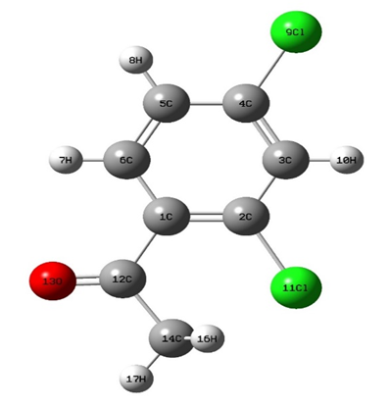

**Fig S1. The optimized geometrical structure of 24DCA**

**Fig S2. Comparative Mulliken population analysis graph of 24DCA By HF, B3LYP and CAM-B3LYP methods with 6-311++G (d, p) basis set**

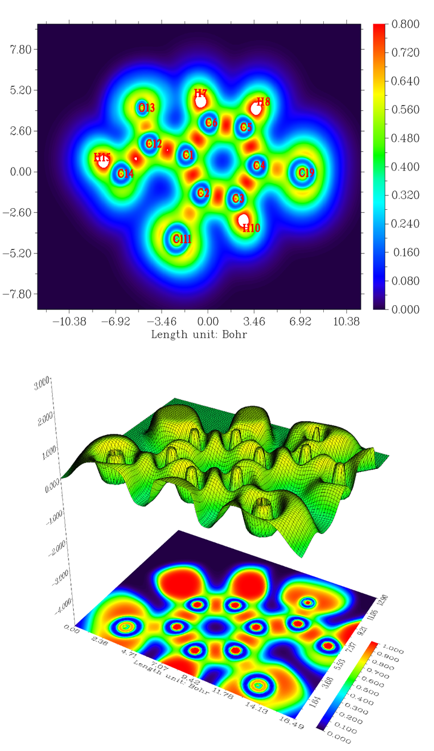

**Fig.S3. Localized Orbital Locator (LOL) and Electron Localization Function colored diagram of the 24DCA**

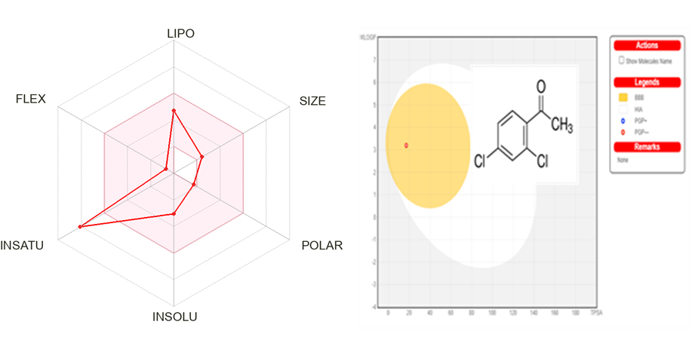

**Fig. S4 BOILED EGG model (top right), the Bio availability radar (pink area exhibits optimal range of particular property) for studied compound by drug likeness criteria (Lipophilicity(-0.7<lopP<5.0),size(150g/mol<MW<500g/mol),polarity (20A2<TPSA<130A2),insolubility(-6<logs0),insaturation(0.25<fraction)Csp3<1)**  **flexibility (0<Num Rotatable bonds<9)**