Supplementary Information
Article title: Mechanisms of attachment and distribution of Nitzschia and Fragilaria at different flow rates
Journal name: Journal of King Saud University - Science.
Author names：Kai Shen¹, Yi Li¹, Zhanyong Zhao², Weirong Li¹, Zhihui Liu³, Shukhrat Giyasov ⁴, Sapar Bayarmagnai⁴, Zhaoyang Lv⁵, Fei Gao⁵, Wenqing Shi⁶, Chao Lu⁶, Di Tie^{1,6}
1.Engineering Research Center of Continuous Extrusion, Ministry of Education, Dalian Jiaotong University,
Dalian 116028, China.
2. School of Materials Science and Engineering, North University of China, Taiyuan 030051, China.
3. State Key Laboratory of Tribology in Advanced Equipment, Tsinghua University, Beijing 100084, China.
4. Tashkent medical academy, Tashkent 100109 Uzbekistan.
5. School of Materials Science and Engineering, Northeastern University, Shenyang 110819, China.
6. School of Materials Science and Engineering, Guangdong Ocean University, Guangdong 529500 China.
Corresponding author：Di Tie, School of Materials Science and Engineering, Guangdong Ocean University. E-mail: tie-di@hotmail.com
Online Resource 1: Experimentation Figures
(a) Slice hanging device used in experiment (b) Hanging point in high velocity region
(c) Hanging point in low velocity region (d) Hanging sample image
Online Resource 2: Agarose gel electrophoresis detection
a. Instruments and reagents
Name | Function | Brand manufacturer
Electrophoresis apparatus | Agarose electrophoresis equipment | LIUYI, FangShan District, Beijing, China
Gel imaging system | Gel imaging equipment | BayGene, Tianzhu airport industrial zone, Beijing, China
Agarose | Agarose gel reagent | Invitrogen, Free trade test area, Shanghai, China
Marker | Measurement standard of molecular weight of nucleic acid | Takara, Economic and Technological development zone, Dalian, China
TAE | Agarose gel electrophoresis buffer | Invitrogen, Free trade test area, Shanghai, China
b. Detection parameter
Marker loading quantity | Sample loading | Electrophoresis time | Agarose concentration | Voltage | Electric current
5μl | 5μl | 20min | 1.20% | 120V | 80mA
Online Resource 3: PCR amplification conditions
a. Samples were uniformly diluted to 20ng/μL.
b. Amplification system (25μL):5×reaction buffer 5μL, 5×GC buffer 5μL, dNTP（2.5mM） 2μL, Forward primer (10uM)1μL, Reverse primer (10Um) 1μL, DNA Template 2μL, ddH2O 8.75μL, Q5 DNA Polymerase 0.25μL.
c. Amplification parameter: Initial denaturation 98℃ 2min, Denaturation 98℃ 15s, Annealing 55℃ 30s, Extension 72℃ 30s, Final extension 72℃ 5min, 10℃ Hold.25-30Cycles.
Online Resource 4: Purification, recovery, and fluorescence quantification of amplification products
a. Add 0.8 times the volume of magnetic beads to 25 μL PCR products, shake and fully suspend them, then adsorb them on a magnetic frame for 5 min, and then carefully suck out the supernatant with a pipette.
b. Add 20 μL 0.8 times of magnetic bead washing liquid, shake and fully suspend, then put it on a magnetic frame for 5 min, and carefully suck out the supernatant.
c. Add 200 μL of 80% ethanol, put it on the magnetic frame in reverse, and use magnetic beads to adsorb to the other side of the PCR tube, and suck out the supernatant after full adsorption.
d. Let it stand at room temperature for 5 min until the alcohol volatilizes completely and the magnetic beads crack.
e. Add 25 μL Elution Buffer for elution.
f. Put the PCR tube on the adsorption rack for 5 min, fully adsorb it, remove the supernatant and store it in a clean 1.5 mL centrifuge tube.
g. The products recovered from PCR amplification were quantified by fluorescence. The fluorescence reagent was Quant-iT Pico Green dsDNA Assay Kit (Invitrogen P7589) and the quantitative instrument was Microplate reader (Bio Tek, FLx800).
Gel image original image
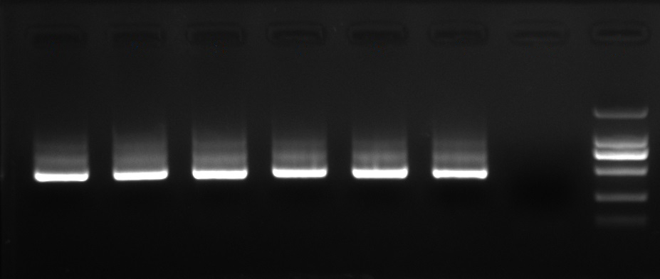
Online Resource 5: Variance calculation of species abundance value and comparison of species distribution uniformity
At first, high-throughput sequencing was used to get the species abundance values of algae in the samples of high-velocity area and low-velocity area at different locations and different sampling periods. Then, Nitzschia and Fragilaria were analyzed as the two dominant species with high abundance. The species abundance values of Nitzschia and Fragilaria are classified and compared according to the high and low velocity, and the data processing is shown in the following Table S1. The variance of species abundance values of two algae species at different flow rates was calculated, and the difference of species abundance distribution at different flow rates was obtained according to the degree of data dispersion.
Table S1 Species abundance analysis data of Nitzschia and Fragilaria
Algae species | Nitzschia |  | Fragilaria
Flow rate | High (0.794m/s) | Low (0.538m/s) | High (0.794m/s) | Low (0.538m/s)
Relative Frequence | 0.20542 | 0.30441 | 0.23118 | 0.22554
 | 0.32146 | 0.45633 | 0.26205 | 0.28461
 | 0.2312 | 0.20409 | 0.32118 | 0.43065
 | 0.25272 | 0.35633 | 0.22205 | 0.35888
Average value | 0.2527 | 0.33029 | 0.259115 | 0.32492
Variance | 0.002475195 | 0.011053459 | 0.002004952 | 0.007944465
The variance of species abundance reflects the distribution difference of species in the community. Specifically, the larger the variance value, the more uneven the distribution of species in the community; The smaller the variance, the more uniform the distribution of species in the community. According to the comparison data, the variance of species abundance values of the two dominant algae genera at flow rate of 0.794m/s are both smaller than the corresponding variance values at flow rate of 0.538m/s, indicating that the dispersion of species abundance values at high flow rate was low and the species distribution was more uniform.

