**Supporting information**

**Colorimetric detection of anionic surfactant using polydiacetylene/zinc (II)/zinc oxide nanocomposites with unique yellow-to-red color transition**

|  |  |  |  |  |  |  |  |  |  |  |
| --- | --- | --- | --- | --- | --- | --- | --- | --- | --- | --- |
| **Table S1.** Colorimetric sensors of anionic surfactants developed by using different types of materials | **Limit of detection** | 1 ppm | N/A | 10⁻⁶ M | N/A | 10⁻⁶ M | 10⁻⁶ M | 0.03 - 0.10 mg/L | 10⁻⁷ M (28.7 ppb) | 71.5 - 120 nM |
| **Working pH range** | N/A | 7.4 | 5.8 | 5.0 | N/A | N/A | 7.5 | N/A | 2-13 |
| **Matrix** | Aqueous solutions | Aqueous solutions and HEPES buffer | Aqueous solutions | Aqueous solutions and filter papers | Aqueous solutions | Aqueous solutions | Aqueous solutions | Aqueous solutions | Aqueous solutions |
| **Analytes** | Lauryl sulfate (LS), Tetradecyl sulfate, Alkylbenzene sulfonate (LAS), and Dodecyl phosphate | Sodium dodecyl sulfate (SDS), Sodium dodecylbenzenesulfonic acid (SDBS), Sodium dodecyl carboxylate (SDC), and Sodium dodecyl phosphate (SDP) | Sodium dodecylbenzenesulfonate (SDBS), Sodium dodecyl sulfate (SDS), Sodium lauryl sulfate (SLS), and Sodium dodecyl carboxylate (SDC) | Sodium dodecanoate (SDC), Sodium dodecyl sulfate (SDS), and Sodium dodecylbenzenesulfonate (SDBS) | Sodium dodecylbenzenesulfonate (SDBS), Sodium dodecyl sulfate (SDS), Sodium lauryl sulfate (SLS), and Sodium dodecyl carboxylate (SDC) | Sodium dodecyl sulfate (SDS), Sodium dodecyl benzenesulfonate (SDBS), and Sodium lauryl sulfate (SLS) | Sodium dodecylbenzene sulfonate (LAS) | Sodium dodecyl sulfate (SDS), Sodium dodecylbenzenesulfonate (SDBS), Sodium dodecylsulfonate (SDSO), and Sodium dodecanoate (SD) | Sodium dodecyl sulfate (SDS) |
| **Maretials** | Imidazolium-containing ionic liquids on a solid support | Imidazolium-functionalized polydiacetylene | A forming complex between poly(3-(4-methyl-3′-thienyloxy)propyltrimethylammonium) (PMTPA) and 8-hydroxy-1,3,6-pyrenetrisulfonic acid trisodium salt (HPTS) or PMTPA/HPTS complex disassembles | Polydiacetylene carrying amino groups, such as primary amine, secondary amine, and ammonium head group | Poly[N,N,N-trimethyl-4-(thiophen-3-ylmethylene)-cyclohexanaminium chloride] (PTCA-Cl) | Poly[3-(1,1′-dimethyl-4-piperidinemethylene)thiophene-2,5-diyl chloride] (PDPMT-Cl) | Poly(acrylic acid)-coated magnetite nanoparticles (PAA@Fe₃O₄) | Naphthalimide-based cationic dyes | TPE-Br (4,4′,4′′,4′′′-(ethene-1,1,2,2-tetrayltetrakis(benzene-4,1-diyl))tetrakis(1-(4-bromobenzyl)pyridin-1-ium) bromide) and TPE-I (4,4′,4′′,4′′′-(ethene-1,1,2,2-tetrayltetrakis(benzene-4,1-diyl))tetrakis(1-methylpyridin-1-ium) iodide) |
| **Author, Year** | Coll et al., 2007 | Chen et al., 2010 | An et al., 2011 | Thongmalai et al., 2011 | Wang et al., 2012 | Li et al., 2012 | Wei and Mo, 2014 | Zhao and Li, 2015 | Feng et al., 2020 |

**References**

An, Y., Bai, H., Li, C., Shi, G. 2011. Disassembly-driven colorimetric and fluorescent sensor for anionic surfactants in water based on a conjugated polyelectrolyte/dye complex. Soft Matter. 7(15), 6873-6877. <https://doi.org/10.1039/C1SM05526G>.

Chen, X., Kang, S., Kim, M. J., Kim, J., Kim, Y. S., Kim, H., Chi, B., Kim, S. J., Lee, J. Y., Yoon, J. 2010. Thin‐film formation of imidazolium‐based conjugated polydiacetylenes and their application for sensing anionic surfactants. Angew. Chem. Int. Ed. 49(8), 1422-1425. <https://doi.org/10.1002/anie.200905041>.

Coll, C., Martinez-Manez, R., Marcos, M. D., Sancenon, F., Soto, J. 2007. A simple approach for the selective and sensitive colorimetric detection of anionic surfactants in water. Angew. Chem. Int. Ed. 46(10), 1675. <https://doi.org/10.1002/anie.200603800>.

Feng, A., Jiang, F., Huang, G., Liu, P. 2020. Synthesis of the cationic fluorescent probes for the detection of anionic surfactants by electrostatic self-assembly. Spectrochim. Acta A Mol. Biomol. Spectrosc. 224, 117446. <https://doi.org/10.1016/j.saa.2019.117446>.

Li, E., Lin, L., Wang, L., Pei, M., Xu, J., Zhang, G. 2012. Synthesis of a new cationic polythiophene derivative and its application for colorimetric and fluorometric detection of iodide ion and anionic surfactants in water. Macromol. Chem. Phys. 213(9), 887-892. <https://doi.org/10.1002/macp.201200100>.

Thongmalai, W., Eaidkong, T., Ampornpun, S., Mungkarndee, R., Tumcharern, G., Sukwattanasinitt, M., Wacharasindhu, S. 2011. Polydiacetylenes carrying amino groups for colorimetric detection and identification of anionic surfactants. J. Mater. Chem. 21(41), 16391-16397. <https://doi.org/10.1039/c1jm12795k>.

Wang, L., Feng, Q., Wang, X., Pei, M., Zhang, G. 2012. A novel polythiophene derivative as a sensitive colorimetric and fluorescent sensor for anionic surfactants in water. New J. Chem. 36(9), 1897-1901. <https://doi.org/10.1039/C2NJ40460E>.

Wei, X. L., Mo, Z. H. 2014. Modified magnetite nanoparticles for colorimetric sensing of anionic surfactants in water. Micro Nano Lett. 9(4), 239-242. <https://doi.org/10.1049/mnl.2014.0037>.

Zhao, Y., Li, X. 2015. Colorimetric and fluorometric detection of anionic surfactants with water soluble sensors. Sens. Actuators B Chem. 209, 258-264. <https://doi.org/10.1016/j.snb.2014.11.122>.

**Table S2.**Hydrodynamic radii (*Rh*) values of PDA(8,12)/Zn2+/ZnO nanocomposites from 3D-DLS measurements at 25 oC (298 K).

|  |  |
| --- | --- |
| PDA(8,12)/Zn2+/ZnO nanocomposites | |
| CTAB conc. (mM) | **Hydrodynamic radii, *Rh* (nm)** |
| 0  0.1  0.3  0.5  1 | 165 ± 2 |
| 192 ± 9 |
| 279 ± 0 |
| 333 ± 4 |
| 454 ± 7 |
| PDA(8,12)/Zn2+/ZnO nanocomposites with 1 mM CTAB | |
| SDS conc. (mM) | **Hydrodynamic radii, *Rh* (nm)** |
| 0.3  0.5  1  3 | 239 ± 3 |
| 205 ± 9 |
| 200 ± 1 |
| 196 ± 2 |

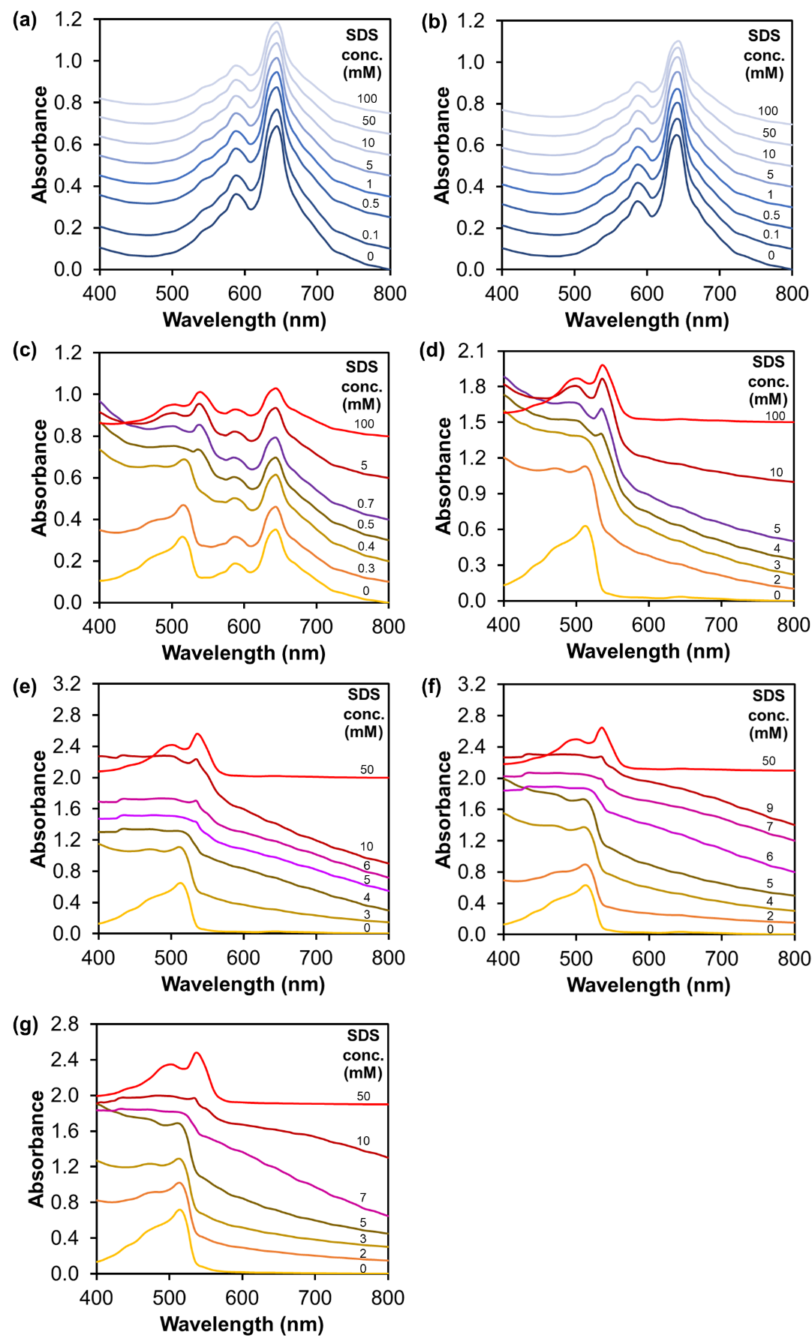

**Fig. S1.** Absorption spectra of PDA(8,12)/Zn2+/ZnO nanocomposites with (a) 0, (b) 0.1, (c) 0.5, (d) 3, (e) 5, (f) 7, and (g) 10 mM CTAB measured upon the addition of SDS.

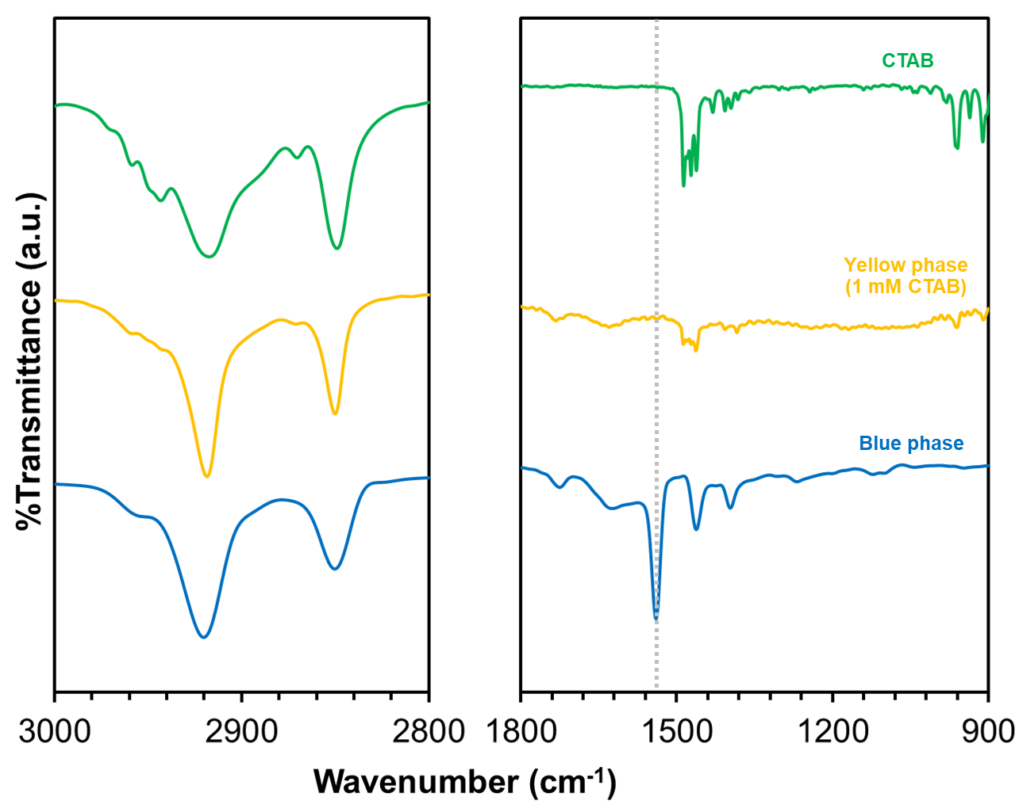**Fig. S2.** FT-IR spectra of (blue phase) PDA(8,12)/Zn2+/ZnO nanocomposites, (yellow phase) PDA(8,12)/Zn2+/ZnO nanocomposites with 1 mM CTAB, and (top) pure CTAB molecules.

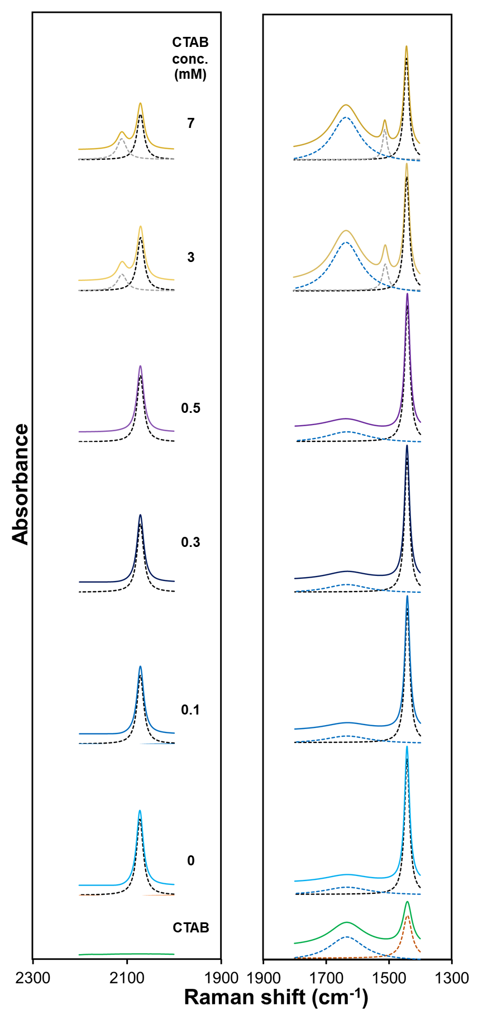

**Fig. S3.** Expanded 2300-1300 cm-1 region of Raman spectra. Lorentz deconvolution function bands of the Raman spectra of PDA(8,12)/Zn2+/ZnO nanocomposites upon the addition of 0, 0.1, 0.3, 0.5, 3, and 7 mM CTAB. Raman spectrum of CTAB is included for comparison. A broad peak is attributed to the scattering of water molecules.

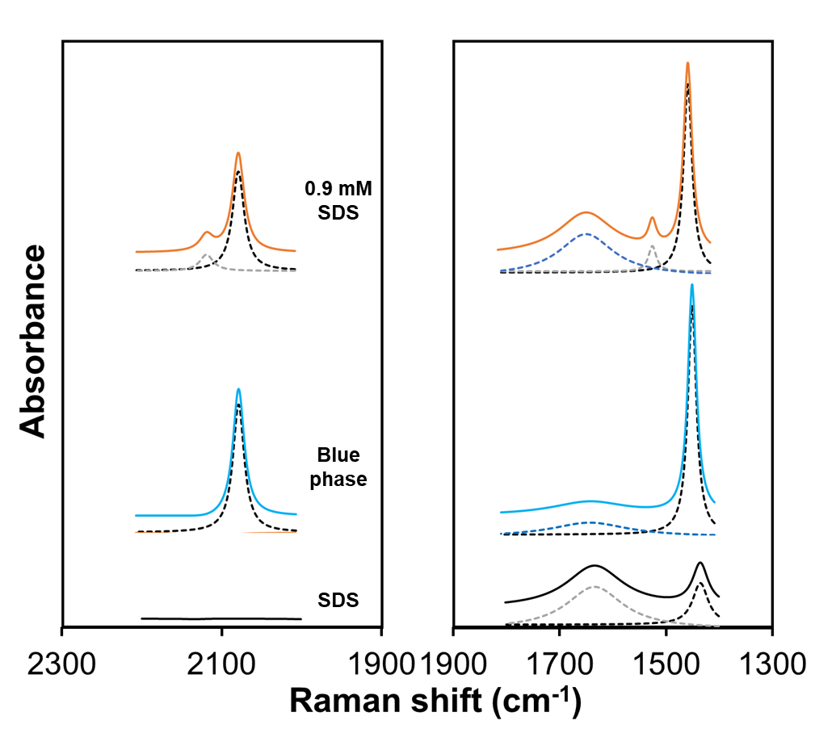

**Fig. S4.** Expanded 2300-1300 cm-1 region of Raman spectra. Lorentz deconvolution function bands of the Raman spectra of (blue phase) pristine PDA(8,12)/Zn2+/ZnO nanocomposites and PDA(8,12)/Zn2+/ZnO nanocomposites with 1 mM CTAB upon the addition of 0.9 mM SDS. Raman spectrum of SDS is included for comparison. A broad peak is attributed to the scattering of water molecules.