**Supplementary file**

Supplementary Table S1.Factor screening for the development of HPLC method of AmB in rat plasma

|  |  |  |  |  |  |  |  |
| --- | --- | --- | --- | --- | --- | --- | --- |
| Experimental Run | AA pH  (A) | Flow rate  (B) | Injection volume (C) | ACN ratio  (D) | AA ratio  (E) | Column temperature  (F) | Sample vial temperature  (G) |
| 1 | 5.5 | 1.5 | 10 | 55 | 35 | 25 | 15 |
| 2 | 4.5 | 0.5 | 10 | 45 | 35 | 25 | 10 |
| 3 | 4.5 | 1.5 | 15 | 55 | 45 | 25 | 10 |
| 4 | 5.5 | 0.5 | 15 | 45 | 45 | 30 | 15 |
| 5 | 4.5 | 0.5 | 10 | 55 | 45 | 25 | 15 |
| 6 | 5.5 | 1.5 | 10 | 45 | 45 | 30 | 10 |
| 7 | 4.5 | 1.5 | 15 | 45 | 35 | 30 | 15 |
| 8 | 5.5 | 0.5 | 15 | 55 | 35 | 25 | 10 |
| **Instrumental method factors** | | |  | | | **Levels** | |
|  | | |  |  |  | Low | High |
| AA pH | | |  |  |  | 4.5 | 5.5 |
| Flow-rate (mL/min) | | |  |  |  | 5.0 | 1.5 |
| Injection-volume (µl) | | |  |  |  | 10.0 | 15.0 |
| ACN ratio | | |  |  |  | 45.0 | 55.0 |
| AA ratio | | |  |  |  | 35.0 | 70.0 |
| Column temperature (°C) | | |  |  |  | 25.0 | 30.0 |
| Sampler vial temperature (°C) | | |  |  |  | 10.0 | 15.0 |



**Supplementary figure S1.** Half-normal graph and pareto-chart depicted the significant variables affecting bio-analytical responses: (A and B) peak area (mAU) and (C and D) retention time (min).

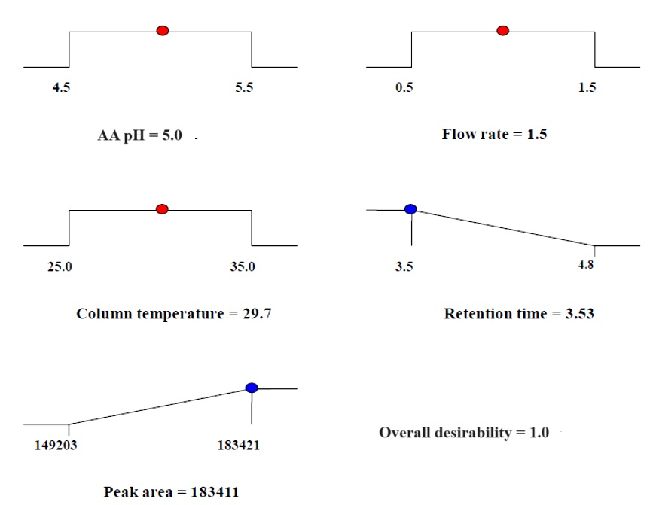

**Supplementary figure S2.** Overall desirability value of the critical attribute(s) (AA pH, flow rate, and column temperature)