**Supplementary information**

**Table S1. Bond-length (Å), Bond angle (Å), and Dihedral angle (°) values of 2-Thiophenecarbonitrile**

|  |  |  |  |
| --- | --- | --- | --- |
| **BOND LENGTH** | | **B3LYP/**  **6-311 ++G(d,p)** | **B3LYP/**  **6-311G +G(d,p)** |
| S1-C2 | | 1.748 | 1.748 |
| S1-C5 | | 1.725 | 1.725 |
| C2-C3 | | 1.377 | 1.377 |
| C2-C9 | | 1.413 | 1.413 |
| C3-C4 | | 1.418 | 1.418 |
| C3-H8 | | 1.081 | 1.081 |
| C4-C5 | | 1.369 | 1.369 |
| C4-H7 | | 1.081 | 1.081 |
| C5-H8 | | 1.08 | 1.080 |
| C9-N10 | | 1.157 | 1.157 |
| **BOND ANGLE** | | **B3LYP/**  **6-311G ++G(d,p)** | **B3LYP/**  **6-311G +G(d,p)** |
| C2-S1-C5 | | 91.004 | 91.004 |
| S1-C2-C3 | | 111.2714 | 111.276 |
| S1-C2-C9 | | 121.1677 | 121.167 |
| C3-C2-C9 | | 127.561 | 127.558 |
| C2-C3-C4 | | 112.6887 | 112.685 |
| C2-C3-H8 | | 122.6687 | 122.67 |
| C4,C3,H8 | | 124.6426 | 124.645 |
| C3-C4-C5 | | 112.6896 | 112.689 |
| C3-C4-H7 | | 123.8938 | 123.896 |
| C3-C4-H7 | | 123.4165 | 123.415 |
| S1-C3-C4 | | 112.3463 | 112.347 |
| C1-C5-C6 | | 119.4809 | 119.478 |
| C4-C5-C6 | | 128.1728 | 128.176 |
| **DIHEDRAL** | **B3LYP/**  **6-311++G(d,p)** | **B3LYP/**  **6-311 +G(d,p)** |
| C5-S1-C2-C3 | 0.0048 | 0.005 |
| C5-S1-C2-H9 | 180.0007 | 180.001 |
| C2-S1-C5-C4 | -0.0016 | -0.001 |
| C2-S1-C5-C6 | 179.9983 | -180.002 |
| S1-C2-C3-C4 | -0.0068 | -0.007 |
| S1,C2,C3,H8 | 179.9974 | -180.003 |
| H9-C2-C3-C4 | 180.0024 | -180.003 |
| H9-C2-C3-H8 | 0.0018 | 0.002 |
| C2,C3,C4,C5 | 0.0057 | 0.006 |
| C2-C3-C4-H7 | 179.9969 | 180.003 |
| H8-C3-C4-C5 | 179.9986 | 180.002 |
| H8-C3-C4-H7 | -0.0012 | -0.001 |
| C3-C4-C5-S1 | -0.0019 | -0.002 |
| C3-C4-C5-C6 | 180.0019 | -180.002 |
| H7-C4-C5-S1 | 180.0006 | 180 |
| H7-C4-C5-C6 | 0.0007 | 0.001 |

**Table S2 The experimental and theoretical UV-Vis spectroscopic parameters of 2TCN**

|  |  |  |  |  |
| --- | --- | --- | --- | --- |
| **Solvent** | **Wavelength (nm)** | | **Oscillator strength** | **Major**  **Contributions** |
| **Experimental** | **Theoretical** |
| Ethanol | 279.20 | 236.27 | 0.2676 | HOMO->LUMO  (80%) |

**Table S3 HOMO and LUMO analysis of 2TCN**

|  |  |  |  |  |
| --- | --- | --- | --- | --- |
| **Property** | **Gas** | **Acetonitrile** | **Methanol** | **Water** |
| ԑHOMO | -7.3035 | -7.1791 | -7.1794 | -7.1769 |
| ԑLUMO | -2.0637 | -1.966 | -1.9662 | -1.9649 |
| Energy gap ΔE | 5.2398 | 5.2131 | 5.2132 | 5.212 |
| Ionisation energy (*I*= ԑHOMO= -HOMO) | 7.3035 | 7.1791 | 7.1794 | 7.1769 |
| Electron Affinity (*A*= ԑLUMO= -LUMO) | 2.0637 | 1.966 | 1.9662 | 1.9649 |
| Global hardness (Ƞ = (*I-A*)/2) | 2.6199 | 2.60655 | 2.6066 | 2.606 |
| Global softness (*S =1/Ƞ)* | 0.381693958 | 0.383648885 | 0.38364153 | 0.3837299 |
| Chemical Potential (μ = -(I+*A*)/2) | -4.6836 | -4.57255 | -4.5728 | -4.5709 |
| Electronegativity (χ = -μ) | 4.6836 | 4.57255 | 4.5728 | 4.5709 |
| Electrophilicity index (ω = μ2/2Ƞ) | 5.360522916 | 5.220072026 | 5.2204075 | 5.2176378 |
| Nucleophilicity index (*N* = 1/ω) | 0.186548965 | 0.191568238 | 0.19155593 | 0.1916576 |
| Electron accepting power (ω+ = *A*2/2(*I-A*) | 0.196925455 | 0.188563427 | 0.18857899 | 0.1884977 |
| Electron donating power (ω+ = *I*2/2(*I-A*) | 0.696925455 | 0.688563427 | 0.68857899 | 0.6884977 |

**Table S4 Mulliken atomic charges of 2TCN**

|  |  |  |
| --- | --- | --- |
| Atom | 6311G++(d,p) | 6311G+(d,p) |
| S1 | -0.228721 | -0.134288 |
| C2 | 0.953647 | 0.995042 |
| C3 | 0.234323 | 0.105927 |
| C4 | -0.502365 | -0.322207 |
| C5 | 0.130333 | 0.00747 |
| H6 | 0.2633 | 0.173466 |
| H7 | 0.16036 | 0.142446 |
| H8 | 0.178126 | 0.147526 |
| C9 | -1.011352 | -0.933089 |
| N10 | -0.177651 | -0.182291 |

**Table S5 Natural Population Analysis of 2TCN**

|  |  |  |  |  |  |  |
| --- | --- | --- | --- | --- | --- | --- |
| Atom | No | Charge | Core | Valence | Rydberg | Total |
| S | 1 | 0.54757 | 9.99857 | 5.40272 | 0.05114 | 15.45243 |
| C | 2 | -0.36304 | 1.99884 | 4.34295 | 0.02124 | 6.36304 |
| C | 3 | -0.20383 | 1.99901 | 4.18696 | 0.01787 | 6.20383 |
| C | 4 | -0.24433 | 1.99912 | 4.22726 | 0.01794 | 6.24433 |
| C | 5 | -0.41519 | 1.99914 | 4.39372 | 0.02233 | 6.41519 |
| H | 6 | 0.24124 | 0 | 0.7571 | 0.00166 | 0.75876 |
| H | 7 | 0.22731 | 0 | 0.77098 | 0.0017 | 0.77269 |
| H | 8 | 0.23348 | 0 | 0.76479 | 0.00172 | 0.76652 |
| C | 9 | 0.29513 | 1.9992 | 3.67051 | 0.03516 | 5.70487 |
| N | 10 | -0.31835 | 1.99958 | 5.29581 | 0.02296 | 7.31835 |
|  | Total | 0 | 21.99346 | 33.81282 | 0.19372 | 56 |

**Table S6 Toxicity Analysis of 2TCN using Pro Tox-II Tools**

**pFPP Values**

Toxicity Class - IV (low toxicity)

LD50(mg/kg) - 1190

Hepatotoxicity -Active (0.69)

Carcinogenicity - Inactive (0.62)

Immunotoxicity - Active (0.96)

Mutagenicity - Inactive (0.97)

Cytotoxicity - Inactive (0.93)

**Table S7 Antioxidant activity of 2TCN**

|  |  |  |
| --- | --- | --- |
| **S. No** | **Concentration µg** | **DPPH Scavenging** |
|  | 25 | 0 |
|  | 50 | 0 |
|  | 100 | 0 |
|  | 200 | 72 |
|  | Standard ASCORBIC ACID (100 µg) | 78 |

**Table S8 Anti-inflammatory study of 2TCN**

|  |  |  |
| --- | --- | --- |
| **S. No** | **Concentration µg** | **Percentage of inhibition** |
| 1 | 25 | 32 |
| 2 | 50 | 38 |
| 3 | 100 | 46 |
| 4 | 200 | 60 |
| 5 | Diclofenac sodium (25 µg) | 72 |

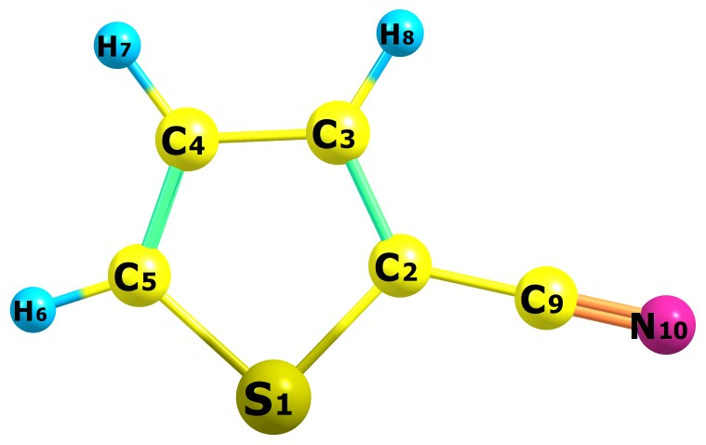

**Fig S1 Optimized Structure of 2TCN**



**Fig S2 DOS spectrum of 2TCN**

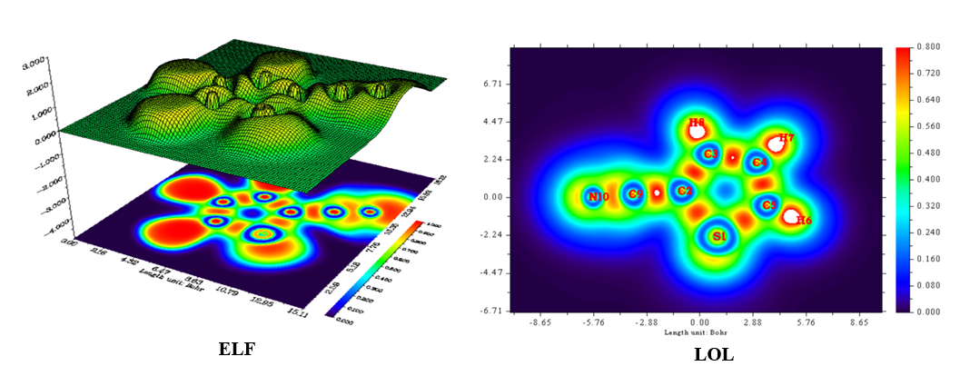**Fig S3 ELF & LOL map of 2TCN**



**Fig S4 ALIE color-filled surface map of 2TCN**

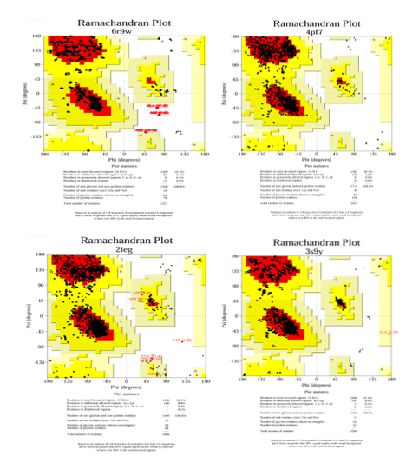

**Fig S5 Ramachandran plot of 2TCN**