**New Quinazoline-N-4-Fluorophenyl Derivatives as Potential Anticancer Agents: Discovery of a Promising Dual EGFR/VEGFR-2 Inhibitor**

Mohammed H. Geesi a

aDepartment of Chemistry, College of science and humanities in Al-Kharj, Prince Sattam bin Abdulaziz University, Al-Kharj 11942, Saudi Arabia.

**1H and 13C NMR spectra of synthesized products**



1H-NMR of compound **3**



13C-NMR of compound **3**

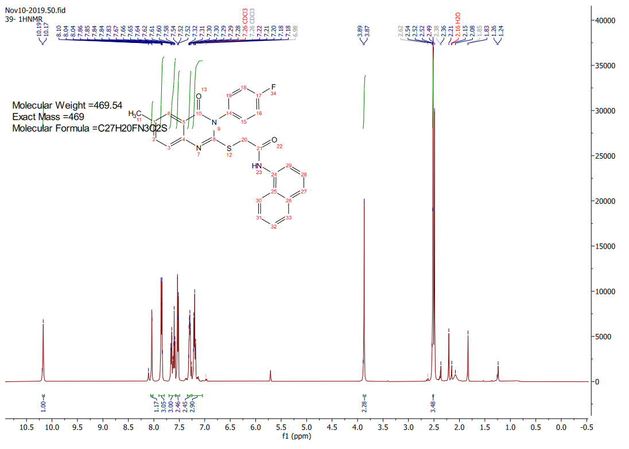

1H-NMR of compound **4a**

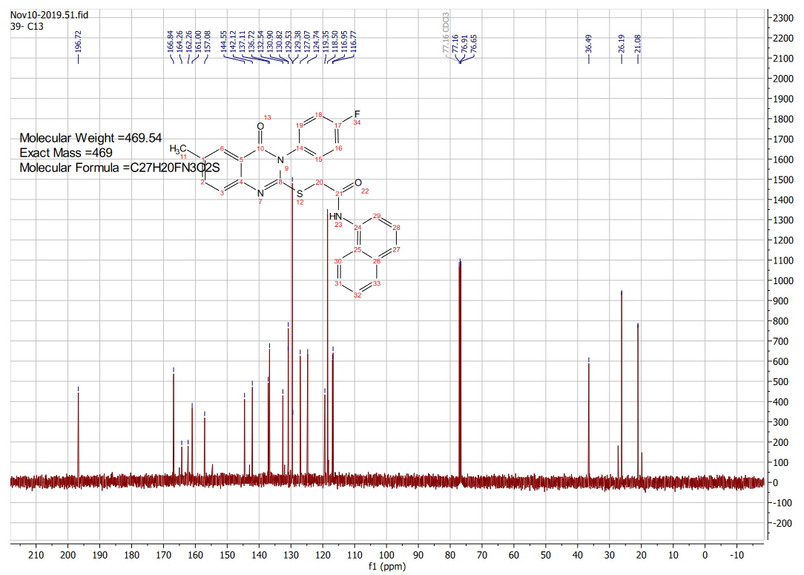

13C-NMR of compound **4a**

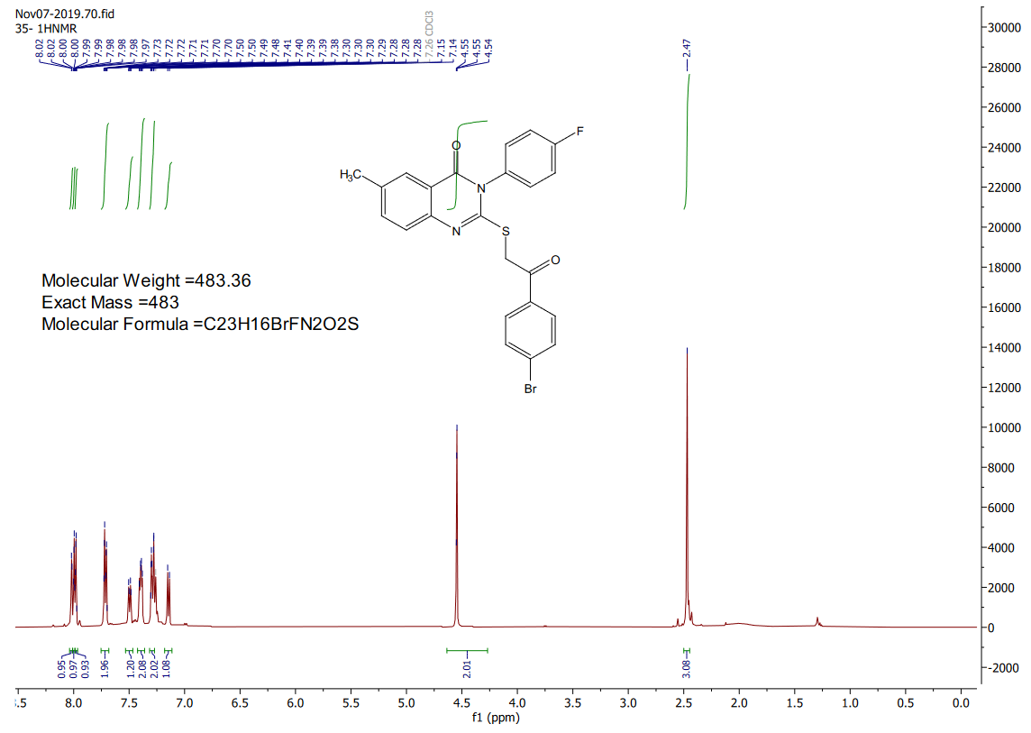

1H-NMR of compound **4b**

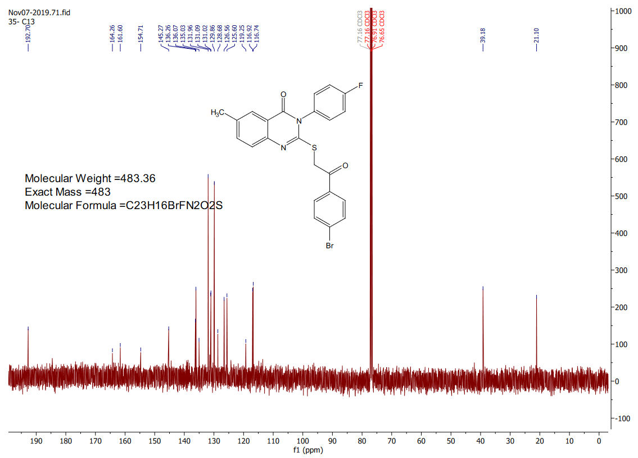

13C-NMR of compound **4b**

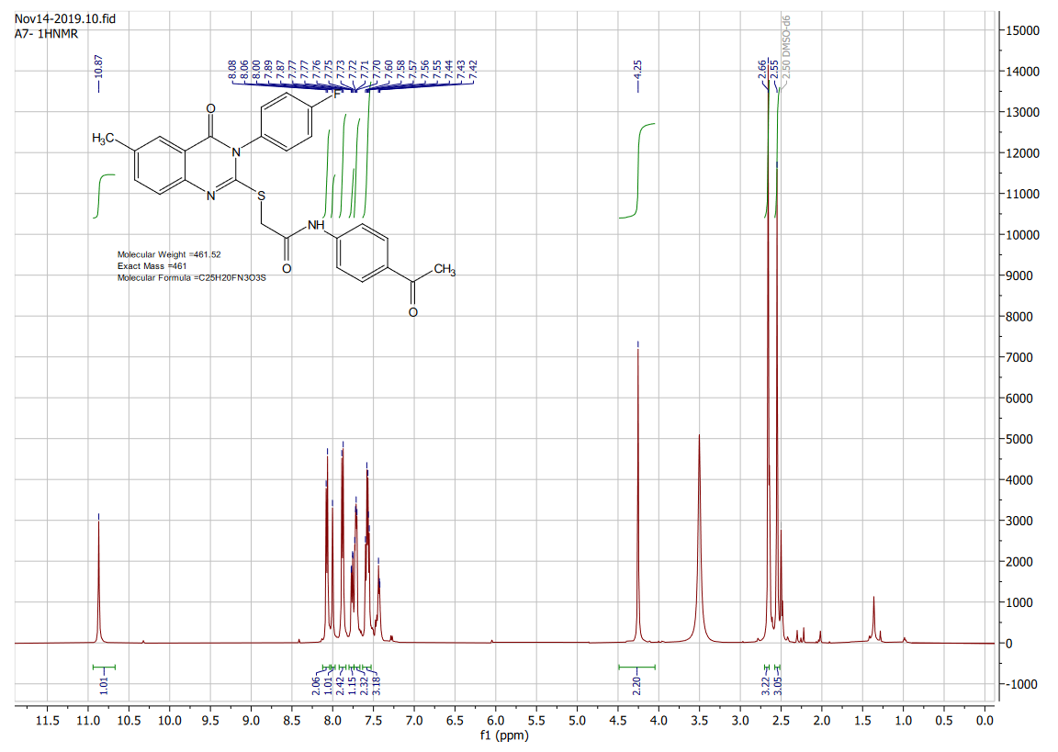

1H-NMR of compound **4c**

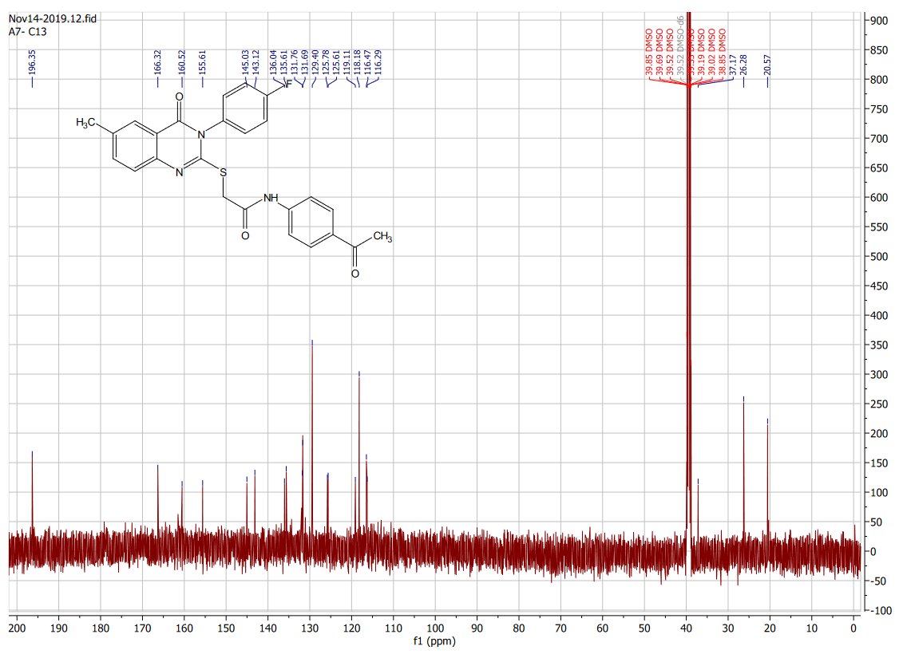

13C-NMR of compound **4c**

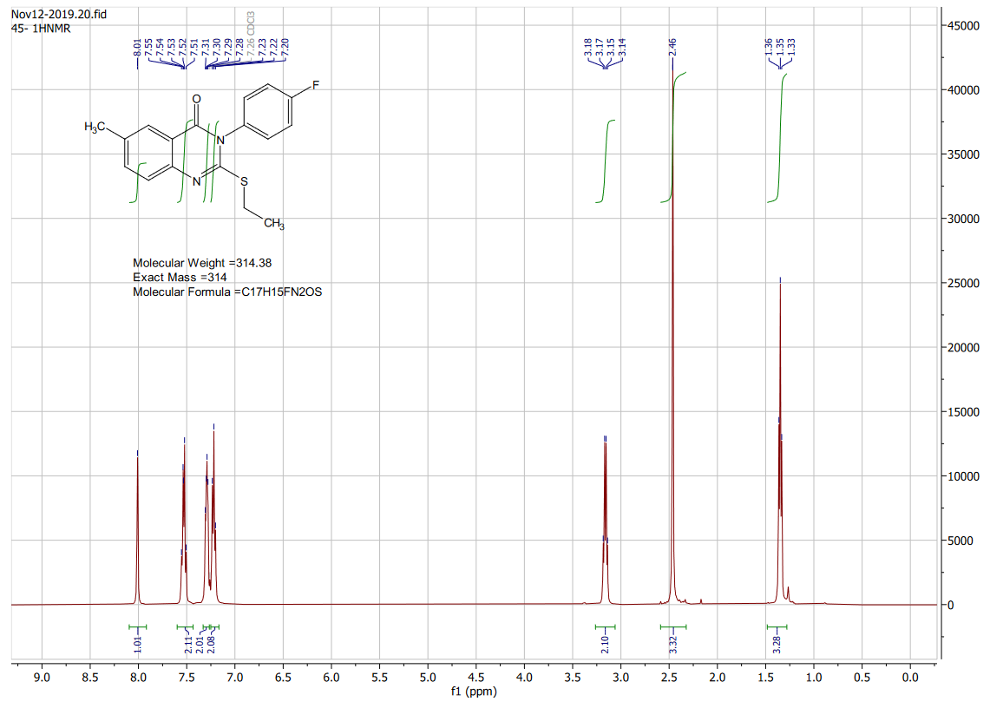

1H-NMR of compound **4d**

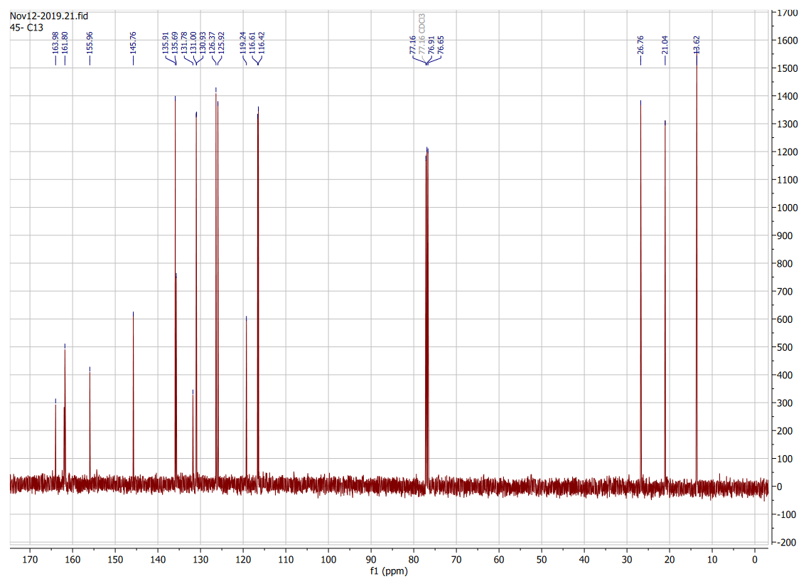

13C-NMR of compound **4d**