**Supporting Information**

**Eco-Friendly Synthesis of Nano Ferrites for Effective Dye Degradation and Enhanced Antimicrobial Protection**

Manikandan Dhayalan1, Rathika Govindasamy2*, Karthikeyan Prakasham3, Moonis Ali Khan4, Anuchit Phanumartwiwath1*

1 College of Public Health Sciences, Chulalongkorn University, Bangkok 10330, Thailand.

2 Department of Chemistry, PSG College of Arts & Science, Coimbatore, 641014, Tamilnadu, India.

3 Research Center for Precision Environmental Medicine, and Ph.D. Program in Environmental and Occupational Medicine, College of Medicine, Kaohsiung Medical University, Kaohsiung City, Taiwan.

4 Chemistry Department, College of Science, King Saud University, Riyadh 11451, Saudi Arabia.

______________________________________________________________________________

* Corresponding authors: Dr. Anuchit Phanumartwiwath and Dr. Rathika Govindasamy

E-mail: [anuchit.p@chula.ac.th](mailto:anuchit.p@chula.ac.th); [rathikapsgcas@gmail.com](mailto:rathikapsgcas@gmail.com)

**Supporting Information**

**Supplementary Figures**

**1: Hysteretic loop of synthesized cobalt and nickel ferrite NPs.**

**2. Kinetic plots of dyes reduction (a) Pseudo first order and (b) Pseudo second order reactions.**

**3.** **Magnetic separation of ferrite nanoparticles after the reaction.**

**4.** **Antibacterial activity of CoFe2O4 (F1) and NiFe2O4 (F2).**

**Supplementary Tables**

**1: Magnetic properties and size ranges of synthesized NPs**

**2. Kinetic data of pseudo first and second order reaction**

**3.** **Antibacterial activity of cobalt and nickel ferrite NPs.**

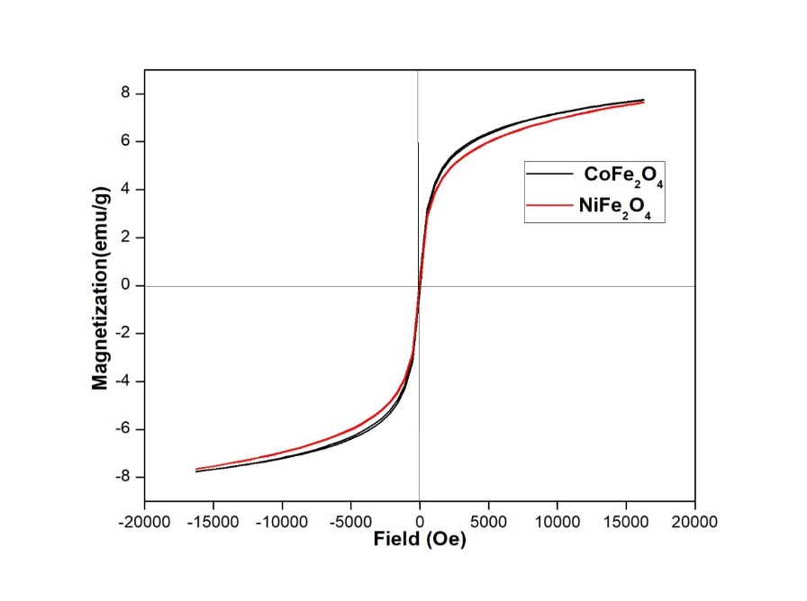

**Supplementary Figure 1:** Hysteretic loop of synthesized cobalt and nickel ferrite NPs.

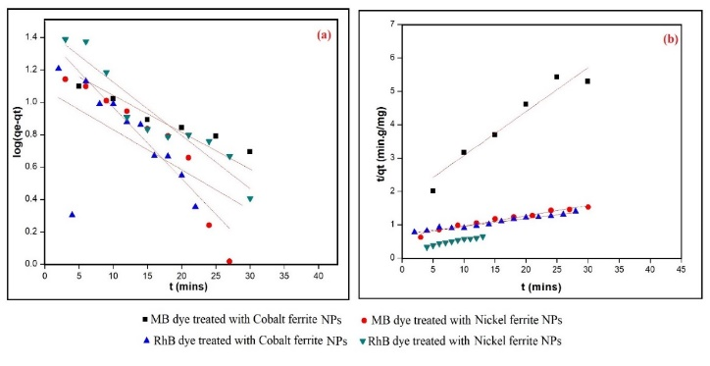

**Supplementary Figure 2:** Kinetic plots of dyes reduction (a) Pseudo first order and (b) Pseudo second order reactions.

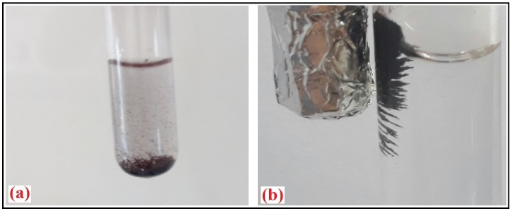

**Supplementary Figure 3:** Magnetic separation of ferrite nanoparticles after the reaction**.**

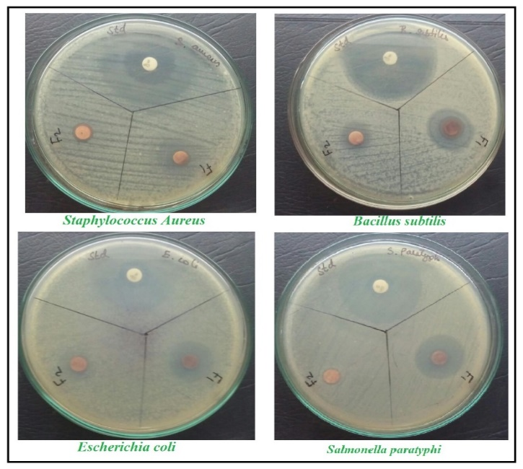

**Supplementary Figure 4:** Antibacterial activity of CoFe2O4 (F1) and NiFe2O4 (F2).

|  |  |  |  |  |  |  |
| --- | --- | --- | --- | --- | --- | --- |
| **Catalyst** | **Ms (emu/g)** | **Mr**  **(emu/g)** | **Hc**  **(Oe)** | **Mr/Ms (%)** | **Crystallite size (nm)** | **Particle**  **Size (nm)** |
| CoFe2O4 | 1.1150 | 0.4160 | 47.7547 | 37.3094 | 1.3 | 15 |
| NiFe2O4 | 0.9631 | 0.1175 | 17.3445 | 12.2002 | 1.2 | 20 |

**Supplementary Table 1:** Magnetic properties and size ranges of synthesized NPs.

|  |  |  |  |  |  |  |  |
| --- | --- | --- | --- | --- | --- | --- | --- |
| Dye | Catalyst used | Pseudo first-order Pseudo second-order | | | | | |
| MB  RhB | CF  NF  CF  NF | *R2* | *K1* | *qe* | *R2* | *K2* | *qe* |
| 0.8615 | 0.0175 | 0.1040 | 0.9586 | 0.0010 | 22.7790 |
| 0.8643 | 0.0848 | 0.1264 | 0.9629 | 0.0015 | 32.2581 |
| 0.2998 | 0.0569 | 0.0329 | 0.9757 | 0.0007 | 42.7350 |
| 0.8894 | 0.2676 | 0.1829 | 0.9833 | 0.0051 | 29.9401 |

**Supplementary Table 2:** Kinetic data of pseudo first and second order reaction.

|  |  |  |  |  |
| --- | --- | --- | --- | --- |
| **No** | **Inhibition Zone (mm)** | | | |
| **Bacterial strain** | **Standard Ciprofloxacin**  **(10 µg/disc)** | **Samples (100 µg/disc)** | |
| **CoFe2O4** | **NiFe2O4** |
| 1 | *Staphylococcus aureus* | 40 | 15 | 10 |
| 2 | *Bacillus subtilis* | 40 | 20 | 11 |
| 3 | *Escherichia Coli* | 32 | 20 | 13 |
| 4 | *Salmonella paratyphi* | 36 | 20 | 09 |

**Supplementary Table 3**: Antibacterial activity of cobalt and nickel ferrite NPs.