***3.3.1 UV-vis spectrophotometer examination***

***UV-vis spectrophotometer examination***

UV-visible spectrum of *Av*AgNPs illustrated an elevated wavelength at 445 nm (Figure 2A). The absence of peaks in this area with comparable intensities in AgNO3 and *Av* extract confirmed that AgNPs was present in the tested reaction mixtures (Figures 2A and 2B). Additionally, distinctive broad peaks were seen in the CS-*S. aureus*-AgNPs at 444.5 nm (Figure 2B). AgNPs' surface plasmon resonance, which verified its production, is responsible for the absorption peak at 400–500 nm. These findings demonstrate that after experimenting with different concentrations of AgNO3, 4 mM was the optimum concentration for AgNP synthesis. Furthermore, the stability of the synthesised AgNPs of both *AV* and CS-*S. aureus* was studied at various time intervals (0 h, 24 h, 48 h and 72 h) at room temperature. The results demonstrated a rising level over time, as shown in (Figures 2A and 2B).

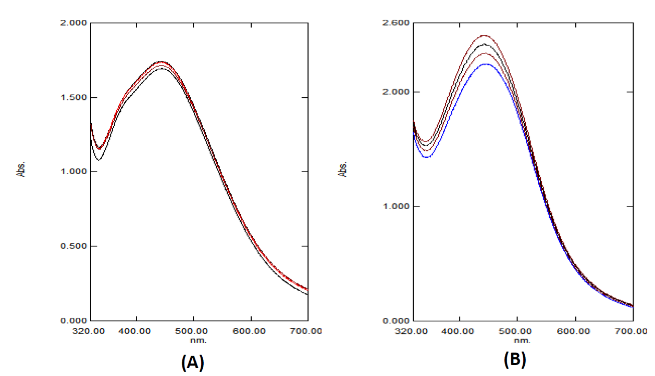**Figure S1:** UV-vis spectrophotometry results of the synthesised *AvAgNPs* at 445 nm (A) and CS- *S. aureus*-AgNPs at 444.5 nm (B) at different time intervals (0h, 24 h, 48 h and 72 h) at room temperature.

***3.3.2 FT-IR results***

***FT-IR findings***

Recognising the functional groups engaged in AgNP bio-reduction and their functions as capping and stabilising factors in the association within metal particles and biomolecules was both made possible by FT-IR, which an essential investigation technique. The FT-IR spectrum of *AV* extract was recorded before the synthesis of AgNPs in Figure 3A (bottom spectrum), which show absorption peaks at 3417.86, 2931.80, 2368.59, 1597.06, 1404.18, 1319.31, 1087.85, 617.22, 547.78 these peaks correspond to O-H stretching, C-H stretching, N-H bending, O-H bending and C–Br stretch, which indicates the presence of alcohol, alkane, amine, phenol and alkyl halides. Meanwhile, Figure 3A (top spectrum) shows the FT-IR spectrum of *AvAgNPs*. They have slightly shifted, with intense peaks appearing at 3433.29, 1589.34, 1388.75, 1087.85, 678.94; these correspond to O-H stretching, N-H bending, S=O stretching and C-N stretching, indicating alcohol, amine, cyclic alkene and sulphate. The FT-IR spectra show that *AV* extract could work as a reducing agent for AgNP synthesis. Moreover, *AV* extract could have formed a layer as biological capping on AgNP to prevent any agglomeration. Thus it was confirm that the phyto-compounds in *AV* extract are capable of reducing and capping AgNP (Mohamed and Elmasry, 2020).

The FT-IR spectra were recorded for CS-*S. aureus* (Figure 3B). As far as we are aware, this is the first time CS *S. aureus* has been examined by FT-IR. Figure 3B (bottom spectrum) shows absorption peaks at 3425.58, 2962.66, 2129.41, 1651.07, 1450, 1404, 1249.87, 1087, which correspond to O-H stretching, C-H stretching, CΞC stretching, C=C stretching, C-H bending, O-H bending and C-N stretching. These readings indicate the presence of alcohol, alkane, alkyne, alkene, alkane (methyl group), alcohol, carboxylic acid and amine. After the synthesis of AgNP (Figure 3B; top spectrum), some of the peaks had shifted, with intense ones occurring at 3425.58, 2962, 1635.64, 1388.75, 1111 and 925.83. They correspond to O-H stretching, C-H stretching, C=C stretching, S=O stretching, C-N stretching and O-H bending, which indicates the presence of alcohol, alkane, alkene, sulphate, amine and carboxylic acids. The FT-IR measurements suggest that the surface of the produced AgNPs comprises biomolecules originating from CS-*S. aureus.* These active groups are crucial for stabilising the AgNPs and reducing metal salts (Singh et al., 2021).

|  |
| --- |
|  |
| **Figure S2:** FT-IR analysis of*Av* extract and *Av*AgNP (A), CS-*S. aureus* and CS-*S. aureus*-AgNP (B). |