**The supplementary materials**

**Evaluation of groundwater quality using revised classical diagrams  and multivariate statistical in light of CoDa analysis : a case study of Wadi Ranyah,  Saudi Arabia**

Table S1 : Principal component analysis of physico-chemical parameters

|  |  |  |
| --- | --- | --- |
|  | **PC1** | **PC2** |
| Ca | -0,2617 | 0,2944 |
| Mg | -0,3378 | 0,1422 |
| Na | -0,3426 | -0,1580 |
| K | -0,3370 | -0,0637 |
| HCO3 | -0,3283 | -0,0529 |
| Cl | -0,2382 | 0,0155 |
| SO4 | -0,3270 | -0,1645 |
| NO3 | -0,0622 | 0,2875 |
| PH | -0,3207 | 0,0932 |
| TDS | -0,2944 | -0,2612 |
| EC | -0,2944 | -0,2612 |
| F | 0,0476 | -0,4540 |
| Zn | -0,0180 | -0,0693 |
| Pb | 0,1639 | -0,4196 |
| Mn | 0,0747 | -0,4682 |
| **EigenValues** | 2.6612 | 1.6148 |
| **Variance %** | 47,21 | 17,38 |
| **Cumulative %** | 47,21 | 64,60 |

Table S2 :The balances of the modified and replaced plots

| **Revised classical**  **diagrams** | **isometric log-ratio coordinates)** | **Symbols** | **Sources** |
| --- | --- | --- | --- |
| **ilr-ion plot** |  | [ Ca2+ , Mg2+| Na+ + K+ ] | (Shelton et al. 2018) |
|  | [ Ca2+ | Mg2+ ] |
|  | [ Cl- , SO42- | HCO3- ] |
|  | [ Cl- | SO42- ] |
| **Gibb’s diagram** | $$Z1 = \sqrt{\frac{D-1}{D}}log\frac{{(X*X* ......*X_{D-1} )}^{1/(D-1)}}{∑allotherpartsupto{10}^{6}}$$ | Balance [TDS] | (Buccianti 2015) |
| $$Z2 = \frac{1}{\sqrt{2}} Log \frac{{Na}^{+}}{{Ca}^{2+}}$$ | Balance [ | ] |
|  | Balance [ | ] |

Table S3 : Sequential binary partitions of ions in the Piper plot (Shelton et al. 2018).

|  |  |  |  |  |  |  |
| --- | --- | --- | --- | --- | --- | --- |
|  | Na + K | Ca | Mg | Cl | HCO3 | SO4 |
| Z0a | **+** | **+** | **+** | **-** | **-** | **-** |
| Z1 |  | **+** | **+** |  |  |  |
| Z2 |  | **+** | **-** |  |  |  |
| Z3 |  |  |  | **-** | **+** | **-** |
| Z4 |  |  |  | **+** |  | **-** |
|  |  |  |  |  |  |  |
| **Z0a *is not used because it is not represented in the Piper plot.*** | | | | | | |

Table S4: Spearman rank correlation coefficients based on the isometric log-ratio transformation.

|  |  |  |  |  |  |  |  |  |  |  |  |  |  |  |  |
| --- | --- | --- | --- | --- | --- | --- | --- | --- | --- | --- | --- | --- | --- | --- | --- |
|  | **Ca2+** | **Mg2+** | **Na+** | **K+** | **HCO3-** | **Cl-** | **SO42-** | **NO3-** | **pH** | **TDS** | **EC** | **F** | **Zn** | **Pb** | **Mn** |
| **Ca2+** | 1 |  |  |  |  |  |  |  |  |  |  |  |  |  |  |
| **Mg2+** | 0.417 | 1 |  |  |  |  |  |  |  |  |  |  |  |  |  |
| **Na+** | -0.249 | 0.444 | 1 |  |  |  |  |  |  |  |  |  |  |  |  |
| **K+** | -0.314 | 0.324 | **0.848** | **1** |  |  |  |  |  |  |  |  |  |  |  |
| **HCO3-** | 0.281 | 0.500 | **0.624** | 0.358 | 1 |  |  |  |  |  |  |  |  |  |  |
| **Cl-** | -0.064 | **0.711** | **0.682** | 0.531 | 0.298 | 1 |  |  |  |  |  |  |  |  |  |
| **SO42-** | -0.276 | 0.449 | **0.928** | **0.780** | **0.563** | **0.742** | **1** |  |  |  |  |  |  |  |  |
| **NO3-** | **0.885** | 0.354 | -0.428 | -0.360 | 0.236 | -0.371 | -0.503 | 1 |  |  |  |  |  |  |  |
| **pH** | 0.389 | 0.332 | -0.253 | -0.230 | -0.157 | 0.055 | -0.185 | 0.483 | 1 |  |  |  |  |  |  |
| **TDS** | -0.105 | 0.159 | 0.189 | 0.049 | 0.292 | 0.014 | 0.170 | 0.108 | -0.060 | 1 |  |  |  |  |  |
| **EC** | -0.105 | 0.159 | 0.189 | 0.049 | 0.292 | 0.014 | 0.170 | 0.108 | -0.060 | 1.000 | 1 |  |  |  |  |
| **F** | -0.079 | -0.315 | -0.435 | -0.434 | -0.271 | -0.422 | -0.311 | 0.026 | 0.306 | 0.305 | 0.305 | 1 |  |  |  |
| **Zn** | 0.254 | -0.132 | -0.617 | -0.641 | -0.298 | -0.288 | -0.533 | 0.287 | 0.358 | 0.009 | 0.009 | 0.428 | 1 |  |  |
| **Pb** | -0.102 | -0.509 | -0.525 | -0.530 | -0.397 | -0.449 | -0.535 | 0.022 | 0.140 | 0.004 | 0.004 | **0.622** | **0.600** | **1** |  |
| **Mn** | -0.177 | -0.691 | -0.558 | -0.476 | -0.417 | -0.650 | -0.523 | -0.014 | -0.093 | 0.160 | 0.160 | 0.668 | 0.548 | **0.811** | 1 |

Table S5: Summary statistics to the principal component analysisof the clr-transformed.

|  |  |  |  |  |  |  |
| --- | --- | --- | --- | --- | --- | --- |
|  |  | Cluster II (*n* = 25) | |  | Cluster I (*n* = 20) | |
| Main ions |  | PC1 | PC2 |  | PC1 | PC2 |
| Min |  | -4.487 | -2.306 |  | 0.245 | -1.664 |
| 1st Q |  | -2.260 | -1.738 |  | 0.885 | 0.387 |
| Median |  | -1.324 | -1.276 |  | 1.487 | 0.581 |
| Mean |  | -1.676 | -0.364 |  | 2.095 | 0.456 |
| 3th Q |  | -0.913 | -0.377 |  | 2.378 | 0.947 |
| Max |  | -0.094 | **4.531** |  | **6.229** | 1.573 |

Table S6 : Summary statistics of WQI

|  |  |  |  |
| --- | --- | --- | --- |
| Wells | WQI | Wells | WQI |
| H-1 | 1 502,54 | R-22 | 1 666,36 |
| H-3 | 1 410,21 | R-26 | 1 412,70 |
| H-8 | 1 764,97 | R-28 | 1 466,90 |
| H-12 | 1 671,52 | R-30 | 1 458,01 |
| H-14 | 1 771,74 | R-31 | 1 417,11 |
| H-18 | 1 681,45 | R-32 | 1 818,04 |
| H-20 | 1 770,82 | R-36 | 1 683,21 |
| H-23 | 1 861,60 | R-38 | 1 772,54 |
| H-26 | 1 720,30 | R-55 | 1 684,88 |
| H-29 | 1 766,91 | R-56 | 1 773,12 |
| H-30 | 1 722,29 | R-58 | 1 957,39 |
| H-32 | 1 812,29 | R-59 | 1 915,75 |
| H-35 | 1 586,03 | R-62 | 1 819,86 |
| H-38 | 1 774,52 | R-63 | 1 779,90 |
| H-46 | 1 948,43 | R-68 | 1 865,33 |
| H-48 | 1 840,12 | R-69 | 1 826,43 |
| H-50 | 1 786,39 | R-71 | 1 777,39 |
| H-51 | 1 343,95 | R-72 | 1 729,13 |
| H-52 | 1 817,88 | R-74 | 1 689,06 |
| H-54 | 1 690,39 | R-75 | 1 732,22 |
| H-55 | 1 260,94 | **Min** | 1 412,70 |
| H-58 | 1 483,11 | **Max** | 1 957,39 |
| H-59 | 1 722,60 | **Mean** | 1 712,27 |
| H-61 | 1 930,79 | **SD** | 159,52 |
| H-62 | 1 494,51 |  |  |
| **Min** | 1 260,94 |  |  |
| **Max** | 1 948,43 |  |  |
| **Mean** | 1 685,45 |  |  |
| **SD** | 178,10 |  |  |

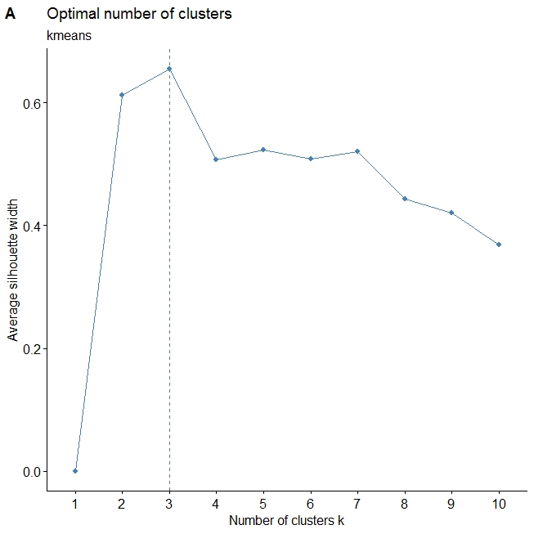

Fig. S1 : Optimal number of cluster using K-means algorithm

**References**

Buccianti, Antonella. 2015. “The FOREGS Repository: Modelling Variability in Stream Water on a Continental Scale Revising Classical Diagrams from CoDA (compositional Data Analysis) Perspective.” Journal of Geochemical Exploration 154 (July): 94–104**.**

Engle, Mark A., and Elisabeth L. Rowan. 2014. “Geochemical Evolution of Produced Waters from Hydraulic Fracturing of the Marcellus Shale, Northern Appalachian Basin: A Multivariate Compositional Data Analysis Approach.” International Journal of Coal Geology 126 (June): 45–56.