**Supplementary Data**

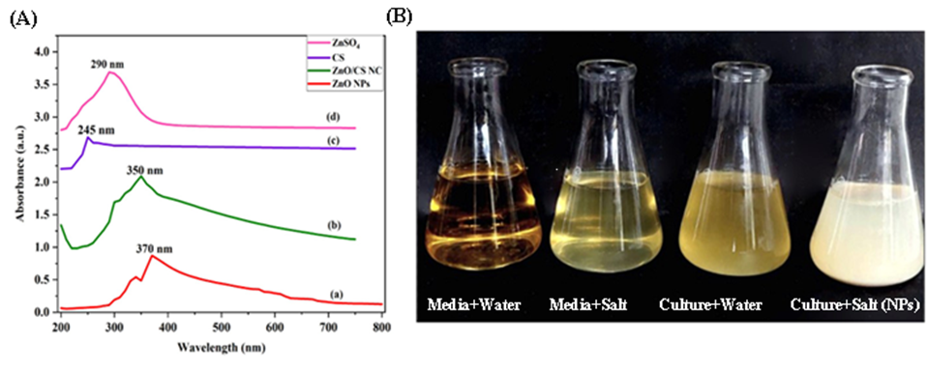

**(a)**

**(b)**

**Supplementary Figure 1.**  Biogenic synthesis of ZnO NPs using bacterial strain *Klebsiella pneumoniae* NST2 **(a)** UV/visible spectrum peak analysis **(b)** Pictorial presentation of theextracellular microbial synthesis of ZnO NPs

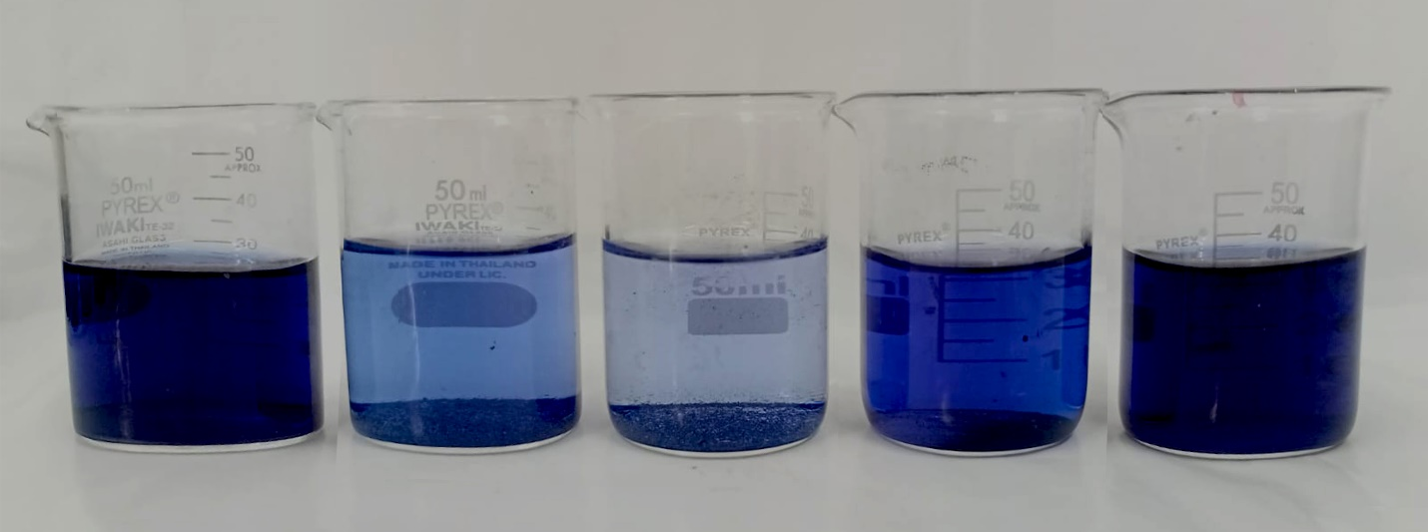

**Control ZnO NPs CS/ZnO NC CS ZnSO4**

**Supplementary Figure 2.** Visual representation of photocatalyticdegradation of RB-5 dye using different nano catalysts in light conditions.

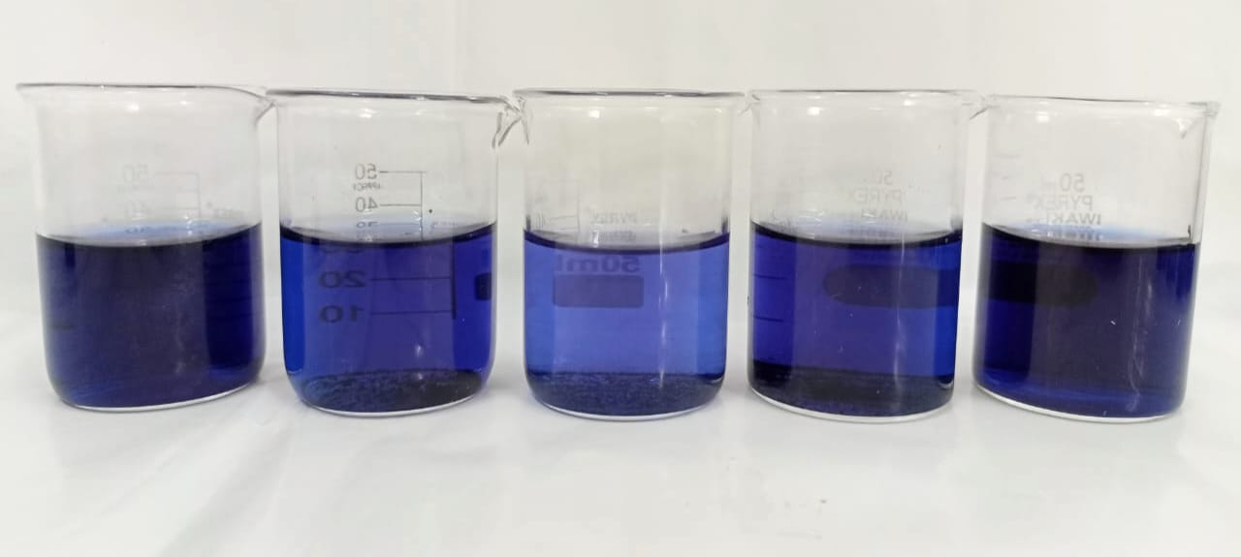

**Control ZnO NPs CS/ZnO NC CS ZnSO4**

**Supplementary Figure 3.** Visual representation of absorptive degradation of RB-5 dye using various catalysts in dark conditions.

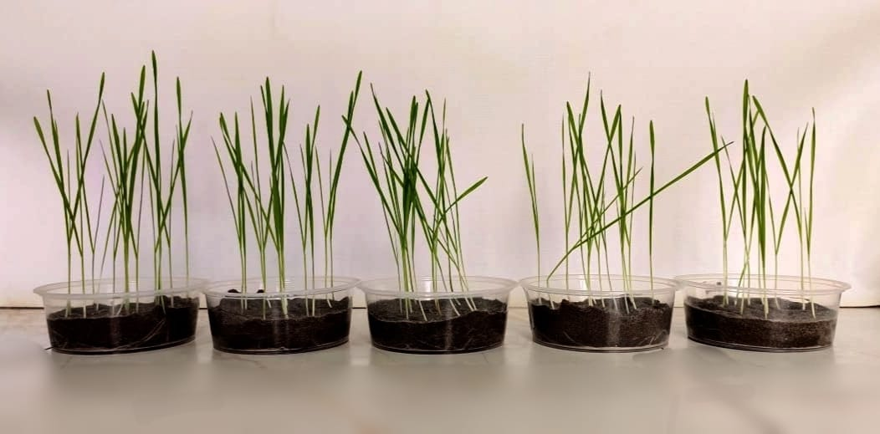

**Control ZnO NPs CS/ZnO NC**

**Supplementary Figure 4.** Application of ZnO NPs and CS/ZnO NC on wheat to check their phytotoxicity

|  |  |  |
| --- | --- | --- |
|  | **Catalysts** | **Adsorbent** |
| **ZnO NPs** | 82% | 41% |
| **CS/ZnO NC** | 98% | 82% |
| **CS** | 56% | 44% |
| **ZnSO4** | 18% | 14% |

**Supplementary Figure 5.** Maximum % degradation of Reactive Black-5 using different catalysts/adsorbent

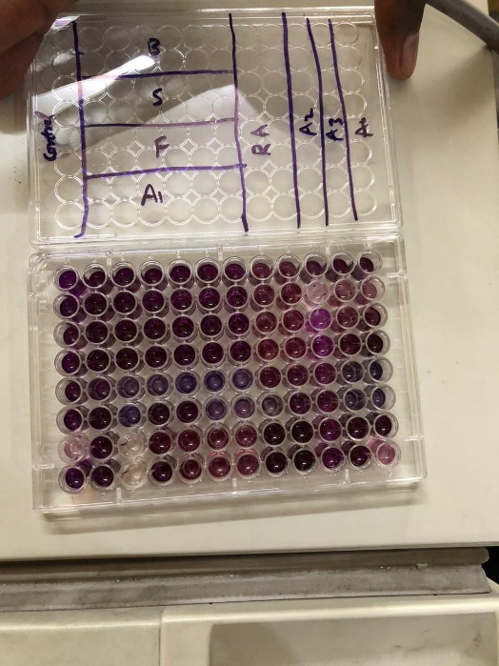

**Supplementary Figure 6.** MTT analysis plate