Screening Levels Spatial Interpolation of Lifetime Carcinogenic Risk by Organochlorine Phosphates across Catchments of River Chena

**SI Table 1**: Comparison of OCPs levels from sediment and water with previously published studies across the globe.

|  |  |  |  |  |  |  |
| --- | --- | --- | --- | --- | --- | --- |
| Study Area | Sample Type | Unit | ∑HCH | ∑DDT | ∑Endosulfan | Reference |
| Nullah Aik and Nullah Palkhu River Chenab, Pakistan | Sediment | ng/g | 18.96 | 49.28 | 12.62 | Present study |
| Daye lake, China | Sediment | ng/g | 1.11 | 3.93 | 1.54 | Bhutto et al. 2021 |
| River Barandu, Pakistan | Sediment | ng/g | 42.897 | 0.326 | 0.526 | Taufeeq et al. 2021 |
| Nullah Aik and Nullah Palkhu River Chenab, Pakistan | Sediment | ng/g | 9.24 | 40.3 | 0.59 | Mahmood et al. 2014 |
| River Ravi, Northern tributaries | Sediment | ng/g | 27.82 | 76.9 | 109.84 | Baqar et al.  2018 |
| Hilly Region, South China | Sediment |  | 9.0 | 15.54 | - | Gong et al. 2020 |
| Nullah Aik and Nullah Palkhu River Chenab, Pakistan | Water | Ng/l | 13.5 | 41.87 | 6.16 | Present study |
| Daye lake, China | Water | ng/l | 1.15 | 1.25 | 0.87 | Bhutto et al. 2021 |
| River Barandu, Pakistan | Water | ug/l | 0.429 | 0.009 | 0.003 | Taufeeq et 2021 |
| Nullah Aik and Nullah Palkhu River Chenab, Pakistan | Water | ng/l | 3.31 | 9.07 | 0.98 | Mahmood et al. 2014 |
| River Ravi, Northern tributaries | Water | ng/l | 4.13 | 9.47 | 2.89 | Baqar et al. 2018 |
| Southern Indian Ocean and coastal antarctic water, india | Water | pg/l | 0.25 | 0.5 | 0.45 | Vadumala et al. 2023 |

|  |  |  |  |
| --- | --- | --- | --- |
| OCPs | Green algae | Daphnia | Fish |
| DDT | 0.059 | 0.013 | 0.014 |
| DDE | 0.069 | 0.015 | 0.014 |
| DDD | 0.232 | 0.071 | 0.087 |
| α-Endosulfan | 2.1 | 0.44 | 0.002 |
| β-Endosulfan | 6.8 | 3.08 | 3.442 |
| α-HCH | 10 | 0.37 | 0.82 |
| β-HCH | 2.7 | 1.565 | 2.238 |

**S1 Table 2:** EC50/LC50 values used for ecological risk assessment of OCPs in water of Nullah Aik and Nullah Palkhu (Sultan et al., 2023)

**SI Fig 1:** Isomeric ratios of OCPs isomers in water of Nullah Aik and Nullah Palkhu

**SI Fig 2**: Isomeric ratios of OCPs isomers in sediment of Nullah Aik and Nullah Palkhu

**SI Fig 3:** Spatial distribution of detected isomers in water from the study area

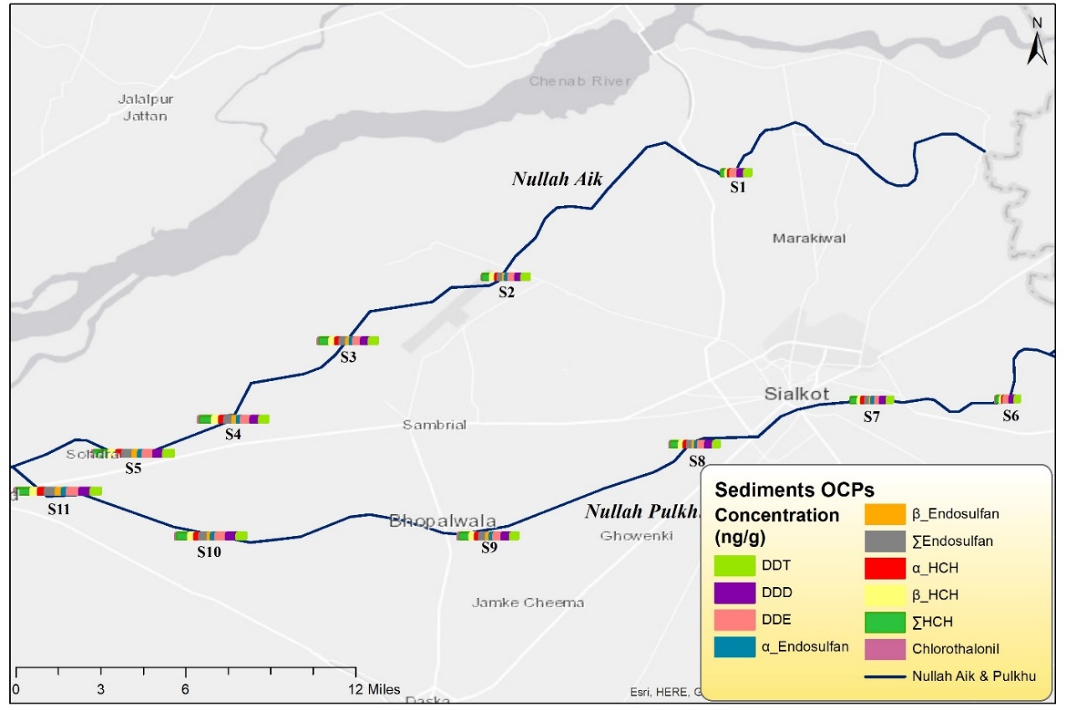

**SI Fig 4:** Spatial distribution of detected isomers in sediments from the study area

**SI Fig 5:** Comparison of OCPs concentrations in sediments with sediment quality guidelines