**Supplementary Information**

**Cholinesterase inhibitory activity and regioselective synthesis of spiropyrrolidinoindole integrated ferrocene hybrid heterocycles *via* multicomponent cycloaddition reaction**

_____________________________________________________________________________________

*General methods*

All reagents and solvents were purchased from commercial suppliers and used without further purification. Reactions were monitored by thin-layer chromatography (TLC) on silica gel. 1H, 13C and two-dimensional NMR spectra were recorded on a JEOL 500 MHz instrument in CDCl3 using Tetramethylsilane (TMS) as internal standard. Standard Bruker software was used throughout. Chemical shifts are given in parts per million (δ-scale) and the coupling constants are given in Hertz. Mass spectra were recorded on a DART-ToF-MS mass spectrometer.

*Spiropyrrolidine****, 6a***

Brown solid; 1H NMR (400MHz, CDCl3): *δ*/ppm 2.91-2.96 (1H, dd, *J* = 13.5, 8.0 Hz), 3.38-3.40 (1H, m), 3.89 (1H, m), 4.08-4.24 (7H, m), 4.38-4.39 (1H, m), 4.47-4.58 (2H, m), 5.14 (1H, d, *J* = 9.5 Hz), 6.79 (2H, m), 6.99 (2H, d, *J* = 8.5 Hz), 7.14-7.24 (8H, m), 7.65-7.70 (4H, m), 8.03 (1H, d, *J* = 7.5 Hz), 8.17 (1H, d, *J* = 6.5 Hz): 13C NMR (100 MHz, CDCl3): *δ/*ppm 30.4, 40.5, 45.1, 62.5, 65.6, 66.1, 67.3, 67.6, 68.2, 69.1, 69.8, 70.3, 71.6, 89.6, 117.9, 121.4, 126.4, 127.3, 128.4, 128.7, 128.9, 129.1, 129.4, 129.9, 131.4, 132.6, 132.8, 136.2, 136.9, 138.7, 141.8, 142.5, 147.5, 147.8, 153.3, 166.2. LC/MS(ESI): *m/z* = 688 (M+).

*Spiropyrrolidine****, 6c***

Brown solid; 1H NMR (500MHz, CDCl3): *δ*/ppm 3.08 (1H, dd, *J* = 14.5, 8.0 Hz), 3.53-3.57 (1H, m), 3.96 (1H, t, J =10.0 Hz), 4.08-4.23 (7H, m), 4.47-4.50 (2H, m), 5.11 (1H, d, *J* = 9.5 Hz), 6.80 (2H, m), 6.94 (2H, m), 7.04-7.14 (4H, m), 7.21-7.30 (4H, H), 7.57-7.79 (4H, m), 8.06 (1H, m), 8.17 (1H, d, *J* = 6.5 Hz): 13C NMR (125 MHz, CDCl3): *δ/*ppm 30.0, 45.6, 62.9, 65.2, 66.3, 67.4, 67.7, 68.5, 68.7, 70.4, 89.7, 119.1, 119.8, 121.5, 126.7, 127.9, 128.3, 128.8, 129.1, 129.4, 129.7, 129.8, 131.6, 132.6, 136.3, 136.7, 139.2, 142.5, 143.2, 164.4, 197.5; LC/MS(ESI): *m/z* = 722 (M+).

*Spiropyrrolidine****, 6e***

Brown solid; 1H NMR (500MHz, CDCl3): *δ*/ppm 2.36 (3H, s), 3.06-3.08 (1H, dd, *J* = 13.5, 8.0 Hz), 3.95-3.96 (1H, m), 4.06 (1H, m), 4.15-4.20 (7H, m), 4.42-4.50 (3H, m), 5.11 (1H, d, *J* = 9.5 Hz), 6.26 (2H, m), 6.97-7.02 (5H, m), 7.22-7.30 (3H, m), 7.58-7.81 (5H, m), 8.04-8.25 (3H, m): 13C NMR (100 MHz, CDCl3): *δ/*ppm 21.4, 30.6, 40.5, 45.6, 55.3, 62.8, 65.9, 66.2, 67.9, 68.1, 68.4, 69.3, 69.8, 70.4, 71.6, 89.8, 118.0, 121.7, 126.9, 127.7, 128.8, 128.9, 129.5, 129.7, 129.9, 131.1, 132.7, 132.8, 136.4, 136.2, 138.7, 141.1, 142.8, 147.8, 148.2, 153.3, 166.3, 197.2; LC/MS(ESI): *m/z* = 702 (M+).

*Spiropyrrolidine****, 6f***

Brown solid; 1H NMR (500MHz, CDCl3): *δ*/ppm 3.08-3.12 (1H, dd, *J* = 13.5, 8.0 Hz), 3.60 (3H, s), 3.94-3.99 (1H, m), 4.08 (1H, m), 4.17-4.21 (7H, m), 4.44-4.51 (3H, m), 5.13 (1H, d, *J* = 9.5 Hz), 6.27 (2H, m), 6.99-7.04 (5H, m), 7.20-7.28 (3H, m), 7.56-7.80 (5H, m), 8.01-8.23 (3H, m): 13C NMR (100 MHz, CDCl3): *δ/*ppm 30.2, 40.7, 45.5, 55.1, 62.6, 65.7, 66.1, 67.8, 67.8, 68.4, 69.2, 69.9, 70.5, 71.8, 89.8, 118.2, 121.4, 126.8, 127.7, 128.9, 128.9, 128.0, 129.4, 129.7, 129.9, 131.2, 132.5, 132.9, 136.3, 136.0, 138.8, 141.0, 142.6, 147.9, 148.1, 153.4, 166.4, 197.4. LC/MS(ESI): *m/z* = 702 (M+).

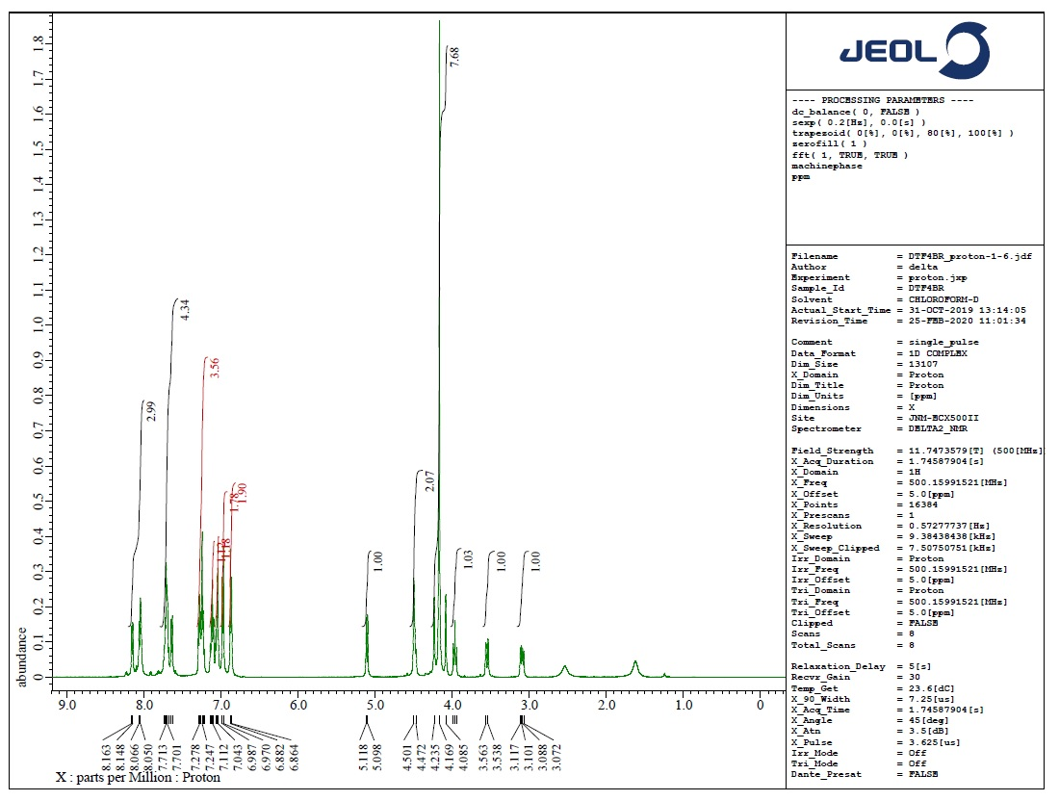

**Fig.S1** 1H NMR spectrum of **5b**

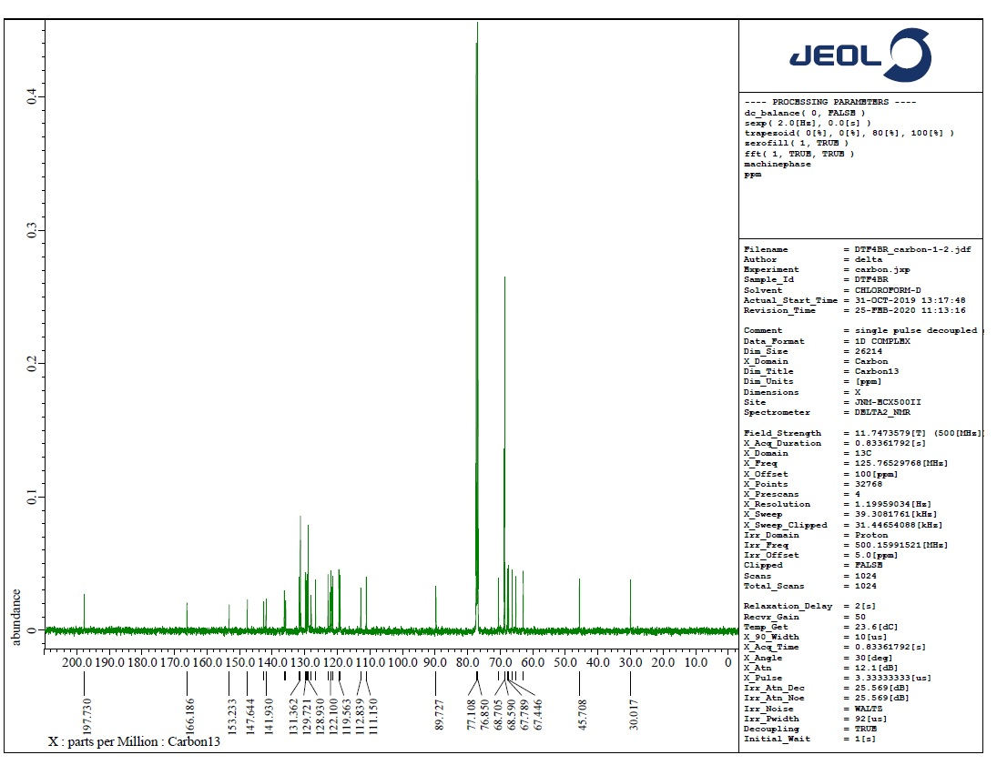

**Fig.S2** 13C NMR spectrum of **5b**

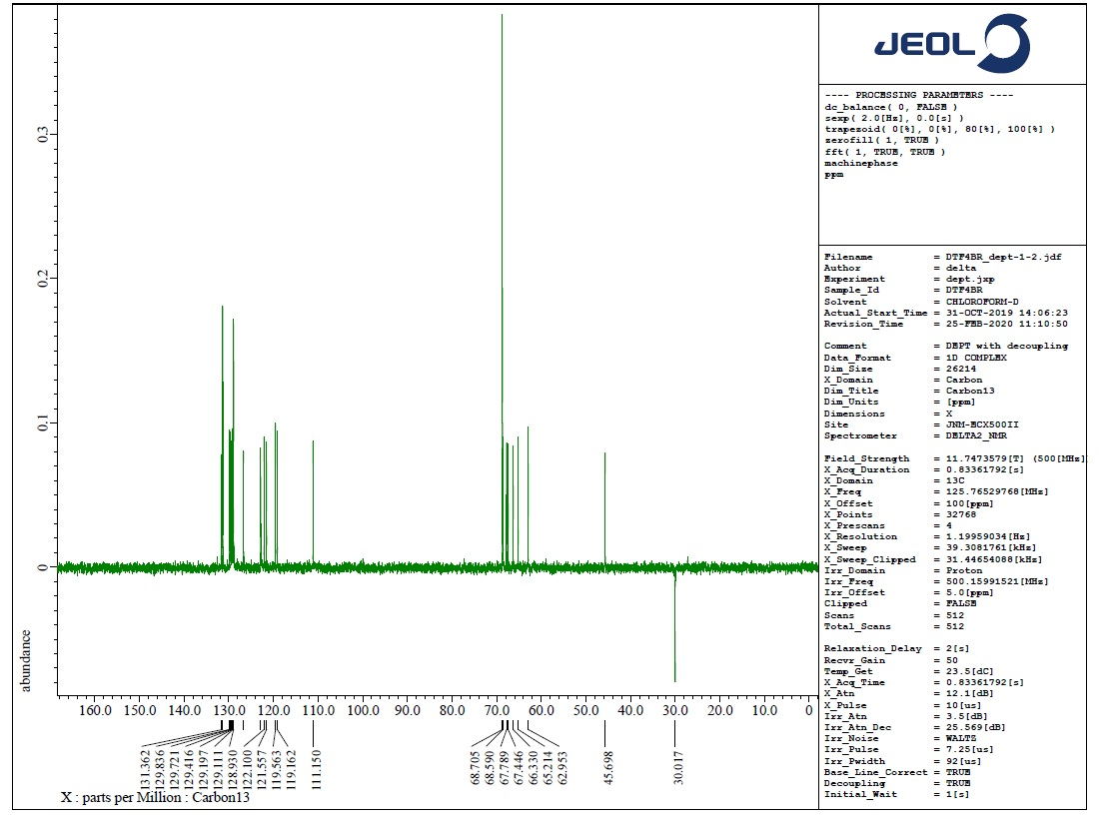

**Fig.S3** DEPT-135 NMR spectrum of **5b**

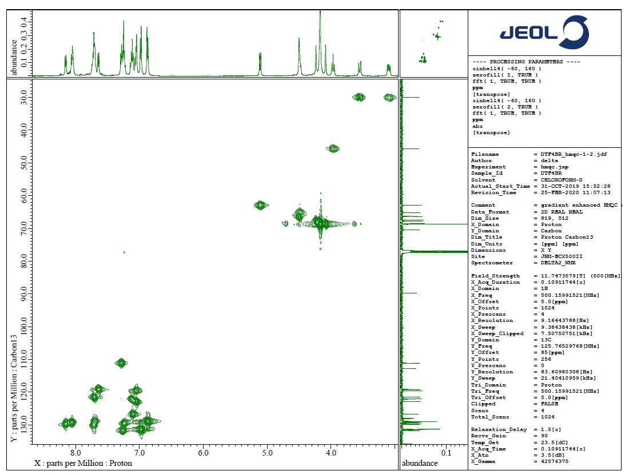

**Fig.S4** HMQC NMR spectrum of **5b**

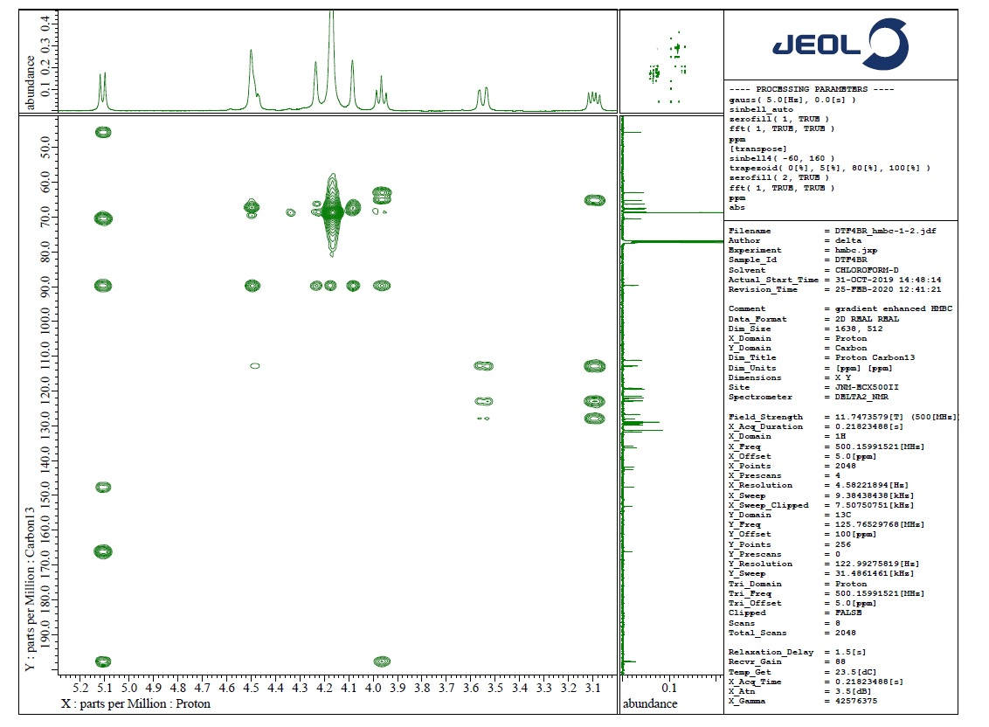

**Fig.S5** HMBC NMR spectrum of **5b**