**SUPPLIMENTARY FILE**

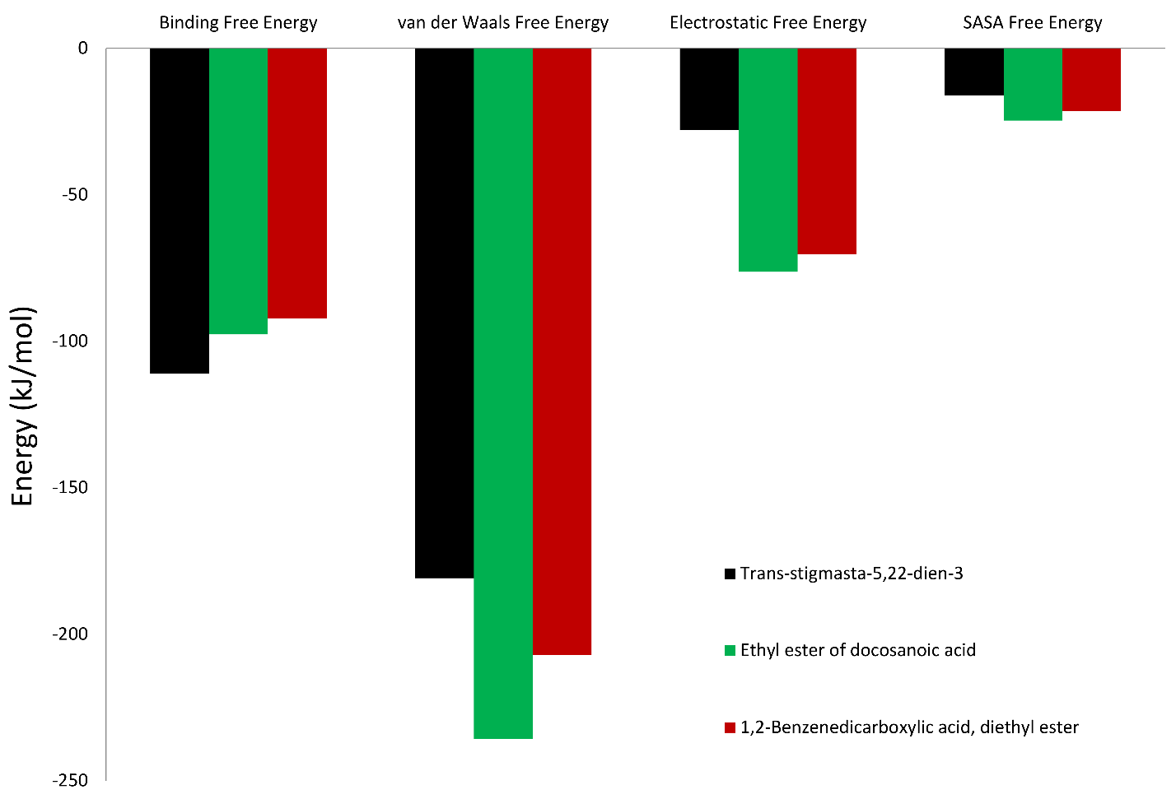

Figure S1. Free binding energy (kJ/mol) calculated using MMGBSA method for three protein–ligand complexes by using molecular dynamics trajectories.

**Table S1. FTIR peak values of *F. racemosa* sample**

|  |  |  |
| --- | --- | --- |
| **Peak Value** | **Bond** | **Functional group** |
| 3404.72 | O-H stretch, free hydroxyl | Alcohols, phenols |
| 2977.22 | C-H strech | Alkenes |
| 2901.97 | C-H strech | Alkenes |
| 2541.22 | O-H strech | Carboxylic acids |
| 2131.55 | -C=C- strech | Alkynes |
| 1649.61 | -C=C- strech | Alkenes |
| 1452.26 | C-C stretch (in-ring)  C-H bend | Aromatics  Alkanes |
| 1407.35 | C-C stretch (in-ring) | Aromatics |
| 1254.26 | C-N stretch | Aromatic amines |
| 1331.97 | N-O symmetric stretch | Nitro compounds |
| 1080.25 | C-O stretch | Alcohols, Carboxylic acids, esters, ethers |
| 1049.33 | C-N stretch | Aliphatic amines |

**Table S2. Identification of active compounds in plant extracts using GCMS**

|  |  |  |  |  |  |  |
| --- | --- | --- | --- | --- | --- | --- |
| **Peak** | **R. Time** | **Area %** | **Height %** | **Molecular Formula** | **Molecular Weight** | **Name of the compounds** |
| 1 | 10.031 | 83.42 | 93.88 | C12H14O4 | 222 | 1,2-Benzenedicarboxylic acid, diethyl ester |
| 2 | 13.992 | 0.19 | 0.16 | C16H32O2 | 256 | Hexadecanoic acid |
| 3 | 14.256 | 0.14 | 0.26 | C17H34O2 | 270 | Pentadecanoic acid, ethyl ester |
| 4 | 15.850 | 0.23 | 0.26 | C18H32O2 | 280 | 9,12-Octadecadienoic acid |
| 5 | 15.929 | 0.47 | 0.39 | C21H36O2 | 320 | 11,14,17-Eicosatrienoic acid, methyl ester |
| 6 | 16.072 | 0.53 | 0.61 | C15H28O | 224 | (Z)6, (Z)9-Pentadecadien-1-ol |
| 7 | 16.168 | 0.75 | 1.21 | C16H28 | 220 | 4-Hexadecen-6-yne |
| 8 | 16.375 | 0.29 | 0.25 | C16H28 | 220 | Ethyl ester of docosanoic acid |
| 9 | 16.607 | 1.22 | 0.46 | C29H60 | 408 | Nonacosane |
| 10 | 22.078 | 12.76 | 2.53 | C29H48O | 421 | Trans-stigmasta-5,22-dien-3.beta |
|  |  | 100.00 | 100.00 |  |  |  |

**Table S3. Binding affinity of phytochemical identified in *F. racemosa* fruit with crystal structure of *E. coli***

|  |  |  |  |  |  |  |  |  |
| --- | --- | --- | --- | --- | --- | --- | --- | --- |
| S. No | CID | Compound Name | Glide  score | Glide  Evdw | Glide  Ecoul | Glide Energy | Glide einternal | Glide emodel |
| 1. | 6781 | 1,2-Benzenedicarboxylic acid, diethyl ester | -2.409 | -19.216 | -2.693 | -21.909 | 1.243 | -22.281 |
| 2 | 985 | Hexadecanoic acid | -4.512 | -19.616 | -1.483 | -21.099 | 6.588 | -19.564 |
| 3. | 38762 | Pentadecanoic acid, ethyl ester | -0.807 | -21.774 | -2.007 | -23.782 | 0.94 | -28.792 |
| 4. | 5280450 | 9,12-Octadecadienoic acid | -4.618 | -20.736 | -2.541 | -23.276 | 7.291 | -25.32 |
| 5. | 5367326 | 11,14,17-Eicosatrienoic acid, methyl ester | -0.145 | -20.455 | -5.015 | -25.47 | 7.162 | -29.593 |
| 6. | 5365570 | (Z)6,(Z)9-Pentadecadien-1-ol | -0.199 | -16.253 | -3.371 | -19.624 | 3.208 | -22.031 |
| 7. | 549001 | 4-Hexadecen-6-yne | 0.409 | -16.283 | -0.51 | -16.794 | 1.729 | -19.088 |
| 8. | 22199 | Ethyl ester of docosanoic acid | -3.389 | -32.39 | -3.248 | -35.639 | 2.879 | -43.526 |
| 9. | 12409 | Nonacosane | -3.678 | -30.932 | -0.265 | -31.197 | 3.174 | -41.263 |
| 10. | 5280794 | Trans-stigmasta-5, 22-dien-3. | -3.237 | -21.613 | -2.883 | -24.496 | 1.752 | -32.217 |
| 11. | 5959 | Chloramphenical | -3.533 | -16.694 | -5.73 | -22.424 | 3.126 | -26.771 |

**Table S4. Binding affinity of phytochemical identified in F. *racemosa* fruit with crystal structure of *C. albicans*.**

|  |  |  |  |  |  |  |  |  |
| --- | --- | --- | --- | --- | --- | --- | --- | --- |
| S.no | CID | Compound Name | Glide score | Glide Evdw | Glide Ecoul | Glide Energy | Glide einternal | Glide emodel |
| 1. | 6781 | 1,2-Benzenedicarboxylic acid, diethyl ester | -4.982 | -33.331 | -0.333 | -33.664 | 1.412 | -44.638 |
| 2 | 985 | Hexadecanoic acid | ~~-~~4.614 | -28.601 | -3.89 | -32.49 | 6.856 | -39.21 |
| 3. | 38762 | Pentadecanoic acid, ethyl ester | -5.863 | -32.801 | -1.407 | -34.208 | 1.08 | -47.261 |
| 4. | 5280450 | 9,12-Octadecadienoic acid | -4.276 | -33.393 | -1.858 | -35.251 | 8.186 | -45.739 |
| 5. | 5367326 | 11,14,17-Eicosatrienoic acid, methyl ester | -4.536 | -43.26 | -0.591 | -43.85 | 7.953 | -59.87 |
| 6. | 5365570 | (Z)6,(Z)9-Pentadecadien-1-ol | -5.75 | -30.424 | 0.467 | -29.957 | 3.456 | -39.753 |
| 7. | 549001 | 4-Hexadecen-6-yne | -3.268 | -27.502 | -0.166 | -27.668 | 0.547 | -37.282 |
| 8. | 22199 | Ethyl ester of docosanoic acid | -8.014 | ~~-~~39.616 | -0.186 | -39.802 | 8.267 | -60.019 |
| 9. | 12409 | Nonacosane | -7.196 | -41.941 | 0.438 | -41.504 | 0.972 | -67.396 |
| 10. | 5280794 | Trans-stigmasta-5,22-dien-3. | -10.849 | -34.691 | -1.224 | -35.915 | 3.614 | -36.349 |
| 11. | 3365 | Flucnazole | -5.391 | -40.459 | -3.011 | -43.47 | 4.759 | -64.771 |