**Treatment of oily bilge waste water using marine fungi**

**Supplementary figures**

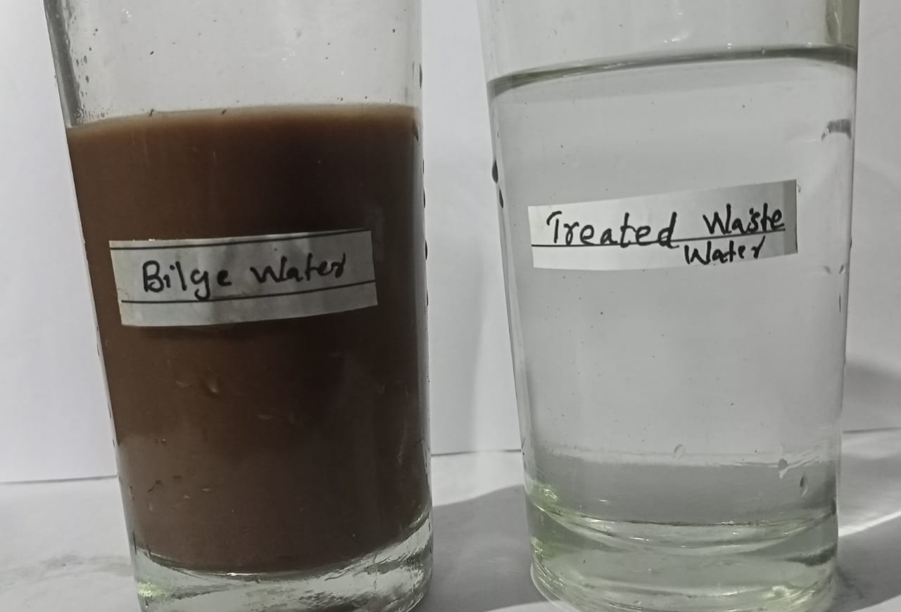

Figure S1 : Bilge before and after *Fusarium magnifereae* degradation

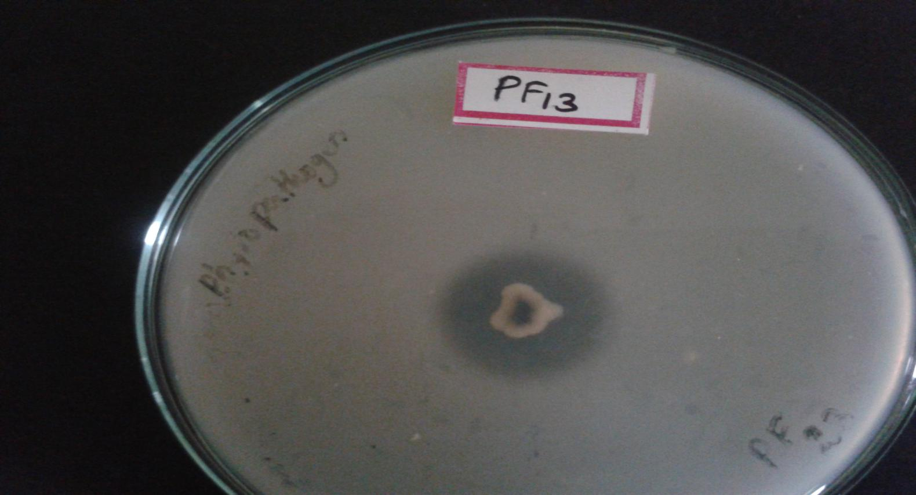 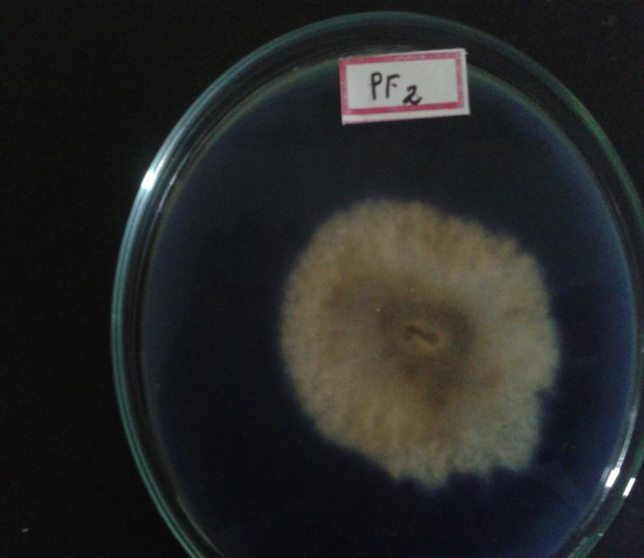

1. After 4 days
2. After 2 days

Figure S2 : Indicates the ZOI of *Fusarium magnifereae* after 2days and 4days of incubation