**Supplementary Material (Figures)**

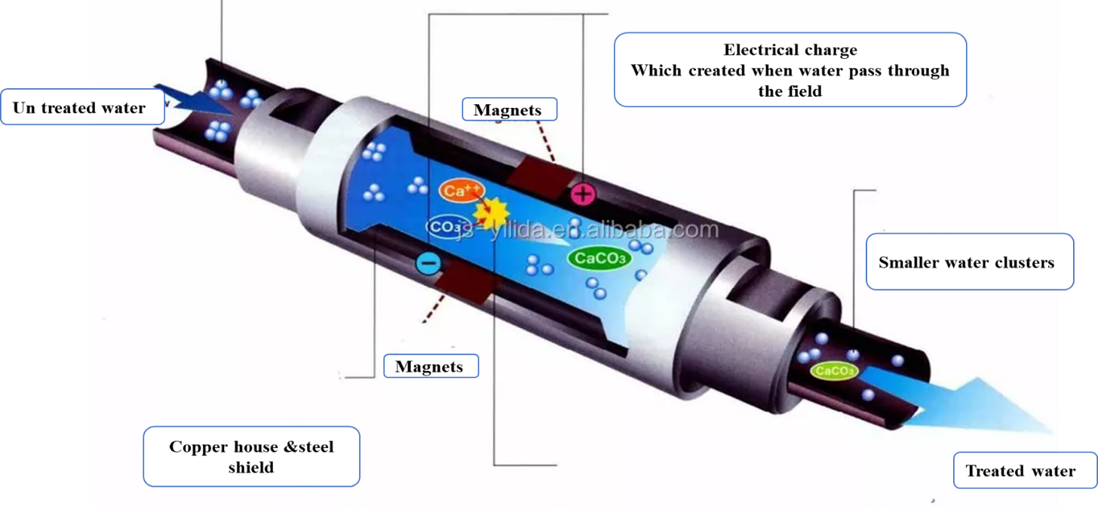

Magnetic force

Figure S1. Components of Test Rig.



Figure.S2: surface tension measurement

Fig.S3 Alkalinity measurement of MWT