**Embryonic Development of Indonesian Native Fish Yellow Rasbora (*Rasbora lateristriata*)**

Supplementary figures

**Suppl. Fig. 1.** Movement of non-yolk cytoplasm (blastodisc) toward the animal pole in the zygote period of yellow rasbora *(Rasbora lateristriata)* embryo (green arrow: movement direction, red arrow: blastodisc expansion).

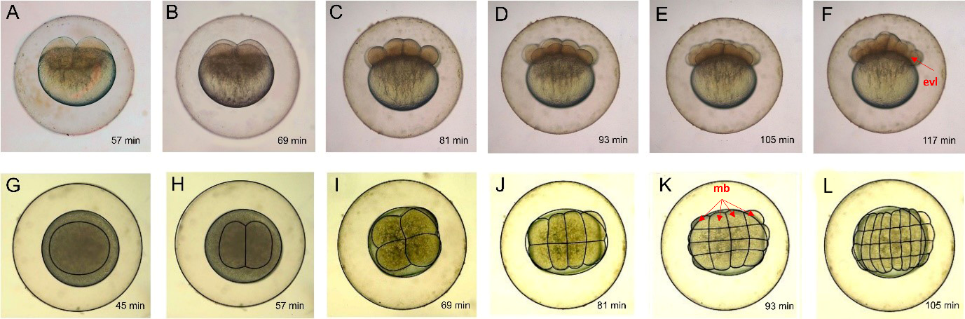

**Suppl. Fig. 2*.***Embryonic development of *(Rasbora lateristriata)* during the cell division stage from lateral (A-F) and dorsal (G-L) view. (A, H) 2 cells, (B, I) 4 cells, (C, J) 8 cells, (D,K) 16 cells, (E, L) 32 cells, (F) 64 cells, and (G) single-cell stages. mb, marginal blastomere; evl, enveloping layer.

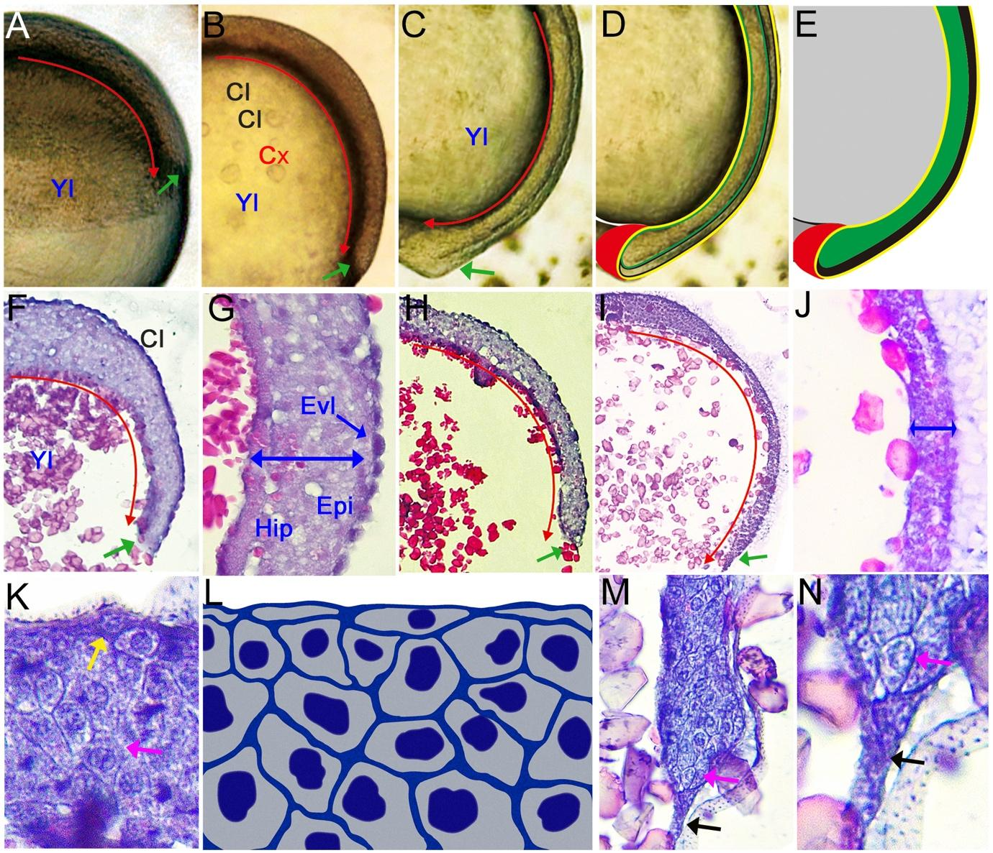

**Suppl. Fig. 3.** Embryonic development of *(Rasbora lateristriata)* from 50% epiboly - gastrulation stage. (A, B, C, D) blastoderm cells expansion and differentiation from (A) 50% epiboly to (D) Bud stage. (F, G, H, I, J) Histological structure and the cellular reconstruction of the zygote showing triploblastic formation of embryonic layer along with development progression of blastomeres cells. (K, L, M, N) cellular proliferation and differentiation during gastrulation. Cl (Cell of Blastoderm), Yl (Yolk), EVL (Enveloping layer), Epi (epiblast layer), Hyp (Hypoblast layer), red arrow: expansion of blastomem cells. Green arrow: tip of cellular expansion, blue double head arrow indicates the transition of layer thickness. Green arrow: guide cell with cytoplasmic expansion. HE staining and 40-400x magnification.

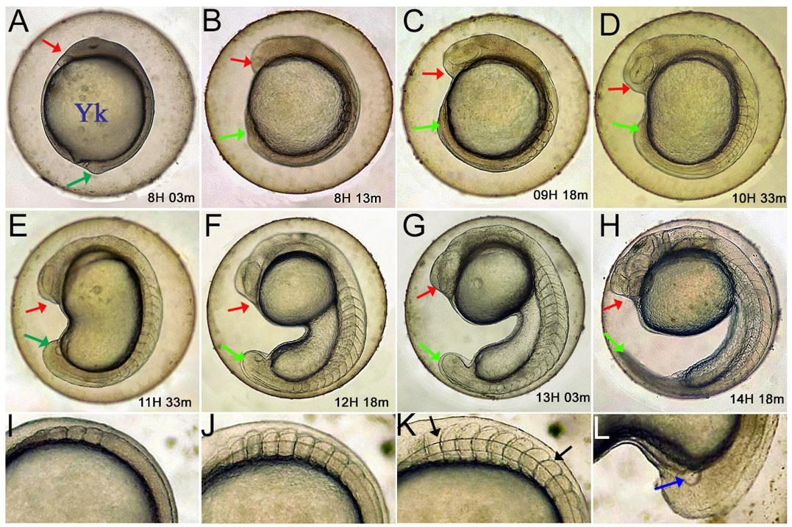

**Supl. Fig. 4.** Embryo development of *(Rasbora lateristriata)* during the segmentation stage. (A) 1, (B) 3, (C) 6, (D) 10, (E) 14, (F) 17, (G) 20, and (H) 25 somites stages. (I, J, K, L) Somit number progression. Red and green arrow: anterior and posterior part of embryo; black arrow: chevron shape of somite; blue arrow: Kupffer’s vesicle.

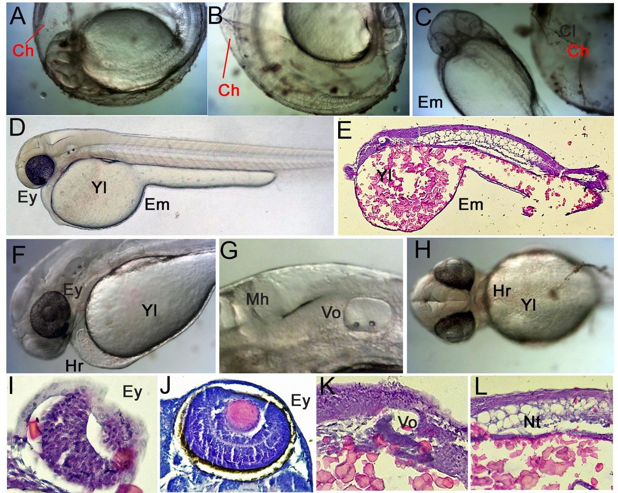

**Suppl. Fig. 5.** Hatching stages of (*Rasbora lateristriata*). (A) before hatching, (B) hatching, (C) after hatching, (D) 24 hpf embryo, (E) histological structure of 24 hpf embryo, (F) eyes, brain, heart, and pneumatocyst, (G) mid-hind brain and otic vesicle, (H) ventra view of eyes, heart and proctodeum, (I, J, K, L) histological structure and the cellular reconstruction of the eyes, otic vesicle and notochord, (I) 24 hpf eyes with no layering, (J) layering eyes on 48 hpf embryo. Ey (eyes), Yl (Yolk), Mh (mid-hind brain), Vo (Otic Vesicle), Hr (heart), Nt (notochord). HE staining and 40-400x magnification.

**Suppl. Fig. 6.** Hatching stages of (*Rasbora lateristriata*). (A) 24 hpf embryo, (B) 48 hpf Embryo, (C) 72 hpf Embryo. Cr (Cranium), Vo (Otic Vesicle), Nt (Notocord), Yl (Yolk), Ey (eyes), Br (brain), Gi (Gills), In (Intestine), Sm (Somits). HE staining and 40x magnification.

**Suppl. Fig. 7*.***SEM images of the head of *Rasbora lateristerata* larvae. ey: egg yolk; e: eye; m: mouth

**Suppl. Fig 8*.***SEM images of *Rasbora lateristerata* larvae. ey: egg yolk; e: eye; H: Head; cf: caudal fin.