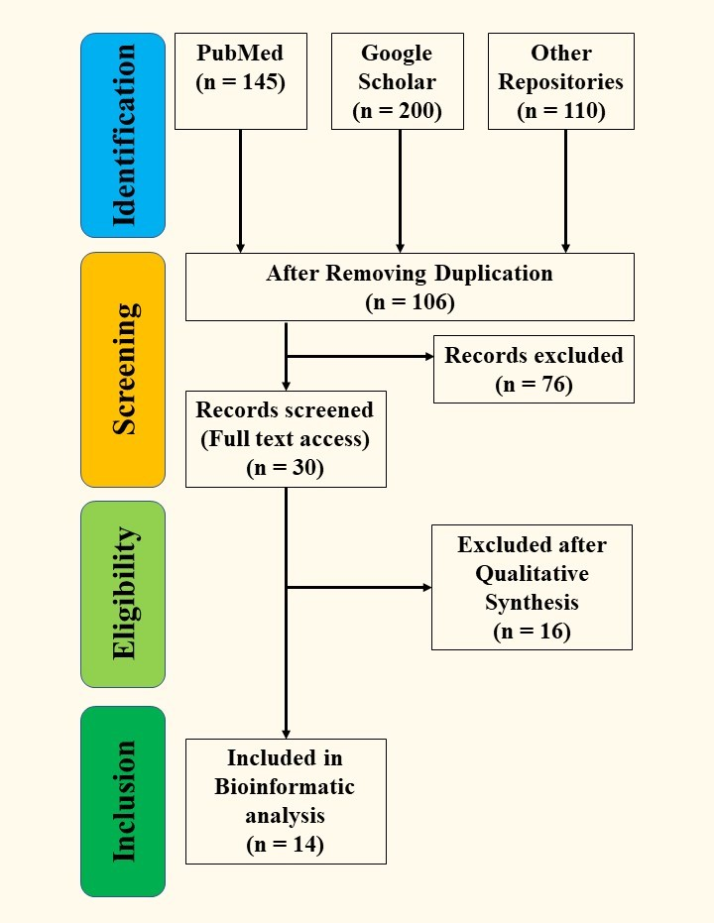

**Supplementary File 1:** PRISMA Flow Diagram for screening procedures used during mining genes of interests from literatures available in online databases (Source: Author’s creation)

**Supplementary File 2:** Inclusion and Exclusion Criteria for selecting research works

|  |  |  |
| --- | --- | --- |
| **Entity** | **Inclusion Criteria** | **Exclusion Criteria** |
| **Focus Group** | Abiotic stress-responsive genes | Various other genes other than abiotic stress-responsive genes |
| **Characteristics** | Gene expression of abiotic stress-responsive genes in O. sativa will only be considered. | Gene expression of insect resistance genes or any other genes will not be considered in this research. |

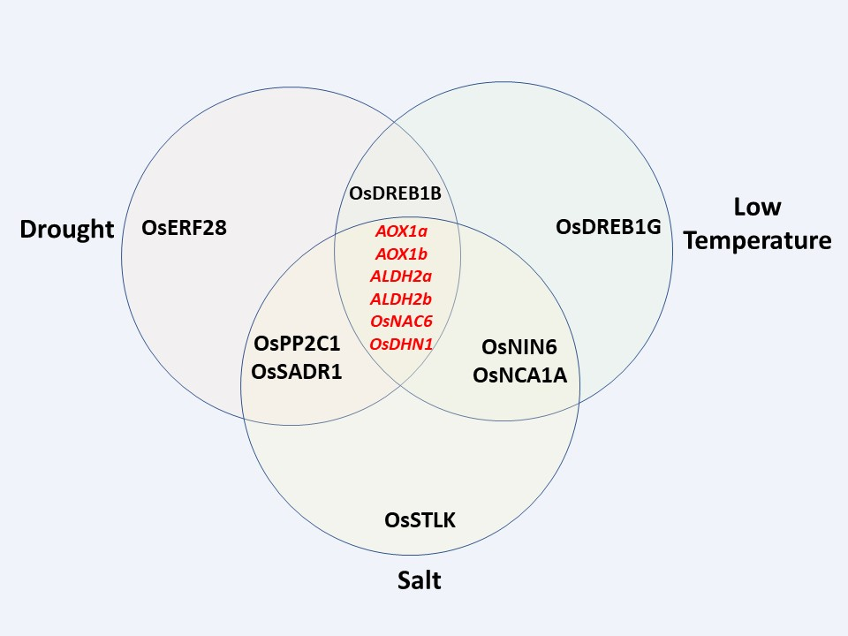

**Supplementary File 3:** Summary of the identified 14 abiotic stress-responsive genes from literature mining. All 14 genes were subjected to bioinformatic analysis and the 6 genes marked in red were further analyzed for in silico expression study (Source: Author’s creation)

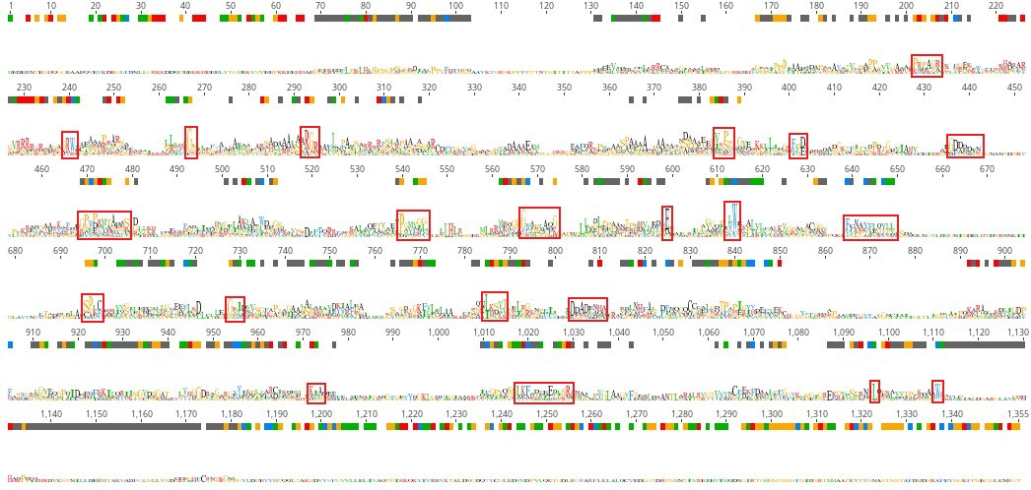

**Supplementary File 4:** Multiple Sequence alignment (MSA) of 14 identified abiotic-stress responsive genes in *O. Sativa* made in Geneious Prime 2022.2.2. The consensus sequence logo is shown red boxes each line of the alignment indicates the highly conserved domains of the genes.

**Supplementary File 5:** Query list of STRING for the 14 identified abiotic-stress responsive genes in *O. sativa*

|  |  |  |  |  |  |
| --- | --- | --- | --- | --- | --- |
| **Index** | **Query Item** | **String Id** | **Identity** | **Bit-score** | **Preferred Name in STRING** |
| 1 | ALDH2a | 4530.OS02T0730000-02 | 100 | 1072.8 | Aldh2a |
| 2 | ALDH2b | 4530.OS06T0270900-01 | 93.8 | 1030 | Aldh2b |
| 3 | AOX1a | 4530.OS04T0600200-01 | 100 | 636.7 | AOX1A |
| 4 | AOX1b | 4530.OS04T0600300-01 | 100 | 672.9 | AOX1B |
| 5 | OsNAC6 | 4530.OS01T0884300-01 | 100 | 555.4 | NAC6 |
| 6 | OsNCA1A | 4530.OS01T0104100-01 | 100 | 663.3 | OS01T0104100-01 |
| 7 | OsNIN6 | 4530.OS11T0175400-01 | 100 | 1140.9 | OsJ_33156 |
| 8 | OsDHN1 | 4530.OS02T0669100-01 | 100 | 287.3 | DHN1 |
| 9 | OsDREB1B | 4530.OS09T0522100-00 | 53.2 | 174.1 | DREB1H |
| 10 | OsDREB1G | 4530.OS02T0677300-02 | 100 | 376.7 | DREB1G |
| 11 | OsERF28 | 4530.OS08T0545500-00 | 100 | 292 | OS08T0545500-00 |
| 12 | OsSADR1 | 4530.OS11T0175500-02 | 94.1 | 983.8 | OS11T0175500-02 |
| 13 | OsSTLK | 4530.OS05T0305900-01 | 100 | 1614.7 | OS05T0305900-01 |
| 14 | OsPP2C | 4530.OS09T0325700-01 | 100 | 557 | OsJ_027745 |

|  |  |  |  |  |  |  |  |  |  |  |
| --- | --- | --- | --- | --- | --- | --- | --- | --- | --- | --- |
| **Supplementary File 6:** Interaction statistics among different nodes at protein level calculated in STRING | | | | | | | | | | |
| **Node 1** | **Node 2** | **Neighbourhood on chromosome** | **Gene fusion** | **Phylogenetic cooccurrence** | **Homology** | **Co-expression** | **Experimentally determined interaction** | **Database annotated** | **Automated text mining** | **Combined score** |
| AOX1A | AOX1B | 0 | 0 | 0.449 | 0.97 | 0.438 | 0 | 0 | 0.843 | 0.459 |
| Aldh2a | OsJ_04113 | 0 | 0 | 0 | 0 | 0 | 0.053 | 0.999 | 0 | 0.999 |
| Aldh2a | OsJ_06966 | 0.071 | 0 | 0 | 0 | 0.163 | 0.059 | 0.951 | 0.598 | 0.982 |
| Aldh2a | Aldh2b | 0 | 0 | 0.449 | 0.98 | 0 | 0 | 0.845 | 0.817 | 0.848 |
| Aldh2a | OS07T0188800-01 | 0 | 0 | 0.382 | 0.708 | 0.105 | 0.243 | 0.985 | 0.461 | 0.991 |
| Aldh2a | OsJ_24269 | 0 | 0 | 0 | 0 | 0.109 | 0 | 0.992 | 0.64 | 0.997 |
| Aldh2b | OsJ_04113 | 0 | 0 | 0 | 0 | 0 | 0.053 | 0.999 | 0 | 0.999 |
| Aldh2b | OsJ_06966 | 0.071 | 0 | 0 | 0 | 0.163 | 0.059 | 0.98 | 0.6 | 0.993 |
| Aldh2b | OS07T0188800-01 | 0 | 0 | 0.382 | 0.713 | 0.105 | 0.243 | 0.991 | 0.461 | 0.994 |
| Aldh2b | OsJ_24269 | 0 | 0 | 0 | 0 | 0.109 | 0 | 0.996 | 0.64 | 0.998 |
| DHN1 | NAC6 | 0 | 0 | 0 | 0 | 0.11 | 0 | 0 | 0.567 | 0.598 |
| NAC6 | OsJ_027745 | 0 | 0 | 0 | 0 | 0.111 | 0.109 | 0 | 0.388 | 0.472 |
| OS03T0297600-01 | OsJ_027745 | 0 | 0 | 0 | 0 | 0 | 0.768 | 0.949 | 0.584 | 0.994 |
| OS07T0188800-01 | OsJ_06966 | 0 | 0 | 0 | 0 | 0.136 | 0 | 0.991 | 0.247 | 0.993 |
| OS07T0188800-01 | OsJ_24269 | 0 | 0 | 0 | 0 | 0.072 | 0 | 0 | 0.473 | 0.49 |
| OS07T0188800-01 | OsJ_027745 | 0 | 0 | 0 | 0 | 0 | 0 | 0 | 0.567 | 0.567 |

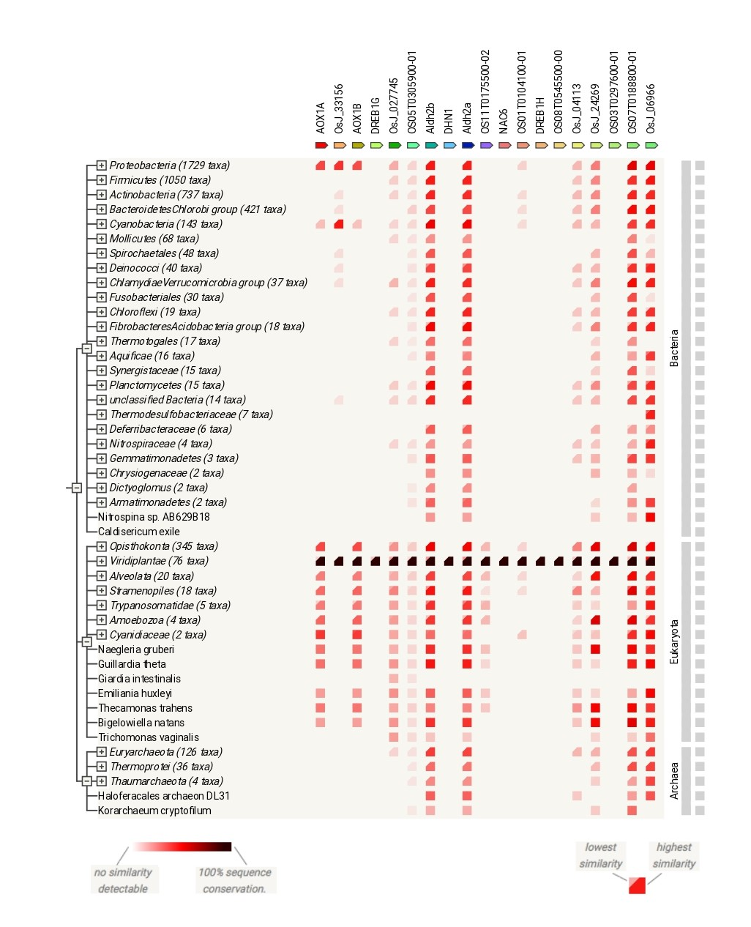

**Supplementary File 7:** Gene co-occurrence study for 14 identified abiotic-stress responsive genes in *Oryza sativa* along with 5 predicted functional protein partners across various taxa (Source: STRING)

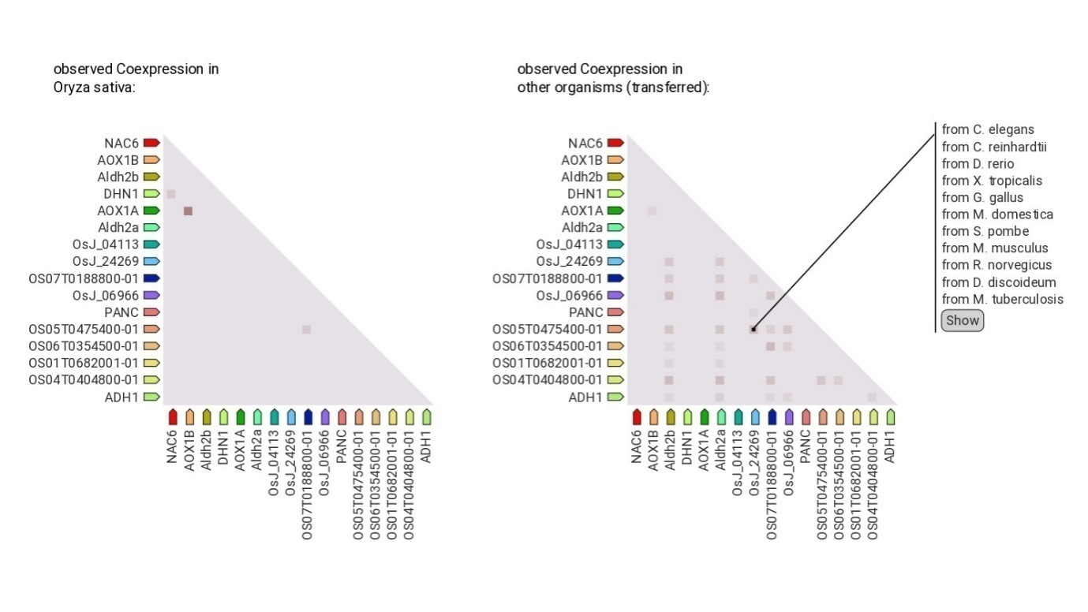

**Supplementary File 8:** Co-expression study of 6 identified abiotic-stress responsive genes in *Oryza sativa* (Source*:* STRING)

**Supplementary File 9:** Profile of potential expressionlevel of each gene under abiotic stress stimulicalculated through the GCOS expression signal

|  |  |  |  |
| --- | --- | --- | --- |
| **Gene: *ALDH2a*** | | | |
| **Group** | **Tissue** | **Expression Level** | **Standard Deviation** |
| 1 | Seedling Root | 1097.99 | 152.07 |
| 2 | Mature Leaf | 475.36 | 189.06 |
| 2 | Young Leaf | 329.73 | 234.62 |
| 3 | SAM | 9510.71 | 715.55 |
| 4 | Young Inflorescence | 30680.27 | 3051.58 |
| 4 | Inflorescence P2 | 53373.2 | 7143.35 |
| 4 | Inflorescence P3 | 32538.93 | 3671.22 |
| 4 | Inflorescence P4 | 22854.3 | 3715.95 |
| 4 | Inflorescence P5 | 2124.06 | 185.39 |
| 4 | Inflorescence P6 | 28428.2 | 1240.4 |
| 5 | Seed S1 | 5871.67 | 2369.4 |
| 5 | Seed S2 | 14121.1 | 2849.78 |
| 5 | Seed S3 | 10093.61 | 1928.21 |
| 5 | Seed S4 | 6586.43 | 1080.4 |
| 5 | Seed S5 | 7096.81 | 1067.74 |
| **Gene: *ALDH2b*** | | | |
| Group | Tissue | Expression Level | Standard Deviation |
| 1 | Seedling Root | 7776.83 | 175.53 |
| 2 | Mature Leaf | 19812.53 | 1153.78 |
| 2 | Young Leaf | 19821.83 | 1137.68 |
| 3 | SAM | 759.8 | 54.53 |
| 4 | Young Inflorescence | 2808.47 | 402.53 |
| 4 | Inflorescence P2 | 2190.69 | 36.8 |
| 4 | Inflorescence P3 | 4479.29 | 453.73 |
| 4 | Inflorescence P4 | 6322.8 | 209.5 |
| 4 | Inflorescence P5 | 5653.06 | 1067.72 |
| 4 | Inflorescence P6 | 6528.73 | 151.28 |
| 5 | Seed S1 | 10997.37 | 121.85 |
| 5 | Seed S2 | 10060.27 | 539.16 |
| 5 | Seed S3 | 11228.3 | 631.98 |
| 5 | Seed S4 | 17791.47 | 313.86 |
| 5 | Seed S5 | 18723.03 | 1156.24 |
| **Gene: *AOX1a*** | | | |
| Group | Tissue | Expression Level | Standard Deviation |
| 1 | Seedling Root | 872.31 | 83.57 |
| 2 | Mature Leaf | 1761.0 | 440.47 |
| 2 | Young Leaf | 957.66 | 262.32 |
| 3 | SAM | 33.83 | 9.86 |
| 4 | Young Inflorescence | 164.53 | 76.55 |
| 4 | Inflorescence P2 | 77.52 | 30.34 |
| 4 | Inflorescence P3 | 408.87 | 70.65 |
| 4 | Inflorescence P4 | 673.2 | 111.91 |
| 4 | Inflorescence P5 | 341.62 | 59.07 |
| 4 | Inflorescence P6 | 2620.22 | 148.83 |
| 5 | Seed S1 | 2861.64 | 78.93 |
| 5 | Seed S2 | 2033.59 | 611.87 |
| 5 | Seed S3 | 1344.63 | 194.93 |
| 5 | Seed S4 | 1307.83 | 169.2 |
| 5 | Seed S5 | 1551.4 | 175.34 |
| **Gene: *AOX1b*** | | | |
| Group | Tissue | Expression Level | Standard Deviation |
| 1 | Seedling Root | 106.43 | 25.68 |
| 2 | Mature Leaf | 2018.73 | 279.52 |
| 2 | Young Leaf | 754.29 | 460.37 |
| 3 | SAM | 5.63 | 3.31 |
| 4 | Young Inflorescence | 29.39 | 5.13 |
| 4 | Inflorescence P2 | 4.37 | 1.22 |
| 4 | Inflorescence P3 | 25.17 | 20.11 |
| 4 | Inflorescence P4 | 62.02 | 22.94 |
| 4 | Inflorescence P5 | 6.63 | 4.44 |
| 4 | Inflorescence P6 | 1227.03 | 61.27 |
| 5 | Seed S1 | 5592.16 | 1256.42 |
| 5 | Seed S2 | 2357.71 | 852.55 |
| 5 | Seed S3 | 851.05 | 52.29 |
| 5 | Seed S4 | 817.32 | 145.6 |
| 5 | Seed S5 | 778.3 | 318.13 |
| **Gene: *OsDHN1*** | | | |
| Group | Tissue | Expression Level | Standard Deviation |
| 1 | Seedling Root | 5380.39 | 213.11 |
| 2 | Mature Leaf | 9711.09 | 2663.81 |
| 2 | Young Leaf | 3556.64 | 1455.64 |
| 3 | SAM | 7546.98 | 1677.74 |
| 4 | Young Inflorescence | 19485.23 | 2457.28 |
| 4 | Inflorescence P2 | 16462.6 | 329.95 |
| 4 | Inflorescence P3 | 16412.9 | 929.34 |
| 4 | Inflorescence P4 | 16834.53 | 1174.63 |
| 4 | Inflorescence P5 | 5285.89 | 308.09 |
| 4 | Inflorescence P6 | 18384.53 | 1077.45 |
| 5 | Seed S1 | 15923.1 | 1660.57 |
| 5 | Seed S2 | 11971.11 | 2363.2 |
| 5 | Seed S3 | 9835.17 | 736.99 |
| 5 | Seed S4 | 5104.67 | 361.67 |
| 5 | Seed S5 | 1068.47 | 145.28 |
| **Gene: *OsNAC6*** | | | |
| Group | Tissue | Expression Level | Standard Deviation |
| 1 | Seedling Root | 2137.44 | 370.12 |
| 2 | Mature Leaf | 23514.37 | 2524.77 |
| 2 | Young Leaf | 6095.85 | 700.4 |
| 3 | SAM | 766.39 | 171.36 |
| 4 | Young Inflorescence | 6693.12 | 1486.45 |
| 4 | Inflorescence P2 | 3650.35 | 339.64 |
| 4 | Inflorescence P3 | 4897.29 | 310.4 |
| 4 | Inflorescence P4 | 4341.4 | 915.63 |
| 4 | Inflorescence P5 | 870.93 | 81.65 |
| 4 | Inflorescence P6 | 6672.56 | 438.37 |
| 5 | Seed S1 | 8952.45 | 159.32 |
| 5 | Seed S2 | 8399.22 | 2427.68 |
| 5 | Seed S3 | 8521.46 | 894.57 |
| 5 | Seed S4 | 10213.62 | 2418.91 |
| 5 | Seed S5 | 10479.76 | 1324.72 |

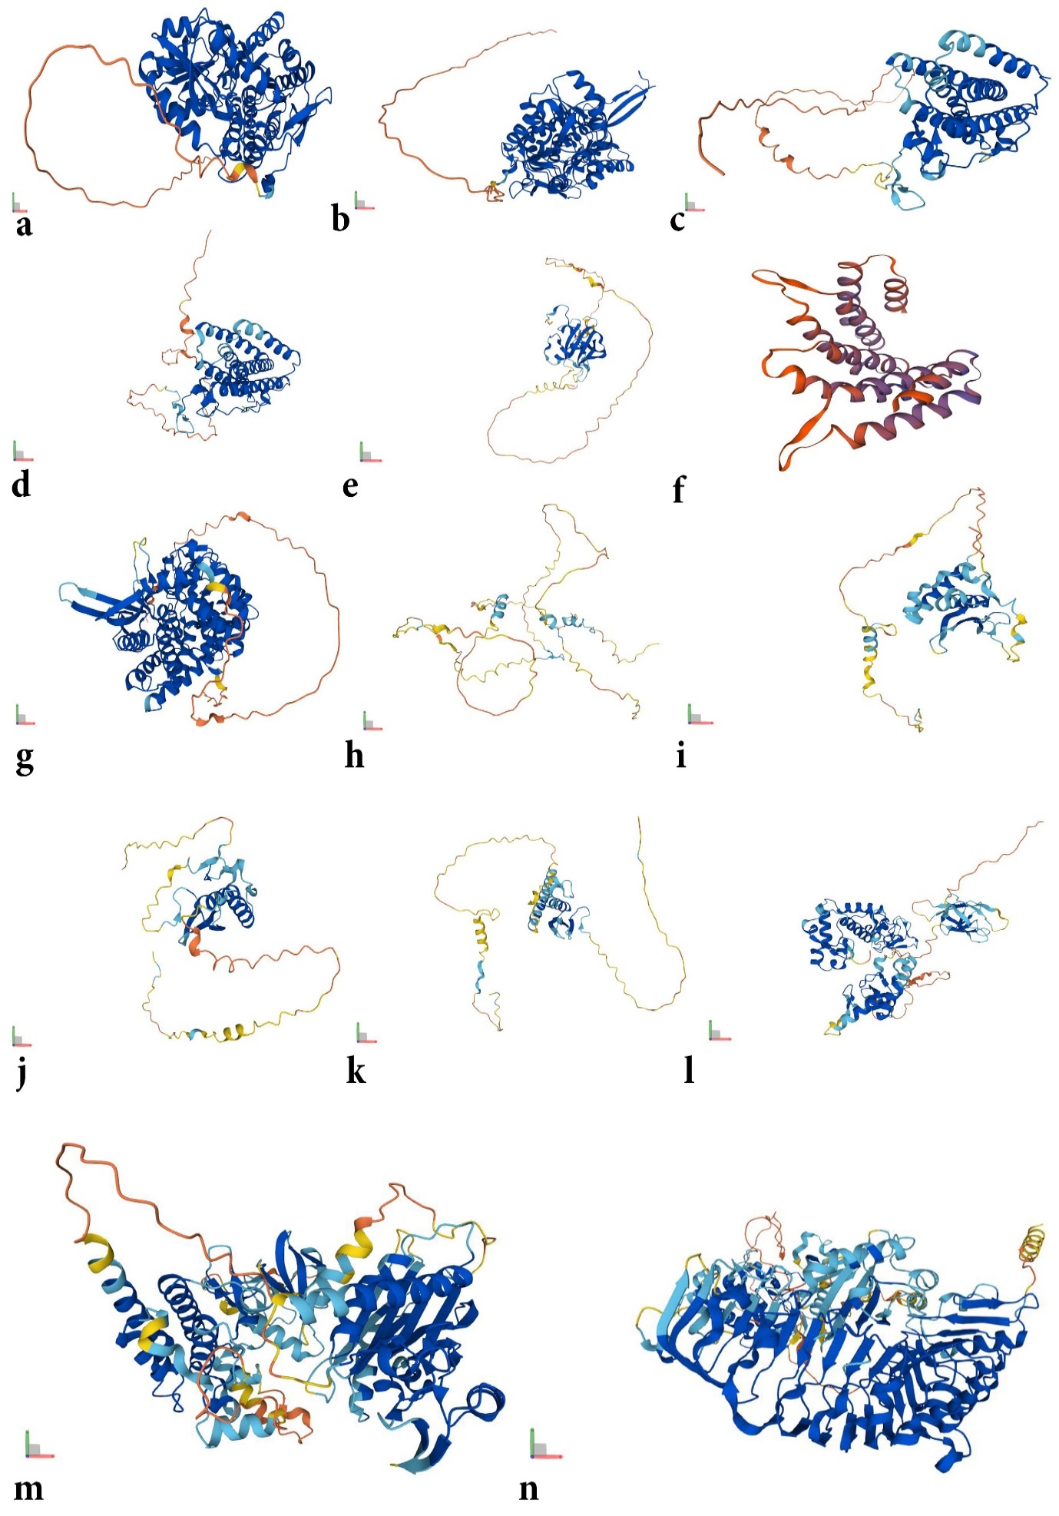**Supplementary File 10:** Predicted protein structure abiotic stress-responsive genes in *O. sativa*

a. ALDH2a; b. ALDH2b; c. AOX1a; d. AOX1b; e. OsNAC6; f. OsNCA1A (retrieved from gene Os01g0104100); g. OsNIN6 (retrieved from gene OsJ_33156); h. OsDHN1; i.OsDREB1B; j. OsDREB1G; k. OsERF28; l. OsSADR1 (retrieved from gene Os11g0175500); m. OsSTLK (retrieved from gene Os05g0305900); n. OsPP2C