**Synthesis, characterization and identification of inhibitory activity on the main protease of COVID-19 by molecular docking strategy of (4-oxo-piperidinium ethylene acetal) trioxonitrate.**

Soﬁan Gatfaoui a, Noureddine ISSAOUI b, Aleksandr S. Kazachenko c,d , Omar M. Al-Dossary e, Thierry Roisnel f and Houda Marouani a

*a Materials Chemistry Laboratory, Faculty of Sciences of Bizerte, Carthage University, 7021 Zarzouna, Tunisia.*

*b Laboratory of Quantum and Statistical Physics, Faculty of Sciences, University of Monastir, Monastir 5079, Tunisia.*

*cSiberian Federal University, pr. Svobodny 79, Krasnoyarsk, 660041 Russia*

*d Institute of Chemistry and Chemical Technology, Krasnoyarsk Scientific Center, Siberian Branch, Rus-sian Academy of Sciences, Akademgorodok 50, bld. 24, Krasnoyarsk, 660036 Russia*

*e Department of Physics and Astronomy, College of Science, King Saud University, PO Box 2455, Riyadh 11451, Saudi Arabia*

*f X-Ray Diffractometry Center, UMR 6226 CNRS, Rennes Chemical Sciences Unit, Rennes I University, 263 General Leclerc Avenue, 35042 Rennes, France.*

* Corresponding authors: Noureddine ISSAOUI, email: issaoui_noureddine@yahoo.fr

**Table S1** Theoretical and actual measurements of the compound in question's bond lengths and angles.

|  |  |  |  |  |  |
| --- | --- | --- | --- | --- | --- |
| **Parameters (Å)** | **B3LYP/6-311++G(d,p)** | **Exp** | **Parameters (°)** | **B3LYP/6-311++G(d,p)** | **Exp** |
| N1-H2 | 1.5803 | 0.96(6) | C4-C7-H9 | 110.5665 | 109.5 |
| N1-H3 | 1.0192 | 0.96(6) | C4-C7-C10 | 111.0411 | 110.8(2) |
| N1-C4 | 1.481 | 1.492(3) | H8-C7-H9 | 107.5943 | 108.1 |
| N1-C17 | 1.4807 | 1.492(3) | H8-C7-C10 | 107.9284 | 109.5 |
| C4-H5 | 1.0923 | 0.9900 | H9-C7-C10 | 109.0402 | 109.5 |
| C4-H6 | 1.0923 | 0.9900 | C7-C10-O11 | 109.9799 | 109.84(19) |
| C4-C7 | 1.5342 | 1.523(4) | C7-C10-O16 | 109.4394 | 109.26(19) |
| C7-H8 | 1.0954 | 0.9900 | C7-C10-C20 | 111.8117 | 111.7(3) |
| C7-H9 | 1.0932 | 0.9900 | O11-C10- O16 | 105.7174 | 106.8(3) |
| C7-C10 | 1.5297 | 1.512(3) | O11-C10- C20 | 110.1607 | 109.84(19) |
| C10-O11 | 1.4438 | 1.421(4) | O16-C10-C20 | 109.5468 | 109.26(19) |
| C10-O16 | 1.4494 | 1.438(4) | C10-O11-C12 | 106.0733 | 109.7(3) |
| C10-C20 | 1.5241 | 1.512(3) | O11-C12-H13 | 117.2616 | 125.7 |
| O11-C12 | 1.3852 | 1.374(5) | O11-C12-C14 | 110.7277 | 108.6(3) |
| C12-H13 | 1.0758 | 0.9500 | H13-C12-C14 | 132.0004 | 125.7 |
| C12-C14 | 1.3267 | 1.461(6) | C12-C14-H15 | 132.0266 | 126.9 |
| C14-H15 | 1.0759 | 0.9500 | C12-C14-O16 | 110.7043 | 106.1(3) |
| C14-O16 | 1.3842 | 1.417(4) | H15-C14-O16 | 117.2602 | 126.9 |
| C17-H18 | 1.0923 | 0.9900 | C10-O16-C14 | 105.9687 | 108.7(3) |
| C17-H19 | 1.0923 | 0.9900 | N1-C17-H18 | 107.0657 | 109.6 |
| C17-C20 | 1.5347 | 1.523(4) | N1-C17-H19 | 108.3537 | 109.6 |
| C20-H21 | 1.0953 | 0.9900 | H18- C17-H19 | 112.9404 | 108.1 |
| C20-H22 | 1.0927 | 0.9900 | H18-C17-H19 | 107.4891 | 108.1 |
| N23-O24 | 1.2054 | 1.246(4) | H18-C17-C20 | 110.2418 | 109.6 |
| N23-O25 | 1.3663 | 1.254(4) | H19- C17-C20 | 110.5407 | 109.6 |
| N23-O26 | 1.2233 | 1.231(4) | C10-C20-C17 | 111.0895 | 110.8(2) |
| H2-N1-H3 | 106.7154 | 110(5) | C10-C20-H21 | 107.926 | 109.5 |
| H2-N1-C4 | 110.2141 | 107.4(16) | C10-C20-H22 | 108.9265 | 109.5 |
| H2-N1-C17 | 110.0598 | 107.4(17) | N1- C17-C20 | 110.3738 | 110.2(2) |
| H3-N1-C4 | 108.9947 | 109.8(16) | C17-C20-H21 | 110.5393 | 109.5 |
| H3-N1-C17 | 109.0175 | 109.8(16) | C17-C20-H22 | 110.59 | 109.5 |
| C4-N1-C17 | 111.6982 | 111.8(3) | H21-C20-H22 | 107.6607 | 108.1 |
| N1-C4-H5 | 107.0649 | 109.6 | O24-N23-O25 | 115.5506 | 119.5(3) |
| N1-C4-H6 | 108.3204 | 109.6 | O24-N23-O26 | 127.38 | 119.4(3) |
| N1-C4-C7 | 112.8089 | 110.2(2) | O25-N23-O26 | 117.0694 | 121.1(3) |
| H5-C4-H6 | 107.4968 | 108.1 | H6-C4-C7 | 110.6402 | 109.6 |
| H5-C4-C7 | 110.3015 | 109.6 | C4-C7-H8 | 110.563 | 109.5 |

**Table S2** (**4−OPEAN**) chemical's enrichment ratio.

|  |  |  |  |  |
| --- | --- | --- | --- | --- |
| ER | H | N | O | C |
| H | 0.84 | 0. 57 | 1.44 | 0.45 |
| N |  | - | - | - |
| O |  |  | 0.05 | 1.48 |
| C |  |  |  | - |
| % Surface | 65.4 | 1.75 | 29.6 | 3.25 |

**Table S3** Topological properties of the (**4−OPEAN**) structure were identified at 6-311++G DFT/B3LYP (d,p).

|  |  |  |  |  |  |  |
| --- | --- | --- | --- | --- | --- | --- |
| **Interactions** | | **ρ(r) (a.u)** | **Δρ(r) (a.u)** | **H(r) (a.u)** | **G(r) (a.u)** | **V(r) (a.u)** |
| H2...O25 | 0.034 | | 0.103 | -0.00049 | 0.0264 | -0.0269 |
| H5-O26 / H18-O26 | 0.006 | | 0.022 | 0.00081 | 0.0046 | -0.0038 |

**Table S4** The examined compound energy value was calculated using the TD-B3LYP/6-311++G(d,p) process.

|  |  |
| --- | --- |
| EHOMO (eV) | -5.47 |
| ELUMO (eV) | -1.36 |
| ΔE (eV) | 4.11 |
| Chemical potential µ (eV) | -3.41 |
| Electronegativity χ (eV) | 3.41 |
| Chemical hardness η (eV) | 2.05 |
| Softness S (eV)−1 | 0.49 |
| Electrophilic index ѱ (eV) | 2.84 |

**Table S5** Assignments of molecular structure of the (4-OPEAN) wavenumbers (cm-1) based on observations and calculations.

|  |  |  |
| --- | --- | --- |
| Experimental  IR | Theoritical IR | Vibrational assignements (% PED) |
| 3053 | 3107 | νNH |
| 2975 | 3077 | νNH, νCH |
| 2908 | 2305 | ν CH, νNH, νNHO |
| 2842 |  | νNH, νNHO, νCH |
| 2751 |  | νNH, ν CH |
| 2643 |  | νNH, ν CH |
| 1652 | 17013 | δNH, δCH |
| 1598 | 1532 | δNH, δCH |
| 1472 | 1309 | δNH, δCH |
| 1368 | 1229 | δNH, δCH, vas(NO3-) |
| 1338 | 1200 | δ CH, vas(NO3-) |
| 1284 | 1121 |  |
| 1254 | 1025 |  |
| 1181 | 964 | vs(NO3-), νCC , νCN, νCO, δ CH, δ(NO3-) |
| 1121 | 916 | νCC , νCN, νCO, δ(NO3-) |
| 1055 | 862 | νCC , νCN, νCO, δ CNC |
| 1036 | 825 | νCC , νCN, νCO, δ(NO3-) |
| 988 | 777 | δ(NO3-) |
| 940 | 723 |  |
| 897 | 614 | δ(CC), δ(CN), δ(CO) |
| 832 |  | δ(NO3-), δ(CC), δ(CN), δ(CO) |
| 795 |  | δ(CC), δ(CN), δ(CO) |
| 765 |  | δ(NO3-), δ(CC), δ(CN), δ(CO) |
| 711 |  | δ(CC), δ(CN), δ(CO) |
| 650 |  | δ(CC), δ(CN), δ(CO) |
| 578 |  | δ(CC), δ(CN), δ(CO) |
| 565 |  | δ(CC), δ(CN), δ(CO) |
|  |  |  |
|  |  |  |
|  |  |  |
|  |  |  |

ν and δ denote stretching deformation modes PED: Information on the distribution of potential energy is derived from VEDA4.

**Table S6** Docking output of the ligand (**4−OPEAN**) with protein combinations.

|  |  |  |  |  |  |
| --- | --- | --- | --- | --- | --- |
| Ligand | Proteins | RMSD | Score for binding energy (S) | E-conﬁg | E-place |
| **4−OPEAN** | 6Y84 | 1. 0299 | -3.1968 | -41.8113 | -19.2555 |
|  | 7EJY | 1. 7153 | -3.0197 | -42.0069 | -18.5020 |

**Table S7** Values of the examined proteins' interaction properties with the (**4−OPEAN**) ligand.

|  |  |  |  |  |  |
| --- | --- | --- | --- | --- | --- |
| Proteins | Compound part | Interacting amino acid | Interactional style | Distance (Å) | E (kcal.mol-1) |
| 6Y84 | C2 | CYS 145 | H-donor | 3.30 | -0.7 |
|  | C2 | ASN 142 | H-donor | 3.81 | -0.7 |
|  | O13 | CYS 145 | H-acceptor | 2.75 | -1.3 |
| 7EJY | O5 | TYR 140 | H-acceptor | 3. 39 | -0.8 |
|  | O13 | LYS 125 | H-acceptor | 2.87 | -1.5 |
|  | O13 | SER 126 | H-acceptor | 2.74 | -3.5 |

C:\Users\USER\Desktop\4-OPEAN\Fig.S1.tif

**Fig. S1.** Proportion of atoms and connections overall that make up 4−OPEAN.

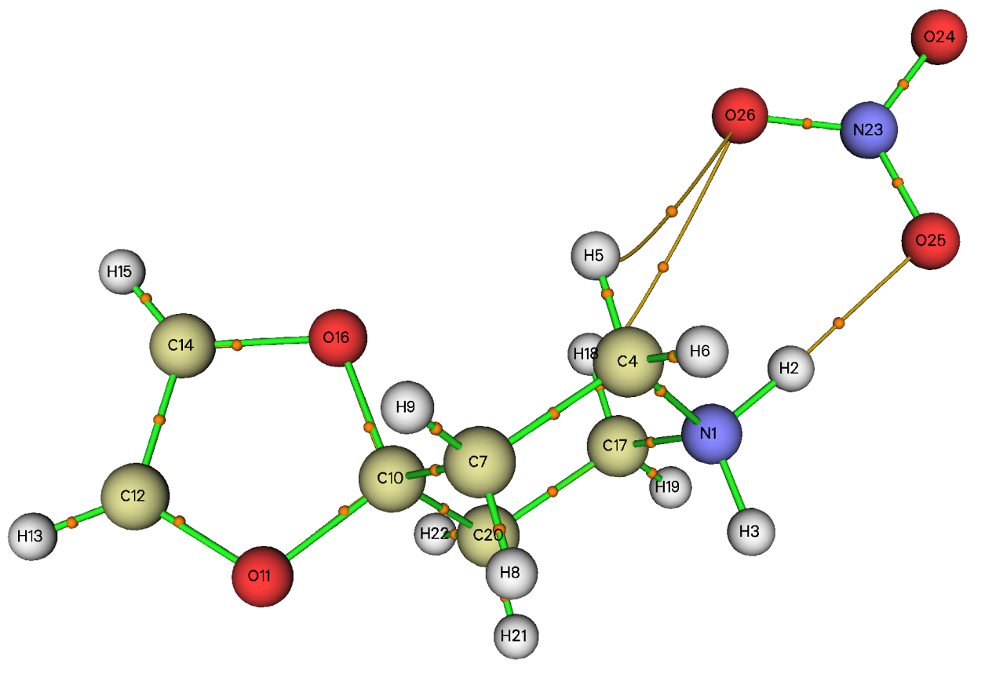

**Fig. S2.** Mapped AIM graph by Multiwfn software of 4−OPEAN Compound.

C:\Users\USER\Desktop\4-OPEAN\Fig.S3.tif

**Fig. S3.** Localized orbital locator (LOL) and electron localization function (ELF) maps for 4−OPEAN.

C:\Users\USER\Desktop\4-OPEAN\Fig.S4.tif

**Fig. S4.** 3D best docked poses and 2D interactions of 4−OPEANcompound with the 7EJY protein.