Phytogenic fabrication of zinc oxide nanoparticles from the aqueous bark extract of *Acacia nilotica* and evaluation of its bioactivities

Manoharan Janania, Thandapani Gomathib, Ranganathan Babujanarthanamc*,

K. Kaviyarasud,e*

aDepartment of Biochemistry, Auxilium College (Autonomous), Gandhi Nagar, Vellore - 632006, Tamil Nadu, India.

bDepartment of Chemistry, D.K.M College for Women (Autonomous), Vellore - 632006, Tamil Nadu, India.

cNano and Energy Bioscience Laboratory, Department of Biotechnology, Thiruvalluvar University, Serkkadu, Vellore - 632115, Tamil Nadu, India.

dUNESCO-UNISA Africa, Nanosciences/Nanotechnology Laboratories, College of Graduate Studies, University of South Africa (UNISA), Muckleneuk Ridge, PO Box 392, Pretoria, South Africa.

eNanosciences African Network (NANOAFNET), Materials Research Group (MRG), iThemba LABS-National Research Foundation (NRF), 1 Old Faure Road, 7129, PO Box 722, Somerset West, Western Cape Province, South Africa.

*Corresponding email: [babukmg@gmail.com](mailto:babukmg@gmail.com) (R. Babujanarthanam);

kavi@tlabs.ac.za (K. Kaviyarasu)

Supplementary Information

**3.9. Antioxidant assessment of AN-ZnO NPs**

*3.9.1. DPPH (2, 2-diphenyl-1-picrylhydrazyl) free radical scavenging activity*

The free radical scavenging trait of AN-ZnO NPs was executed out using standard assay protocol and the acquired data were illustrated in Fig. S1(A). The report acquired provided that with the elevation in the concentrations of AN-ZnO NPs, an impressive increased antiradical activity was achieved in the DPPH test. The radical scavenging efficacy of AN-ZnO NPs was from 19.0% (at 20 µg/mL) to 80.21% (at 60 µg/mL). Also, an IC50 level for AN-ZnO NPs was 34.54 µg/mL. Ascorbic acid reference conveyed IC50 value of 30.55 µg/mL, respectively. *Malus pumila* as well as *Juglen regia* extract inspired genesis of ZnO NPs, also showed a dose mediated elevation in the radical scavenging trait. Discolouration of the purplish chromophore of DPPH to a yellowish chromophore by adopting electrons from the antioxidants is the signature trait in this assay. The diminutive size and transfer of electrons from the densified layer of an oxygen atom to the odd electrons in the residing nitrogen atom of DPPH are liable for the antioxidant trait.

*3.9.2. NO (Nitric oxide) radical scavenging activity*

In vivo NO (nitric oxide) genesis occurs consistently in diverse biological functions. The superfluous nitric oxide along with oxygen forms highly reactive free radical species that include nitrite and peroxyl nitrite anions. An escalation of the nitric oxide, free radical species is toxic and directly creates tissue damage attributing to the threat of cancer, arthritis, and Alzheimer’s disease.Varied concentrations of AN-ZnO NPs were experimented for nitric oxide scavenging capacity. With the escalation of concentrations of AN-ZnO NPs, the radical scavenging trait were also elevated which was 13.74% (at 20 µg/mL) and 80.61% (at 60 µg/mL) as provided in Fig. S1(B). The acquired results on the NO assay offered the utmost activity for AN-ZnO NPs with an IC50 of 38.0 µg/mL. Ascorbic acid, IC50 was calculated as 35.54 µg/mL. The biogenically formed AN-ZnO NPs directly competed with the oxygen and inhibited the concentration of reactive radical species, thereby bearing a trait of counteracting the deleterious nitric oxide formation and thus it was concluded that they may possess activity to hinder the ill-effects of in vivogenerated nitric oxide. A remarkable antioxidant property of ZnO NPs designed using *Curcuma longa* was also witnessed.

*3.9.3. Hydroxyl radical (OH-) scavenging activity*

Hydroxyl radical are an immensely reactive form of free radical generated within the living entities and bring about a deleterious impression on the pivotal bio-organic molecules like lipids, proteins, and nucleic acid molecules. The inhibitory trait on hydroxyl radial by the formed AN-ZnO NPs was perceived by using varying amounts and the results are presented in Fig. S1(C). Ascorbic acid was utilized as a comparative reference standard. At the lowest amount (20 µg/mL) the radical scavenging capacity of AN-ZnO NPs was 14.13% and at the highest used concentration (60 µg/mL) was 91.39%. The IC50 value of 41.34 µg/mL was for AN-ZnO NPs whereas, 37.10 µg/mL was for ascorbic acid. The tested AN-ZnO NPs presented a dose-mannerly scavenging activity. Dhandapani *et al.,* [1], fabricated ZnO NPs from *Melia azedarach* and presented hydroxyl radical scavenging property on a dose-related basis (14.57% to 54.97%).

3.8.4. 2,2’-Azino-bis (3-ethylbenzothiazoline-6-sulfonic acid) radical scavenging activity

The accomplishment of the ABTS radical scavenging assay was done with diverged concentrations of AN-ZnO NPs. Ascorbic acid was utilized as a comparative standard against the test AN-ZnO NPs for the antiradical trait. A dose-proportional antiradical activity was presented by the AN-ZnO NPs. The radical scavenging activity of 14.69% to 88.78% was achieved with the raised AN-ZnO NPs concentrations. Results were presented in Fig. S1(D). The IC50 value were calculated for both AN-ZnO NPs and ascorbic acid which were 35.41 µg/mL and 30.39 µg/mL. Chemically provoked ABTS free radicals and their scavenging assay is specific and highly sensitive test. Our results are in concurrence with currently available report.

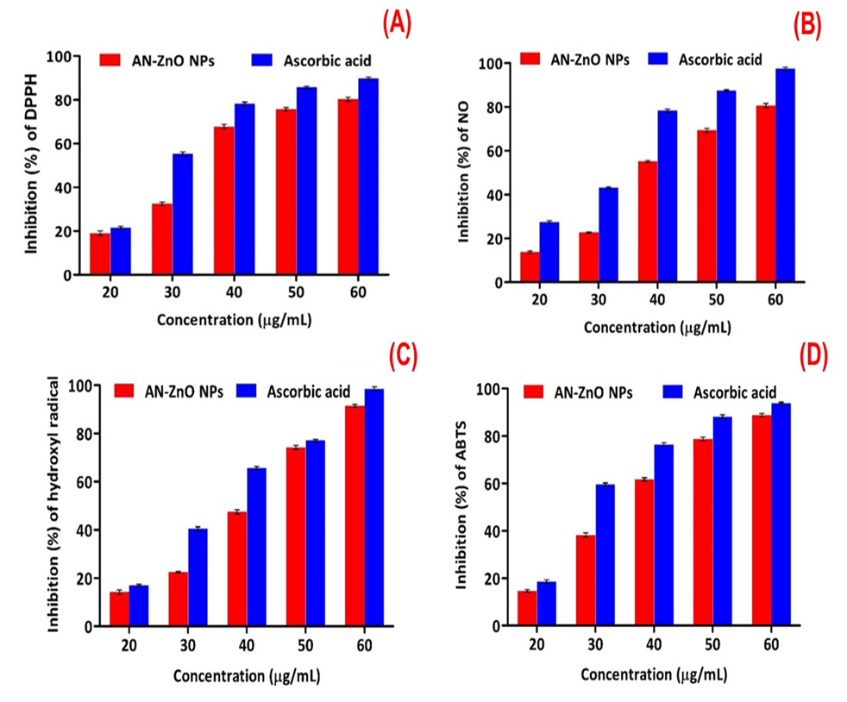

**Fig. S1.** Antioxidant role of AN-ZnO NPs executed in three trials for each assay. The results are given as mean ± standard deviation (SD) at p < 0.05; (A) DPPH radical quenching efficacy of AN-ZnO NPs; (B) Nitric oxide (NO) scavenging efficacy of AN-ZnO NPs; (C) Hydroxyl radical scavenging efficacy of AN-ZnO NPs; (D) ABTS radical scavenging efficacy of AN-ZnO NPs.

**3.10. Cytotoxic assay**

*3.10.1. MTT-mediated cytotoxic evaluation of AN-ZnO NPs*

The biocompatible and cytotoxic trait of AN-ZnO NPs was executed by MTT assay on MCF-7 cell line. The reduction of yellow coloured MTT to purple-blue coloured formazan by the enzyme succinate dehydrogenase of mitochondria was measured. The impact of AN-ZnO NPs on the viability of MCF-7 cell line was performed with varied concentrations (10 µg/mL to 90 µg/mL) and the values were provided in terms of IC50. The percentage rate of survival of the breast cancer cells (MCF-7 cell line) was repressed with the raised concentration of AN-ZnO NPs in Fig. S2. Thus, proving that the raised concentration of fabricated AN-ZnO NPs depicted inhibition in the cancerous cell growth and division. The minimum inhibitory concentration (IC50) to cause 50% cellular death in breast cancer cells on AN-ZnO NPs exposure for 24 h was observed as 37.15 µg/mL. Furthermore, it can be concluded that the phytofabricated AN-ZnO NPs could profoundly serve as a breast cancer controlling factor. Loganathan *et al.,* [2], enlightened the antiproliferative potentiality of *Knoxia sumatrensis* based harnessed ZnO NPs on MCF-7 cell line with an IC50 value of 58.87 µg/mL. Spontaneous development of ROS by the ZnO NPs with the diminutive feature is a critical factor in exposing the cytotoxic impression on the cancerous cells.

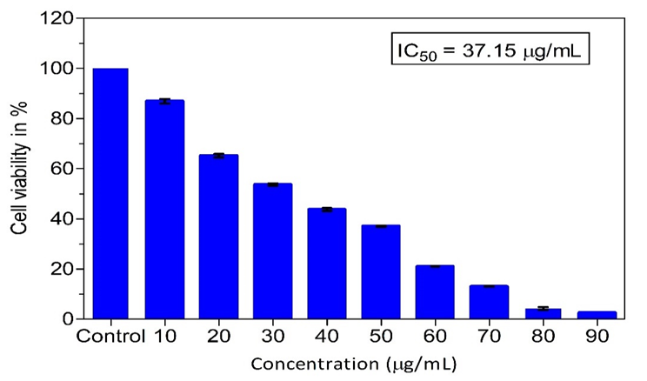

**Fig. S2.** Impact of AN-ZnO NPs on the MCF-7 (breast cancer cell) cells viability. Results are provided as mean ± standard deviation (SD) of three separate trails for each concentration (p < 0.05).

*3.10.2. Determination of ROS using DCFH-DA (Dichloro-dihydrofluorescein diacetate method)*

The impact of phytofabricated AN-ZnO NPs on the evolution of ROS in the MCF-7 exposed cells was scrutinized using DCFH-DA stain. Intense greenish coloured fluorescence in the AN-ZnO NPs treated MCF-7 cells were visualized at IC50 range of 37.15 µg/mL on 24 h and 48 h treatment, respectively. The photographic images captured delineated the enhanced in vivo generation of ROS in the AN-ZnO NPs treated cells. There was a lack of fluorescence intensity within the control (negative) cells, implying diminished ROS formation. But in the standard (Doxorubicin) drug-treated cells greenish fluorescence was high concluding more ROS release in Fig. S3(A-E). The intensity of fluorescence obtained by the spectrofluorimetric tool has direct proportionality to the ROS quantity. In vivocopious production of reactive oxygen species (ROS) provokes oxidative stress which is the key inducer of apoptotic reactions and proposing oxidative-based obliteration of mitochondria and other integral molecules. Experimental outcomes have illustrated the active involvement of inorganic nanoparticles (ZnO NPs) in contributing cellular toxicity straight through the genesis of ROS conciliated oxidative stress.

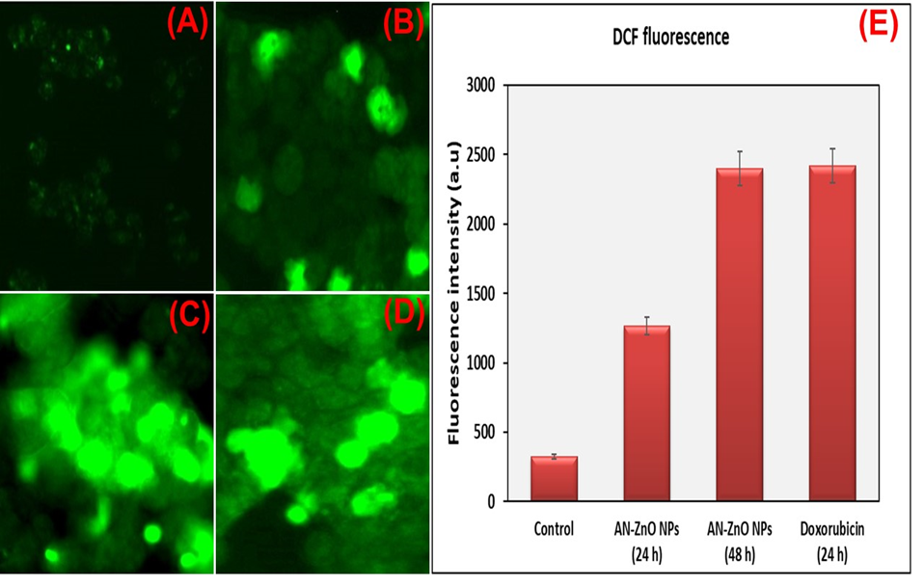

**Fig. S3.** Fluorescence microscopic photograph of MCF-7 breast cancer cells on DCFH-DA staining for ROS genesis identification (A) Negative control; (B) AN-ZnO NPs (37.15 µg/mL) exposed cells for 24 h; (C) AN-ZnO NPs (37.15 µg/mL) exposed cells for 48 h; (D) Doxorubicin (500 µg/mL), a positive control exposed MCF-7 cells; (E) Bar chart illustrating the fluorescence intensity of DCF related to ROS origin in negative control, AN-ZnO NPs exposed and Doxorubicin reacted MCF-7 cells.

*3.10.3. Analysis of mitochondrial membrane potential (MMP) using Rhodamine 123 staining*

The outcome of AN-ZnO NPs at their IC50 value (37.15µg/mL) on the potentiality of the mitochondrial membrane was assessed by utilizing Rhodamine 123 dye. Damaged mitochondrial membrane morphology can be excellently notified using Rhodamine123 dye in the cancerous cells. In the image captured by the fluorescence microscope, the untreated (negative control) cells displayed a higher range of green coloured fluorescence in contrary to the AN-ZnO NPs treated MCF-7 cells with the mildest greenish fluorescence. Thus, clearly illustrating the loss in the intactness of mitochondrial membrane after AN-ZnO NPs exposure in MCF-7 cells. Even the doxorubicin (500 µg/mL) utilized as a positive control exposed lessened fluorescence. Further, the spectrofluorimetric data validated the fact that AN-ZnO NPs would have brought loss in the potentiality of mitochondrial membrane. Illustration of report were given in Fig. S4(A-E). The intactness trait is pivotal for the effectual ATP generation by mitochondria for cellular survival. The damage to the mitochondrial membrane leads to drastic falls in ATP thus mediating apoptotic-induced cellular killing.

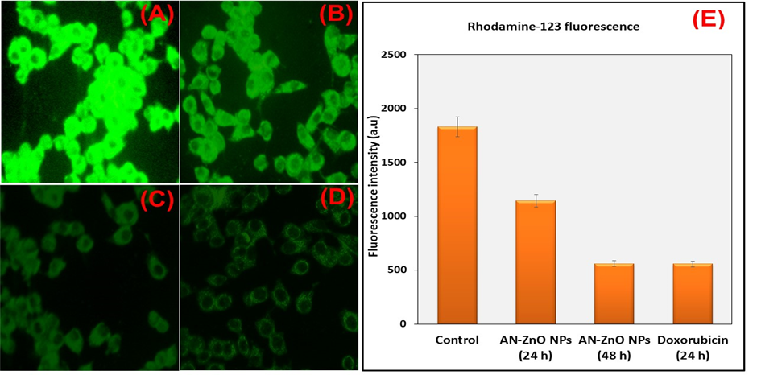

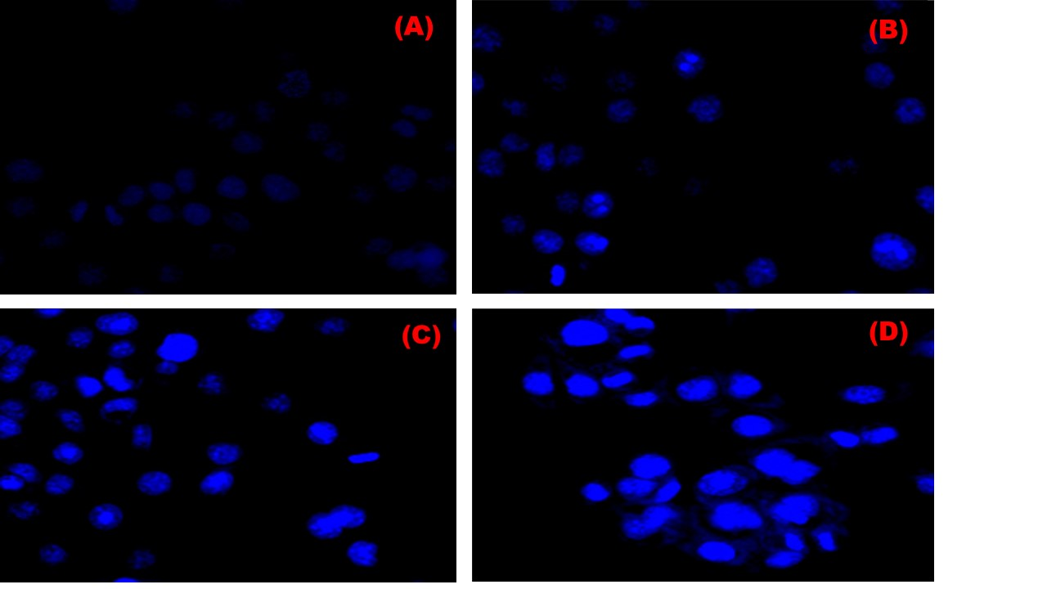**Fig. S4.** Fluorescence microscopic photograph of MCF-7 breast cancer cells on Rhodamine 123 staining illustrating MMP; (A) Negative control; (B) AN-ZnO NPs (37.15 µg/mL) exposed cells for 24 h; (C) AN-ZnO NPs (37.15 µg/mL) exposed cells for 48 h; (D) Doxorubicin (500 µg/mL), a positive control exposed MCF-7 cells; (E) Bar chart illustrating the fluorescence intensity of Rhodamine-123 in negative control, AN-ZnO NPs exposed, and Doxorubicin reacted MCF-7 cells.

*3.10.4. Morphological assessment of nucleus using DAPI*

The morphological alterations of the nucleus induced on MCF-7 cells by phytofabricated AN-ZnO NPs at IC50 of 37.15 µg/mL were shown in Fig. S5(A-D). Clear nucleus damage was visualized in the AN-ZnO NPs treated MCF-7 cells. There was a greater intensity in the blue coloured fluorescence in AN-ZnO NPs exposed MCF-7 cells, contrary to the control (untreated) cells thus depicting damage in the nucleus of the MCF-7 cells. The acquired results were compared to Doxorubicin (positive control). Oxidative damage triggered by ROS upsurges DNA strand cleavage effectuating an apoptotic mechanism.

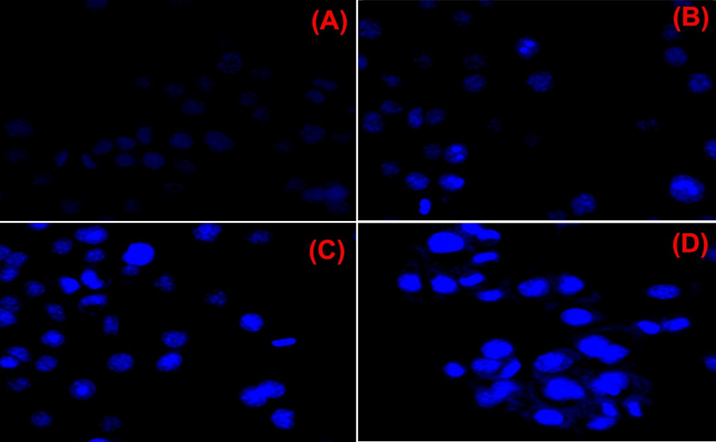

**Fig. S5.** DAPI staining depicting fragmentation of nucleus in MCF-7 cells (A)Negative control (B) AN-ZnO NPs (37.15 µg/mL) exposed cells for 24 h (C) AN-ZnO NPs (37.15 µg/mL) exposed cells for 48 h (D) Doxorubicin (500 µg/mL), a positive control exposed MCF-7 cell.

*3.10.5. Western blotting technique*

Verification of expression of the anti-apoptotic, proapoptotic gene and proliferative protein markers in the phytofabricated AN-ZnO NPs on exposure to MCF-7 breast cancer cells was executed by applying the western blot analytical technique. When exposed to the AN-ZnO NPs, there appeared a significant upregulation of certain proteins like Bax, Caspase-3 and Caspase- 9, whereas Bcl-2, Cyclin-D1 and PCNA were downregulated in the breast cancer cells (MCF-7). The results were compared to β-actin (standard control) in Fig. S6(A & B). The performed experiment confirmed the potentiality of phytofabricated AN-ZnO NPs to inhibit the expression of cancer proliferative proteins and regulate the expression of apoptotic-related proteins. Kavithaa *et al.,* [3], in her experimentation reported the cytotoxicity feature of *Santalum album* leaves fabricated ZnO nanorods in dose-basis on MCF-7 cells. Even the overexpression of Bax and Bcl-2 decreased expression occurred on treatment with 10 µg/mL and 15 µg/mL concentrations of ZnO nanorods. Diminutive Bcl-2 and excessive expression of proapoptotic protein Bax, upgrade apoptotic programmed cell death.In the apoptotic mechanism, caspase-9 and caspase-3 are crucial as the first one serves as the initiator of the caspase cascade whereas, caspase-3 is engaged in the activation of the apoptosis-based mechanism. Studies have proclaimed that raised Bax and dropped Bcl-2 levels have escorted caspase-3 and caspase-9 activation rendering irreversible apoptotic mediated cancer cell lysis. Over-presentation of cyclin D1 has been shown for raising the risk of breast cancer. PCNA (proliferating cell nuclear antigen) is a crucial protein playing a significant function in the replication of DNA, remodelling of chromatin and repair of DNA. As it over occurs in the cancerous cell, it serves as a proliferative marker for cancer. PCNA is a potent biomarker for breast cancer diagnosis as its level is found to be excessive within the cancerous cells. Furthermore, it insinuated the probable usage of zinc oxide nanoparticles in cancer therapeutics in the future.

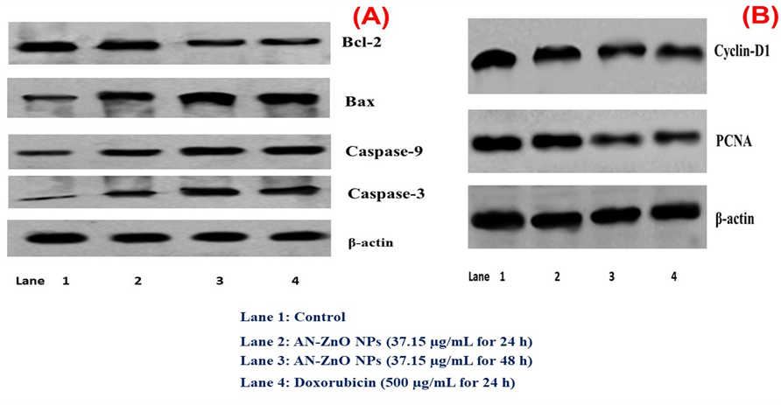

**Fig. S6.** Western blot technique displaying; (A) The level of expression of apoptotic protein expression in the control, AN-ZnO NPs (24 h & 48 h) exposed and Doxorubicin (24 h) in MCF-7 cells;(B) Inhibition of proliferative marker protein expression in control, AN-ZnO NPs (24 h & 48 h) exposed, Doxorubicin (24 h) in the MCF-7 cells.

*3.11. Larvicidal efficacy of AN-ZnO NPs*

The larvicidal efficacy was observed by applying varied concentrations (0.1- 0.5 ppm) of AN-ZnO NPs to *Anopheles stephensi* mosquito larvae after 24 h treatment. The obtained results inferred 75.66% mortality at 0.5 ppm (higher concentration) and 15.33% mortality at 0.1 ppm (lowest concentration). The lethality dosage values (LC50 and LC90) determined from mortality percentage of *Anopheles stephensi* mosquito larvae were 0.31ppm and 0.59 ppm, respectively, in Fig. S7. The AN-ZnO NPs displayed excellent dosed-mannered larvicidal trait. Penetration and accrual of ZnO NPs in the cytosolic section of larval cells and genesis of ROS by the released cytotoxic zinc ions distort vital bio-organic moieties such as nucleic acid, lipids, enzymes, and proteins. Thus, forming the pivotal apoptotic mechanism for the larval lysis by ZnO NPs. A constructive type of larvicidal trait was accounted for a study on *Momordica charantia* implemented ZnO NPs fabrication at *Anopheles stephensi* and *Culex quinquefasciatus* with the IC50 values of 5.42 mg/L and 4.87 mg/L.

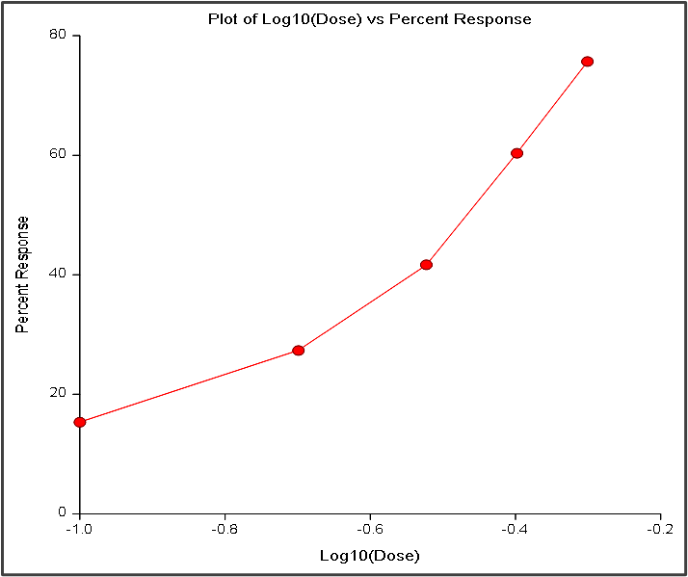

**Fig. S7.** Probit graph for the larvicidal activity of AN-ZnO NPs on *Anopheles stephensi larvae*.

*3.11.1. Acetylcholinesterase inhibition by AN-ZnO NPs*

AN-ZnO NPs with six varying concentrations (0.25, 0.5, 0.75, 1.0, 1.25 and 1.5 µg/mL) were scrutinized for the inhibition activity on the acetylcholinesterase enzyme acquired from the dead larval homogenate solution of *Anopheles stephensi.* A stupendous inhibition of acetylcholinesterase enzyme activity occurred with the elevation in the concentration of AN-ZnO NPs. The results were provided in Fig. S8. The IC50level for the acetylcholinesterase inhibition by AN-ZnO NPs was computed to be 0.77 µg/mL. The green fabricated ZnO NPs contained acetylcholinesterase inhibition trait which may be owned to their huge-surface area Dhavan *et al.,* [4] found that *A.aeypti* larvae on exposure to *Lumnitzera racemose* wrapped ZnO NPs displayed paralysis of respiratory muscles leading to rigidity and tremors. This happened due to the inhibition of the AChE enzyme. Thus, the undertook study pinpointed the neurotoxicity trait of AN-ZnO NPs.

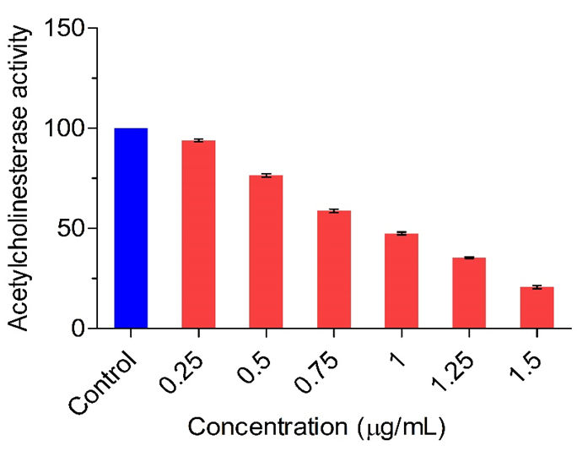

**Fig. S8.** Decline in the activity of acetylcholineasterase enzyme with the increase in the concentration of AN-ZnO NPs. Results are provided as mean ± standard (SD) of three separate trails for each concentration (p < 0.05).

*3.11.2. Histological* *assessment of Anopheles stephensi*

Visualization of histological slides of the control and AN-ZnO NPs exposured mosquito larvae of *Anopheles stephensi* were provided in Fig. S9(A & B). AN-ZnO NPs reacted larvae of *Anopheles stephensi* presented disorganized layer of columnar epithelial cells, swelling along with the exuded cellular material in the anterior section of the gut. In the lumen of the gut, the epithelial cells appeared to be vacuolated and expanded with a huge cytoplasmic compartment due to AN-ZnO NPs aggregation. Degeneration in the ganglia cells was also validated for neurotoxic damage. All these morphological distortions appeared in the larvae of the mosquito confessed the excellent nano-larvicidal trait of AN-ZnO NPs. In the control larvae of *Anopheles stephensi*,the morphology was normal. Likewise, morphological distortion was presented by Kalpana *et al.,* [5], on *Lagenaria siceraria* extract and ZnO NPs produced from the plant extract on *Anopheles stephensi*.

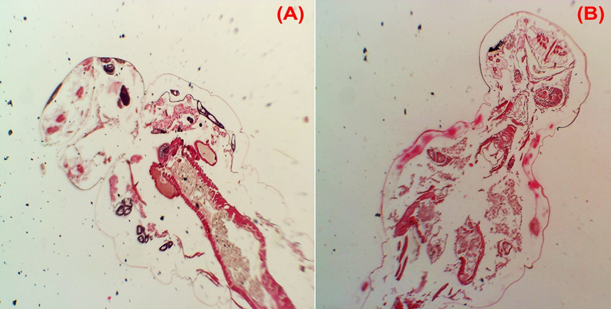

**Fig. S9.** Histological images of larvae of *Anopheles stephensi* (A) Control (without AN-ZnO NPs exposure) (B) AN-ZnO NPs exposed larvae showing morphological distortions.

*3.12. Antibiofilm efficacy of AN-ZnO NPs*

The efficacy of AN-ZnO NPs on the formed biofilm by pathogenic *Staphylococcus aureus* and *Klebsiella pneumoniae* was noted by executing a microtiter plate assay with a crystal violet stain. The data obtained by this assay proclaimed for the antibiofilm trait of AN-ZnO NPs in a dose-basis on tested gram-positive and gram-negative strains of bacteria. With the rise in the concentration of AN-ZnO NPs, the inhibitory trait on biofilm development was noticed in both the selected strains of bacteria. The greater inhibition was 91.94% against *Staphylococcus aureus* with IC50 level of 23.80 µg/mL, whereas, raised inhibition of 72.13 % was achieved for *Klebsiella pneumoniae* with IC50 level of 23.31 µg/mL at a maximum concentration (300 µg/mL) in Fig. S10. The biofilm genesis inhibition was chiefly due to bacterial cell suppression by the AN-ZnO NPs. *Laurus nobilis* leaf extract wrapped ZnO NPs, displayed good biofilm inhibition activity against *Staphylococcus aureus* and *Pseudomonas aeruginosa* in dose mannered as achieved in synchroneity to our findings. Rupturing of the cellular membrane of bacteria in responsive to the electrostatic interactive trait between the nanoparticles and bacterial exterior lyse the cells. ROS further imposes the lysis of bacteria by distortion of proteins of the bacterial membrane.

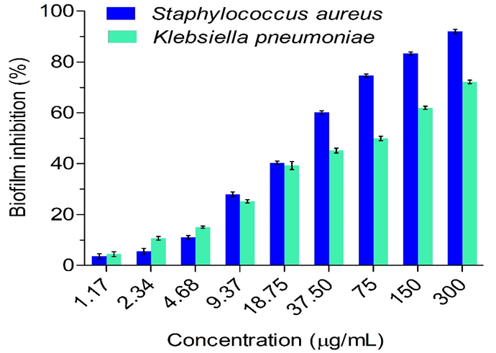

**Fig. S10.** Biofilm inhibition in percentage (%) by phytofabricated AN-ZnO NPs on *Staphylococcus aureus* and *Klebsiella pneumoniae*. Results are provided as mean ± standard (SD) of three separate trails for each bacterial strain (p <0.05).

**References**

1. K.V. Dhandapani, D. Anbumani, A.D. Gandhi, P. Annamalai, B.S. Muthuvenkatachalam, P. Kavitha, B. Ranganathan, Green route for the synthesis of zinc oxide nanoparticles from Melia azedarach leaf extract and evaluation of their antioxidant and antibacterial activities, Biocatal. Agric. Biotechnol. 24, (2020), 101517.
2. S. Loganathan, M.S. Shivakumar, S. Karthi, S.S. Nathan, K. Selvam, Metal oxide nanoparticle synthesis (ZnO-NPs) of Knoxia sumatrensis (Retz.) DC. Aqueous leaf extract and It’s evaluation of their antioxidant, anti-proliferative and larvicidal activities, Toxicol. Reports. 8, (2021), 64 -72.
3. K. Kavithaa, M. Paulpandi, T. Ponraj, K. Murugan, S. Sumathi, Induction of intrinsic apoptotic pathway in human breast cancer (MCF-7) cells through facile biosynthesized zinc oxide nanorods, Karbala Int. J. Mod. Sci. 2, (2016), 46 - 55.
4. P.P. Dhavan, B.L. Jadhav, Eco-friendly approach to control dengue vector Aedes aegypti larvae with their enzyme modulation by Lumnitzera racemosa fabricated zinc oxide nanorods, SN Appl. Sci. 2, (2020), 1-15.
5. V.N. Kalpana, K.M. Alarjani, V.D. Rajeswari, Enhancing malaria control using Lagenaria siceraria and its mediated zinc oxide nanoparticles against the vector Anopheles stephensi and its parasite Plasmodium falciparum, Sci. Rep. 10, (2020), 1-12.