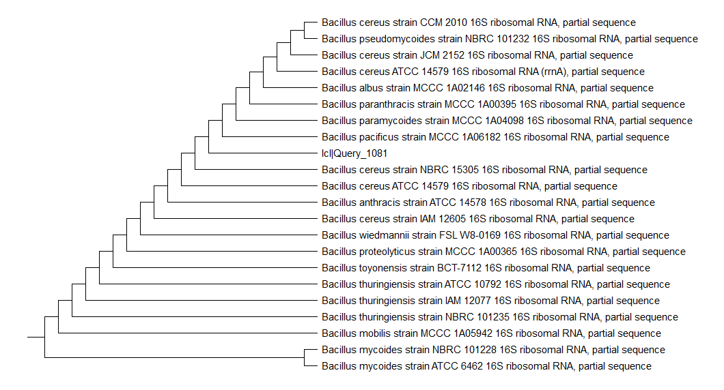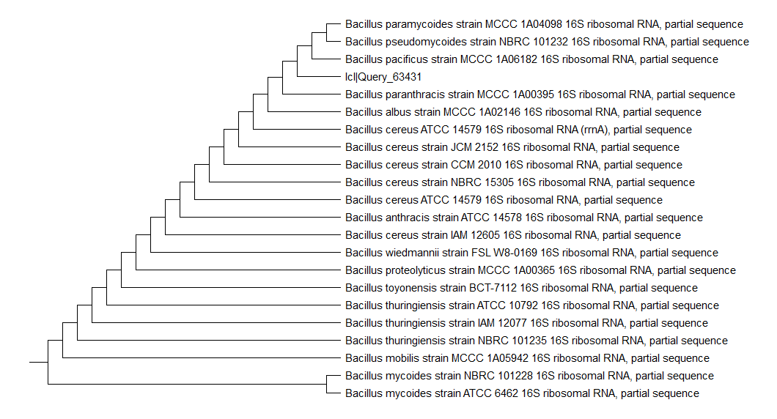

**E8**

**E7**

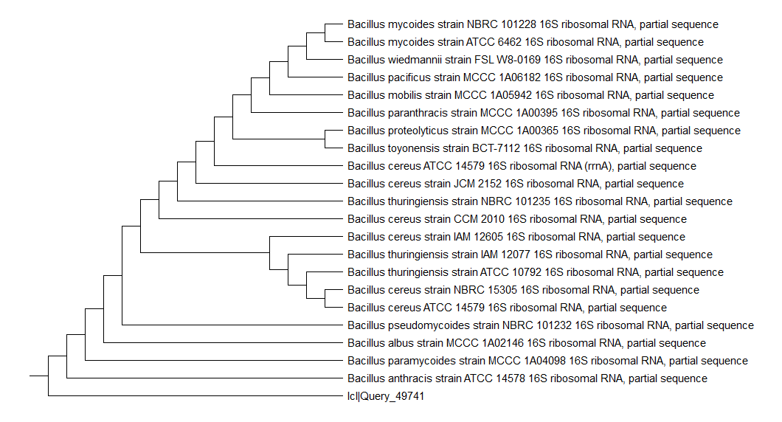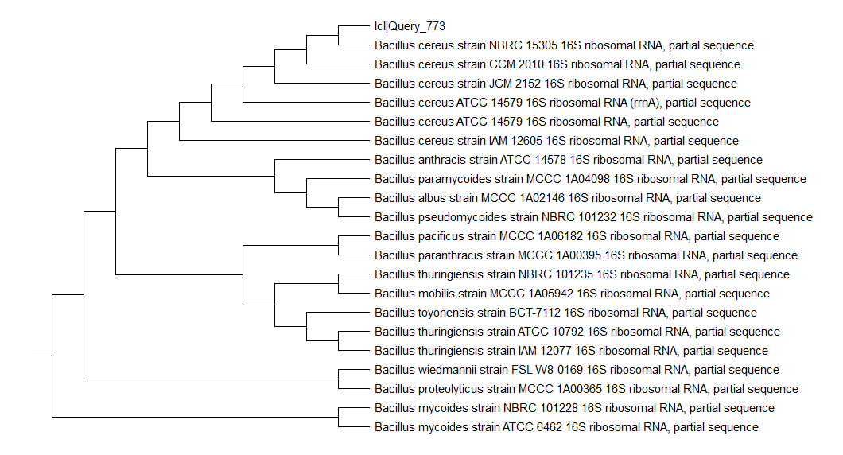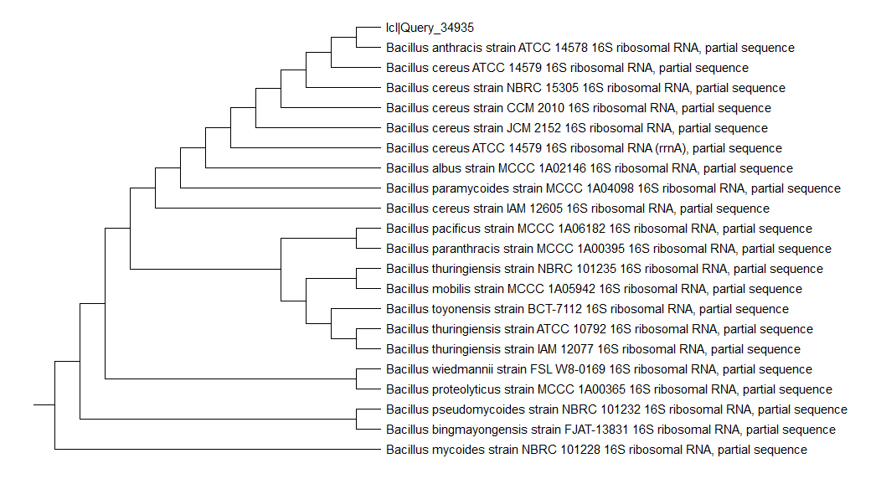

**Fig. S1. Phylogenetic relationships of the tested strains and the most closely related bacterial species. *Bacillus pacificus* strain MCCC 1A06182 (E7 & E8), *Bacillus cereus* strain ATCC 14579 (E9) and *Bacillus paramycoides* strain MCCC 1A04098 (E11 & 13).**

**E13**

**E11**

**E9**